Candidate Details

Name: Cameron Conn  
Centre Number: 17632  
 Candidate Number: 4030

Comp 4 Project

A ‘Pulley System on an Incline’ Learning Tool

# Contents

Analysis 12

Background to and identification of problem 12

Description of the current system 13

Observations 13

Confirmation of Observations 14

Identification of the prospective users 14

Identification of user needs and acceptable limitations 15

Interview with Mr Slator: Maths office, 2:00pm, Wednesday 17th September 2014: 15

Final Identification of User Needs and Acceptable Limitations 17

Data source(s) and destination(s) 17

Data volumes 17

Analysis Data Dictionary (from perspective of end user) 18

DfDs (existing and proposed system) to level 1 22

Existing Solution level 0 22

Existing Solution level 1 22

Proposed System Level 0 23

Proposed System Level 1 23**.**

Objectives for the proposed system 24**.**

Realistic appraisal of the feasibility of potential solutions 24

Paper handouts of multiple examples of pulley system on an incline, with pictures 24

Already existing interactive software teaching pulley systems on an incline 24

Bespoke local software 25

Justification of chosen solution 25

Identification of Objects and Analysis diagrams for Object-Oriented Programmed solutions 25

Design 26

Overall System Design 26

Main Menu Form (Start-up Form) Structure Chart 27

Own Model Form Structure Chart 28

Practice Form Structure Chart 29

Description of modular structure of the system 30

Definition of Data Requirements (validation and processing) 32

Identification of processes and suitable algorithms for data transformation 34

Animating a model (Part of Animate Model Module) 35

*High Level View* 35

*Low Level View* 37

Calculating if Upslope, Downslope or Stationery 37

Animation 37

Outputting why Stationary 38

Update Model Module 39

*High Level View* 39

*Low Level View* 39

Create Random Problem Module 40

*High Level View* 40

*Low Level View* 41

Calculating the Tension 41

Checking if Random Values Satisfy an M1 problem 42

Class/Object Diagrams/Definitions and details of object behaviours and methods 43

User Interface design (HCI) rationale: 43

Sample of planned data capture and entry designs: 44

*Main Menu Form* 44

*Own Model Form* 45

*Practice Form* 46

Sample of planned valid output designs: 47

*Own Model Form* 47

*Practice Form* 48

*Displayed Messages* 49

Description of measures planned for security and integrity of data 50

Description of measures planned for system security 50

Overall test strategy in relation to the problem being solved and tested 50

System Testing 51

Test Plan 51

Introduction 51

Test Plan Tables 53

Integration Test Plan 53

System Test Plan 54

Testing 64

Integration Testing 64

System Testing 65

Screenshot Evidence 70

Test 1 70

Test 2 71

Test 3 72

Test 4 73

Test 5 74

Test 6 75

Test 7 76

Test 8 77

Test 9 78

Test 10 79

Test 11 80

Test 12 81

Test 13 82

Test 14 83

Test 15 84

Test 16 85

Test 17 86

Test 18 87

Test 19 88

Test 20 89

Test 21 90

Test 22 91

Test 23 92

Test 24 93

Test 25 94

Test 26 95

Test 27 96

Test 28 97

Test 29 98

Test 42 99

Test 43 100

Test 47 101

System Maintenance 102

Introduction 108

Embedded Resource File Explained 108

User Interface 108

Introduction to User Interface 108

Main Menu Form 109

Main Menu Clean 109

Main Menu Annotated 110

Main Menu Table 111

Create your own Model Form 112

Create your own Model Clean 112

Create your own Model Annotated 113

Create your own Model Table 114

Practice Form 115

Practice Clean 115

Practice Annotated 116

Practice Table 117

Description of System Settings 118

Functionality 119

Introduction to Functionality 119

BallUnit/TBall Object Overview 119

Uses 119

Class Declarations 119

Unit Global Variables 119

Constants 119

Explanation of each subroutine’s functionality 120

Constructor TBall.Create(Stream:TStream;Var AOwner) 120

Destructor TBall.Destroy 120

Explanation of modular structure of this Unit’s code and how the code works 120

Creating a Ball on screen: 120

Freeing a ball from memory: 120

MainMenuUnit 121

Uses 121

Class Declarations 121

Unit Global Variables 121

Constants 121

Explanation of each subroutine’s functionality 122

procedure TMainMenuForm.CloseProgramButtonClick(Sender: TObject); 122

procedure TMainMenuForm.GoToOwnModelButtonClick(Sender: TObject); 122

procedure TMainMenuForm.GoToPracticeButtonClick(Sender: TObject); 122

Explanation of modular structure of this Unit’s code and how the code works (With references to Design and Testing) 122

Closing the program 122

Moving to the OwnModelForm 122

Moving to the PracticeForm 122

OwnModelUnit 123

Uses 123

Class Declarations 123

Unit Global Variables 125

Constants 125

Explanation of each subroutine’s functionality 126

function ConvertMetresToPixels(Input : real) : real; 126

function CalculateHeightofPlankToUseInPixels : real; 126

function CalculateSignificantFigures(Input:String) : integer; 126

function RoundInputasString(Input:String;EndLength:Integer) : string; 126

function MakeXDigits(Input:real;X:Integer) : real; 126

function CalculateIfValidXDigitPositiveReal(Input:String; X:integer) : boolean; 126

function CalculateTopOfSlopeY (HeightOfPlankPixels : real) : real; 126

function CalculateTopOfSlopeX (HeightOfPlankPixels : real) : real; 126

procedure TOwnModelForm.AnimateBallsToCorrectPositions; 126

procedure TOwnModelForm.AnimateModelButtonClick(Sender: TObject); 126

procedure TOwnModelForm.AnimatePlankAngle; 126

procedure TOwnModelForm.AnimatePlankStringAngleAndPosition(TopOfSlopeY,TopOfSlopeX : real); 126

procedure TOwnModelForm.AnimateVerticalStringPosition(TopOfSlopeY,TopOfSlopeX: Real); 126

procedure TOwnModelForm.AnimateStringToCorrectHeight; 126

procedure TOwnModelForm.UpdateModel; 126

procedure TOwnModelForm.UpdateModelButtonClick(Sender: TObject); 127

procedure TOwnModelForm.AngleOfPlankSelectorChange(Sender: TObject); 127

procedure TOwnModelForm.CoefficientOfFrictionSelectorChange(Sender: TObject); 127

procedure TOwnModelForm.ResetButtonClick(Sender: TObject); 127

procedure TOwnModelForm.ResetToDefaultValues; 127

procedure TOwnModelForm.ReturnToMenuButtonClick(Sender: TObject); 127

procedure TOwnModelForm.CheckChosenValues; 127

procedure TOwnModelForm.CloseProgramButtonClick(Sender: TObject); 127

procedure TOwnModelForm.FormCreate(Sender: TObject); 127

procedure TOwnModelForm.FormKeyUp(Sender: TObject; var Key: Word; var KeyChar: Char; Shift: TShiftState); 127

procedure TOwnModelForm.FormShow(Sender: TObject); 127

procedure TOwnModelForm.HowFarBall1UpPlankSelectorChange(Sender: TObject); 127

procedure TOwnModelForm.LengthOfPlankSelectorChange(Sender: TObject); 127

procedure TOwnModelForm.LengthOfStringSelectorChange(Sender: TObject); 127

procedure TOwnModelForm.MassOfBall1SelectorChange(Sender: TObject); 127

procedure TOwnModelForm.MassOfBall2SelectorChange(Sender: TObject); 128

Explanation of modular structure of this Unit’s code and how the code works (With references to Design and Testing) 128

Initializing variables and objects when the form is created (at program start up) 128

Initializing model to default arrangement when the form is shown 128

Changing the Plank Angle 129

Changing the Mass of Ball 1 130

Changing the Mass of Ball 2 130

Changing the Plank Length 131

Changing the String Length 131

Changing the distance Ball 1 starts up the Plank 132

Changing the Coefficient Of Friction 132

Updating the model to a user defined configuration (Note Design for Update Model Algorithm is found in Design document) 133

Animating the model based on its current configuration (Annotated. Note Design for Animation Algorithm is found in Design document) 134

Resetting the Model 141

Closing the Program 142

Returning to the Main Menu 142

Referenced subroutines 143

ConvertMetresToPixels 143

CalculateHeightofPlankToUseInPixels 143

CalculateSignificantFigures 143

RoundInputasString 143

MakeXDigits 144

CalculateIfValidXDigitPositiveReal 145

CalculateTopOfSlopeY 145

CalculateTopOfSlopeX 146

AnimateBallsToCorrectPositions 146

AnimatePlankAngle 146

AnimatePlankStringAngleAndPosition 146

AnimateVerticalStringPosition 147

AnimateStringToCorrectHeight 147

UpdateModel 147

ResetToDefaultValues 147

CheckChosenValues 148

PracticeUnit 150

Uses 150

Class Declarations 150

Unit Global Variables 152

Constants 153

Explanation of each subroutine’s functionality 153

function ConvertMetresToPixels(Input : real) : real; 153

function CalculateHeightofPlankToUseInPixels : real; 153

function CalculateSignificantFigures(Input:String) : integer; 153

function Random3DigitReal : real; 153

function RoundInputasString(Input:String;EndLength:Integer) : string; 153

function MakeXDigits(Input:real;X:Integer) : real; 153

function CalculateTension:real; 153

procedure CreateRandomValues; 153

function CalculateTopOfSlopeY (HeightOfPlankPixels : real) : real; 153

function CalculateTopOfSlopeX (HeightOfPlankPixels : real) : real; 153

function SensibleM1Problem : boolean; 153

procedure TPracticeForm.ChangeBallsToCorrectPositions; 153

procedure TPracticeForm.ChangePlankAngle; 154

procedure TPracticeForm.ChangePlankStringAngleAndPosition(TopOfSlopeY,TopOfSlopeX : real); 154

procedure TPracticeForm.ChangeVerticalStringPosition(TopOfSlopeY,TopOfSlopeX: Real); 154

procedure TPracticeForm.CheckAndAnimateButtonClick(Sender: TObject); 154

procedure TPracticeForm.CloseProgramButtonClick(Sender: TObject); 154

procedure TPracticeForm.ChangeStringToCorrectHeight; 154

procedure TPracticeForm.UpdateModel; 154

procedure ResetValuestoZero; 154

procedure TPracticeForm.CreateProblem; 154

procedure TOwnModelForm.FormCreate(Sender: TObject); 154

procedure TOwnModelForm.FormShow(Sender: TObject); 154

procedure TPracticeForm.NewProblemButtonClick(Sender: TObject); 154

procedure TPracticeForm.ReturnToMenuButtonClick(Sender: TObject); 154

Explanation of modular structure of this Unit’s code and how the code works (With references to Design and Testing) 155

Initializing variables, objects and randomize table when the form is created (at program start up) 155

Initializing model to a random arrangement when the form is shown 155

Returning to the Main Menu 155

Closing the Program 156

Checking answers to questions and animating the model 156

Generating and displaying a new problem (Note Design for Create Random Problem Algorithm is found in Design document) 163

Referenced Subroutines 164

ConvertMetresToPixels 164

CalculateHeightofPlankToUseInPixels 164

CalculateSignificantFigures 164

Random3DigitReal 164

RoundInputasString 165

MakeXDigits 166

CalculateTension 167

CreateRandomValues 167

CalculateTopOfSlopeY 168

CalculateTopOfSlopeX 168

SensibleM1Problem 168

ChangeBallsToCorrectPositions 170

ChangePlankAngle 170

ChangePlankStringAngleAndPosition 170

ChangeVerticalStringPosition 171

ChangeStringToCorrectHeight 171

UpdateModel 171

ResetValuestoZero 171

CreateProblem 172

Code Appendix 175

BallUnit 175

MainMenuUnit 177

OwnModelUnit 179

PracticeUnit 200

User Manual 222

Introduction 224

Installation 225

System Requirements 225

Installation Guide 225

Tutorial 226

Getting Started – The Main Menu 226

‘Close the Program’ Button 226

‘Create your own model!’ Button 226

‘Practice!’ Button 226

Create your own model! 227

Returning to the Menu 228

Close the Program 228

Updating the model 228

Animating the model 230

Resetting the model 232

Practice! 233

Returning to the Menu 234

Close the Program 234

Check answers and Animate! 235

New Problem 237

Error Messages 238

The Main Menu 238

Create your own Problem! 238

Angle of Incline 238

Mass of Ball 1 238

Mass of Ball 2 239

Length of Incline 239

Length of String 239

Distance Ball 1 up Incline 239

Coefficient of Friction 240

Distance Ball 1 starts up the Plank < Length of the Plank 240

Distance Ball 1 starts up the Plank + Length of the String > Length of the Plank 240

(Length of the Plank * Sin(Plank Angle)) – Length of the String + Length of the Plank – Distance Ball 1 starts up the Plank > 0 241

If Ball 1 moving up the slope: (Length of the Plank * Sin(Plank Angle)) – Length of the String + Extra Displacement < 0 241

If Ball 1 moving down the slope: Length of the Plank – Length of the String + Extra Displacement < 0 241

Practice! 241

Appraisal 242

Introduction 242

Fulfilment of Objectives 242

User Feedback 244

Analysis of User Feedback 245

Potential System Improvements 245

Make ‘random’ problems truly random 245

UI Improvements 246

Labelling Ball 1 and Ball 2 246

Adding a Floor 246

Changing how the direction of motion question is answered 246

Sharing problems across the school network 246

# Analysis

## Background to and identification of problem

Merchant Taylors’ School is an independent school in Northwood, Greater London. It has approximately 850 pupils, from year 7 to year 13.

Sixth Form students complete A levels in their time at MTS, and are able to select subjects they wish to study as long as the head of department agrees it is sensible. In a given Sixth Form of 250 pupils, roughly half will study Mathematics in some form.

Pupils have the option to study Mathematics or Further Mathematics. Both courses are studied using the Edexcel specification. Under this specification, the Mathematics course consists of 6 modules, 4 of which are compulsory. The other 2 are selected from the areas of Mechanics, Statistics and Decision. The Further Mathematics course consists of 12 modules, 6 of these are compulsory, and again the other 6 are selected from the areas of Mechanics, Statistics and Decision.

The freedom to select modules means that a pupil studying the Edexcel specification could take a Mathematics course and not do any Mechanics Modules. However, at MTS, it is compulsory for all Mathematics students to study mechanics module M1, while it is compulsory for all Further Mathematics student to study mechanics modules M1, M2 and M3. Therefore all Mathematics students will study M1 at some point.

Considering that Mechanics is much easier modelled and understood using a computer, where the many different variables can be quickly calculated and displayed, it is surprising to find out that the Mathematics department uses no modelling software in order to aid the students with the M1 syllabus. Having spoken to many pupils, they complain that it is very hard to understand the different types of mechanical situations as there is so much to take into account, and that they find it even harder to visualize the situations they are meant to ‘fully understand’. They told me they end up learning many equations, but without being able to visualise what is going on, the meaning of the equations is often lost. This means that students make many ‘silly errors’ as they don’t really understand the concepts.

Therefore, if students were able to interact with a computer program displaying a model of a mechanical situation, it may be easier to visualize similar situations in the future, and so would be easier to solve problems involving a similar model in the future. One of the hardest parts of the M1 syllabus is ‘Pulley systems on an incline’, and so I chose to focus on this part of the course.

## Description of the current system

Currently, Pulley systems on an incline are taught using textbooks and a whiteboard. I was lucky enough to sit in on one of Mr.Slator’s (Head of Mathematics and a M1 teacher at MTS) lessons where this was being taught, and here is what I observed:

### Observations

First, the pupils were directed to page 63 of the Edexcel M1 textbook:

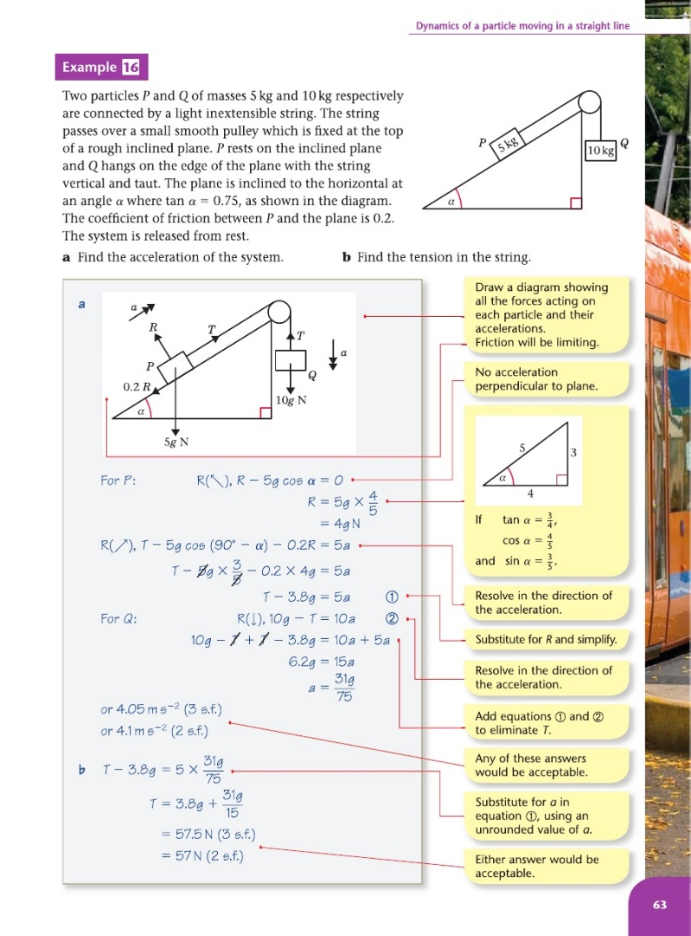

Terminology:

Coefficient of Friction – a number which represents how rough a surface is. The higher the number, the rougher it is.

Mr Slator then went through ‘Example 16’ in the book with the students. He explained the basics of pulley systems on an incline. Three main points which may help understand this analysis are:

1. The two connected objects are modelled as balls/particles which encounter no air resistance.
2. The incline is modelled as a 2D Plank.
3. Edexcel suggest the object on the incline is referred to as Ball 1 while the other object is referred to as Ball 2.

Following this, he made his own example on the board, which was discussed with the pupils. His example differed in that it required calculation of what would happen to the system after one of the two connected objects hit the ground. After explaining how to do this, the pupils began a worksheet to be started in class and finished for homework. The next lesson the students would move onto a new topic. I felt this was insufficient for students to truly understand the topic.

### Confirmation of Observations

Following my observation, I asked Mr Slator whether he ever used resources other than the textbook and the worksheet to teach this topic. He said that when he first taught the topic he also used a physical experiment to explain what was happening, but this was no use due to imperfections in how the system actually operated (Air resistance had an effect, for example). He accepted that the current teaching methods were probably insufficient for full understanding, but explained that he has never found a high quality resource to allow students to interact with and understand a pulley system.

Following this discussion I concluded that my initial observation was correct. This being that the current teaching methods do not allow students to truly understand pulley systems on an incline.

## Identification of the prospective users

Prospective users for a computerised interactive model of a pulley system on an incline would be the teachers of the M1 Mathematics module. Every year these teachers change (the staff rotate, teaching different modules). Therefore my prospective users include the Mathematics Staff at MTS and any pupils who take M1 at MTS in the future. A list of all the teachers in the Mathematics department is as follows:

* Mr Slator
* Miss Peers
* Mrs Gedalla
* Mr Rowlands
* Mr Illing
* Dr Andrews
* Mr Miller
* Mr Fothergill

## However, Mr Slator will be my main point of contact during the development and evaluation of the system.

## Identification of user needs and acceptable limitations

To get an initial idea of my user needs I sent Mr Slator an email explaining my idea for a computerised interactive model to help M1 students understand pulley systems on an incline. I had also suggested that the model should be accompanied by questions so the pupils can test their understanding while using the program. He gave me this written reply:

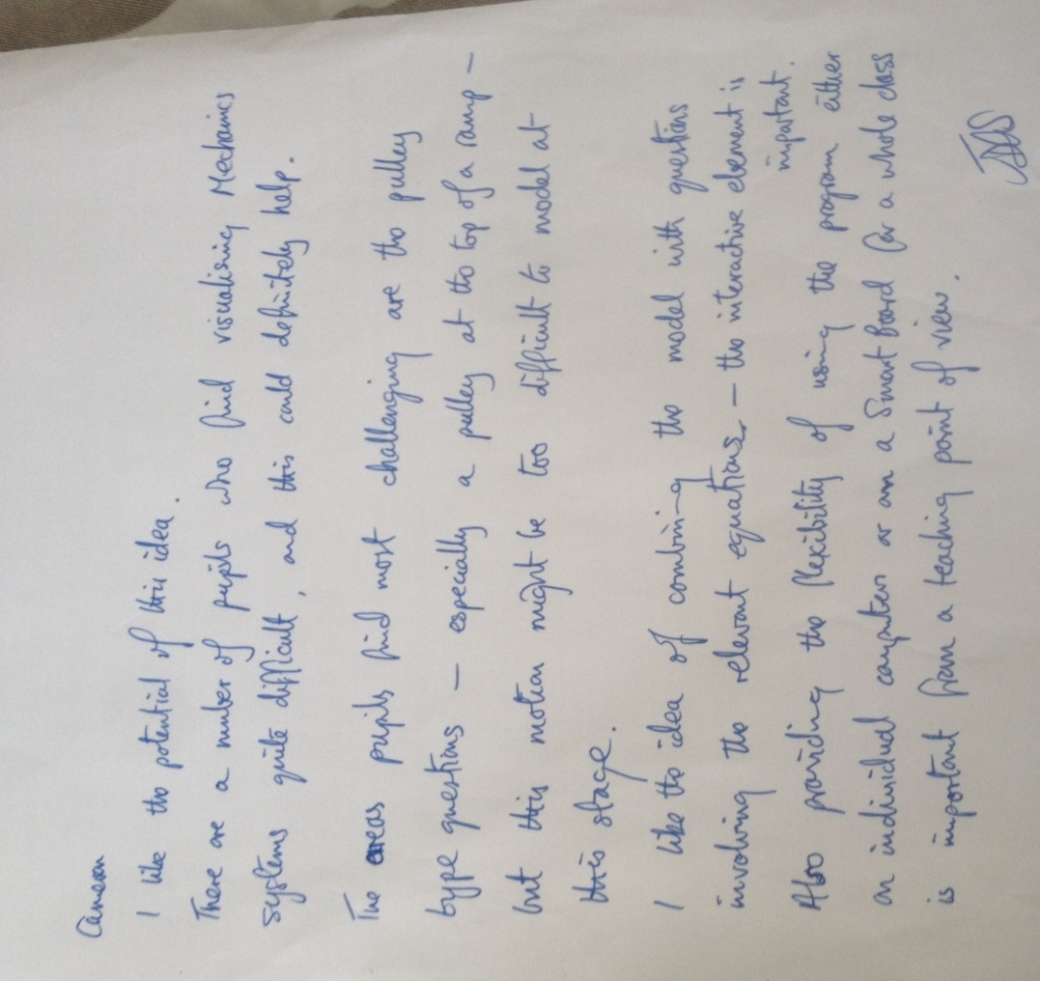

I then interviewed Mr Slator to get more information on the needs and limitations:

### Interview with Mr Slator: Maths office, 2:00pm, Wednesday 17th September 2014:

*Please could you describe the current teaching method for pulley systems on an incline?*

I first show the students an example of a problem in the textbook, which has the solution written out beneath it. After discussing this briefly, I create another example and write it on the board. This example is much trickier than the example in the book, and is what I would consider a ‘worst case scenario’ should this topic come up in an exam. After going through this problem together, I point out what variables can be ignored so we can solve these types of problems, such as air resistance. I then set the class a MEI worksheet to start in class and finish for homework.

*How easy do students find learning pulley systems on an incline?*

Students tend to find the equations relatively simple, and with a bit of luck will get most questions right. However, there is definitely a lack of general understanding and visualisation, which means that in more complex questions students tend to struggle.

*Would a program that allowed students to interact with a model of a pulley system on an incline and see an animation of what happens be helpful?*

Yes, very much so. I very much like the idea of an animation, this will keep the students engaged. Although, some systems will not move, so if this is the case please could you make the program explain why? I would also like to use the program in front of the class from time to time, so it mustn’t be limited to just the students PC’s. It must have smart board compatibility and if possible be full screen.

*Would it be helpful to have two parts to the program, one that questions students on a pre-defined model and one that allows the user to create their own model with their own variable values?*

That’s sounds very useful indeed. I would use the latter part a lot. Make sure that the part that questions students only animates once they have got the questions correct! This will encourage them to do them properly.

*For the part the questions students on the model, would you like these to be randomized?*

The questions themselves needn’t be randomized, considering that exam questions are always very similar in style. It would however be useful if the values used, such as the masses of each ball on the system, were randomized.

*Would you like to write the questions yourself? And would you like the ability to add/delete questions from a database which would in turn change the questions used in the program.*

I see no benefit in the database. In fact I wouldn’t like it at all. I would like the program to be self-sustaining, in the sense it needs no other files to be fully functional. The questions never change and I’m happy for the questions to be somehow hardcoded into the program. For the questions I trust you to do it as you have access to the textbook and past papers. I would like there to be roughly 3 questions on display per model, so it’s not too overwhelming but understanding can be properly tested.

*Ah, I understand. Are there any things that I needn’t include in the model?*

Insignificant and difficult to calculate variable such as air resistance are not required in M1. These needn’t be included.

*Would you like the ability to save, load and print different models?*

I feel that this is unnecessary, I already have the textbook and worksheets to provide me with questions.

*Do you have any other suggestions?*

I have one. Please make sure that at no point during the question any model created is beyond the M1 specification. These sorts of models can sometimes arise even when you ignore variables like air resistance.

*I’m sure that’s fine, what type of situation did you have in mind?*

If the ball falling vertically is given too large a mass, the other ball travelling up the incline will fly off the edge of the system at the top.

*No problem, I’ll make sure it handles those types of inputs. Is that everything?*

I believe so. Thank you.

*~~-~~*

### Final Identification of User Needs and Acceptable Limitations

From these two sets of information I have identified the following user needs:

The program must be split into two parts. Part 1 will allow a user to create a model of a pulley system using their own values, while Part 2 will present a M1 ‘pulley systems on an incline’ model and question the user on it. The model in the latter part must use random variable values to make each set of questions, while similar in style, unique. There should be roughly 3 questions per model. The program must function without the need for any other files. Both models must animate what would happen to the pulley system if it was left in its current configuration. However, the model in Part 2 must only animate once students have got all the questions for that model correct. If the system would not move and therefore result in no animation, the program must explain why. Moreover, the program must scale with screen size and be full screen so that it is usable on a teaching smart board as well as on students PC’s. Finally, the program must handle/reject any user inputs that would make the model more complex than is necessary for the M1 specification.

Acceptable limitations for the system include not needing the program to save, load and print different models. Furthermore, the models can ignore variables that aren’t dealt with in the M1 specification, such as air resistance. After the interview I came up with the idea of also creating a tablet form of the program, which may benefit some students. After discussing this idea with Mr Slator, it was decided this was not necessary. Mr Slator doesn’t think that many students would benefit from a tablet form, and would prefer me to concentrate on the PC/Smart board functionality.

## Data source(s) and destination(s)

The Data sources will be the end users (any teachers or students using the program), a random number generator and an embedded resource file. The random number generator will be used to obtain random values to use in the questions, while the resource file will allow embed a text file and image file to be embedded into the program’s executable file.

The Data destination will simply be the end users. The end users will either see a model animate, or will receive notifications that their answers to questions were correct or incorrect.

## Data volumes

The resource file will allow a text file and image file to be embedded into the program’s executable file. The image file will simply be a PNG image of a black ball. I expect this image file to be between 5-10 Kilobytes in size. The text file will store the different questions that the program will use during execution to question the user on a model. From early research, there will be approximately 10 questions that are included. These questions will be approximately 40 characters in length, and assuming 1 byte per character, this will total to 400 bytes.

## Analysis Data Dictionary (from perspective of end user)

From the perspective of the end user, these data fields will be required for processing of the models and what will happen after they are left in their configurations:

|  |  |  |  |  |  |
| --- | --- | --- | --- | --- | --- |
| Field Name | Field Unit | Field Type | Field Size | Example Data | Individual Validation |
| Mass of Ball 1 | Kilograms | Real | 3 digits | 25.3 | Must be positive and required digit length |
| Mass of Ball 2 | Kilograms | Real | 3 digits | 25.3 | Must be positive and required digit length |
| Coefficient of Friction between Ball 1 and the Plank/Incline | - | Real | 4 digits | 0.383 | Must be positive and required digit length |
| Angle of Plank/Incline | Degrees | Integer | 2 digits | 47 | Must be between 0 and 90 |
| Length of Plank/Incline | Metres | Real | 3 digits | 8.1 | Must be positive and required digit length |
| Length of String connecting Ball 1 and Ball 2 | Metres | Real | 3 digits | 4.2 | Must be positive and required digit length |
| How far Ball 1 starts up the Plank/Incline | Metres | Real | 3 digits | 5.9 | Must be positive and required digit length |

Note: All field sizes and field types are based on the M1 specification.

This data will either be input by the end user or randomly generated by the program based on what part of the program is being used.

There are two other variables that will need to be displayed at certain points in the program to aid the user during calculations. They could also be subject to questions.

|  |  |  |  |  |  |
| --- | --- | --- | --- | --- | --- |
| Field Name | Field Unit | Field Type | Field Size | Example Data | Individual Validation |
| Acceleration | Metres per second squared | Real | 7 digits | 2.456829 | None |
| Tension | Newtons | Real | 4 digits | 45.65 | None |

Note: These variables are calculated using the variables in the other table, and hence no validation is needed. Moreover, the field sizes for these two variables were advised to me by Mr.Slator. This degree of precision is needed so that the user can work backwards from these variables to accurately calculate the variables in the other table.

Other validation checks are also necessary to make sure that the model lies within the bounds of the M1 specification. These validation checks are found below:

*Validation Rule 1:*

Ball 1 must lie on the incline. Therefore:

**Distance Ball 1 starts up the Plank < Length of the Plank**

*Validation Rule 2:*

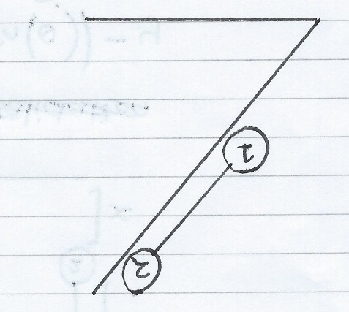The String connecting Ball 1 and Ball 2 must be long enough to hang over the top of the plank. In other words, the scenario below is not valid:

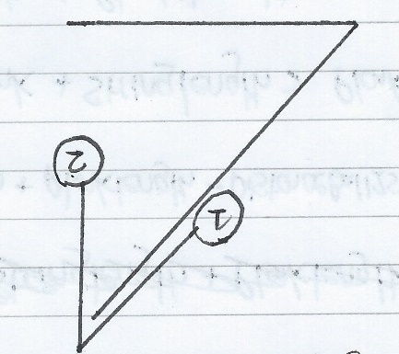The system should look like this:

Therefore:

**Distance Ball 1 starts up the Plank + Length of the String > Length of the Plank**

*Validation Rule 3:*

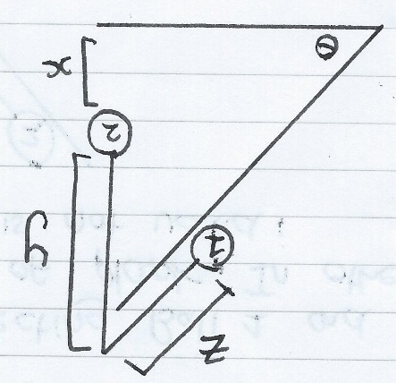Ball 2 cannot be on the floor. In the diagram below, this means that the length X must be greater than 0:

X = Length of the Plank * Sin() – Y

Y = Length of the String – Z

Z = Length of the Plank – Distance Ball 1 starts up the Plank

Therefore:

**(Length of the Plank * Sin()) – Length of the String + Length of the Plank – Distance Ball 1 starts up the Plank > 0**

*Validation Rule 4:*

If moving up the slope, Ball 1 will initially move until Ball 2 hits the ground (Initial Movement), before moving a small distance (Extra Displacement) due to its previous momentum. It will then fall to its resting position.

Initial Movement can be calculated because it is the height Ball 2 started off the ground. Extra Displacement can be calculated by using the constant acceleration formula:

S = (V2 – U2)/2a

To remain an M1 problem, Ball 1 mustn’t fall off the top of the slope during this motion.

Therefore:

**Distance Ball 1 starts up Plank + Initial Movement + Extra Displacement < Length of the Plank**

This can also be written as follows if you follow through the calculations:

**(Length of the Plank * Sin()) – Length of the String + Extra Displacement < 0**

*Validation Rule 5:*

If moving down the slope, Ball 2 will initially move until Ball 1 hits the ground (Initial Movement), before moving a small distance (Extra Displacement) due to its previous momentum. It will then fall to its resting position.

Initial Movement = Distance Ball 1 starts up Plank. Extra Displacement can again be calculated using the constant acceleration formula:

S = (V2 – U2)/2a

To remain an M1 problem, Ball 2 mustn’t reach a height higher than the top of the slope during this motion.

Therefore:

**(Length of the Plank * Sin()) – Length of the String + Length of the Plank – Distance Ball 1 starts up the Plank+ Initial Movement + Extra Displacement < (Length of the Plank * Sin())**

This can also be written as follows if you follow through the calculations:

**Length of the Plank – Length of the String + Extra Displacement < 0**

## DfDs (existing and proposed system) to level 1

Please note I have considered the students’ ‘learning’ a piece of data because I think it needs to be represented in these cases to fully show the data flow.

### Existing Solution level 0

Learning

Student Questions

Worksheet Questions

Question answers and direct teaching

Student Questions

Page 63

### Existing Solution level 1

Student Questions

Student Questions

Student Interaction

Question answers and direct teaching

Question answers and direct teaching

Question Answers

Learning

Learning

Learning

Page 63

Worksheet Questions

### Proposed System Level 0

Relevant Part Displayed

Relevant Part Displayed

User Inputs

User Inputs

User Part Selection

Learning

Learning

### Proposed System Level 1

Variable Values

Variable Values

Questions and Variable Values

Questions and Variable Values

Variable Values

Questions

Random Numbers

Variable Values

Variable Values

Variable Values

User Answers

User Values

Relevant Part Displayed

Relevant Part Displayed

User Part Selection

Learning

## Objectives for the proposed sytem

The objectives of the system/program to be implemented are as below. These were agreed with Mr.Slator following a final meeting with him:

1. To make the program consist of two parts, one which allows a user to create their own model of a pulley system on an incline and then see it animate, and another which questions the user on a randomly created model.
2. To make both parts of the program have the functionality to animate the model to show what would happen if the model was left in its configuration.
3. To make the program correctly calculate the direction of motion (if any) of a model.
4. To make the program correctly calculate the initial accleration (if any) of a model.
5. To make the program correctly calculate any extra displacement that a Ball undertakes after passing the equilibrium position due to its own momentum.
6. To make the program such that it is usable as a stand-alone executable without the need for any other files.
7. To have 3 questions per model in the part of the program that questions the user on a randomly created model.
8. To make the part where the user is questioned on the model only animate if the user has got all the questions correct.
9. To have the program explain why a model remained stationary if this has occurred.
10. To make sure that any animated model is within the bounds of the M1 specification.
11. To display error messages within 2 seconds.
12. To make items displayed in the program scale with screen size.
13. To make the program fullscreen.
14. To design the interface such that a user can understand and operate it with the aid of a user guide within 5 minutes.
15. To process and display randomly created models within 2 seconds of the action that triggered it.
16. To begin animations within 2 seconds of the action that triggered it.

## Realistic appraisal of the feasibility of potential solutions

Possible solutions include:

### Paper handouts of multiple examples of pulley system on an incline, with pictures

I feel like this would be an improvement on the current system, as students would see far more examples than they currently do under the current system (currently only 2). The pictures may also help the students to better visualise the questions in the future. However, the absence of questions would in my opinion make it harder for the students to remember how to solve the problems as there would be little interaction to stimulate learning. The current system at least has questions so does better in this regard. Moreover, distributing this solution to students would be expensive in material resources, such as paper.

### Already existing interactive software teaching pulley systems on an incline

One of the better solutions I found was: *http://demonstrations.wolfram.com/TwoMassesOnInclinedPlaneWithPulley.*  
This software was a fairly good solution. It allows people to interact with a pulley system on an incline from within a browser. You can tweak a lot of variables and customize the system. However, all the variables required to fulfil the M1 specification were not present (such as distance of one ball up the slope), and the software required a plugin. This plugin was rather hard to install and came with some bloat-ware. The software also does not provide any questions or animation functionality.

### Bespoke local software

This solution would allow for all the user’s requirements to be met with a system being made specifically for them. Although this would take the longest to implement, it would allow for the problems presented to most importantly:

* Be within M1 specifications
* Provide animation functionality
* Question students on models

## Justification of chosen solution

The solution selected will provide a system that will exactly match all the end-user’s requirements as there are currently no other solutions available that would allow the software to be used both as a demonstrative tool and as a self-learning tool through both user-created and randomly generated problems. This solution would be guaranteed to work on all computers within the school, scaling to the size of whatever screen is used. I had originally decided to code the system in ProcessingJS, which I had encountered on the Khan Academy website. It is very good for animations and easy to distribute in a webpage, so there would be no need to distribute an executable. However, as I began making a small prototype of a potential solution I found that it wasn’t as good for event-driven programming. This was something that I deemed very important as I would like the program to be as interactive as possible. To this end, I have chosen to code the system in Delphi-Firemonkey due to its ability to create forms with ease, it is event-driven and it allows for a compiled executable to be created with an embedded resource file.

## Identification of Objects and Analysis diagrams for Object-Oriented Programmed solutions

I intend to use many of the Objects that Delphi has built into it. Such as TStringList and TResourceStream. However, there is one class that I intend to self-define. This class will be ‘TBall’, Ball 1 and Ball 2 being membesr/objects of this class. TBall will inherit from the TImage class in Delphi as follows:

TBall

TImage

I will override the Create and Destroy TImage methods so that the Balls can be displayed using my own embedded image file. Inheriting from TImage will also give me access to the Balls’ positions and the animate method. It was not an option to just make Ball 1 and Ball 2 members of TImage is because you cannot independently animate two TImages objects at the same time in Delphi-Firemonkey.

Design

Overall System Design

The system will be a Delphi-Firemonkey program that is split into three parts. These three parts will be three forms that each perform a function for the User. I will refer to the three forms as the Main Menu Form, the Own Model Form and the Practice Form.

1. The Main Menu Form will allow the user to traverse the program from a central hub.
2. The Own Model Form will allow the user to create their own M1 standard Pulley systems on an incline model. The user will then be able to animate the model based on its configuration.
3. The Practice Form will generate a Random M1 standard Pulley systems on an incline model. This model will be accompanied by questions that test whether the user knows how to apply mathematics to solve problems regarding the model. If all questions are answered correctly, the model will animate.

This overall system design can be represented in the following structure charts. They are set out as follows:

Level 0 – Form Name

Level 1 – Different Functionality found in Form

Level 2 and onwards – Breaking down Functionality into simpler parts

Main Menu Form (Start-up Form) Structure Chart

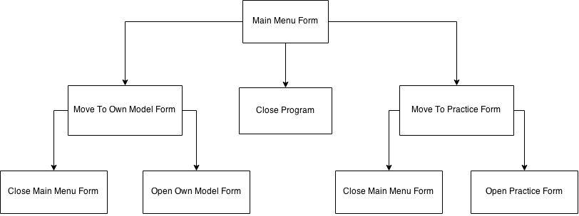

Own Model Form Structure Chart

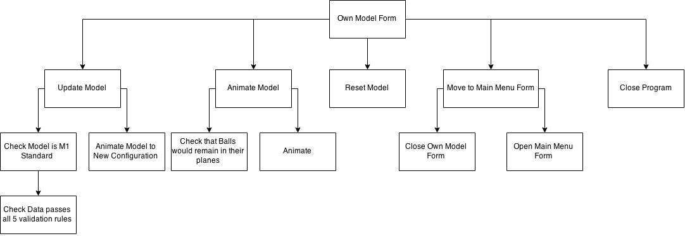

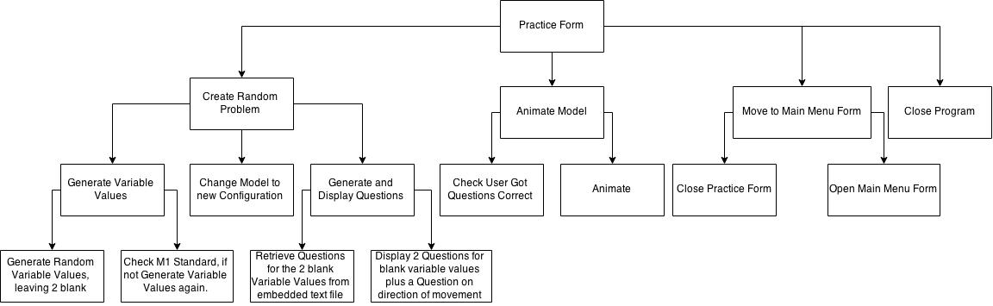Practice Form Structure Chart

Description of modular structure of the system

For my system, I have defined a module as one or more subroutines that contribute to achieving a main piece of system functionality. Therefore, these modules are the Level 1 Functionalities found in Overall System Design. To this end, I would recommend referencing the Overall System Design when trying to understand my design for the system. The description of the modules is tabulated below:

|  |  |  |
| --- | --- | --- |
| **Name of Module** | **Form(s) the module is found in** | **Description** |
| Move to … Form | Main Menu Form, Own Model Form, Practice Form | This module allows the user to traverse the system. Closing the current form and opening the new chosen one. In all forms it will be triggered by a button press. |
| Close Program | Main Menu Form, Own Model Form, Practice Form | This module closes the program. In all forms it will be triggered by a button press. |
| Animate Model | Own Model Form, Practice Form | In general, this module will perform some validation, before animating the given model based on its current configuration. In the Own Model Form, the validation is checking that the Balls would remain in their planes. In the Practice Form, the validation is checking that the User has got all the questions correct. The animation will generally use Force analysis and constant acceleration formulae to calculate movement time over small delta distances, before using the Delphi-Firemonkey animation function to repeatedly animate these distances in those times. Refer to Identification of processes and suitable algorithms for data transformation to find the Animation algorithm. In both forms this module will be triggered by a button press. |
| Update Model | Own Model Form | This module checks that the user defined model is M1 standard before updating the model to its new configuration. Refer to Identification of processes and suitable algorithms for data transformation to find the Update Model algorithm. For more information on the validation checks that this module applies when checking if the model is M1 standard, see Definition of Data Requirements. This module will be triggered by a button press. |
| Reset Model | Own Model Form | This module resets the model to its default configuration. It will be triggered by a button press. |
| Create Random Problem | Practice Form | This module generates an M1 Standard model, displaying the model and all but two of the associated variable values. Moreover, the module displays three questions, one for the two variable values to be found and one questioning the user on direction of motion. Refer to Identification of processes and suitable algorithms for data transformation to find the Create Random M1 Standard Variable Values algorithm. The module will be triggered by a button press. |

Definition of Data Requirements (validation and processing)

The program will have to validate inputs in the Own Model Form. The validation on each variable will be as follows:

|  |  |
| --- | --- |
| Name (Variable Name) | Individual Validation |
| Mass of Ball 1 (Ball1Mass) | Must be positive and less than or equal to 3 digits in length. |
| Mass of Ball 2 (Ball2Mass) | Must be positive and less than or equal to 3 digits in length. |
| Coefficient of Friction between Ball 1 and the Plank (CoefficientofFriction) | Must be positive and less than or equal to 4 digits in length. |
| Angle of Plank (PlankAngle) | Must be between 0 and 90 and an integer. |
| Length of Plank (PlankLength) | Must be positive and less than or equal to 3 digits in length. |
| Length of String connecting Ball 1 and Ball 2 (StringLength) | Must be positive and less than or equal to 3 digits in length. |
| How far Ball 1 starts up the Plank (DistanceBall1StartsUpPlank) | Must be positive and less than or equal to 3 digits in length. |

Moreover, in both parts of the program the 5 validation rules I defined in my Analysis (see Analysis Data Dictionary for an in depth explanation) must also be kept true for a problem to be M1 standard. These are (Using Variable Names):

*Validation Rule 1:*

**DistanceBall1StartsUpPlank < PlankLength**

*Validation Rule 2:*

**DistanceBall1StartsUpPlank + StringLength > PlankLength**

*Validation Rule 3:*

**(PlankLength * Sin(PlankAngle)) – StringLength + PlankLength – DistanceBall1StartsUpPlank > 0**

*Validation Rule 4(Only applicable if Ball 1 moving up the slope):*

**Distance Ball 1 starts up Plank + InitialMovementLength + ExtraDisplacementLength < PlankLength**

This can also be written as follows if you follow through the calculations:

**(PlankLength * Sin(PlankAngle)) – StringLength + ExtraDisplacementLength < 0**

*Validation Rule 5(Only applicable if Ball 1 moving down the slope):*

**(PlankLength * Sin(PlankAngle)) – StringLength + PlankLength – DistanceBall1StartsUpPlank+ InitialMovementLength + ExtraDisplacementLength < (PlankLength * Sin(PlankAngle))**

This can also be written as follows if you follow through the calculations:

**PlankLength – StringLength + ExtraDisplacementLength < 0**

In the Practice Form model. The user’s answers will have to be validated as to whether the answer is right or not.

An embedded text file and an embedded image file will be used as storage for the executable. These will store a list of questions and the image for the Balls. The embedded text file will store this information:

*What is the Tension in the string? (4SF)*

*What is the Initial Acceleration of the system? (7SF)*

*What is the Angle of Incline? (2SF)*

*What is the Mass of Ball 1? (3SF)*

*What is the Mass of Ball 2? (3SF)*

*What is the Coefficient of Friction? (3SF)*

*What is the Initial Displacement of the System? (3SF)*

*What is the Displacement that occurs after one of the balls hits the ground? (3SF)*

*Does Ball 1 move 'up' the slope or 'down' the slope?*

I will then be able to refer to this text file by line number to retrieve the question I need.

To this end, data will be processed from the user, the random number generator, or the embedded text file and image files.

Identification of processes and suitable algorithms for data transformation

In this section I will design the non-standard or complicated algorithms that will be used in the system. Due to the nature of the problem, the algorithms tend to be very mathematically complex. Therefore to aid my own understanding for when I refer back to the design later, I have split each algorithm into two parts. The first part will be a high level view of the whole algorithm, which will help me to implement the basic structure of the algorithm when I implement the program. The second part will be a lower level view of one or more particular parts of the algorithm that will help me to regain understanding of the intricacies of the mathematics or algorithm if I forget in the future.

Note that in many of the Low Level View algorithms the following abbreviations are used to make them simpler to understand:

|  |  |
| --- | --- |
| Variable | Abbreviation |
| Ball1Mass | M1 |
| Ball2Mass | M2 |
| CoefficientofFriction | u |
| PlankAngle | **θ** |
| PlankLength | PL |
| StringLength | SL |
| DistanceBall1StartsUpPlank | DB1S |

Animating a model (Part of Animate Model Module)

This is the core functionality of the program (it is used in Own Model Form and Practice Form) and is by far the most complicated algorithm. It is made very complicated because I can’t just use Delphi-Firemonkey’s built in animation functionality to move a Ball from A to B, as this gives no sense of acceleration. I have to use the built in animation many times over extremely small delta distances, working out the time that the Ball would take to travel that distance under the acceleration. Note that in both views of the algorithm, the ‘SmoothnessConstant’ or ‘SC’ will be a programmer defined constant that will define how smooth the animations are. The greater the integer, the smoother the animation.

*High Level View*

Begin

Calculate If Upslope,DownSlope or Stationary

If Upslope

Calculate InitialMovementLength

Calculate ExtraDisplacementLength

DeltaInitialMovementLength InitialMovementLength/SmoothnessConstant

DeltaExtraDisplacementLength ExtraDisplacementLength/SmoothnessConstant

If Not M1 problem using Validation Rule 4 Then output error

Else

For 1 to SmoothnessConstant do

Calculate Time for Balls to move another DeltaIntialMovementLength

Calculate New X and Y coordinates for each ball

Calculate New lengths of String

Animate Ball 1 upslope Ball 2 downwards using calculated time

EndFor

For 1 to SmoothnessConstant do

Calculate Time for Ball 1 to move DeltaExtraDisplacementLength up slope

Calculate New X and Y coordinates for Ball 1

Calculate New lengths of String

Animate Ball 1 upslope using calculated time

EndFor

For 1 to SmoothnessConstant do

Calculate Time for Ball 1 to move DeltaExtraDisplacementLength down slope

Calculate New X and Y coordinates for Ball 1

Calculate New lengths of String

Animate Ball 1 downslope using calculated time

EndFor

EndIf

If DownSlope

Calculate InitialMovementLength

Calculate ExtraDisplacementLength

DeltaInitialMovementLength InitialMovementLength/SmoothnessConstant

DeltaExtraDisplacementLength ExtraDisplacementLength/SmoothnessConstant

If Not M1 problem using Validation Rule 5 Then output error

Else

For 1 to SmoothnessConstant do

Calculate Time for Balls to move another DeltaIntialMovementLength

Calculate New X and Y coordinates for each ball

Calculate New lengths of String

Animate Ball 1 downslope Ball 2 upwards using calculated time

EndFor

For 1 to SmoothnessConstant do

Calculate Time for Ball 2 to move DeltaExtraDisplacementLength upwards

Calculate New Y coordinates for Ball 2

Calculate New lengths of String

Animate Ball 2 upwards using calculated time

EndFor

For 1 to SmoothnessConstant do

Calculate Time for Ball 2 to move DeltaExtraDisplacementLength downwards

Calculate New Y coordinates for Ball 2

Calculate New lengths of String

Animate Ball 2 downwards using calculated time

EndFor

EndIf

If Stationery

Output Why Stationery

EndIf

End

*Low Level View*

Calculating if Upslope, Downslope or Stationery

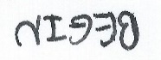

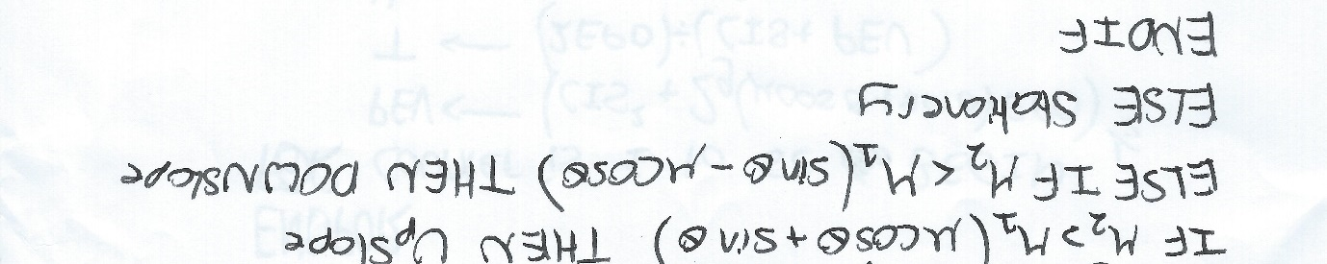

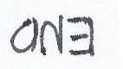

Animation

I have only designed a Low Level view for the UpSlope animation because I can see from my High Level design that the DownSlope animation will be extremely similar:

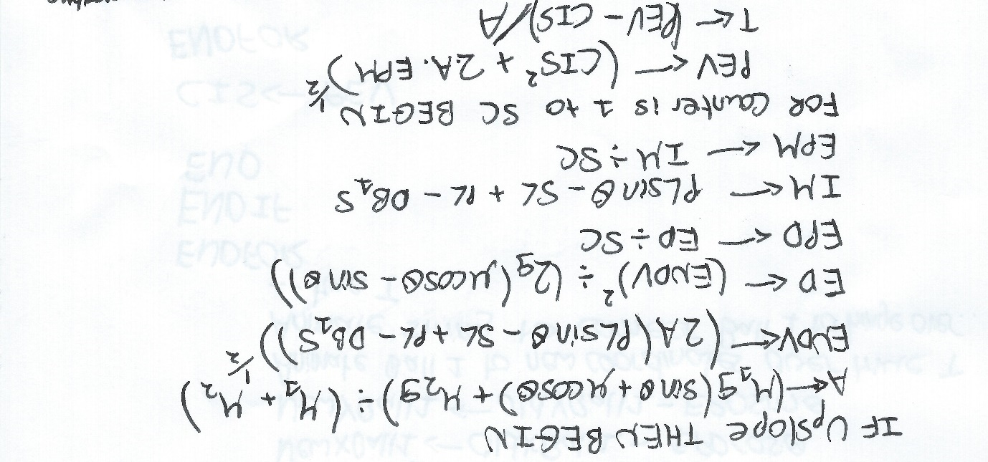

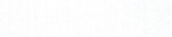

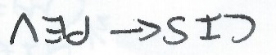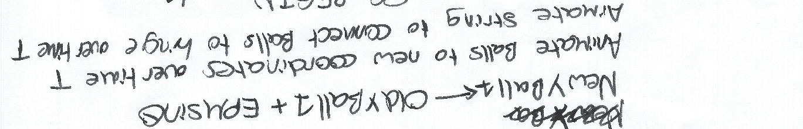

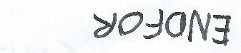

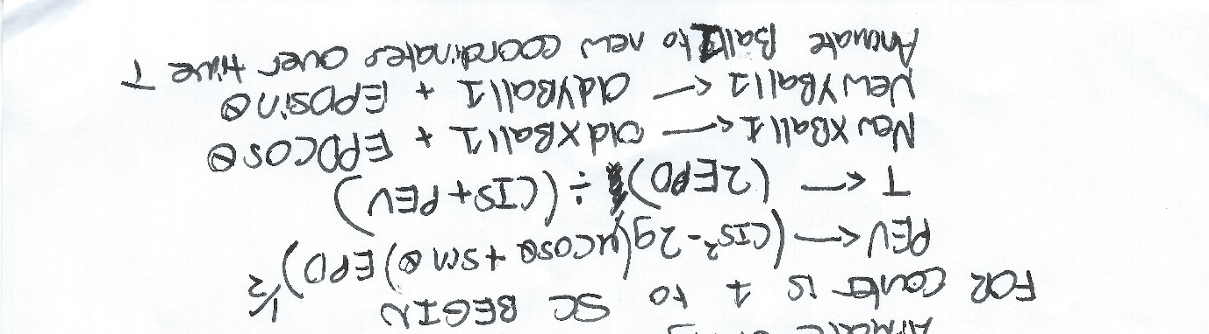

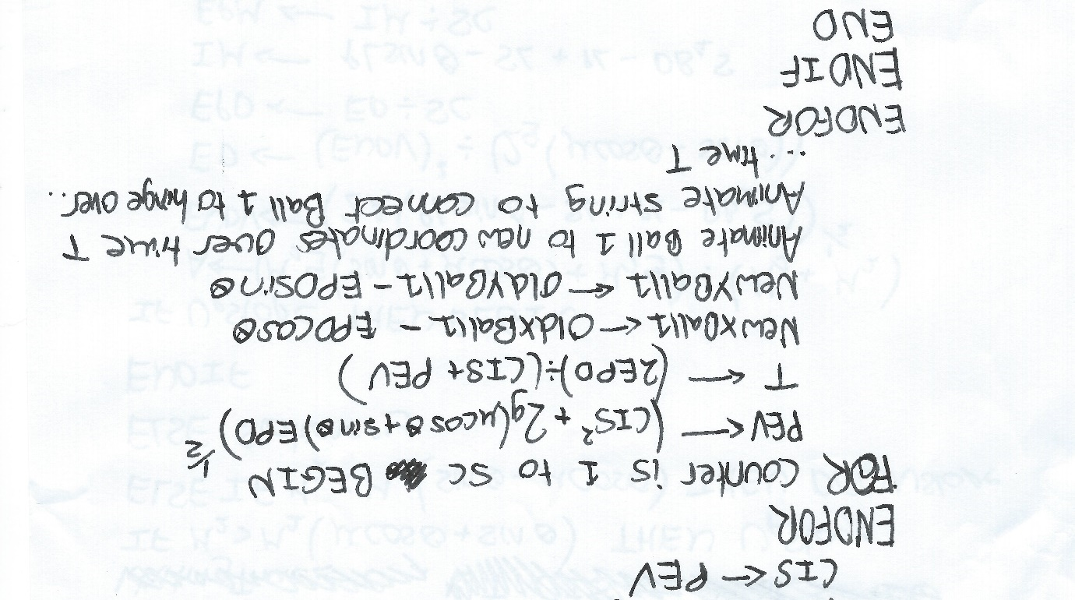

Outputting why Stationary



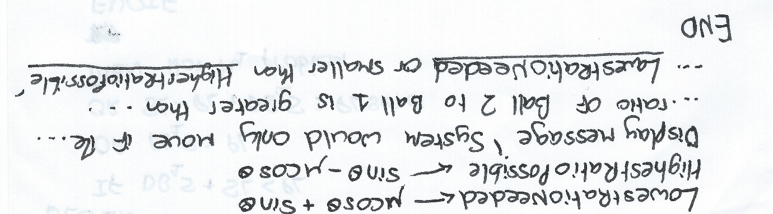

Update Model Module

This algorithm is used in Own Model Form and updates the displayed model to a user defined model. For more information on the validation rules used here see the Definition of Data Requirements.

*High Level View*

Begin

If FormHeight<FormWidth then HeightOfPlankPixels FormHeight

Else HeightOfPlankPixels FormWidth

Validate that M1 problem using validation rules 1-3, If not M1 problem then Output error

Else

TopOfSlopeX HeightOfPlankPixels*Sin(90-PlankAngle)

TopOfSlopeY HeightOfPlankPixels*Cos(90-PlankAngle)

Animate Plank Angle

Animate Plank String Angle

Animate String to TopOfSlopeX,TopOfSlopeY

Animate Balls to correct positions

Animate String Lengths

EndIf

End

*Low Level View*

None needed. This algorithm is much simpler than the other two I have designed.

Create Random Problem Module

This algorithm is used in Practice Form. It creates the random model along with the questions for that model. It takes into account that if a question on Ball 1’s mass is asked then a question on the coefficient of friction or plank angle cannot be asked as it would be an unsolvable problem.

*High Level View*

Begin

While not M1 Problem do Create Random Values of correct digit length

Calculate Tension

Load Questions From Embedded File

While

RandomInteger1=RandomInteger2

Or Random1Integer1=4 and RandomInteger2=6

Or Random1Integer1=6 and RandomInteger2=4

Or Random1Integer1=3 and RandomInteger2=6

Or Random1Integer1=6 and RandomInteger2=3

Do

RandomInteger1 Random number between 1 and 6 inclusive

RandomInteger2 Random number between 1 and 8 inclusive

EndWhile

Case RandomInteger1:

1: TensionQuestion True

2: AccelerationQusetion True

3: AngleQuestion True

4: Ball1MassQuestion True

5: Ball2MassQuestion True

6: CoefficientQuestion True

EndCase

Case RandomInteger2:

1: TensionQuestion True

2: AccelerationQusetion True

3: AngleQuestion True

4: Ball1MassQuestion True

5: Ball2MassQuestion True

6: CoefficientQuestion True

EndCase

Question1 QuestionsFile[9]

Question2 QuestionsFile[RandomInteger1]

Question3 QuestionsFile[RandomInteger2]

If TensionQuestion = true then don’t display Tension

Else display Tension

If AccelerationQuestion = true then don’t display Acceleration

Else display Acceleration

If AngleQuestion = true then don’t display Angle

Else display PlankAngle

If Ball1MassQuestion = true then don’t display Ball1Mass

Else display Ball1Mass

If Ball2MassQuestion = true then don’t display Ball2Mass

Else display Ball2Mass

If CoefficientQuestion = true then don’t display Coefficient

Else display CoefficientofFriction

Update the Model to the new configuration

End

*Low Level View*

Calculating the Tension

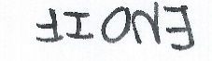



Checking if Random Values Satisfy an M1 problem

I’ve only considered the DownSlope possibility because the UpSlope possibility will use very similar maths.

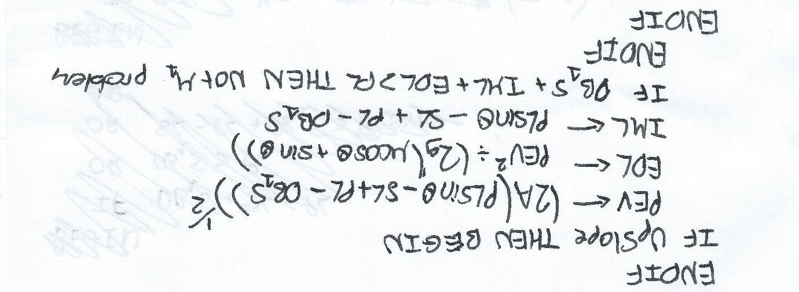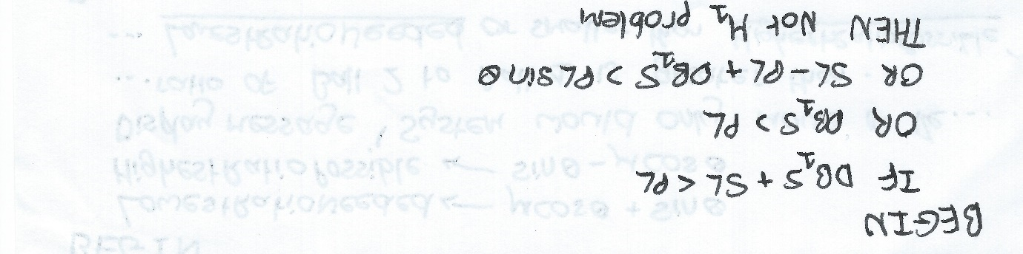

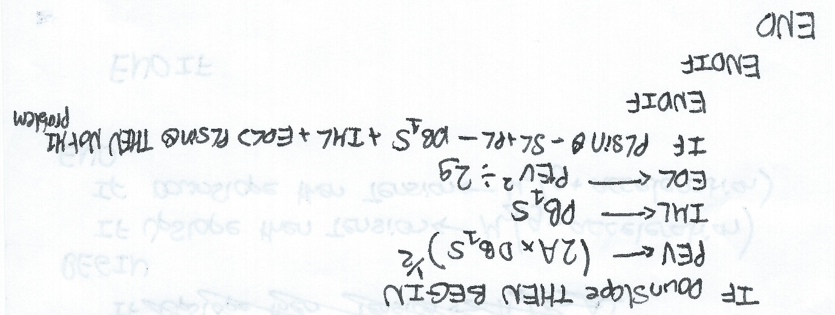



Class/Object Diagrams/Definitions and details of object behaviours and methods

My self-defined TBall class will inherit from the TImage class:

TImage

TBall

This will give the TBall class the ability to display an image on screen from a file, while also allowing me to take advantage of the ‘animate’ method.

I have overridden the Create and Destroy methods from TImage so a member of the TBall class can be shown and hidden using a resource file.

User Interface design (HCI) rationale:

I would like the design of the program to reflect what it will be used for. This being an educational tool to be used in school. To this end, the colour scheme will be grey and black, to maintain a business-like feel and not confuse the user. The font used will be Segoe UI. I have chosen this font because I feel it is very clear and easy to read. I will use size 18 font for button captions, size 28 font for information and size 36 font for titles.

As described earlier, I plan to have 3 forms in the program:

1. The ‘Main Menu’ Form. This will allow the user to traverse the program.
2. The ‘Own Model’ Form. This will allow the user to create their own M1 Model and watch it animate.
3. The ‘Practice’ Form. This will randomly generate an M1 model for the user, and question them on it.

All forms will scale with screen size and be full screen to fit the user’s requirement. In the ‘Own Model’ and ‘Practice’ form, I like the layout to be similar for ease of use, even if the controls are different. Generally, information and user input will take place on the right side of the screen, while on the left side of the screen the model will be displayed.

Sample of planned data capture and entry designs: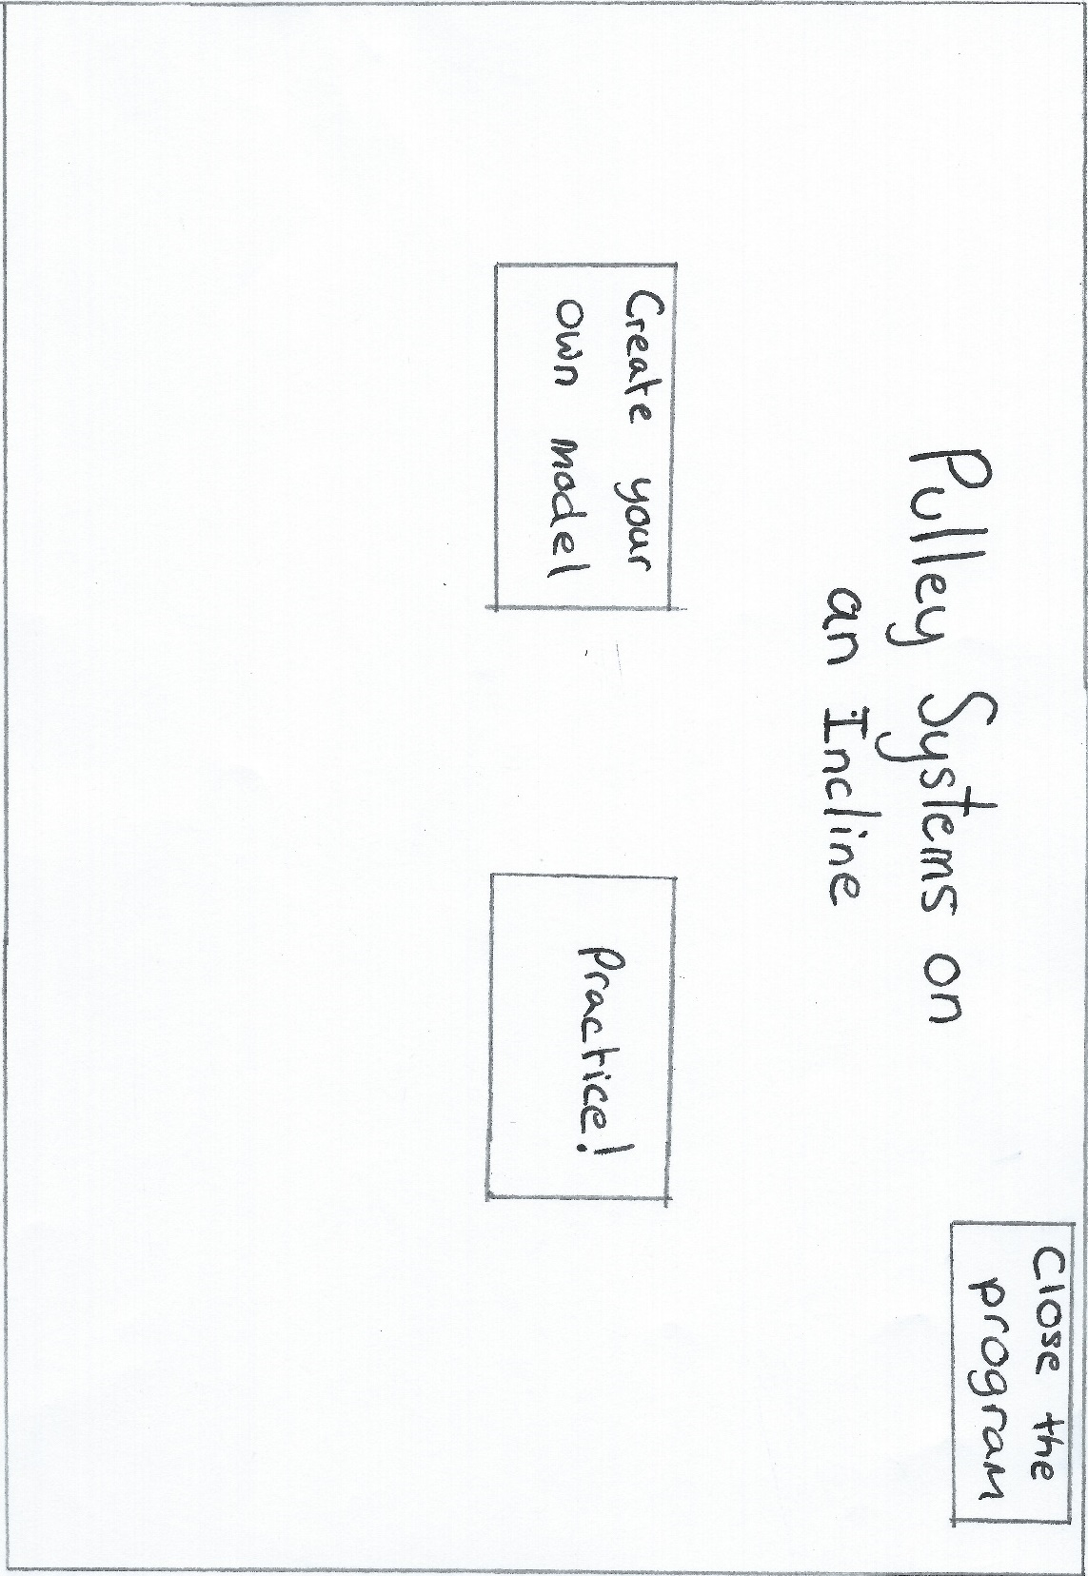

*Main Menu Form*

Buttons to either go to one of the other forms or close the program.

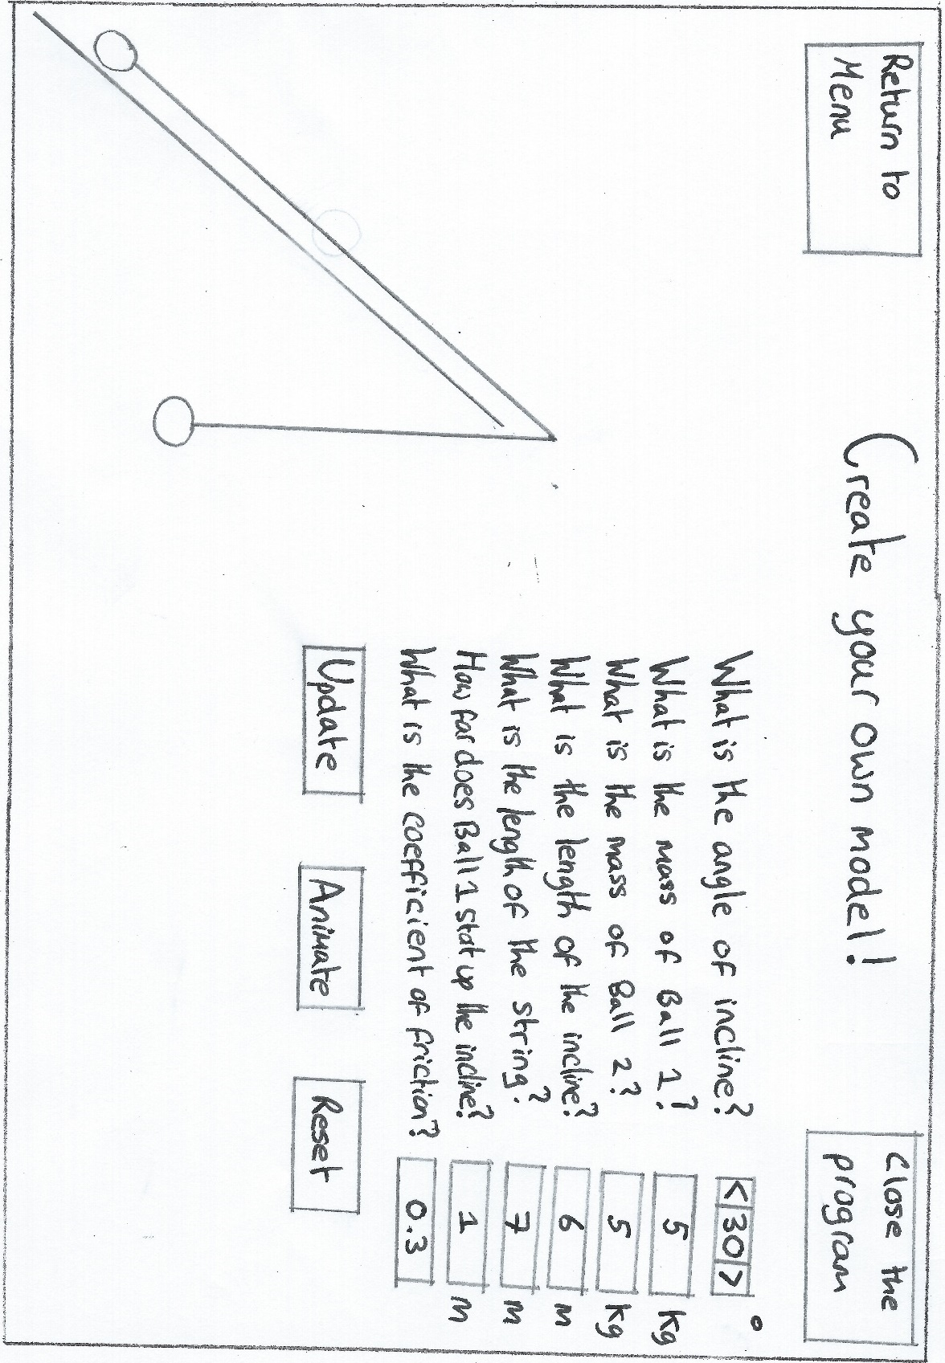

Buttons to either return to the main menu or close the program.

*Own Model Form*

Spin-boxes to all user to only select integers

Text-boxes to allow user to make selections

Buttons to either update the model, animate the model, or reset the model to default values. Note that the update button can be triggered by pressing the enter key.

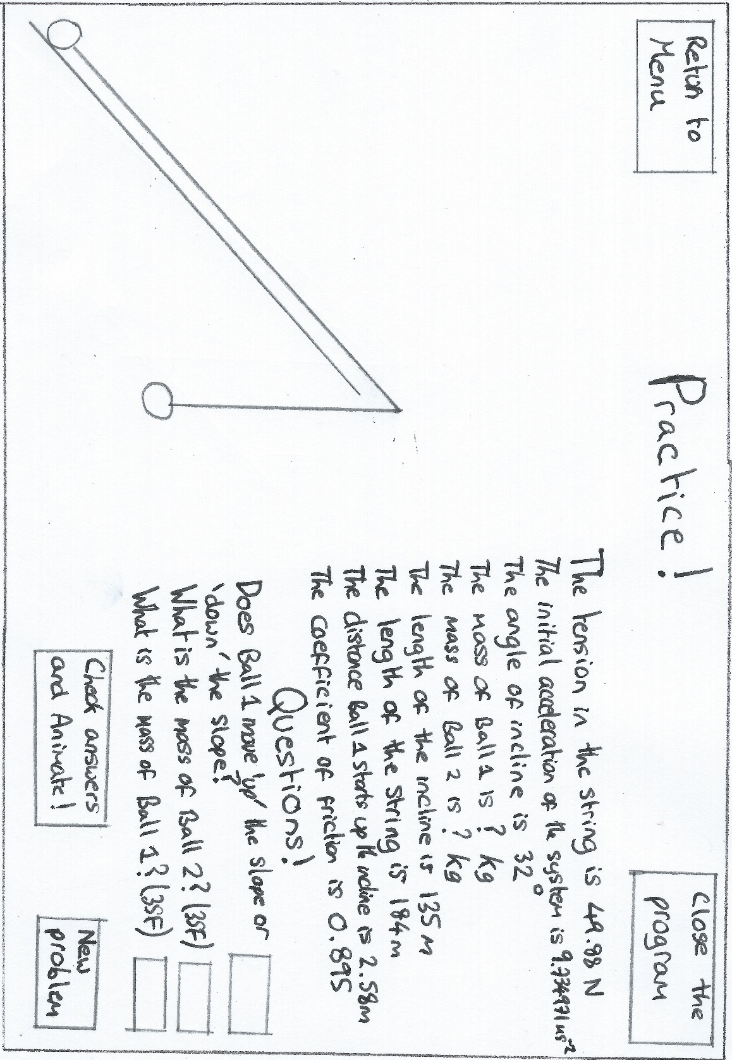

Buttons to either return to the main menu or close the program.

*Practice Form*

Text-Boxes to allow user to answer questions.

Buttons to check user answers and if correct animate, or generate a new problem.

Sample of planned valid output designs:

*Own Model Form*

If the user presses the reset button these selectors will be reset to default values. If an invalid entry is made that entry will be reset to its default value.

Model displayed here, it will update to the user defined values, animate based on the user defined values, or reset to default values based on what buttons/keys the user presses.

*Practice Form*

These values are displayed based on the generated model and what questions are being asked.

Model displayed here, it will animate if the user checks their answers and they are correct. It will also change to a new problem if the respective button is pressed.

*Displayed Messages*

At some point during the problem, a message has to be displayed on screen. For example, this may be a message informing the user why an input is invalid. I will use the built in ‘Showmessage’ function in Delphi, which produces a message which looks like:

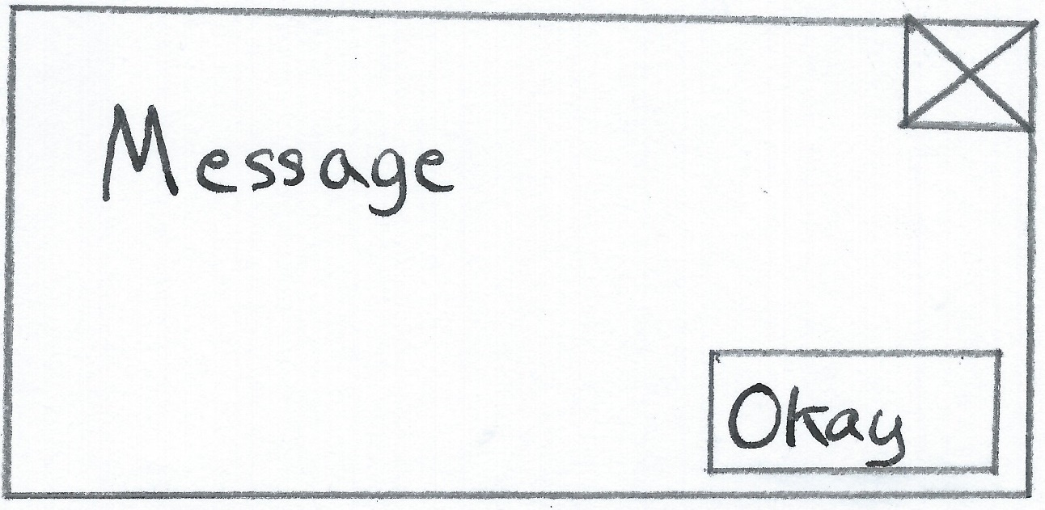

Description of measures planned for security and integrity of data

My school, Merchant Taylors’, has a policy that restricts any pupil from running any executable file. Therefore to make the program usable by both teachers and pupils, I will have to get permission from the IT department to distribute the program’s executable across the school’s network. The permission to run the executable will then have to be distributed to all pupils.

As all data files used are to be embedded within the program’s executable by using a resource file, there is no chance of data loss without the program itself being lost. The program itself will be distributed to all computers (including those connected to smart boards) via the school’s network. Therefore the only chance of losing the program is if the school’s network to fail. Luckily, the school’s network is very safe as it has high redundancy due to the use of a RAID 5 array and is backed up often. A full backup is performed onto a backup server each day based on the daily incremental changes that have occurred on the network. Additionally, magnetic tape backups are kept off site in the event of both the school’s network and the backup server failing.

Description of measures planned for system security

The program will be stored in compiled form on the school’s network. This means that everyone will be able to access the executable without being able to alter or see the system code. The program does not store any sensitive data, so no additional security needs to be planned.

Overall test strategy in relation to the problem being solved and tested

In order to properly test the program, I will test all functionality of the program using normal, boundary and erroneous data. I have created a test plan that can be found in the ‘System Testing’ section of this document which will help me keep my testing focused. Once the testing is complete, I will use the results of my tests together with user feedback in order to evaluate the final program.

# System Testing

## Test Plan

### Introduction

I will complete the integration testing before I test the system’s functionality. The three units tested are the ‘Main Menu’ Unit, the ‘Practice’ Unit and the ‘User Model’ Unit.

My system testing will have to check normal, boundary and erroneous data entries. I have created a Test Plan which will test the functionality of the models, as well as various user inputs. I felt that the most important thing to test was that the models are always restricted to an M1 style problem, as there are many validation checks associated with this and there is potential for extreme user input to cause issues.

I will generally use screenshots as evidence for my testing. However, in my application animation is key to functionality. To this end, I will also use video evidence where any sort of animation is expected or could possibly occur.

The Forms that each unit displays are provided for reference:

Main Menu Form:

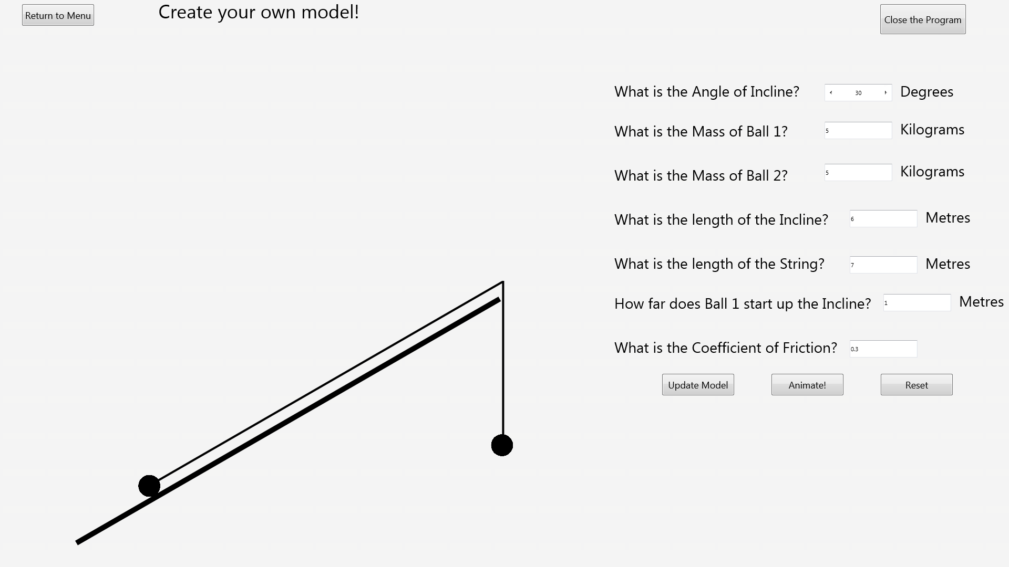Own Model Form:

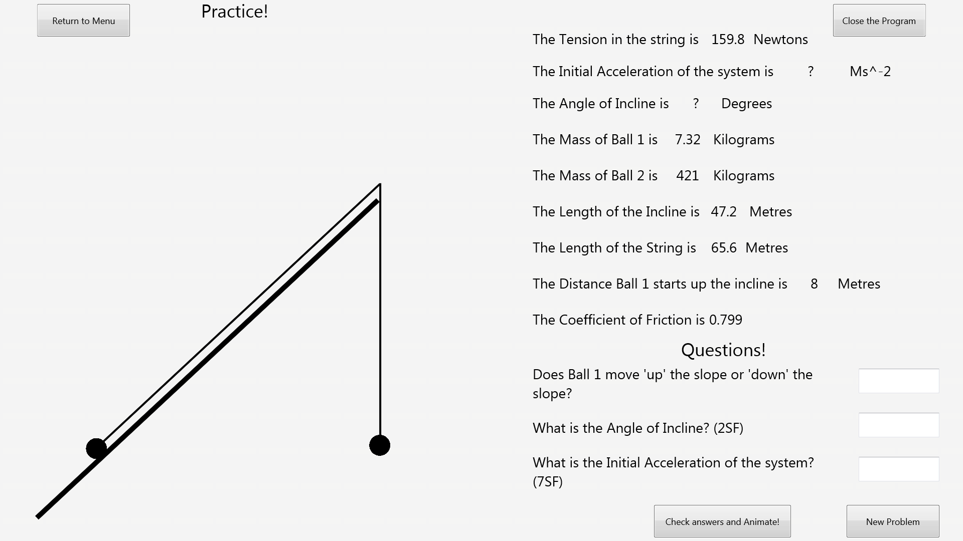Practice Form:

### Test Plan Tables

#### Integration Test Plan

|  |  |  |
| --- | --- | --- |
| **Test Number** | **Functionality to be tested** | **Expected Result** |
| 1 | Program Start-up | The program should start and the Main Menu should be shown. |
| 2 | Pressing the Close Program button on the Main Menu | The program should close. |
| 3 | Pressing the Create your own Model button on the Main Menu | The Create your own Model form should open. The model shown should be in its default configuration. |
| 4 | Pressing the Practice button on the Main Menu | The Practice form should open. A Random model with questions should be displayed. |
| 5 | Pressing the Return to Menu button on the Create your own Model form. | The Main Menu should open. |
| 6 | Pressing the Close Program Button on the Create your own Model Form. | The program should close. |
| 7 | Pressing the Return to Menu button on the Practice form. | The Main Menu should open. |
| 8 | Pressing the Close Program Button on the Practice Form. | The program should close. |

#### System Test Plan

Here are the individual data ranges for reference, for more information on the more complex validation rules tested refer to the Definition of Data Requirements in the Design Section:

|  |  |
| --- | --- |
| Name | Individual Validation |
| Mass of Ball 1 | Must be positive and less than or equal to 3 digits in length. |
| Mass of Ball 2 | Must be positive and less than or equal to 3 digits in length. |
| Coefficient of Friction between Ball 1 and the Incline | Must be positive and less than or equal to 4 digits in length. |
| Angle of Incline | Must be between 0 and 90 and an integer. |
| Length of Incline | Must be positive and less than or equal to 3 digits in length. |
| Length of String connecting Ball 1 and Ball 2 | Must be positive and less than or equal to 3 digits in length. |
| How far Ball 1 starts up the Incline | Must be positive and less than or equal to 3 digits in length. |

|  |  |  |  |  |  |
| --- | --- | --- | --- | --- | --- |
| **Test Number** | **Unit** | **Functionality to be tested** | **Type of Data** | **Data** | **Expected Result** |
| 9 | User Model | Where the user can enter the incline angle, make sure that normal data (between 0-90 non-inclusive) is accepted. | Normal | 1. Incline Angle: 37 | No output from the program, as the input is valid. |
| 10 | User Model | Where the user can enter the incline angle, make sure that boundary data (1 or 89) is accepted | Boundary | 1. Incline Angle: 89 | No output from the program, as the input is valid. |
| 11 | User Model | Where the user can enter the incline angle, make sure that erroneous data (less than 1 or greater than 89) is rejected. | Erroneous | 1. Incline Angle: -16 | The program should output an error message informing the user why the input is invalid and the incline angle should be reset to its default value (30). |
| 12 | User Model | Where the user can enter the Mass of Ball 1, make sure that normal data (A 3 digit or less positive real number) is accepted. | Normal | 1. Mass of Ball 1: 80 | No output from the program, as the input is valid. |
| 13 | User Model | Where the user can enter the Mass of Ball 1, make sure that boundary data (0.01 or 999) is accepted. | Boundary | 1. Mass of Ball 1: 999 | No output from the program, as the input is valid. |
| 14 | User Model | Where the user can enter the Mass of Ball 1, make sure that erroneous data (Not a 3 digit or less positive number) is rejected. | Erroneous | 1. Mass of Ball 1: 4.253 | The program should output an error message informing the user why the input is invalid and the Mass of Ball 1 should be reset to its default value (5). |
| 15 | User Model | Where the user can enter the Mass of Ball 2, make sure that normal data (A 3 digit or less positive real number) is accepted. | Normal | 1. Mass of Ball 2: 812 | No output from the program, as the input is valid. |
| 16 | User Model | Where the user can enter the Mass of Ball 2, make sure that boundary data (0.01 or 999) is accepted. | Boundary | 1. Mass of Ball 2: 0.01 | No output from the program, as the input is valid. |
| 17 | User Model | Where the user can enter the Mass of Ball 2, make sure that erroneous data (Not a 3 digit or less positive number) is rejected. | Erroneous | 1. Mass of Ball 2: -6.3 | The program should output an error message informing the user why the input is invalid and the Mass of Ball 2 should be reset to its default value (5). |
| 18 | User Model | Where the user can enter the length of the incline, make sure that normal data (A 3 digit or less positive real number) is accepted. | Normal | 1. Length of the Incline: 7.2 | No output from the program, as the input is valid. |
| 19 | User Model | Where the user can enter the length of the incline, make sure that boundary data (0.01 or 999) is accepted. | Boundary | 1. Length of the Incline: 999 | No output from the program, as the input is valid. |
| 20 | User Model | Where the user can enter the length of the incline, make sure that erroneous data (Not a 3 digit or less positive number) is rejected. | Erroneous | 1. Length of the Incline: 89.123 | The program should output an error message informing the user why the input is invalid and the length of the incline should be reset to its default value (6). |
| 21 | User Model | Where the user can enter the length of the string, make sure that normal data (A 3 digit or less positive real number) is accepted. | Normal | 1. Length of the String: 63.4 | No output from the program, as the input is valid. |
| 22 | User Model | Where the user can enter the length of the string, make sure that boundary data (0.01 or 999) is accepted. | Boundary | 1. Length of the String: 0.01 | No output from the program, as the input is valid. |
| 23 | User Model | Where the user can enter the length of the string, make sure that erroneous data (Not a 3 digit or less positive number) is rejected. | Erroneous | 1. Length of the String: -12.34 | The program should output an error message informing the user why the input is invalid and the length of the string should be reset to its default value (7). |
| 24 | User Model | Where the user can enter the distance Ball 1 starts up the incline, make sure that normal data (A 3 digit or less positive real number) is accepted. | Normal | 1. Distance Ball 1 Starts Up Incline: 121 | No output from the program, as the input is valid. |
| 25 | User Model | Where the user can enter the distance Ball 1 starts up the incline, make sure that boundary data (0.01 or 999) is accepted. | Boundary | 1. Distance Ball 1 Starts Up Incline: 999 | No output from the program, as the input is valid. |
| 26 | User Model | Where the user can enter the distance Ball 1 starts up the incline, make sure that erroneous data (Not a 3 digit or less positive number) is rejected. | Erroneous | 1. Distance Ball 1 Starts Up Incline: 49883 | The program should output an error message informing the user why the input is invalid and the distance Ball 1 starts up the incline should be reset to its default value (1). |
| 27 | User Model | Where the user can enter the coefficient of friction, make sure that normal data (A 4 digit or less real number greater than or equal to 0) is accepted. | Normal | 1. Coefficient of Friction: 0.762 | No output from the program, as the input is valid. |
| 28 | User Model | Where the user can enter the coefficient of friction, make sure that boundary data (0) is accepted. | Boundary | 1. Coefficient of Friction: 0 | No output from the program, as the input is valid. |
| 29 | User Model | Where the user can enter the coefficient of friction, make sure that erroneous data (Not a 4 digit or less real number greater than or equal to 0) is rejected. | Erroneous | 1. Coefficient of Friction: 0.3459 | The program should output an error message informing the user why the input is invalid and the coefficient of friction should be reset to its default value (0.3). |
| 30 | User Model | When the update model button is pressed, normal data satisfying the inequality distance ball 1 starts up incline < length of incline should be accepted. | Normal | 1. Distance Ball 1 Starts Up Incline: 2.1  2. Length of Incline: 6.4 | The model on the left side of the screen should update to the changed configuration. |
| 31 | User Model | When the update model button is pressed, boundary data satisfying the inequality distance ball 1 starts up incline < length of incline should be accepted. | Boundary | 1. Distance Ball 1 Starts Up Incline: 6.4  2. Length of Incline: 6.41  ***3. Length of String: 2.24 (Note this is only used to stop other validation checks from kicking in).*** | The model on the left side of the screen should update to the changed configuration. |
| 32 | User Model | When the update model button is pressed, erroneous data that doesn’t satisfy the inequality distance ball 1 starts up incline < length of incline should be rejected. | Erroneous | 1. Distance Ball 1 Starts Up Incline: 18.4  2. Length of Incline: 3 | The program should output an error message informing the user why the inputs are invalid and the model on the left side of the screen should reset to its default. |
| 33 | User Model | When the update model button is pressed, normal data satisfying the inequality distance ball 1 starts up incline + length of string > length of incline should be accepted. | Normal | 1. Distance Ball 1 Starts Up Incline: 16  2. Length of Incline: 25  3. Length of String: 12 | The model on the left side of the screen should update to the changed configuration. |
| 34 | User Model | When the update model button is pressed, boundary data satisfying the inequality distance ball 1 starts up incline + length of string > length of incline should be accepted. | Boundary | 1. Distance Ball 1 Starts Up Incline: 3.29  2. Length of Incline: 7.41  3. Length of String: 4.13 | The model on the left side of the screen should update to the changed configuration. |
| 35 | User Model | When the update model button is pressed, erroneous data that doesn’t satisfy the inequality distance ball 1 starts up incline + length of string > length of incline should be rejected. | Erroneous | 1. Distance Ball 1 Starts Up Incline: 22  2. Length of Incline: 83  3. Length of String: 34.6 | The program should output an error message informing the user why the inputs are invalid and the model on the left side of the screen should reset to its default. |
| 36 | User Model | When the update model button is pressed, normal data satisfying the inequality (length of the incline* Sin(incline angle)) – length of the string + length of the incline – distance Ball 1 starts up the incline > 0should be accepted. | Normal | 1. Distance Ball 1 Starts Up Incline: 2.1  2. Length of Incline: 3.91  3. Length of String: 2.98  4. Incline Angle: 30 | The model on the left side of the screen should update to the changed configuration. |
| 37 | User Model | When the update model button is pressed, boundary data satisfying the inequality (length of the incline* Sin(incline angle)) – length of the string + length of the incline – distance Ball 1 starts up the incline > 0should be accepted. | Boundary | 1. Distance Ball 1 Starts Up Incline: 2.99  2. Length of Incline: 4  3. Length of String: 3  4. Incline Angle: 30 | The model on the left side of the screen should update to the changed configuration. |
| 38 | User Model | When the update model button is pressed, erroneous data that doesn’t satisfy the inequality (length of the incline* Sin(incline angle)) – length of the string + length of the incline – distance Ball 1 starts up the incline > 0should be rejected. | Erroneous | 1. Distance Ball 1 Starts Up Incline: 23.2  2. Length of Incline: 32  3. Length of String: 487  4. Incline Angle: 47 | The program should output an error message informing the user why the inputs are invalid and the model on the left side of the screen should reset to its default. |
| 39 | User Model | When the animate model button is pressed and the configuration is such that Ball 1 would move down the slope, the model should animate to reflect this. | Normal | 1. Incline Angle: 40  2. Mass of Ball 1: 120  3. Mass of Ball 2: 20.2  4. Length of Incline: 4.52  5. Length of String: 5.8  6. Distance Ball 1 Starts Up Incline: 1.19  7. Coefficient of Friction: 0.213 | The model should animate such that Ball 1 moves down the slope. |
| 40 | User Model | When the animate model button is pressed and the configuration is such that Ball 1 would move up the slope, the model should animate to reflect this. | Normal | 1. Incline Angle: 27  2. Mass of Ball 1: 44  3. Mass of Ball 2: 89.4  4. Length of Incline: 9.1  5. Length of String: 9.21  6. Distance Ball 1 Starts Up Incline: 0.7  7. Coefficient of Friction: 0.41 | The model should animate such that Ball 1 moves up the slope. |
| 41 | User Model | When the animate model button is pressed and the configuration is such that the Balls wouldn’t move, no animation should occur and a message should display explaining to the user why this has happened. | Normal | 1. Incline Angle: 36  2. Mass of Ball 1: 9.83  3. Mass of Ball 2: 12  4. Length of Incline: 6.21  5. Length of String: 7.8  6. Distance Ball 1 Starts Up Incline: 1.4  7. Coefficient of Friction: 0.912 | The model should not animate, and a message should display explain to the user why the current configuration would not move. |
| 42 | User Model | When the animate model button is pressed, the initial acceleration of the system should be correctly calculated. This will be checked by using the debug tool within Delphi XE5 to see what the variable changes to. | Normal | 1. Incline Angle: 30  2. Mass of Ball 1: 4  3. Mass of Ball 2: 5.2  4. Length of Incline: 6.1  5. Length of String: 6.98  6. Distance Ball 1 Starts Up Incline: 0.98  7. Coefficient of Friction: 0.156 | Initial Acceleration is 2.83305… |
| 43 | User Model | When the animate model button is pressed, the extra displacement should be correctly calculated. This will be checked by using the debug tool within Delphi XE5 to see what the variable changes to. | Normal | 1. Incline Angle: 36  2. Mass of Ball 1: 11  3. Mass of Ball 2: 24.2  4. Length of Incline: 8.2  5. Length of String: 7.5  6. Distance Ball 1 Starts Up Incline: 2.3  7. Coefficient of Friction: 0.456 | Extra displacement is 1.30763… |
| 44 | User Model | When the Reset Button is pressed, the model should reset to its default. | Normal | None (Just a button click) | The model should reset to its default values and configuration. |
| 45 | Practice | When the Check Answers and Animate button is pressed, if the user’s answers are correct, a message should display informing the user and the model should begin to animate. | Normal | 1. All questions answered correctly (calculated beforehand on paper) | A message telling the user they got their answers right should be displayed. Following this, the model should animate based on its configuration. |
| 46 | Practice | When the Check Answers and Animate button is pressed, if the user’s answers are incorrect, a message should display informing the user which questions they got wrong. | Normal | 1. Question 1 and 3 answered incorrectly  2. Question 2 answered correctly (calculated beforehand on paper)  ***Note: I have chosen to just test this scenario to shorten the testing as I feel testing all possibilities would be fairly redundant. This scenario was chosen at random.*** | A message telling the user which answers they got wrong should be displayed. The model should not animate. |
| 47 | Practice | When the New Problem button is pressed, a new problem should be generated. | Normal | None (Just a button click) | The values in the top right of the form should change to a new configuration, with some listed as ‘?’. The questions should also be reset with new ones based on which values are listed as ‘?’. The model should update to reflect the new configuration. |

## Testing

For information about what functionality was tested and what data was used, cross-reference with the test plan. Screenshots can be found in the ‘Screenshot Evidence’ section (found after the ‘System Testing’ section). Video Evidence can be found in the accompanying USB drive included with this document.

### Integration Testing

|  |  |  |  |  |
| --- | --- | --- | --- | --- |
| **Test Number** | **Expected Result** | **Actual Result** | **Pass/Fail** | **Evidence Location** |
| 1 | The program should start and the Main Menu should be shown. | The program started up and the Main Menu was shown. | Pass | Screenshot Evidence: Test 1 |
| 2 | The program should close. | The program closed. | Pass | Screenshot Evidence: Test 2 |
| 3 | The Create your own Model form should open. The model shown should be in its default configuration. | The Create your own Model form opened and the model shown was in its default configuration. | Pass | Screenshot Evidence: Test 3 |
| 4 | The Practice form should open. A Random model with questions should be displayed. | The Practice form opened and a random model with questions was displayed. | Pass | Screenshot Evidence: Test 4 |
| 5 | The Main Menu should open. | The Main Menu opened. | Pass | Screenshot Evidence: Test 5 |
| 6 | The program should close. | The program closed. | Pass | Screenshot Evidence: Test 6 |
| 7 | The Main Menu should open. | The Main Menu opened. | Pass | Screenshot Evidence: Test 7 |
| 8 | The program should close. | The program closed. | Pass | Screenshot Evidence: Test 8 |

### System Testing

|  |  |  |  |  |
| --- | --- | --- | --- | --- |
| **Test Number** | **Expected Result** | **Actual Result** | **Pass/Fail** | **Evidence Location** |
| 9 | No output from the program, as the input is valid. | The program produced now output. | Pass | Screenshot Evidence: Test 9 |
| 10 | No output from the program, as the input is valid. | The program produced no output. | Pass | Screenshot Evidence: Test 10 |
| 11 | The program should output an error message informing the user why the input is invalid and the Incline angle should be reset to its default value (30). | The program outputted an error message and then reset the Incline Angle to 30. | Pass | Screenshot Evidence: Test 11 |
| 12 | No output from the program, as the input is valid. | The program produced no output. | Pass | Screenshot Evidence: Test 12 |
| 13 | No output from the program, as the input is valid. | The program produced no output. | Pass | Screenshot Evidence: Test 13 |
| 14 | The program should output an error message informing the user why the input is invalid and the Mass of Ball 1 should be reset to its default value (5). | The program outputted an error message and then reset the Ball 1 Mass to 5. | Pass | Screenshot Evidence: Test 14 |
| 15 | No output from the program, as the input is valid. | The program produced no output. | Pass | Screenshot Evidence: Test 15 |
| 16 | No output from the program, as the input is valid. | The program produced no output. | Pass | Screenshot Evidence: Test 16 |
| 17 | The program should output an error message informing the user why the input is invalid and the Mass of Ball 2 should be reset to its default value (5). | The program outputted an error message and then reset the Ball 2 Mass to 5. | Pass | Screenshot Evidence: Test 17 |
| 18 | No output from the program, as the input is valid. | The program produced no output. | Pass | Screenshot Evidence: Test 18 |
| 19 | No output from the program, as the input is valid. | The program produced no output. | Pass | Screenshot Evidence: Test 19 |
| 20 | The program should output an error message informing the user why the input is invalid and the length of the incline should be reset to its default value (6). | The program outputted an error message and then reset the Incline Length to 6. | Pass | Screenshot Evidence: Test 20 |
| 21 | No output from the program, as the input is valid. | The program produced no output. | Pass | Screenshot Evidence: Test 21 |
| 22 | No output from the program, as the input is valid. | The program produced no output. | Pass | Screenshot Evidence: Test 22 |
| 23 | The program should output an error message informing the user why the input is invalid and the length of the string should be reset to its default value (7). | The program outputted an error message and then reset the String Length to 7. | Pass | Screenshot Evidence: Test 23 |
| 24 | No output from the program, as the input is valid. | The program produced no output. | Pass | Screenshot Evidence: Test 24 |
| 25 | No output from the program, as the input is valid. | The program produced no output. | Pass | Screenshot Evidence: Test 25 |
| 26 | The program should output an error message informing the user why the input is invalid and the distance Ball 1 starts up the incline should be reset to its default value (1). | The program outputted an error message and then reset the Distance Ball 1 starts up the incline to 1. | Pass | Screenshot Evidence: Test 26 |
| 27 | No output from the program, as the input is valid. | The program produced no output. | Pass | Screenshot Evidence: Test 27 |
| 28 | No output from the program, as the input is valid. | The program produced no output. | Pass | Screenshot Evidence: Test 28 |
| 29 | The program should output an error message informing the user why the input is invalid and the coefficient of friction should be reset to its default value (0.3). | The program outputted an error message and then reset the Coefficient of Friction to 0.3. | Pass | Screenshot Evidence: Test 29 |
| 30 | The model on the left side of the screen should update to the changed configuration. | The model updated to the new configuration. | Pass | Video Evidence: Test 30 |
| 31 | The model on the left side of the screen should update to the changed configuration. | The model updated to the new configuration. | Pass | Video Evidence: Test 31 |
| 32 | The program should output an error message informing the user why the inputs are invalid and the model on the left side of the screen should reset to its default. | The program produced an error message informing the user why the inputs were invalid and the model on the left side of the screen reset to default. | Pass | Video Evidence: Test 32 |
| 33 | The model on the left side of the screen should update to the changed configuration. | The model updated to the new configuration. | Pass | Video Evidence: Test 33 |
| 34 | The model on the left side of the screen should update to the changed configuration. | The model updated to the new configuration. | Pass | Video Evidence: Test 34 |
| 35 | The program should output an error message informing the user why the inputs are invalid and the model on the left side of the screen should reset to its default. | The program produced an error message informing the user why the inputs were invalid and the model on the left side of the screen reset to default. | Pass | Video Evidence: Test 35 |
| 36 | The model on the left side of the screen should update to the changed configuration. | The model updated to the new configuration. | Pass | Video Evidence: Test 36 |
| 37 | The model on the left side of the screen should update to the changed configuration. | The model updated to the new configuration. | Pass | Video Evidence: Test 37 |
| 38 | The program should output an error message informing the user why the inputs are invalid and the model on the left side of the screen should reset to its default. | The program produced an error message informing the user why the inputs were invalid and the model on the left side of the screen reset to default. | Pass | Video Evidence: Test 38 |
| 39 | The model should animate such that Ball 1 moves down the slope. | The model animated such that Ball 1 moved down the slope. | Pass | Video Evidence: Test 39 |
| 40 | The model should animate such that Ball 1 moves up the slope. | The model animated such that Ball 1 moved up the slope. | Pass | Video Evidence: Test 40 |
| 41 | The model should not animate, and a message should display explain to the user why the current configuration would not move. | The model didn’t animate and the program displayed a message explaining why. | Pass | Video Evidence: Test 41 |
| 42 | Initial Acceleration is 2.83305… | Initial Acceleration was correct. | Pass | Screenshot Evidence: Test 42 |
| 43 | Extra displacement is 1.30763… | Extra displacement was correct. | Pass | Screenshot Evidence: Test 43 |
| 44 | The model should reset to its default values and configuration. | The model reset to its default values and configuration. | Pass | Video Evidence: Test 44 |
| 45 | A message telling the user they got their answers right should be displayed. Following this, the model should animate based on its configuration. | The program displayed a message informing the user they got the questions correct. Once this was closed the model animated. | Pass | Video Evidence: Test 45 |
| 46 | A message telling the user which answers they got wrong should be displayed. The model should not animate. | The program displayed a message informing the user which questions they got wrong. The model didn’t animate. | Pass | Video Evidence: Test 46 |
| 47 | The values in the top right of the form should change to a new configuration, with some listed as ‘?’. The questions should also be reset with new ones based on which values are listed as ‘?’. The model should update to reflect the new configuration. | The values in the top right were updated to a new configuration. Those questions were also updated linking to the values who were listed as ‘?’. The model updated instantaneously to the new configuration. | Pass | Screenshot Evidence: Test 47 |

## Screenshot Evidence

### Test 1

Before:



After:

### Test 2

Before:

After:

### Test 3

Before:

After:

### Test 4

Before:

After:

### Test 5

Before:

After:

### Test 6

Before:

After:

### Test 7

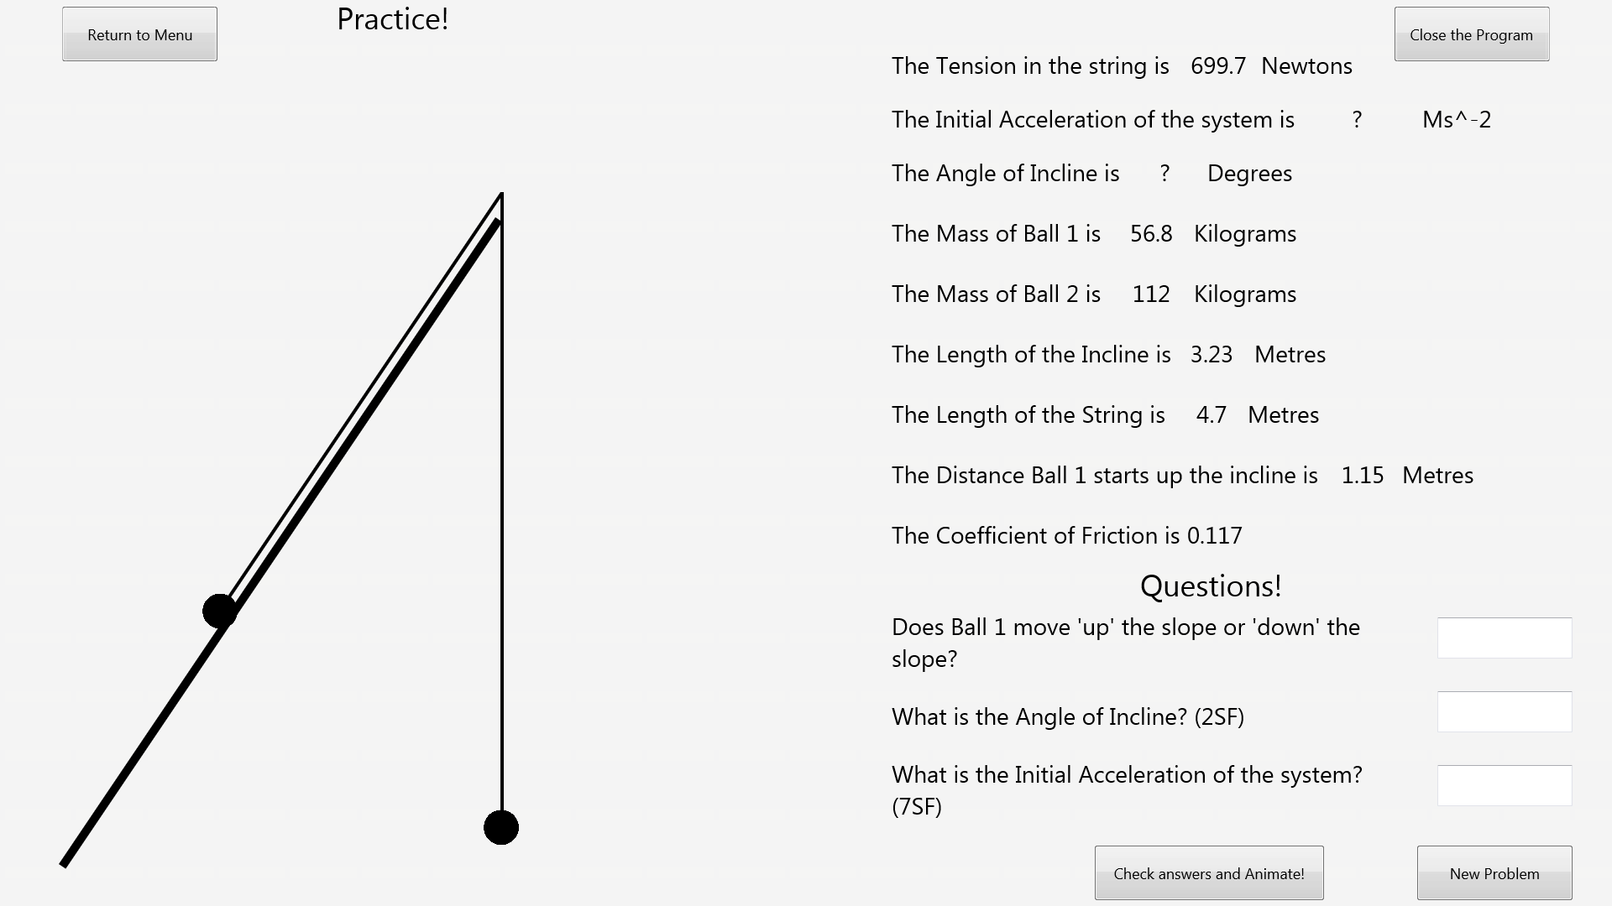Before:

After:

### Test 8

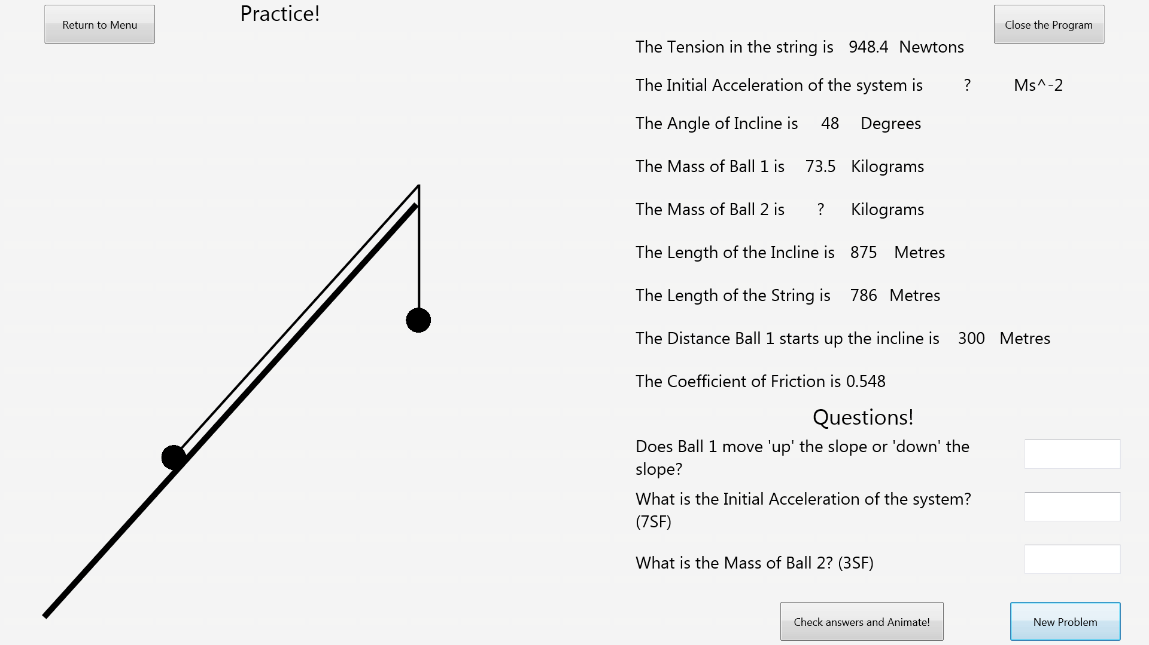Before:

After:

### Test 9

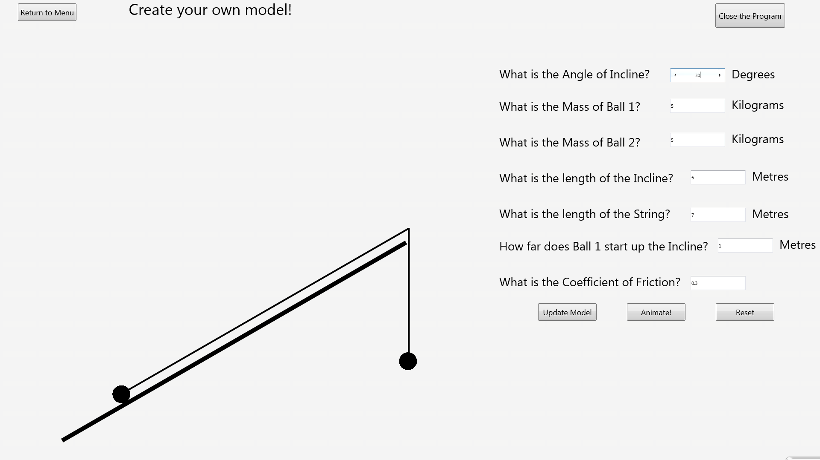Before:

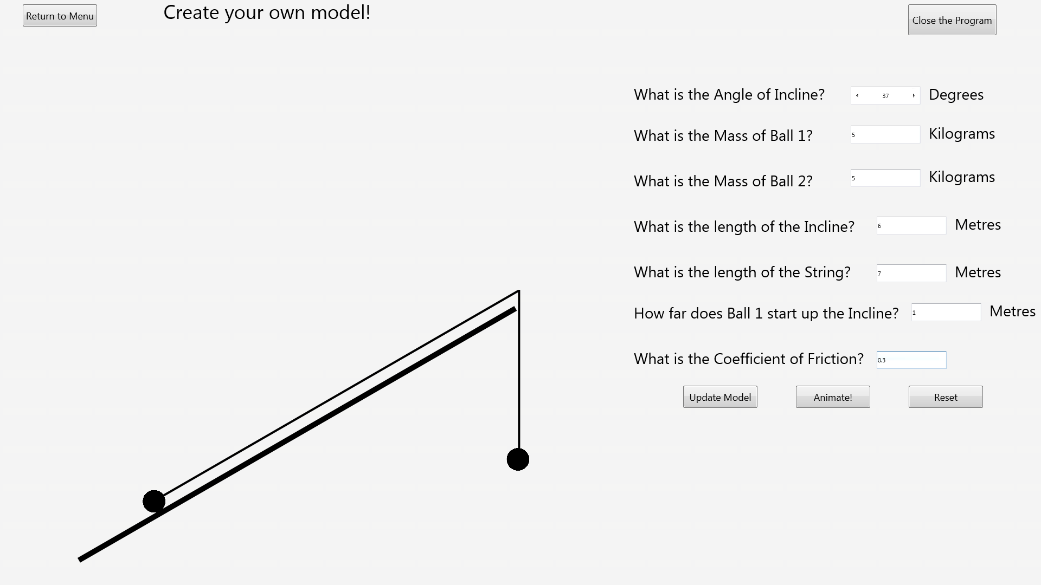After:

### Test 10

Before:

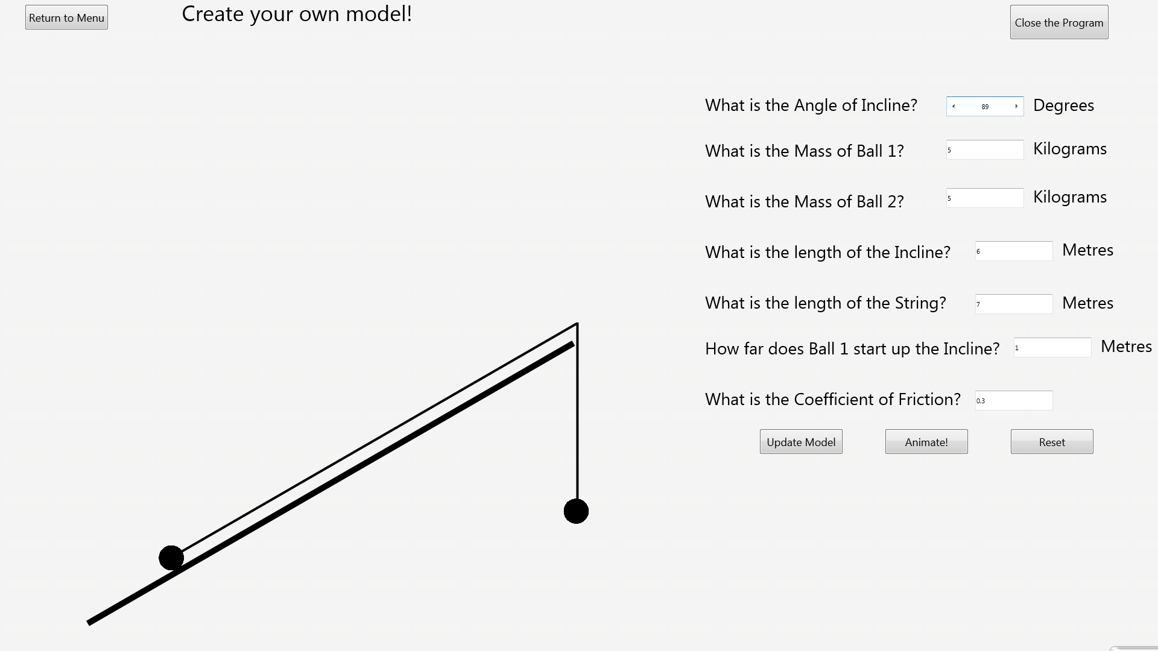After:

### Test 11

Before:

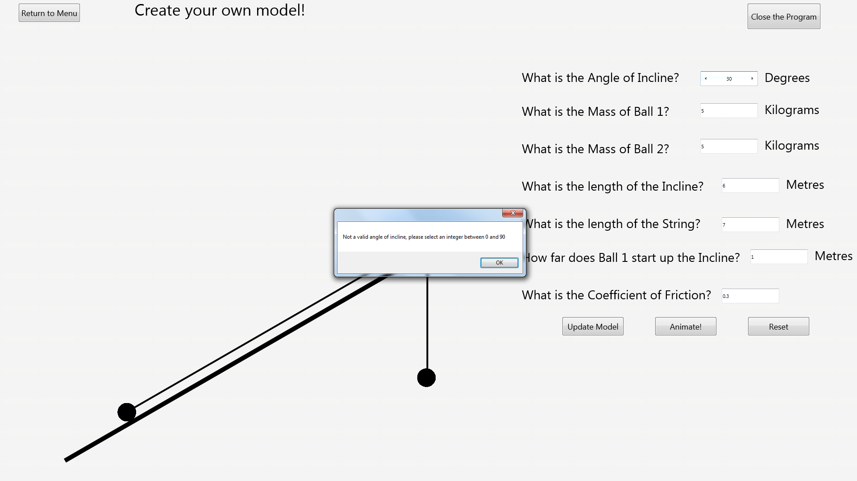After:

### Test 12

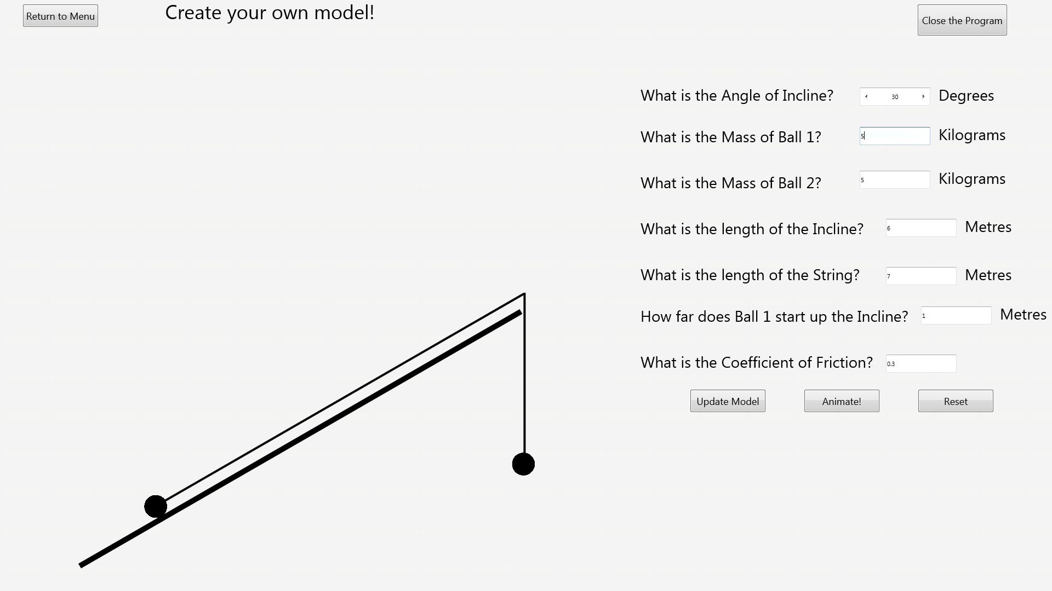Before:

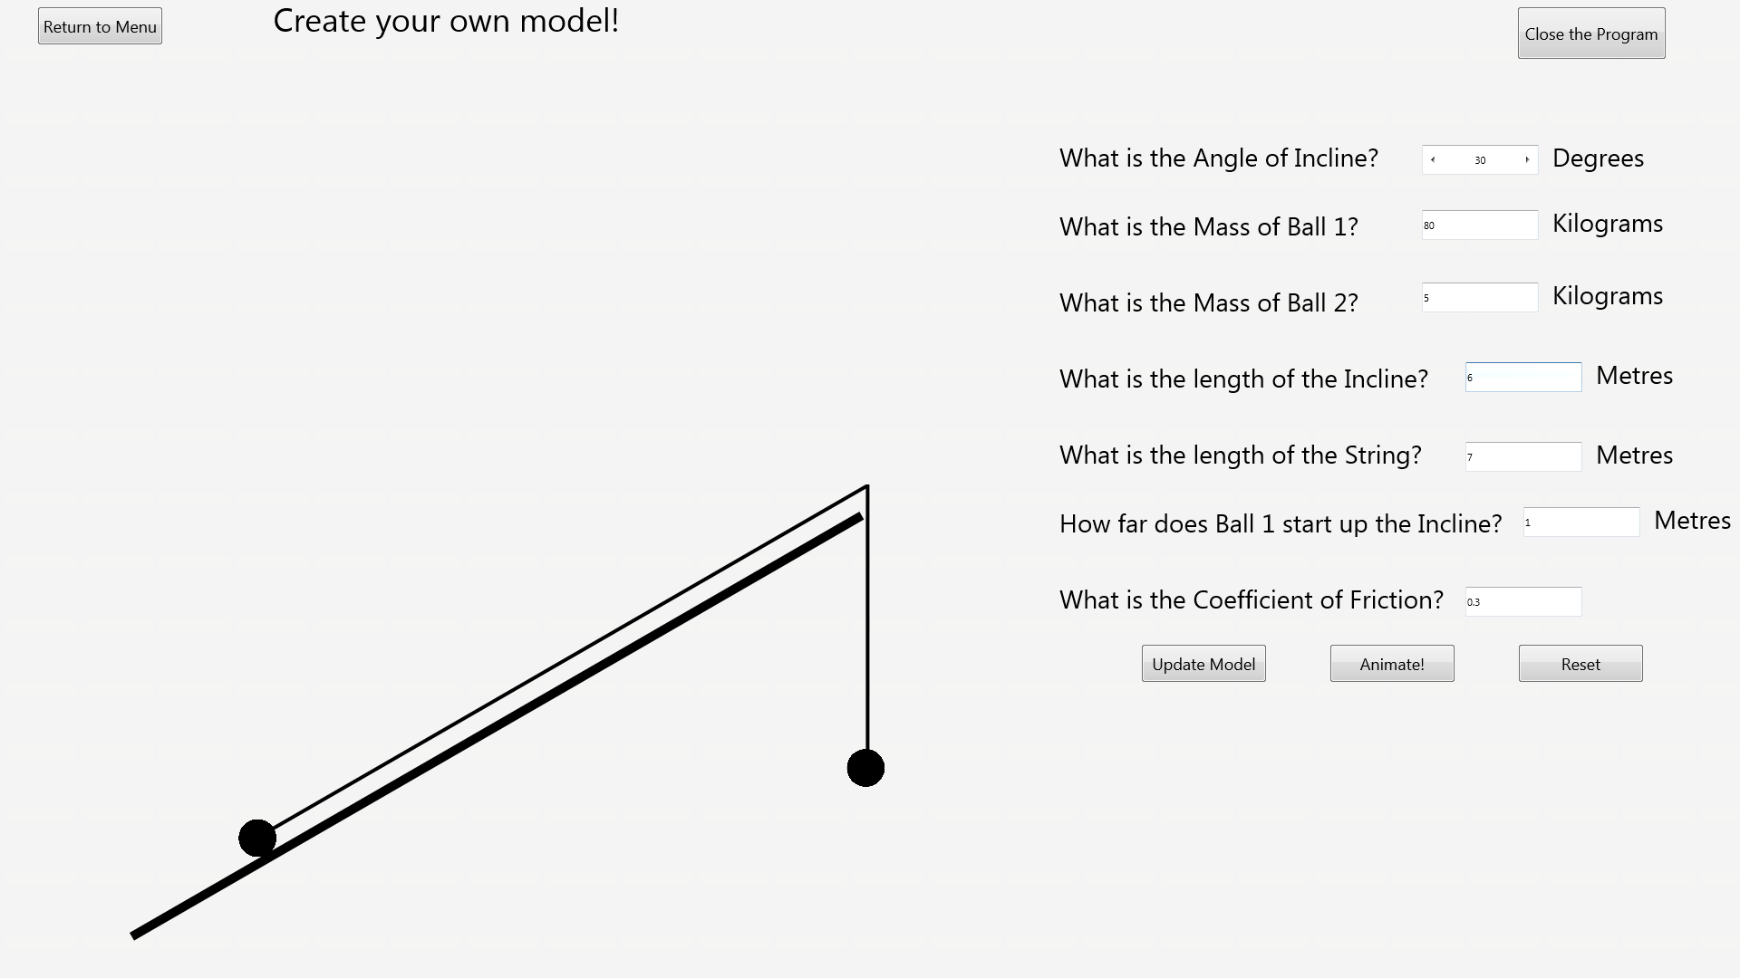After:

### Test 13

Before:

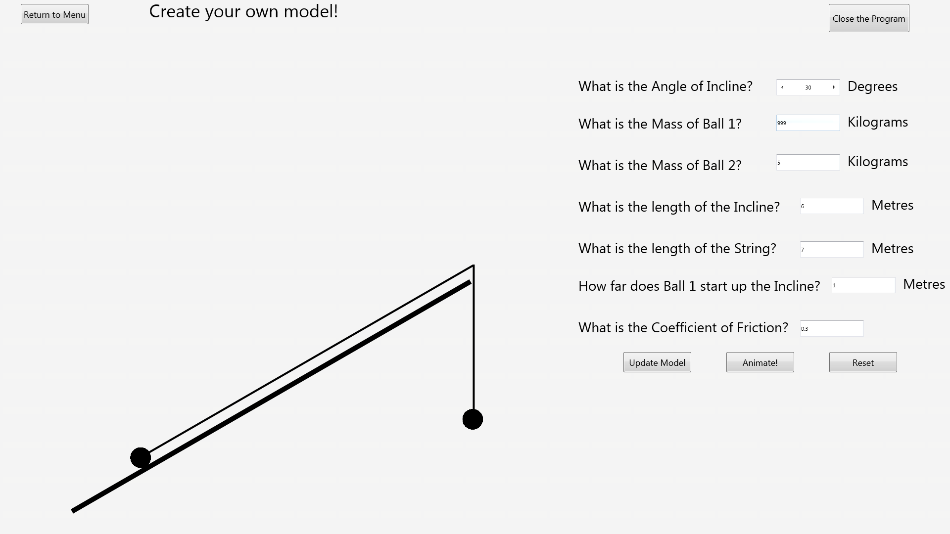After:

### Test 14

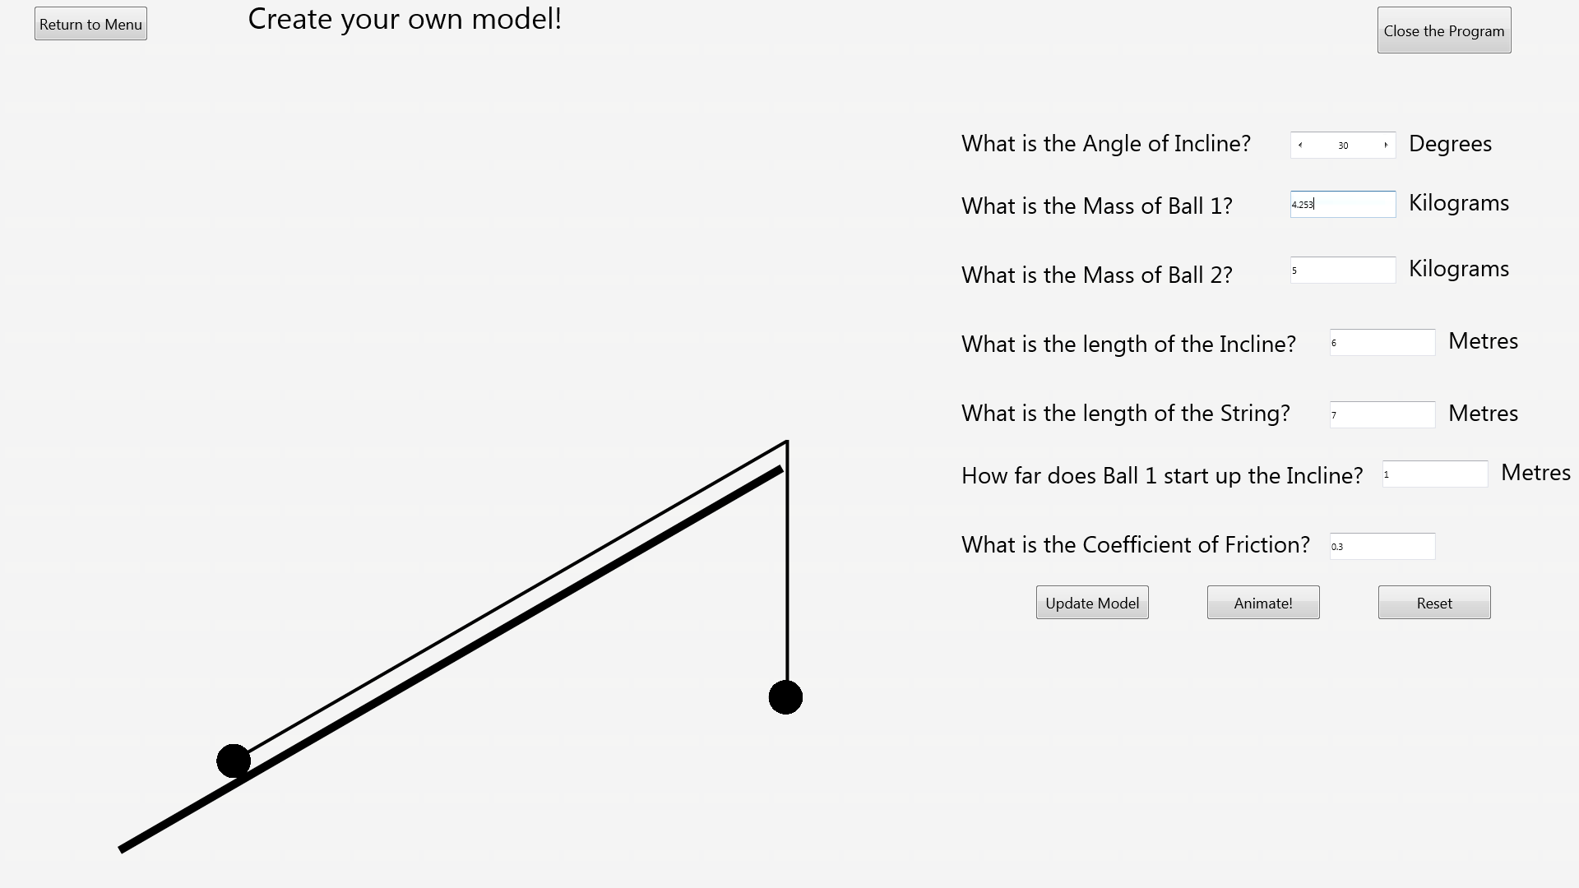Before:

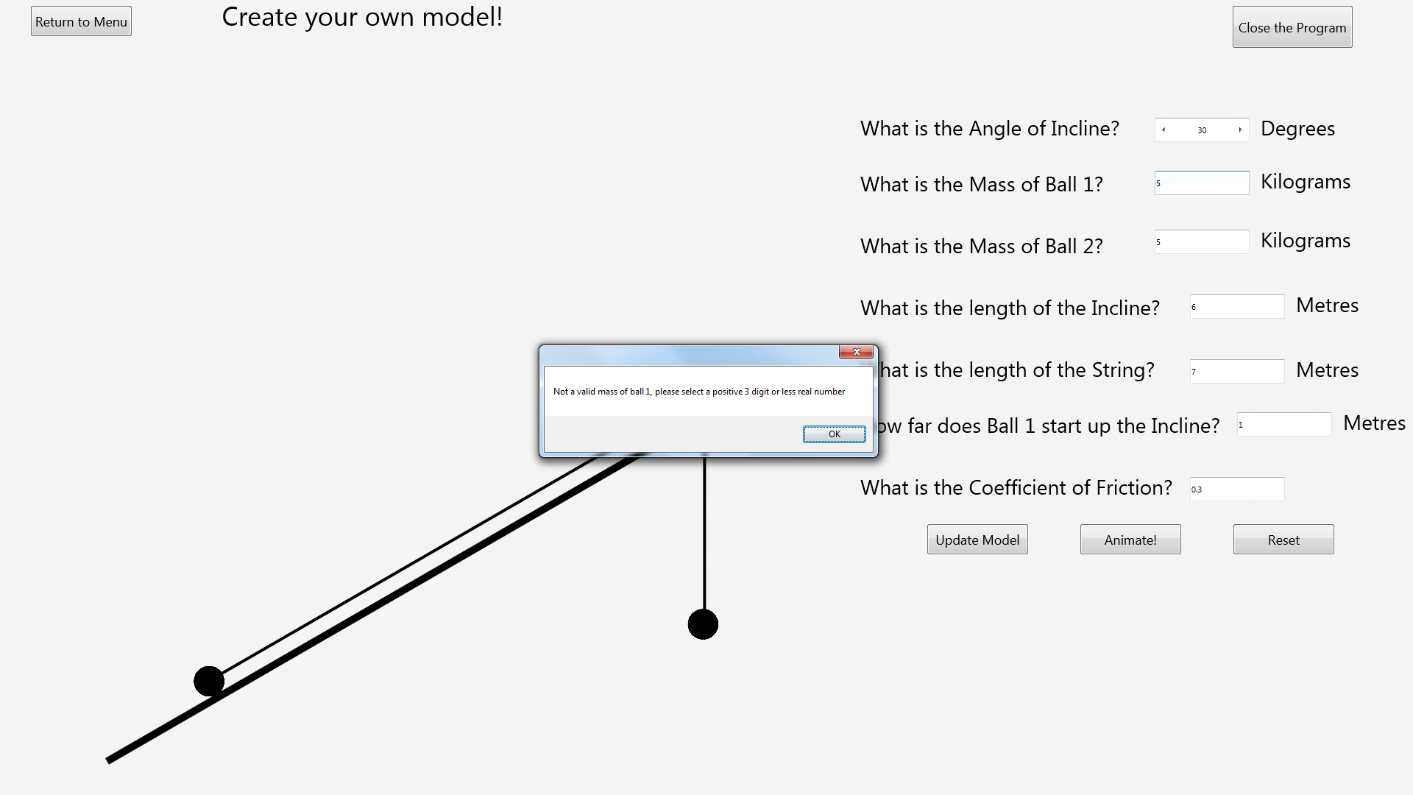After:

### Test 15

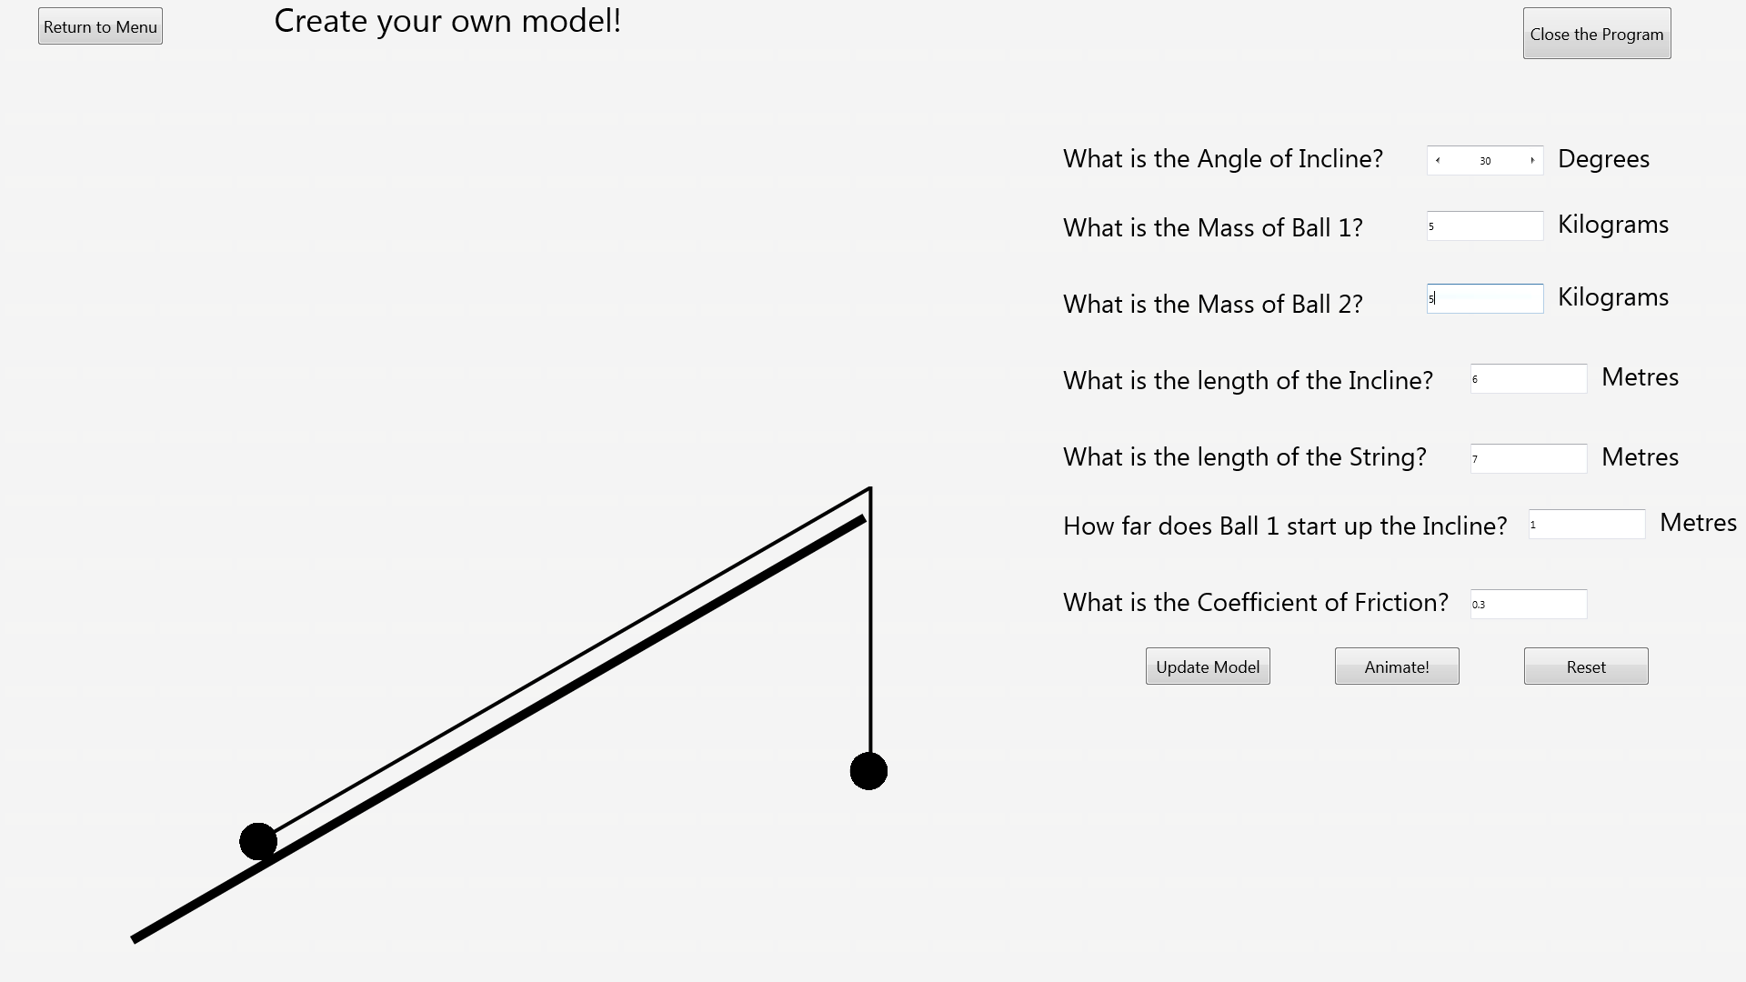Before:

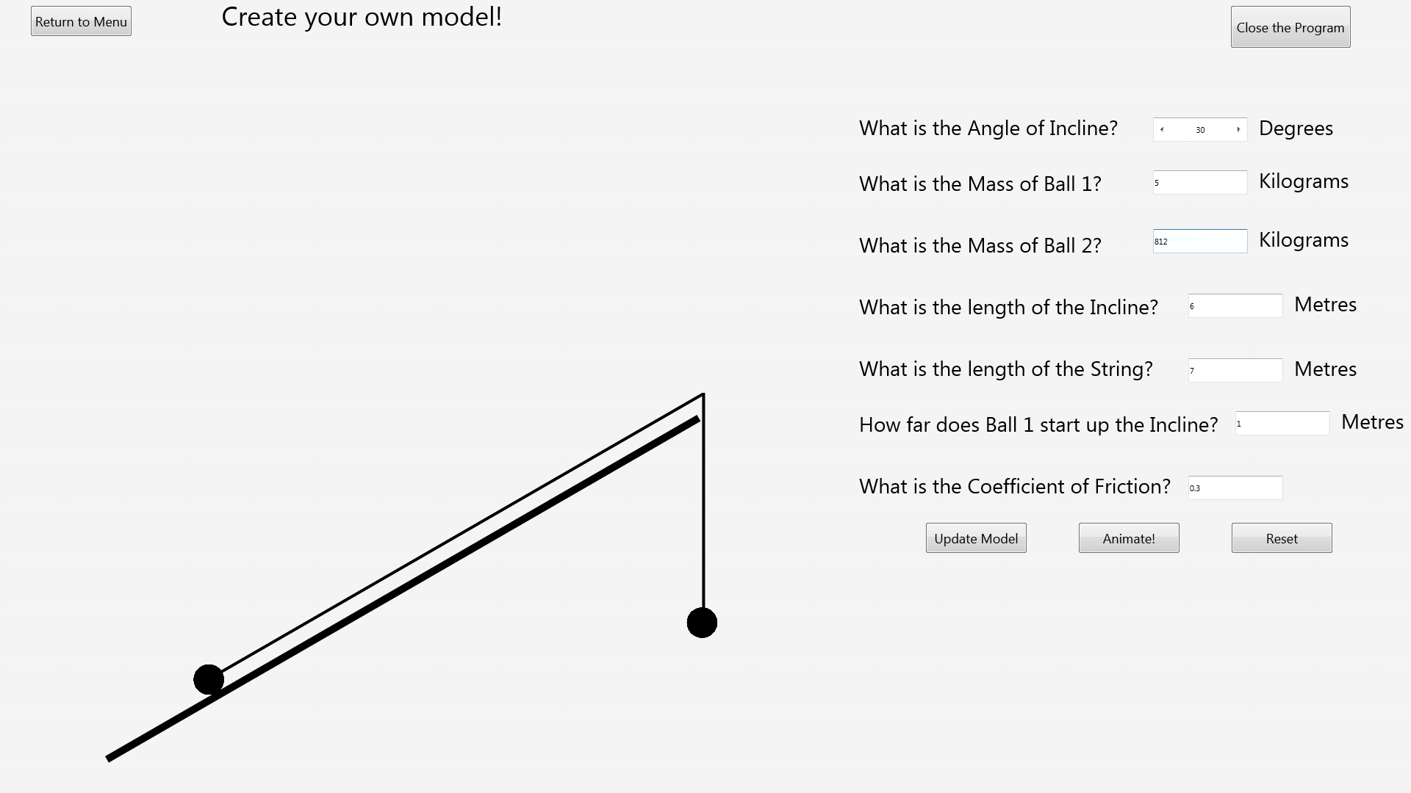After:

### Test 16

Before:

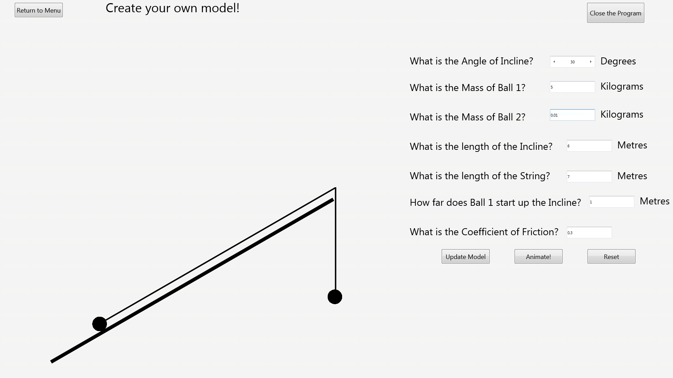After:

### Test 17

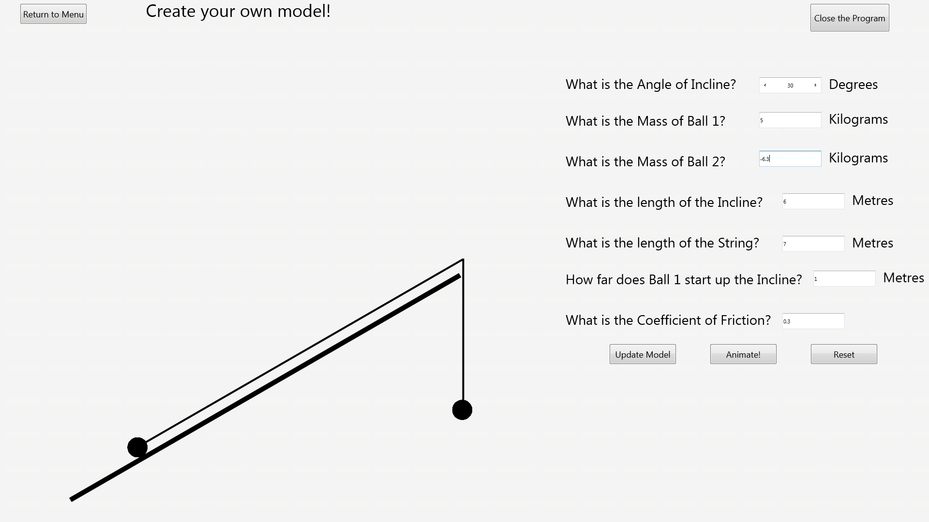Before:

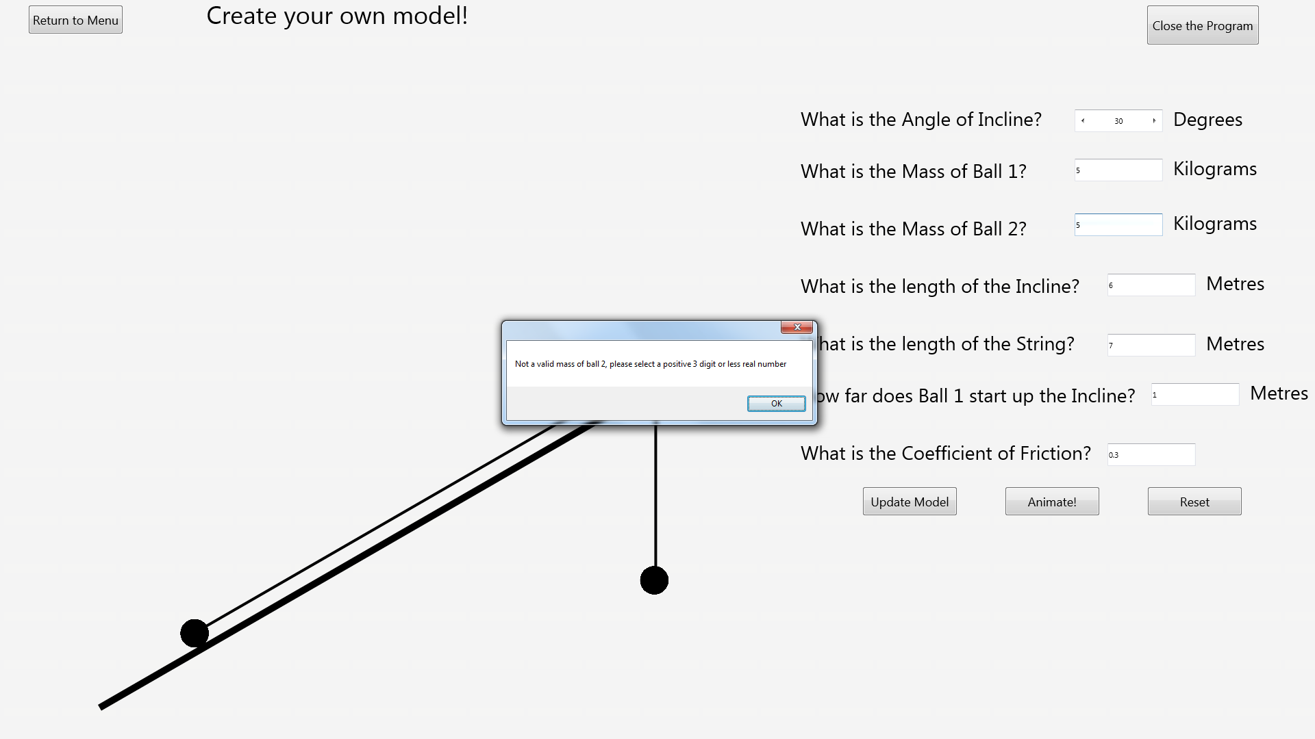After:

### Test 18

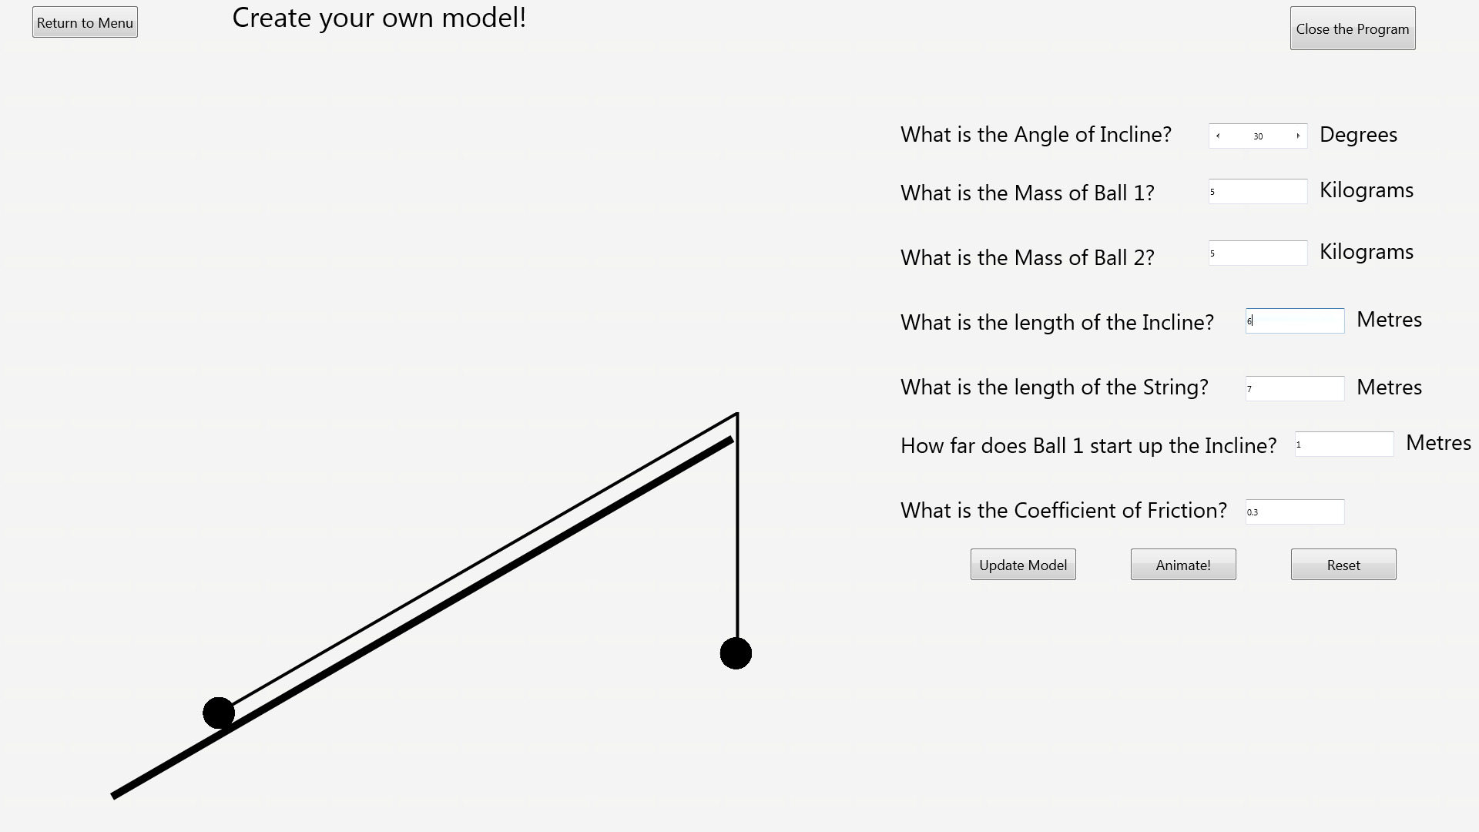Before:

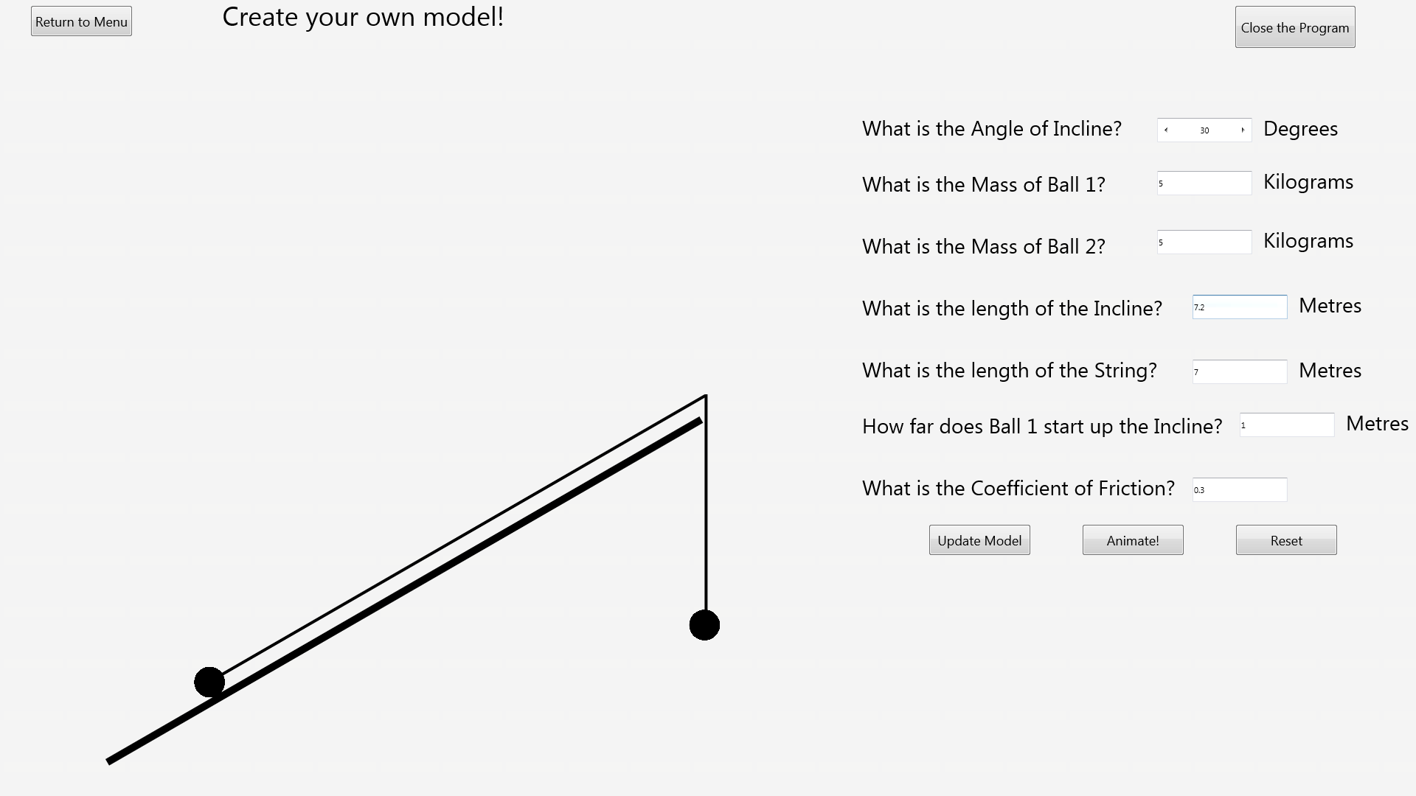After:

### Test 19

Before:

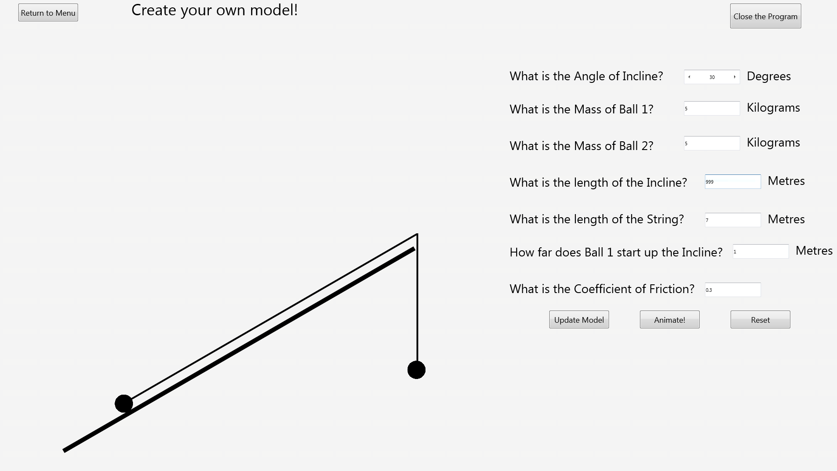After:

### Test 20

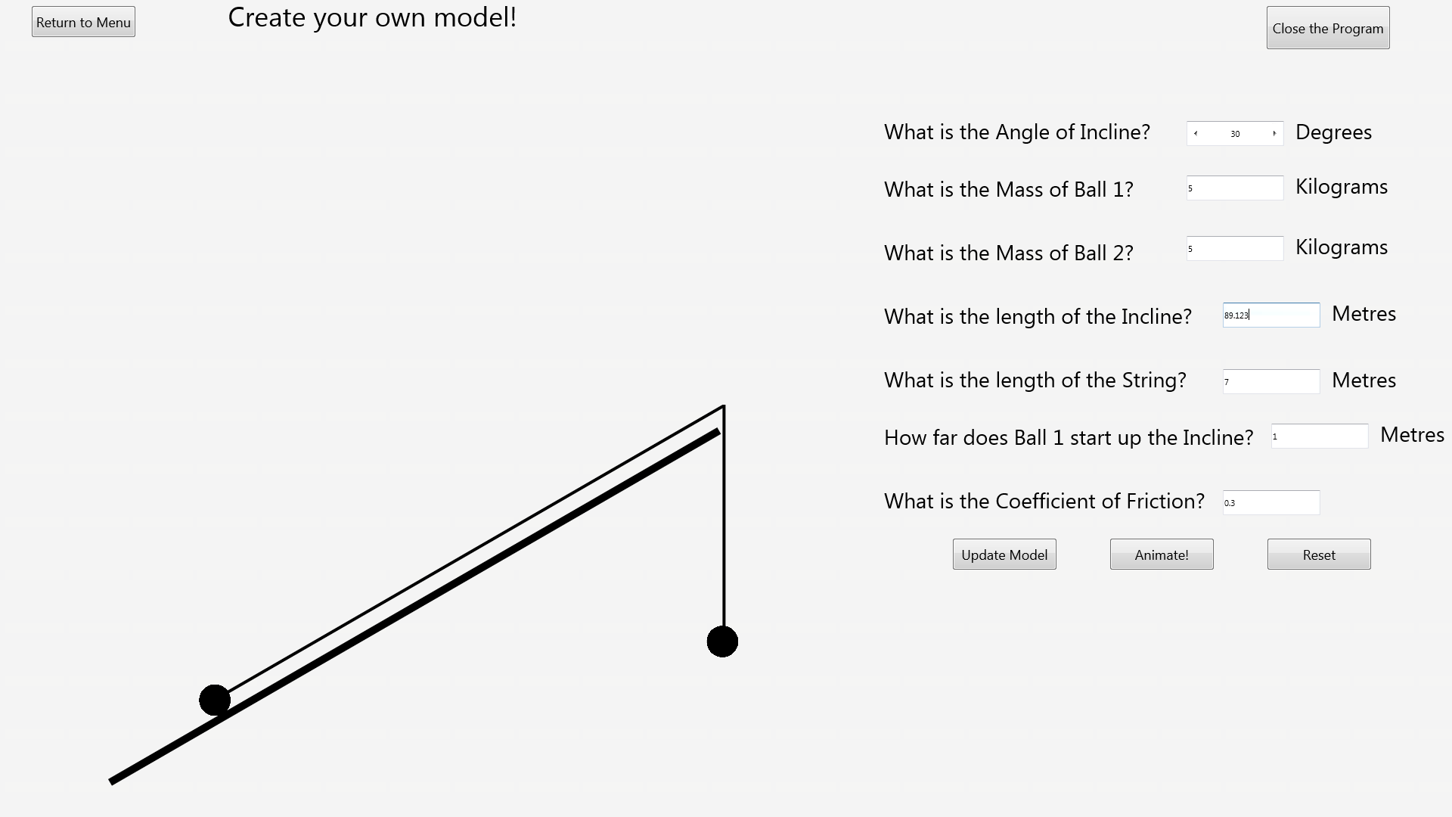Before:

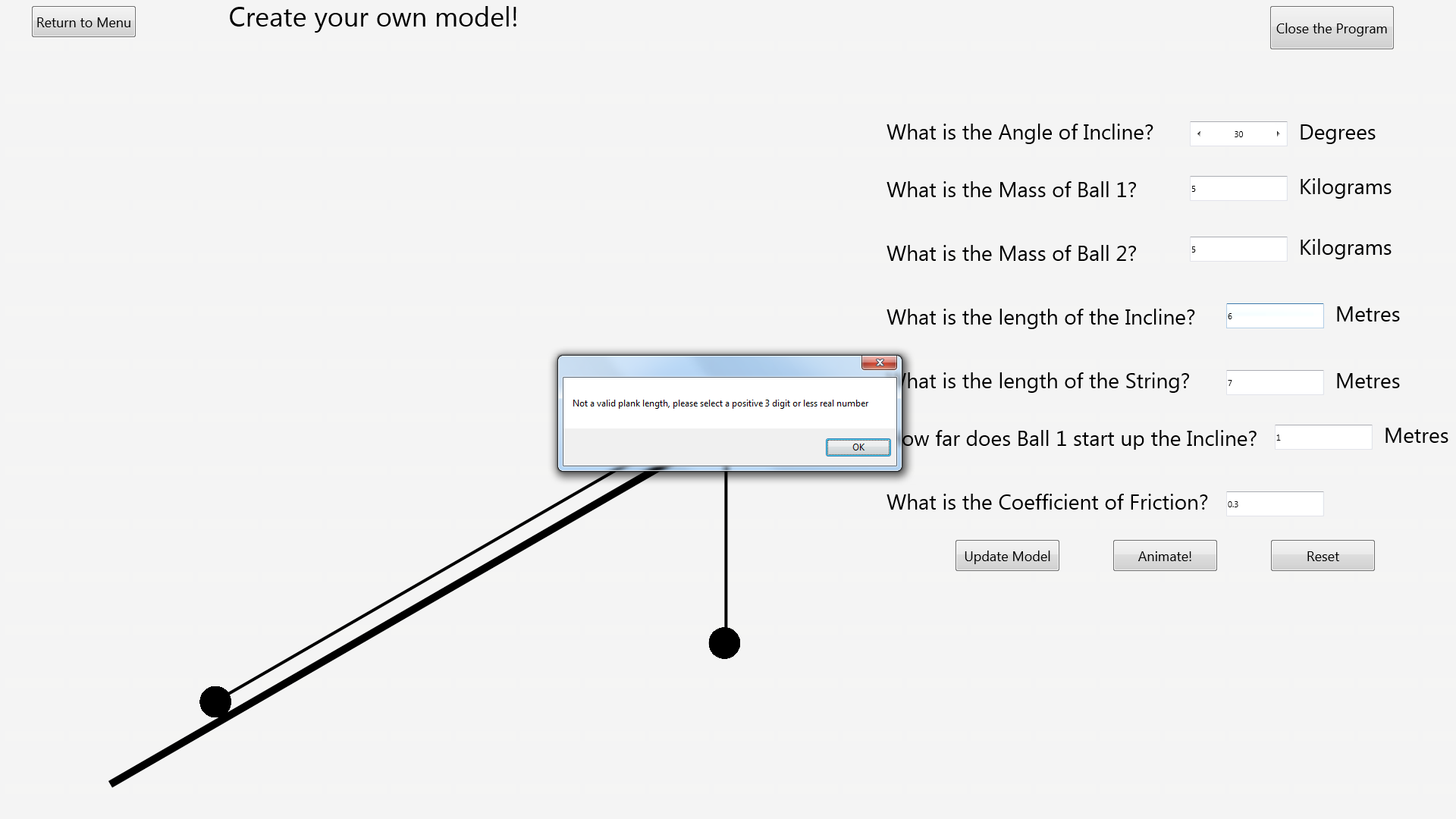After:

### Test 21

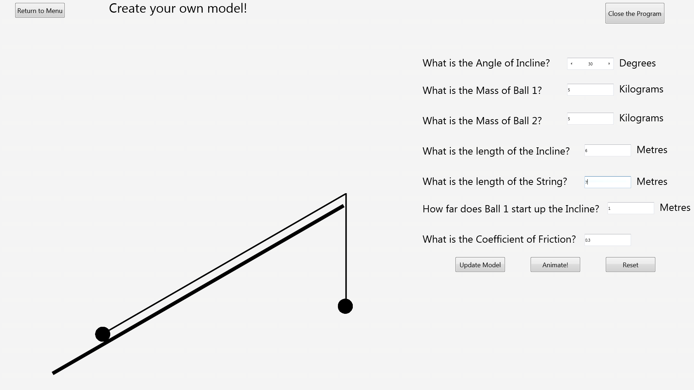Before:

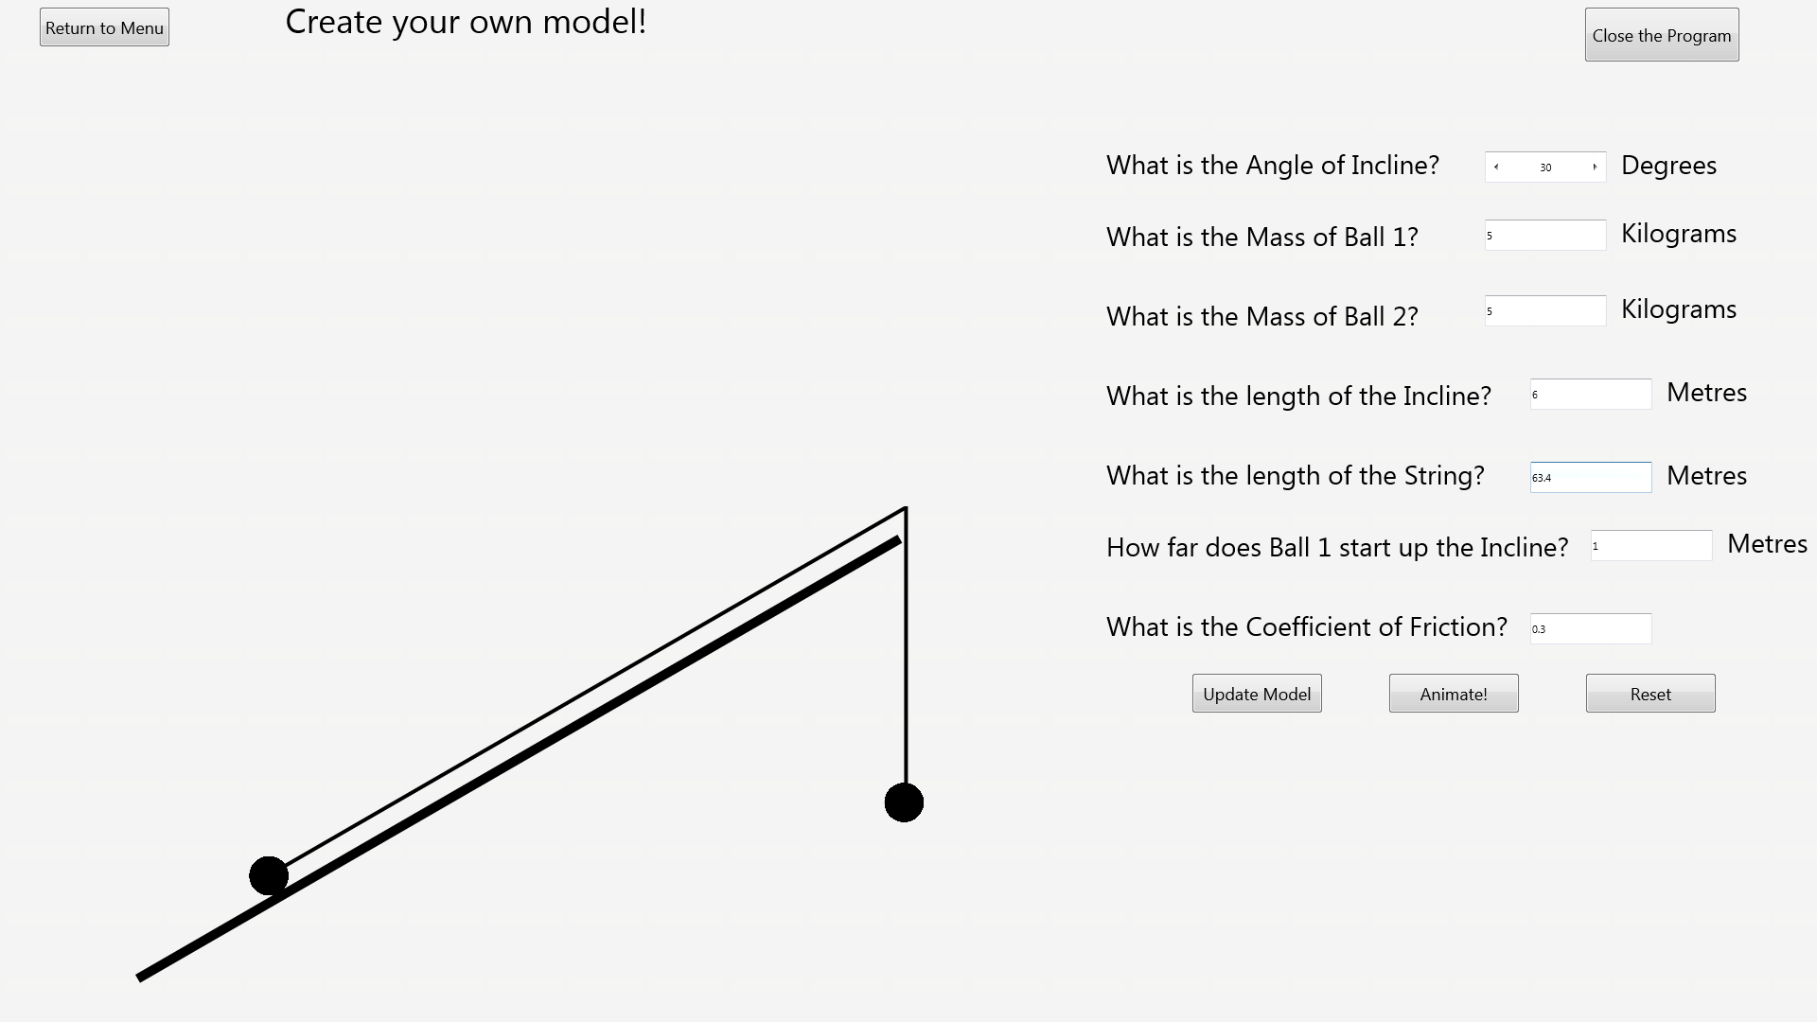After:

### Test 22

Before:

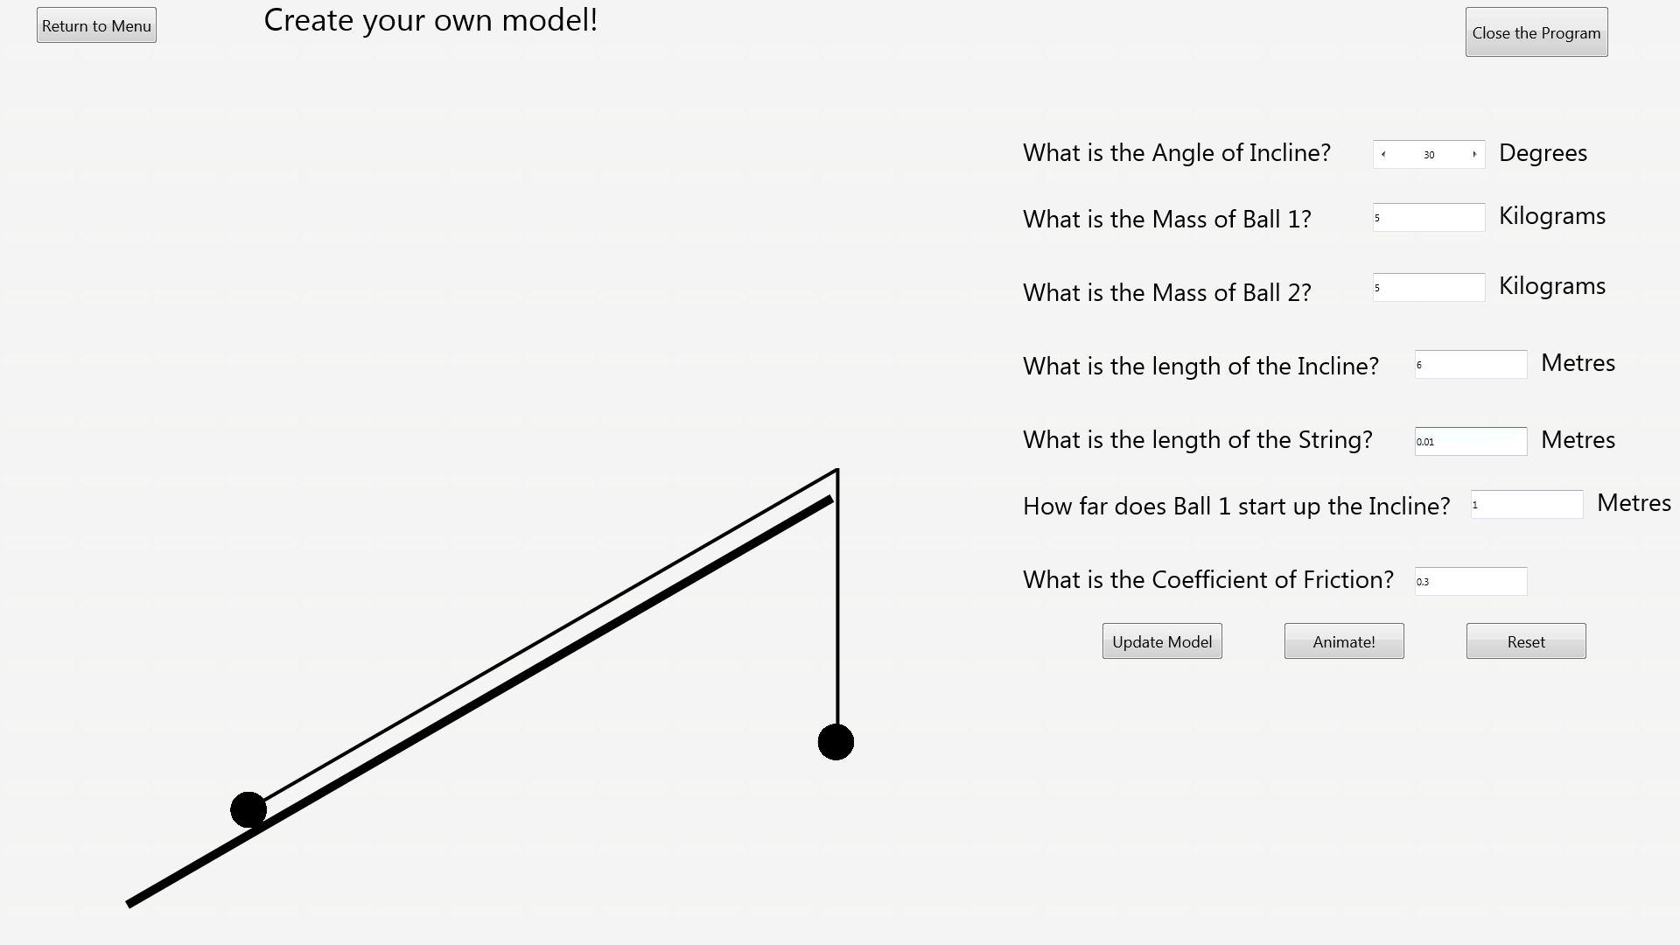After:

### Test 23

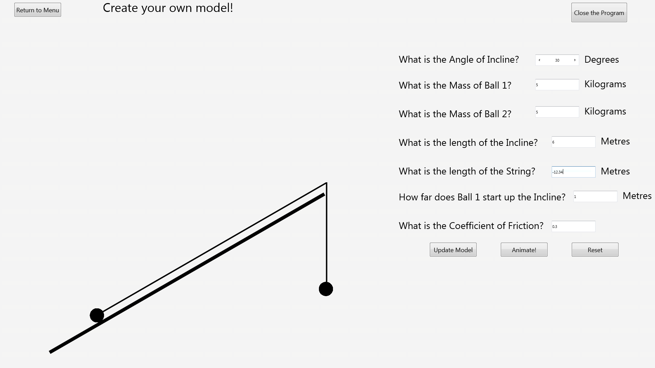Before:

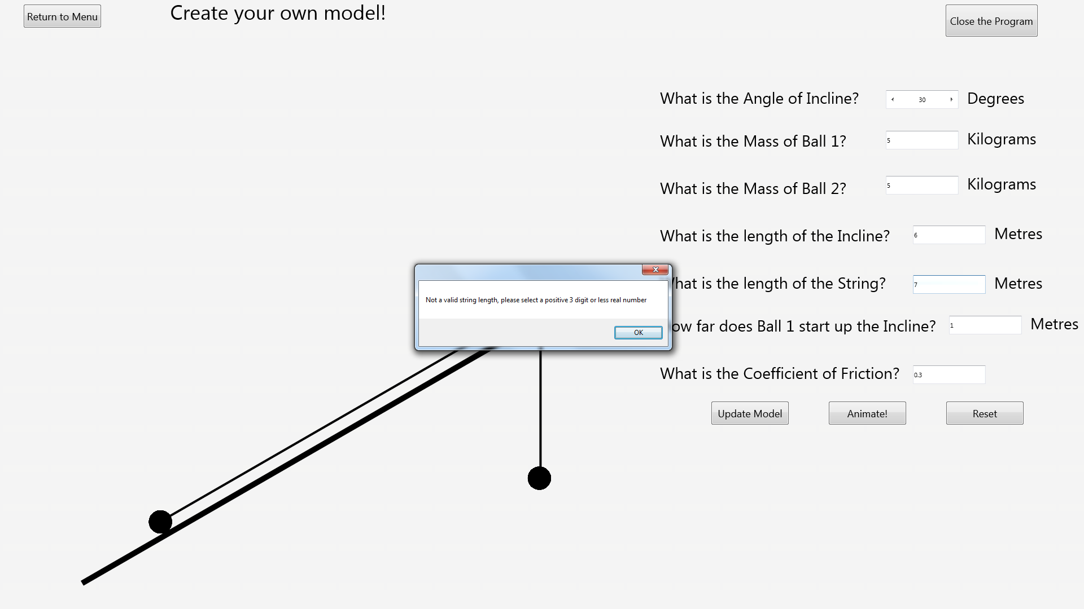After:

### Test 24

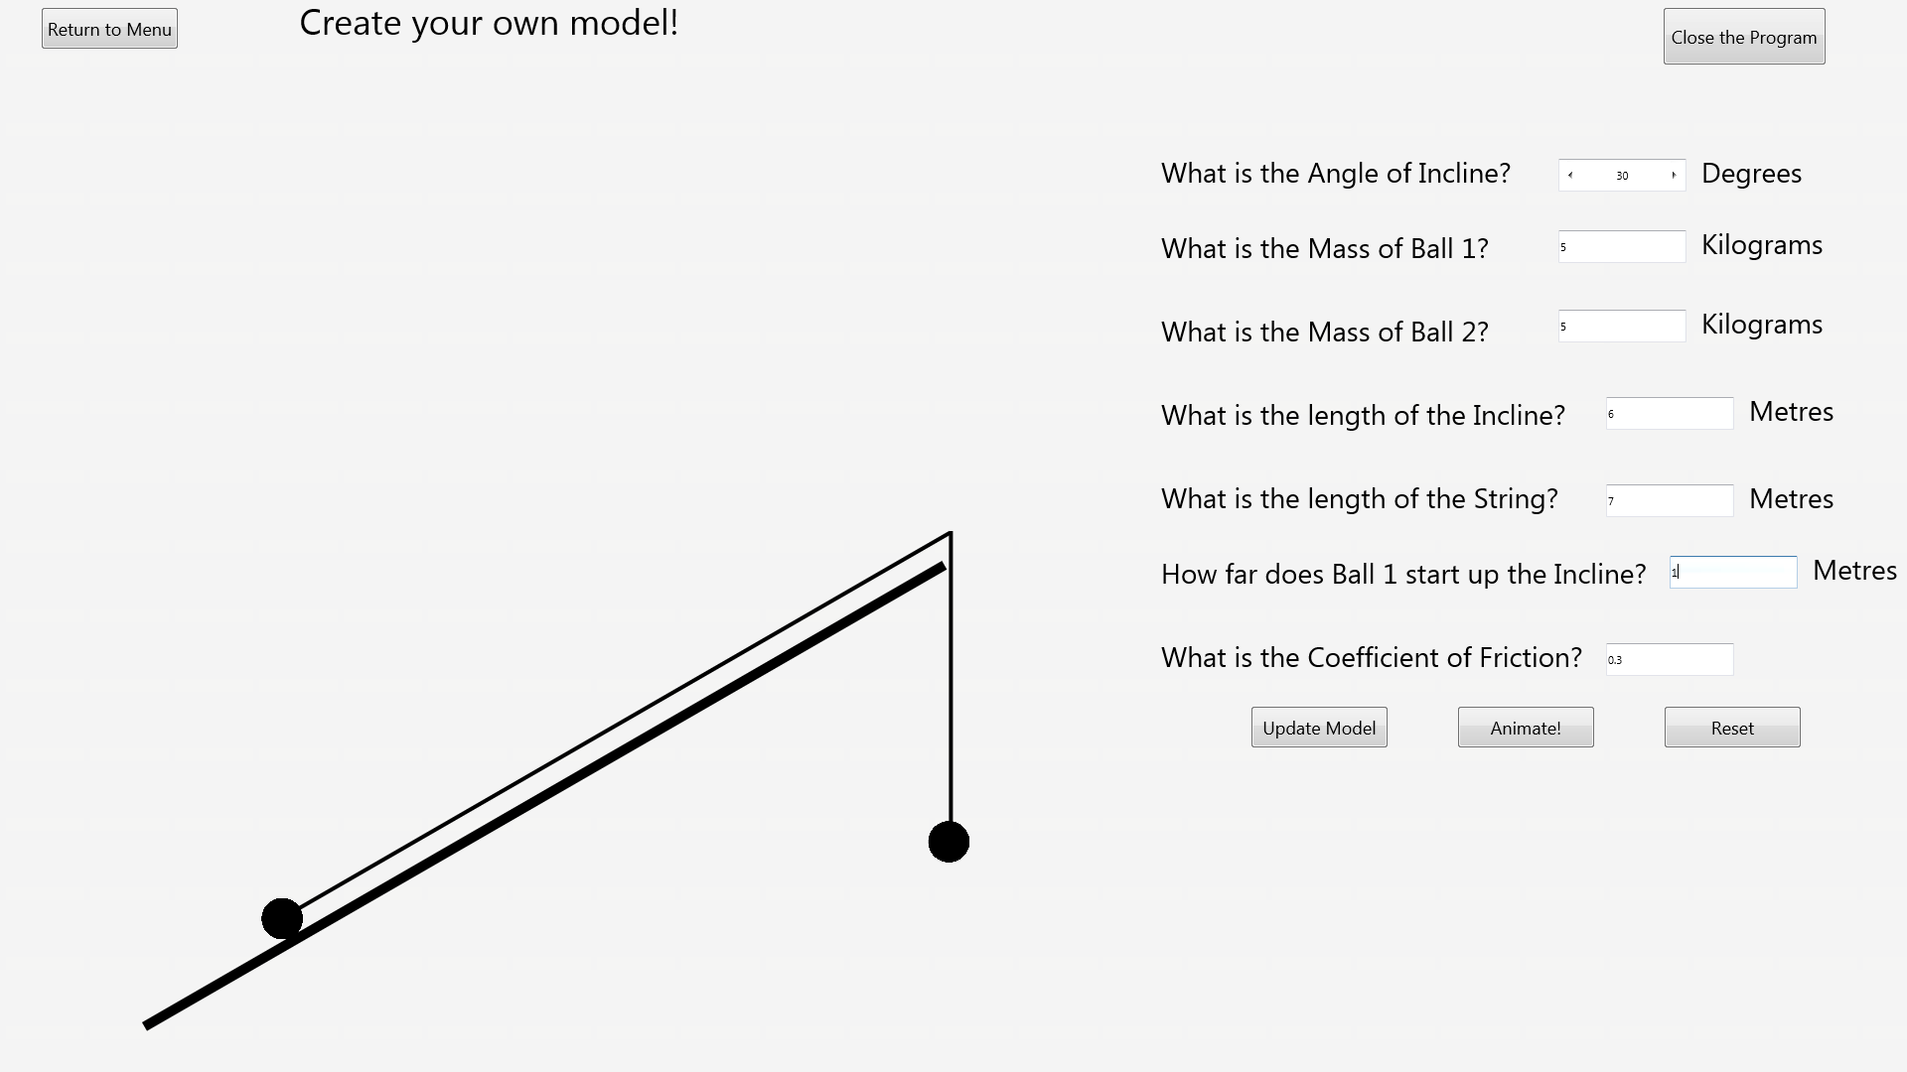Before:

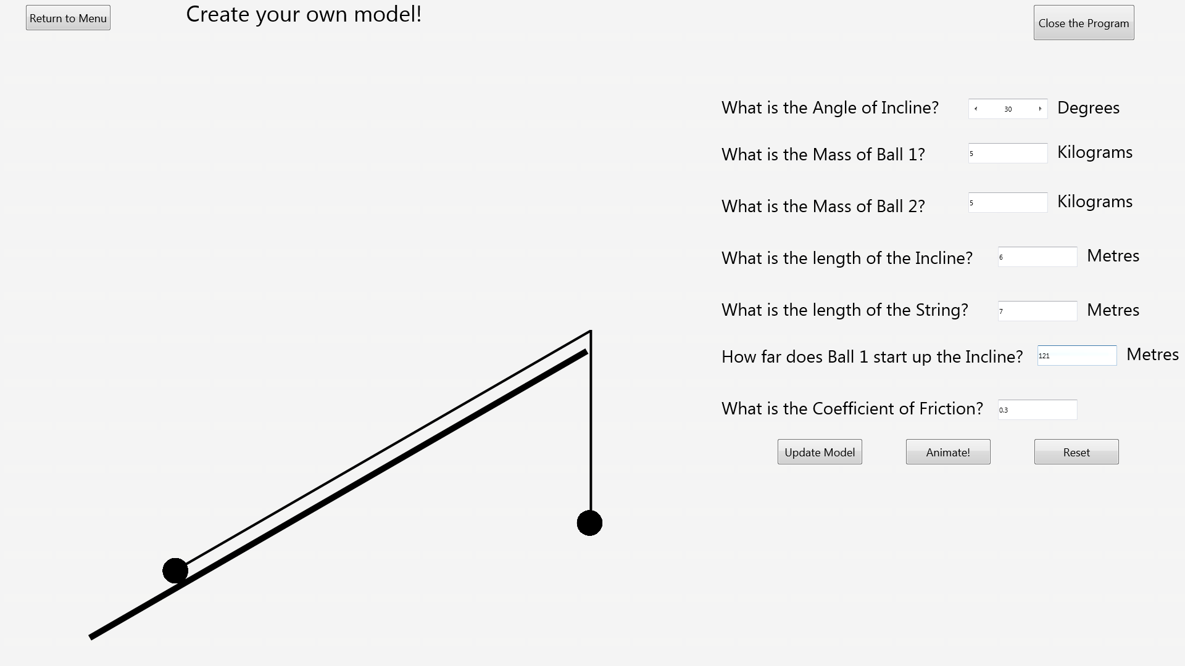After:

### Test 25

Before:

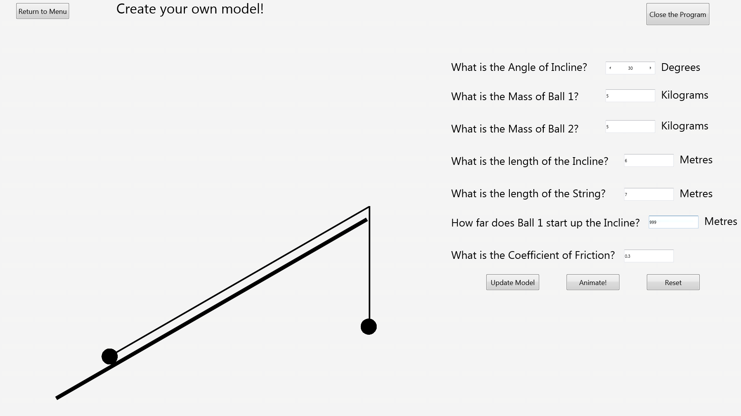After:

### Test 26

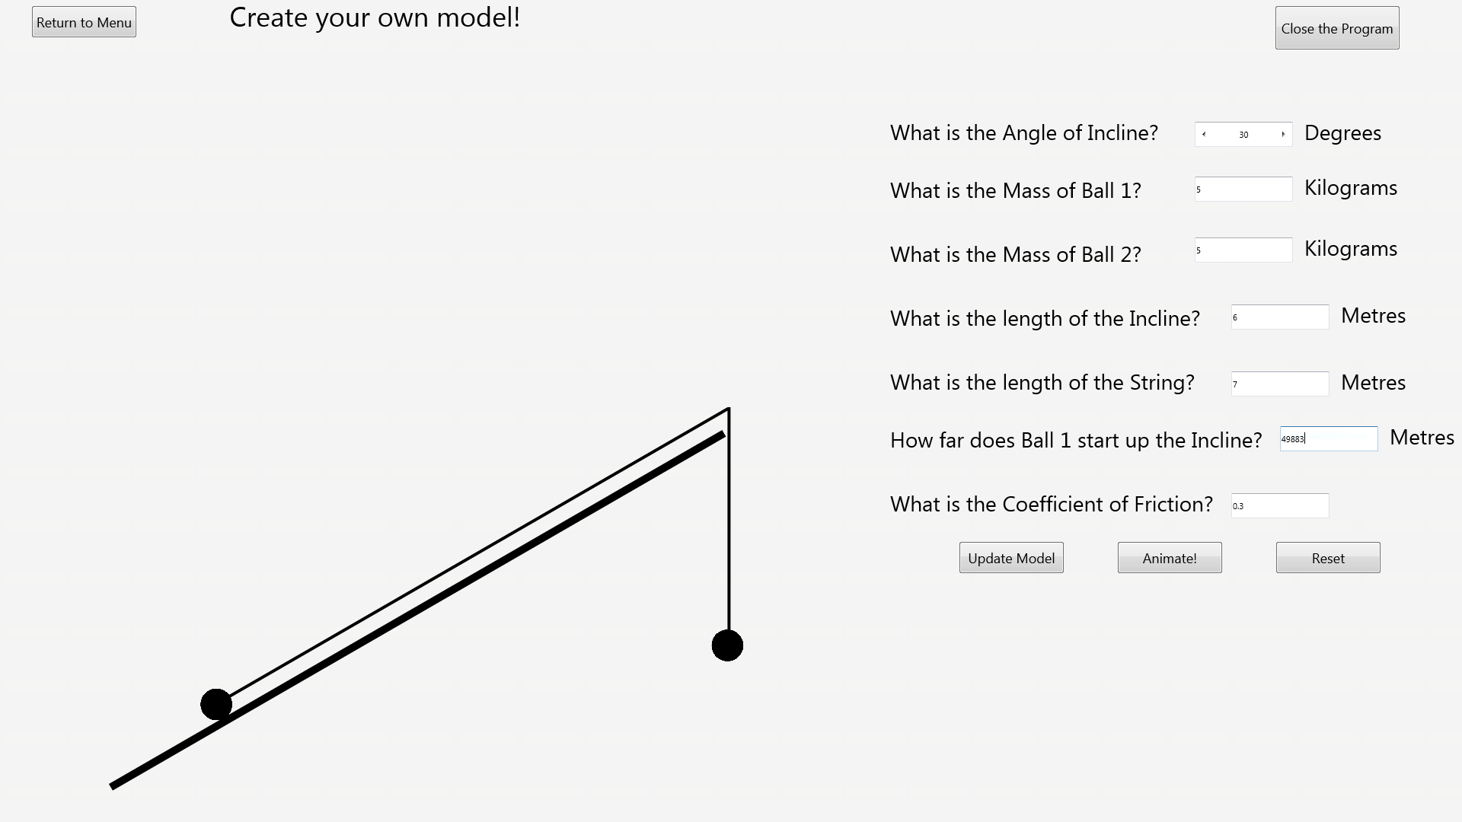Before:

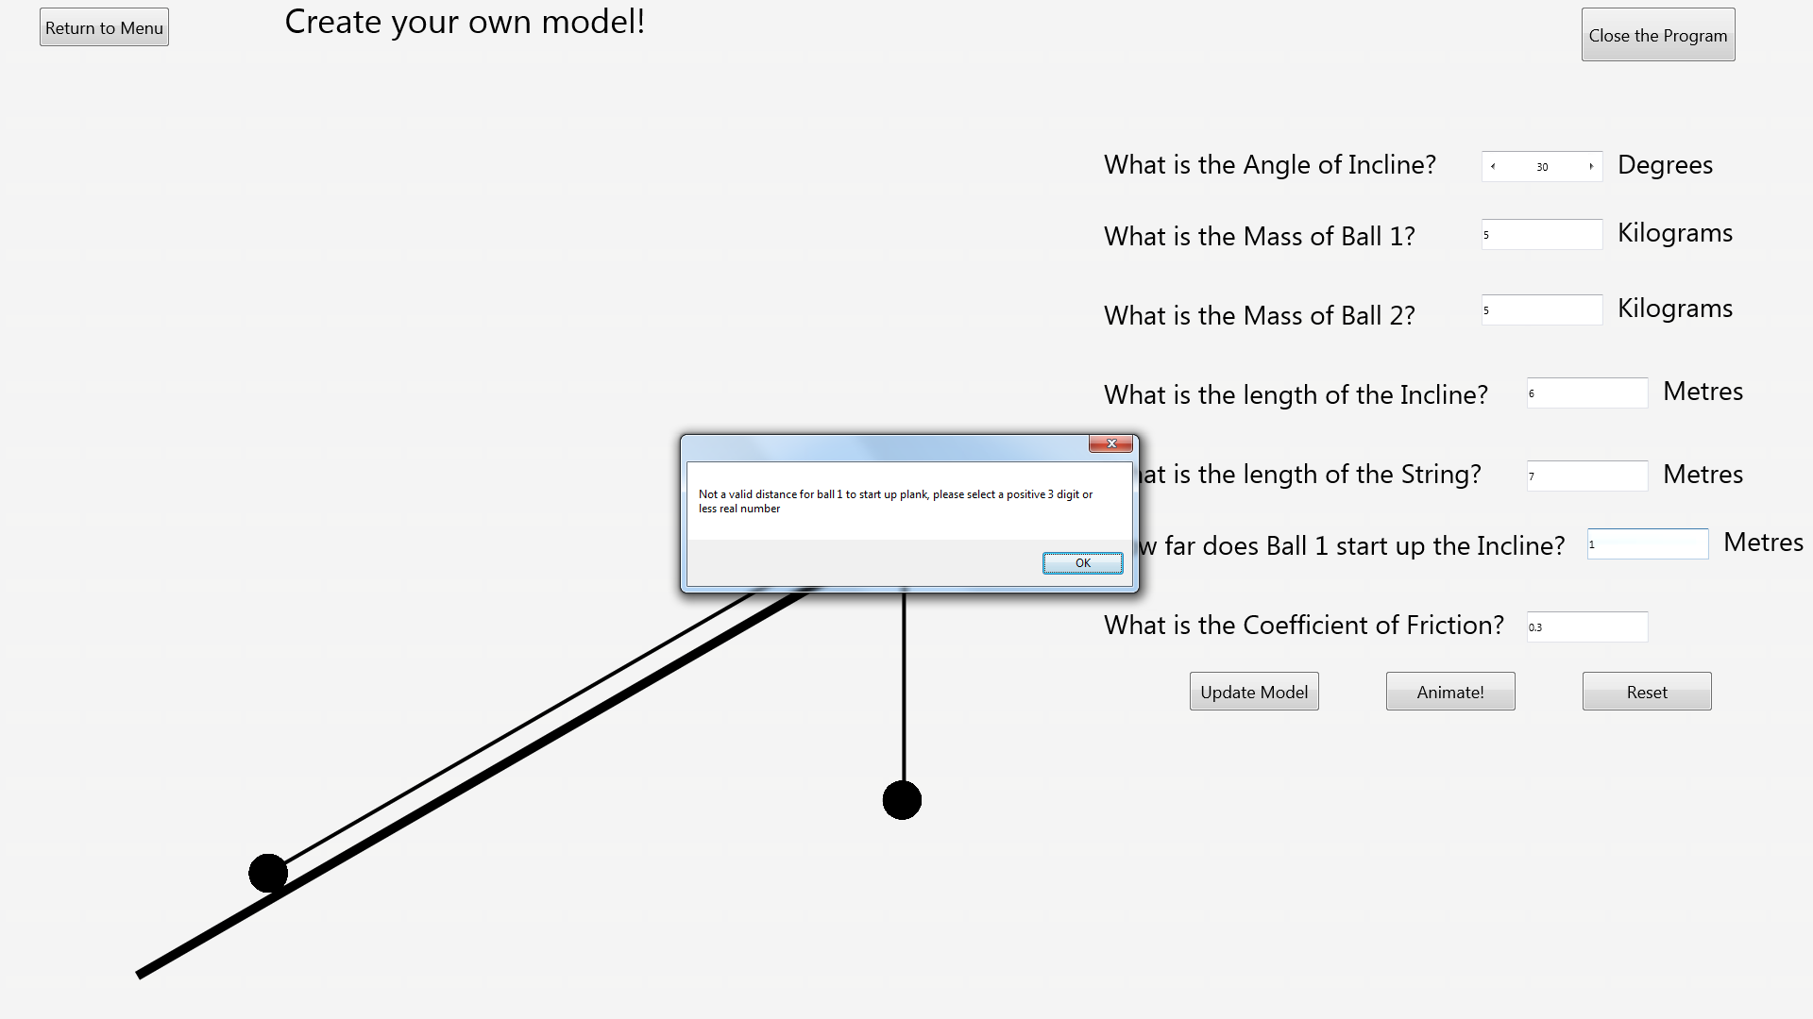After:

### Test 27

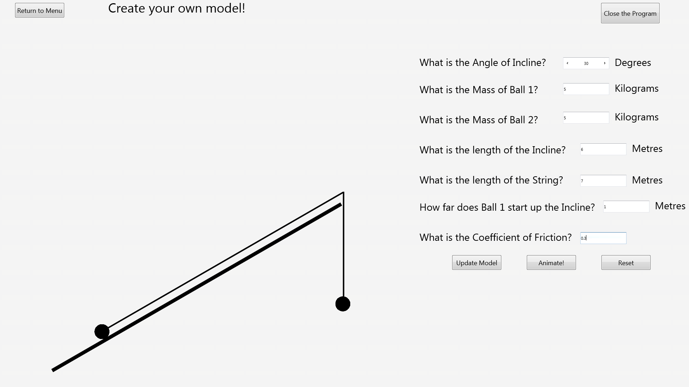Before:

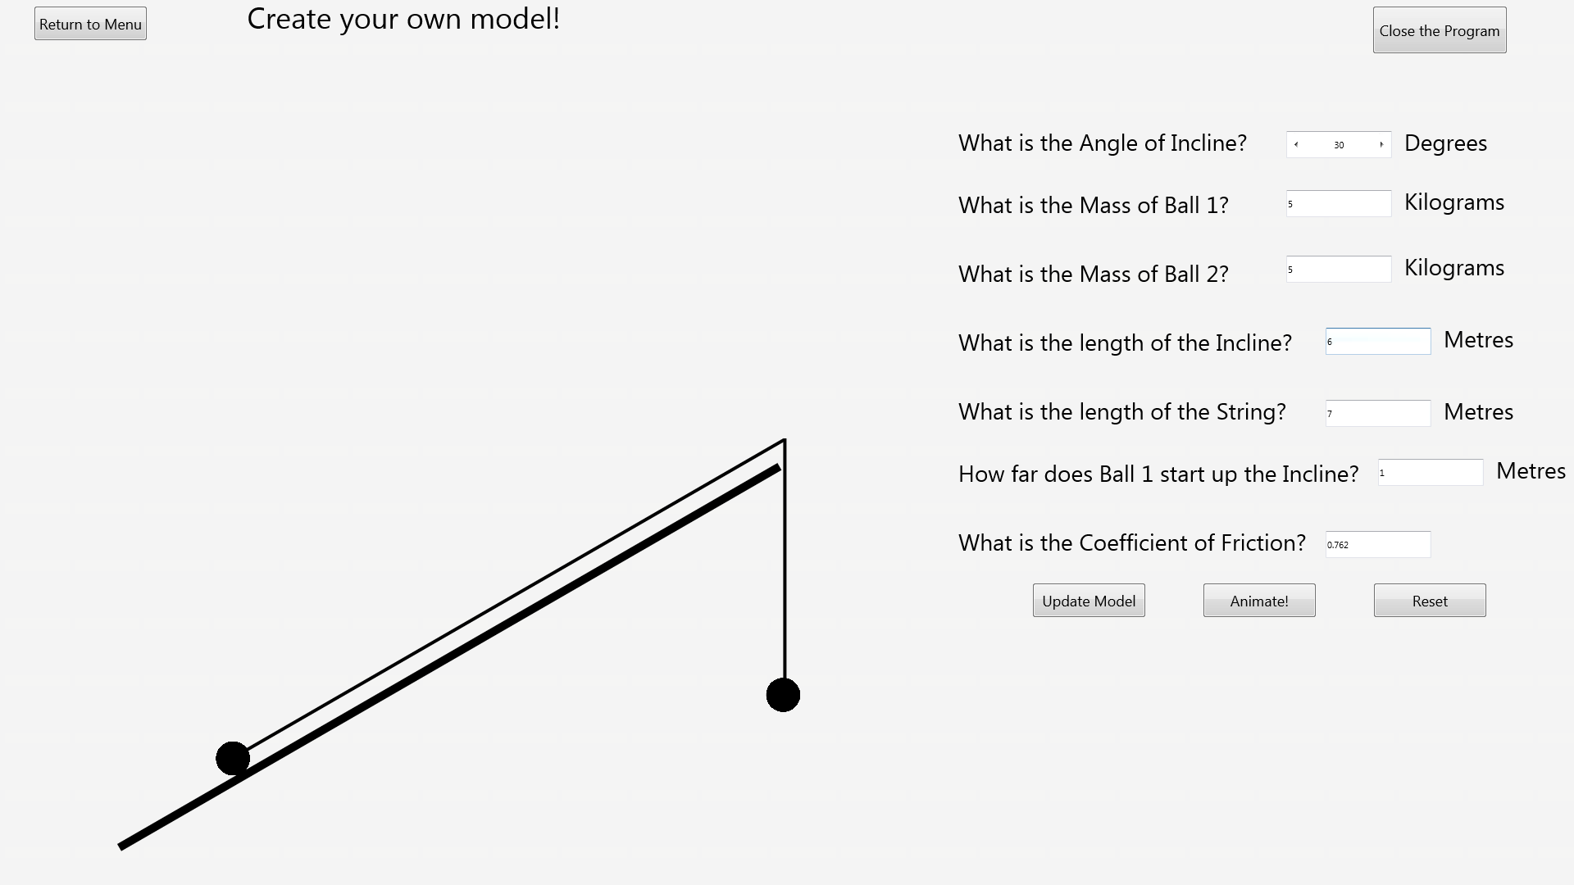After:

### Test 28

Before:

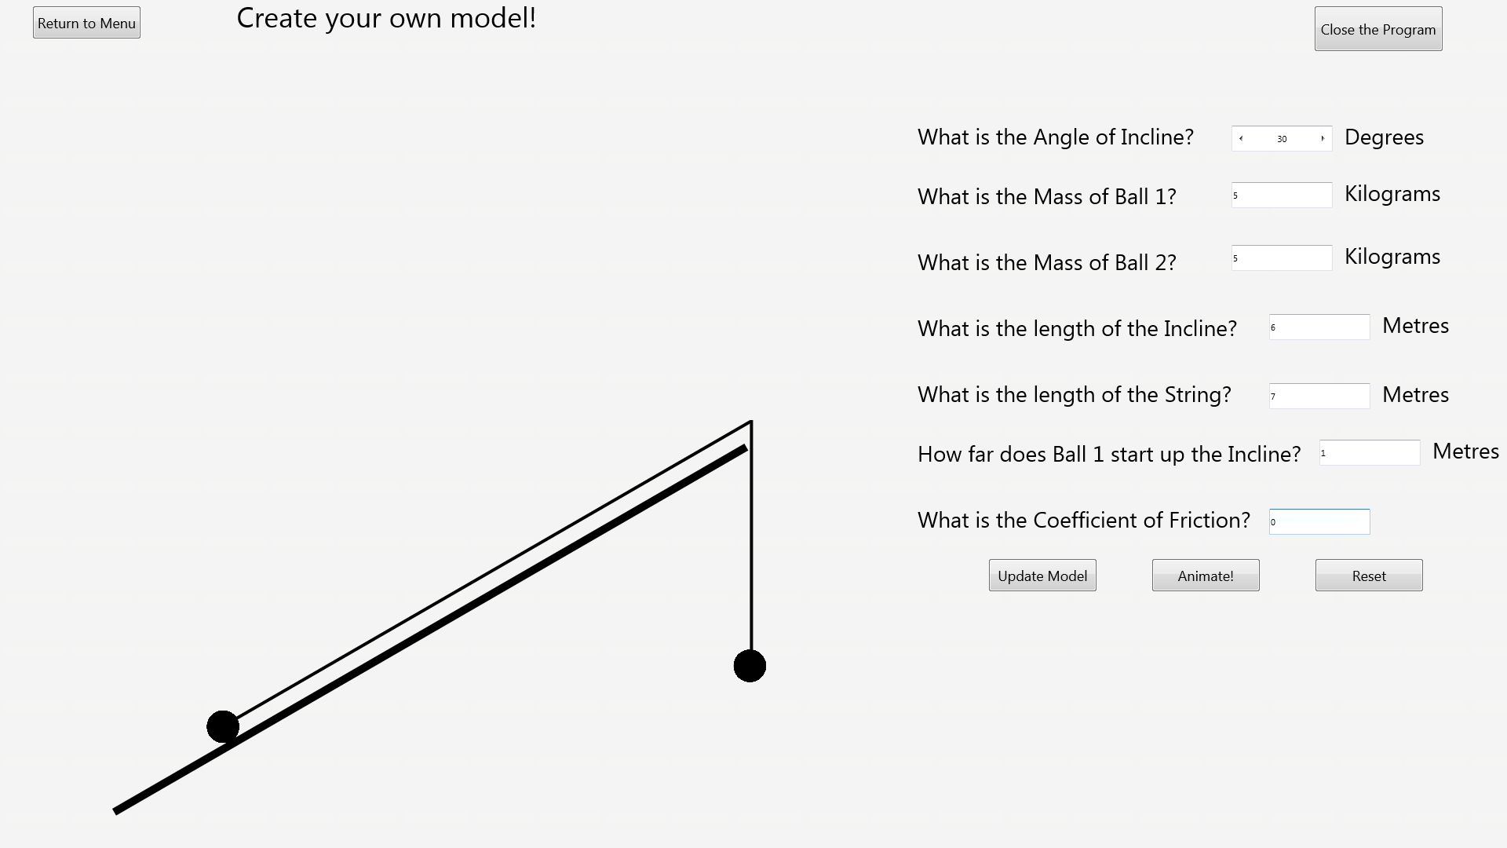After:

### Test 29

Before:

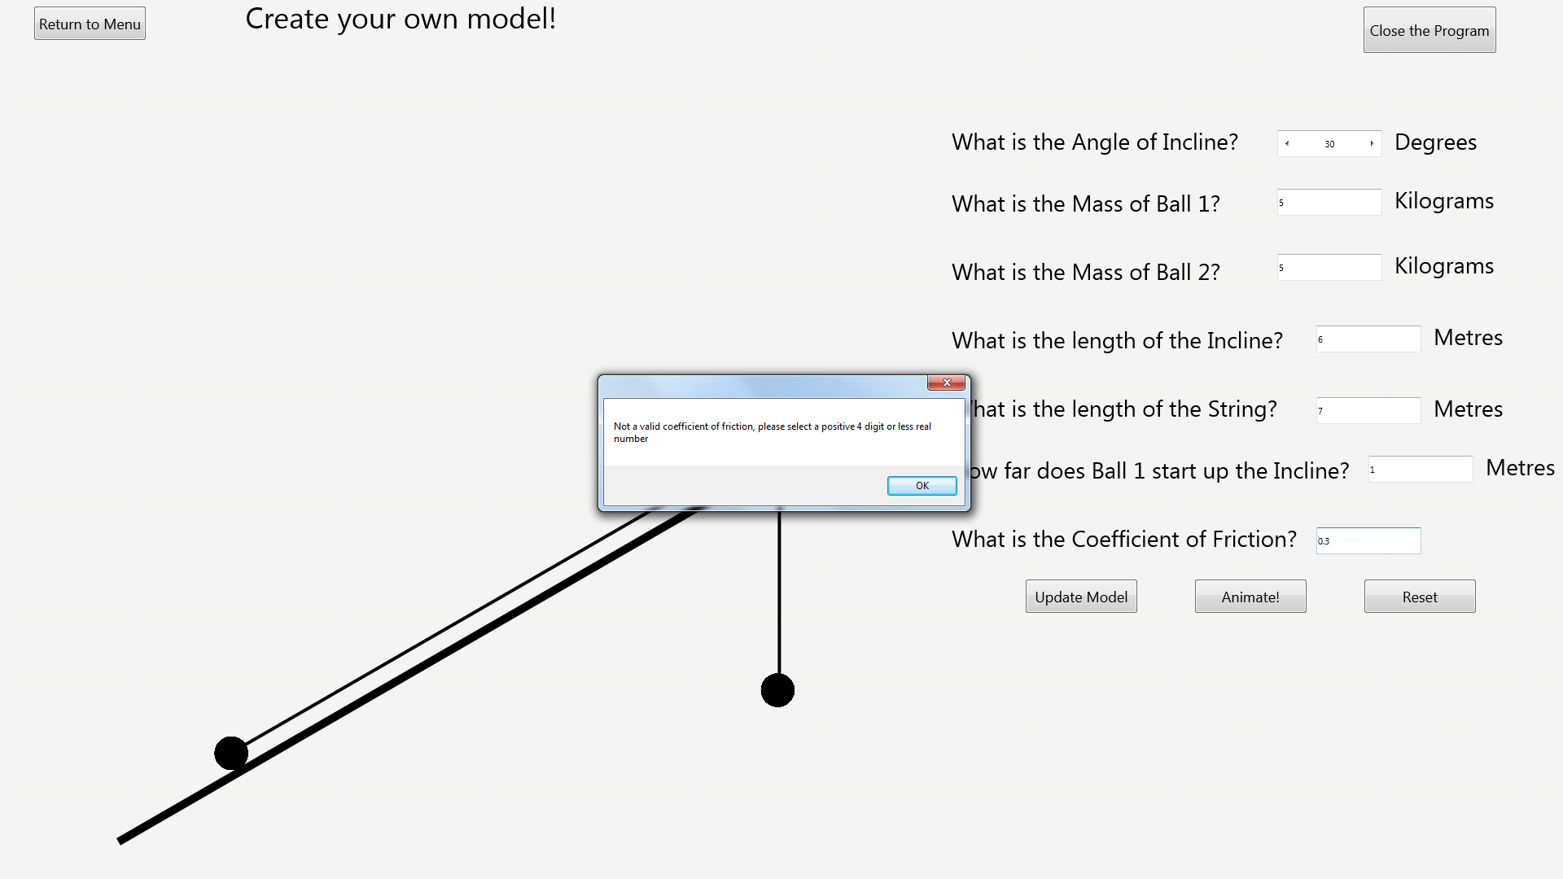After:

### Test 42

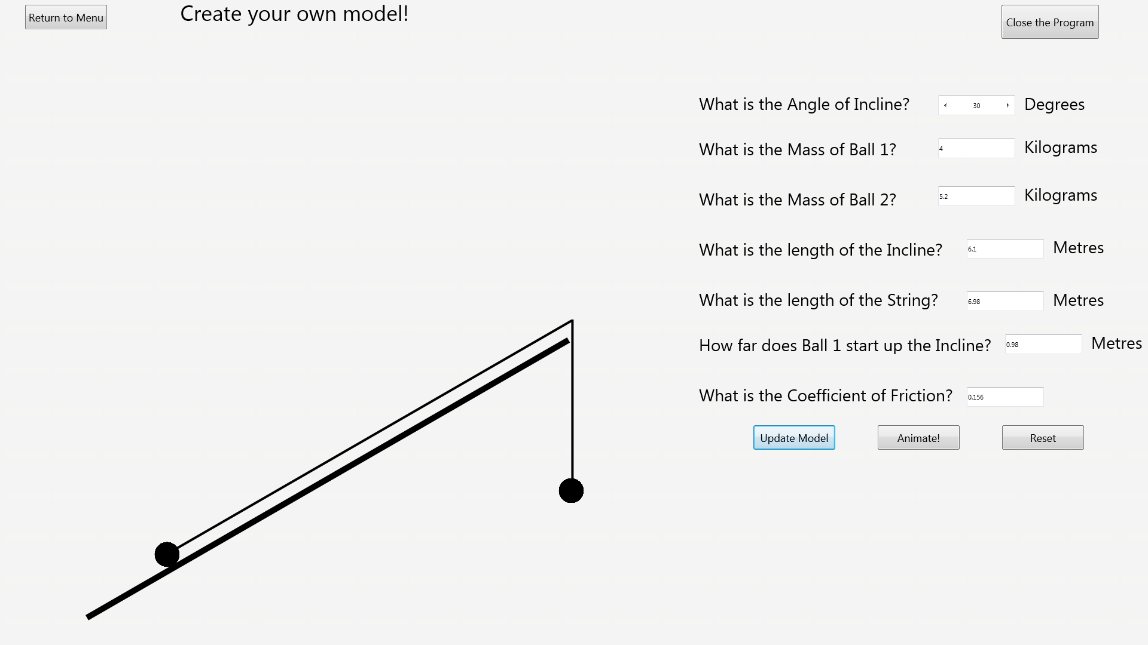Before:

After:

### Test 43

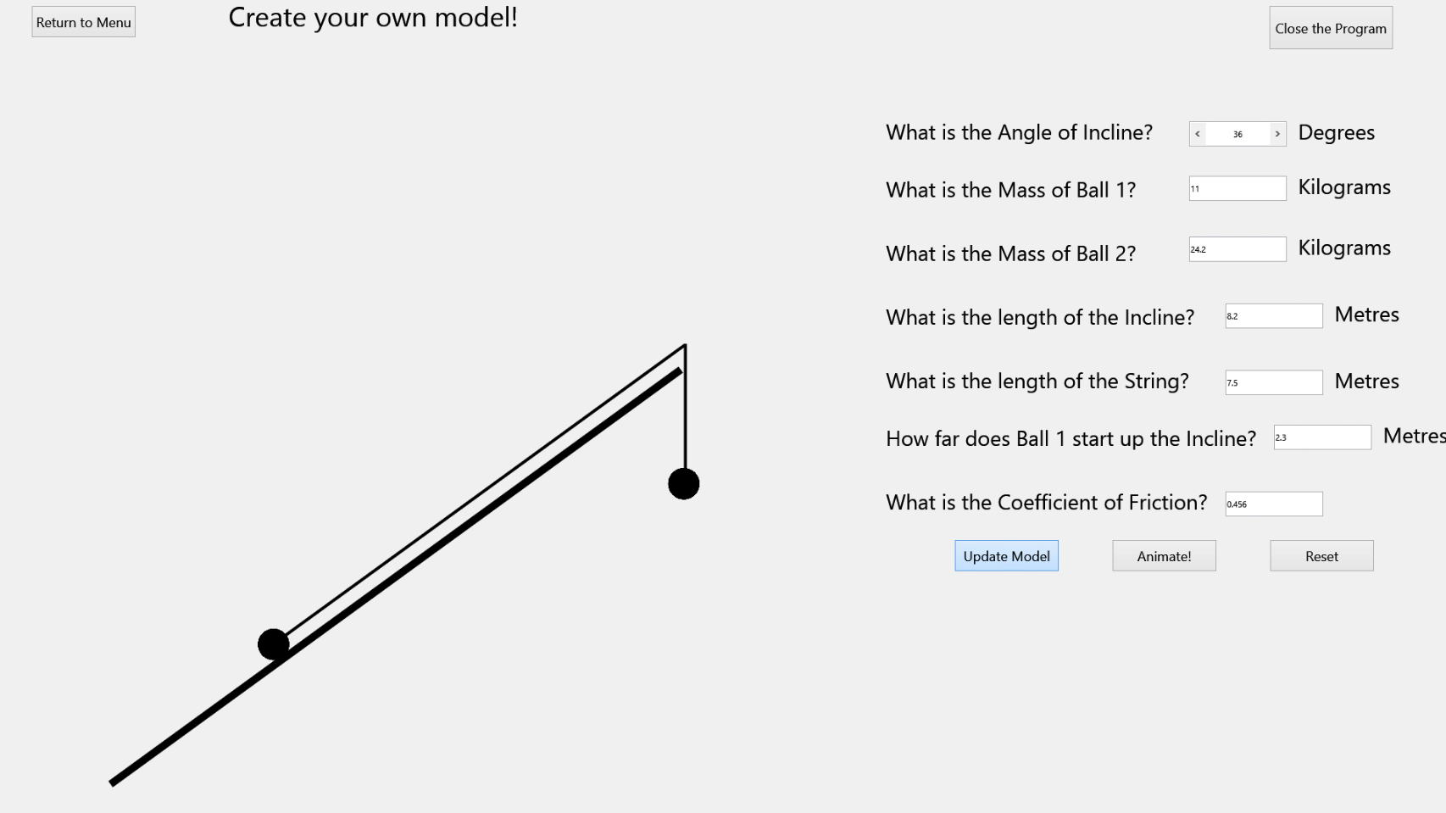Before:

After:

### Test 47

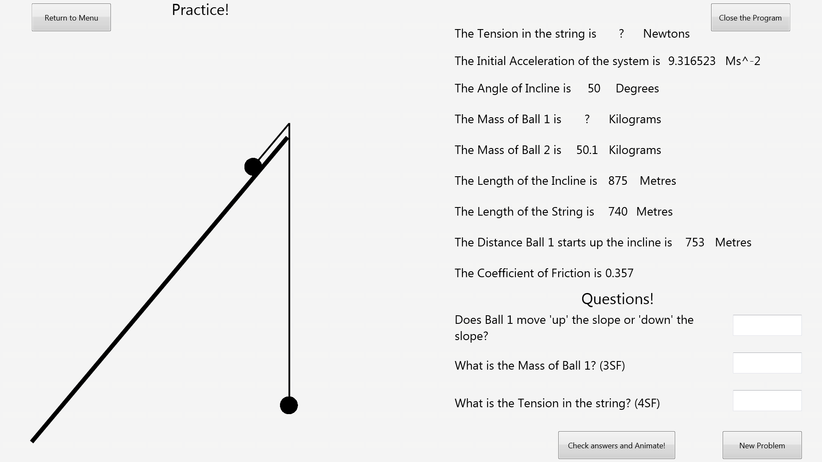Before:

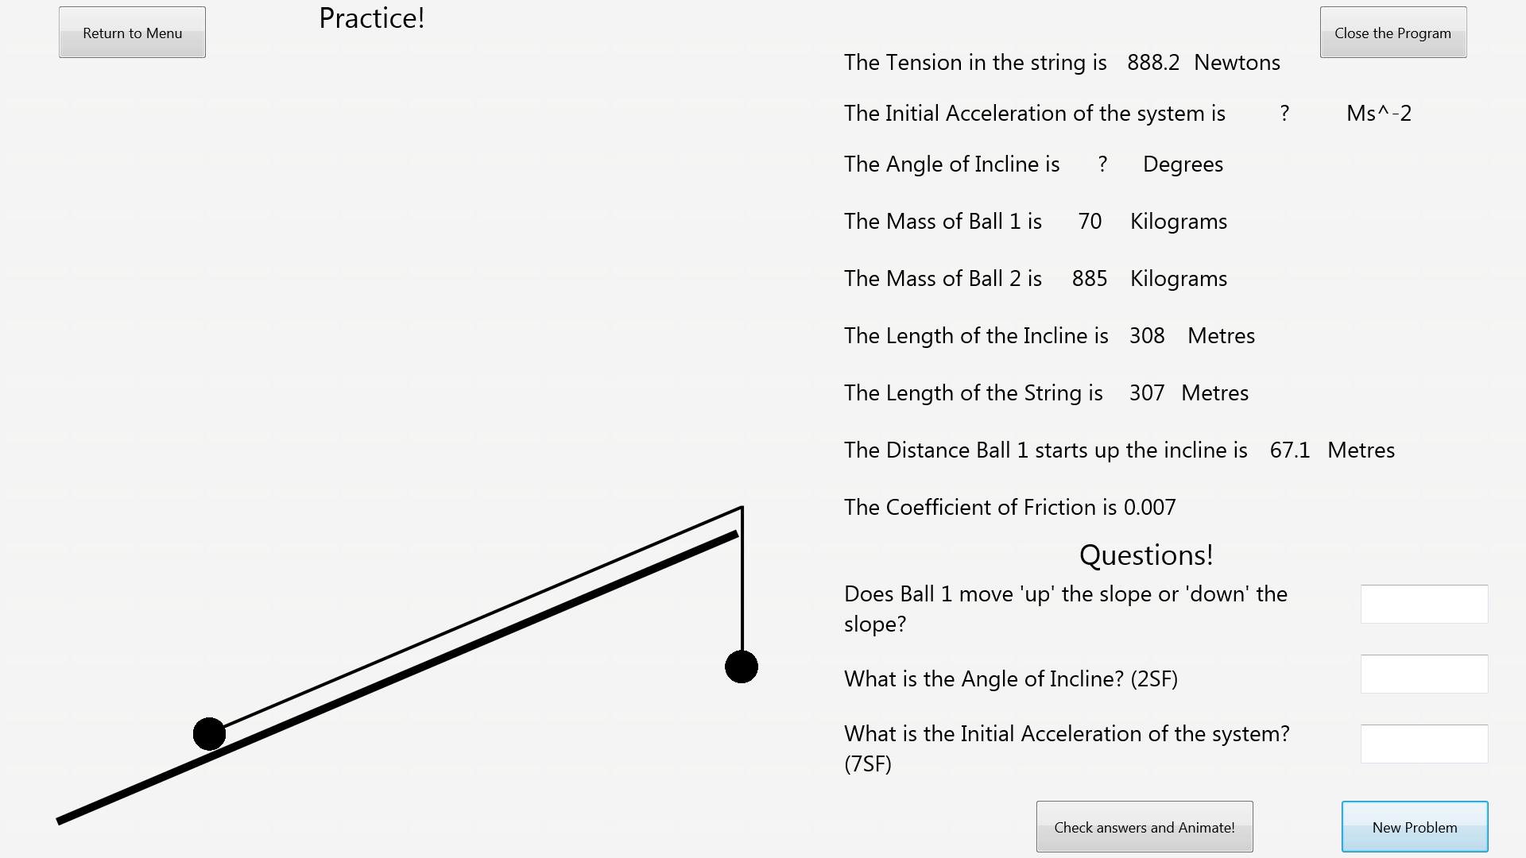After:

# System Maintenance

System Maintenance 102

Introduction 108

Embedded Resource File Explained 108

User Interface 108

Introduction to User Interface 108

Main Menu Form 109

Main Menu Clean 109

Main Menu Annotated 110

Main Menu Table 111

Create your own Model Form 112

Create your own Model Clean 112

Create your own Model Annotated 113

Create your own Model Table 114

Practice Form 115

Practice Clean 115

Practice Annotated 116

Practice Table 117

Description of System Settings 118

Functionality 119

Introduction to Functionality 119

BallUnit/TBall Object Overview 119

Uses 119

Class Declarations 119

Unit Global Variables 119

Constants 119

Explanation of each subroutine’s functionality 120

Constructor TBall.Create(Stream:TStream;Var AOwner) 120

Destructor TBall.Destroy 120

Explanation of modular structure of this Unit’s code and how the code works 120

Creating a Ball on screen: 120

Freeing a ball from memory: 120

MainMenuUnit 121

Uses 121

Class Declarations 121

Unit Global Variables 121

Constants 121

Explanation of each subroutine’s functionality 122

procedure TMainMenuForm.CloseProgramButtonClick(Sender: TObject); 122

procedure TMainMenuForm.GoToOwnModelButtonClick(Sender: TObject); 122

procedure TMainMenuForm.GoToPracticeButtonClick(Sender: TObject); 122

Explanation of modular structure of this Unit’s code and how the code works (With references to Design and Testing) 122

Closing the program 122

Moving to the OwnModelForm 122

Moving to the PracticeForm 122

OwnModelUnit 123

Uses 123

Class Declarations 123

Unit Global Variables 125

Constants 125

Explanation of each subroutine’s functionality 126

function ConvertMetresToPixels(Input : real) : real; 126

function CalculateHeightofPlankToUseInPixels : real; 126

function CalculateSignificantFigures(Input:String) : integer; 126

function RoundInputasString(Input:String;EndLength:Integer) : string; 126

function MakeXDigits(Input:real;X:Integer) : real; 126

function CalculateIfValidXDigitPositiveReal(Input:String; X:integer) : boolean; 126

function CalculateTopOfSlopeY (HeightOfPlankPixels : real) : real; 126

function CalculateTopOfSlopeX (HeightOfPlankPixels : real) : real; 126

procedure TOwnModelForm.AnimateBallsToCorrectPositions; 126

procedure TOwnModelForm.AnimateModelButtonClick(Sender: TObject); 126

procedure TOwnModelForm.AnimatePlankAngle; 126

procedure TOwnModelForm.AnimatePlankStringAngleAndPosition(TopOfSlopeY,TopOfSlopeX : real); 126

procedure TOwnModelForm.AnimateVerticalStringPosition(TopOfSlopeY,TopOfSlopeX: Real); 126

procedure TOwnModelForm.AnimateStringToCorrectHeight; 126

procedure TOwnModelForm.UpdateModel; 126

procedure TOwnModelForm.UpdateModelButtonClick(Sender: TObject); 127

procedure TOwnModelForm.AngleOfPlankSelectorChange(Sender: TObject); 127

procedure TOwnModelForm.CoefficientOfFrictionSelectorChange(Sender: TObject); 127

procedure TOwnModelForm.ResetButtonClick(Sender: TObject); 127

procedure TOwnModelForm.ResetToDefaultValues; 127

procedure TOwnModelForm.ReturnToMenuButtonClick(Sender: TObject); 127

procedure TOwnModelForm.CheckChosenValues; 127

procedure TOwnModelForm.CloseProgramButtonClick(Sender: TObject); 127

procedure TOwnModelForm.FormCreate(Sender: TObject); 127

procedure TOwnModelForm.FormKeyUp(Sender: TObject; var Key: Word; var KeyChar: Char; Shift: TShiftState); 127

procedure TOwnModelForm.FormShow(Sender: TObject); 127

procedure TOwnModelForm.HowFarBall1UpPlankSelectorChange(Sender: TObject); 127

procedure TOwnModelForm.LengthOfPlankSelectorChange(Sender: TObject); 127

procedure TOwnModelForm.LengthOfStringSelectorChange(Sender: TObject); 127

procedure TOwnModelForm.MassOfBall1SelectorChange(Sender: TObject); 127

procedure TOwnModelForm.MassOfBall2SelectorChange(Sender: TObject); 128

Explanation of modular structure of this Unit’s code and how the code works (With references to Design and Testing) 128

Initializing variables and objects when the form is created (at program start up) 128

Initializing model to default arrangement when the form is shown 128

Changing the Plank Angle 129

Changing the Mass of Ball 1 130

Changing the Mass of Ball 2 130

Changing the Plank Length 131

Changing the String Length 131

Changing the distance Ball 1 starts up the Plank 132

Changing the Coefficient Of Friction 132

Updating the model to a user defined configuration (Note Design for Update Model Algorithm is found in Design document) 133

Animating the model based on its current configuration (Annotated. Note Design for Animation Algorithm is found in Design document) 134

Resetting the Model 141

Closing the Program 142

Returning to the Main Menu 142

Referenced subroutines 143

ConvertMetresToPixels 143

CalculateHeightofPlankToUseInPixels 143

CalculateSignificantFigures 143

RoundInputasString 143

MakeXDigits 144

CalculateIfValidXDigitPositiveReal 145

CalculateTopOfSlopeY 145

CalculateTopOfSlopeX 146

AnimateBallsToCorrectPositions 146

AnimatePlankAngle 146

AnimatePlankStringAngleAndPosition 146

AnimateVerticalStringPosition 147

AnimateStringToCorrectHeight 147

UpdateModel 147

ResetToDefaultValues 147

CheckChosenValues 148

PracticeUnit 150

Uses 150

Class Declarations 150

Unit Global Variables 152

Constants 153

Explanation of each subroutine’s functionality 153

function ConvertMetresToPixels(Input : real) : real; 153

function CalculateHeightofPlankToUseInPixels : real; 153

function CalculateSignificantFigures(Input:String) : integer; 153

function Random3DigitReal : real; 153

function RoundInputasString(Input:String;EndLength:Integer) : string; 153

function MakeXDigits(Input:real;X:Integer) : real; 153

function CalculateTension:real; 153

procedure CreateRandomValues; 153

function CalculateTopOfSlopeY (HeightOfPlankPixels : real) : real; 153

function CalculateTopOfSlopeX (HeightOfPlankPixels : real) : real; 153

function SensibleM1Problem : boolean; 153

procedure TPracticeForm.ChangeBallsToCorrectPositions; 153

procedure TPracticeForm.ChangePlankAngle; 154

procedure TPracticeForm.ChangePlankStringAngleAndPosition(TopOfSlopeY,TopOfSlopeX : real); 154

procedure TPracticeForm.ChangeVerticalStringPosition(TopOfSlopeY,TopOfSlopeX: Real); 154

procedure TPracticeForm.CheckAndAnimateButtonClick(Sender: TObject); 154

procedure TPracticeForm.CloseProgramButtonClick(Sender: TObject); 154

procedure TPracticeForm.ChangeStringToCorrectHeight; 154

procedure TPracticeForm.UpdateModel; 154

procedure ResetValuestoZero; 154

procedure TPracticeForm.CreateProblem; 154

procedure TOwnModelForm.FormCreate(Sender: TObject); 154

procedure TOwnModelForm.FormShow(Sender: TObject); 154

procedure TPracticeForm.NewProblemButtonClick(Sender: TObject); 154

procedure TPracticeForm.ReturnToMenuButtonClick(Sender: TObject); 154

Explanation of modular structure of this Unit’s code and how the code works (With references to Design and Testing) 155

Initializing variables, objects and randomize table when the form is created (at program start up) 155

Initializing model to a random arrangement when the form is shown 155

Returning to the Main Menu 155

Closing the Program 156

Checking answers to questions and animating the model 156

Generating and displaying a new problem (Note Design for Create Random Problem Algorithm is found in Design document) 163

Referenced Subroutines 164

ConvertMetresToPixels 164

CalculateHeightofPlankToUseInPixels 164

CalculateSignificantFigures 164

Random3DigitReal 164

RoundInputasString 165

MakeXDigits 166

CalculateTension 167

CreateRandomValues 167

CalculateTopOfSlopeY 168

CalculateTopOfSlopeX 168

SensibleM1Problem 168

ChangeBallsToCorrectPositions 170

ChangePlankAngle 170

ChangePlankStringAngleAndPosition 170

ChangeVerticalStringPosition 171

ChangeStringToCorrectHeight 171

UpdateModel 171

ResetValuestoZero 171

CreateProblem 172

Code Appendix 175

BallUnit 175

MainMenuUnit 177

OwnModelUnit 179

PracticeUnit 200

## Introduction

Throughout this guide, if you would like to reference the raw code, see the Code Appendix at the end of the guide.

This guide will covers how the Interactive ‘Pulley Systems on an Incline’ program has been created so that it can be maintained. Any maintenance should be done using the program source code file within a Delphi-Firemonkey compiler. An understanding of the Edexcel M1 Mathematics syllabus and Delphi-Firemonkey is recommended. More information on how the functionality is presented to the user not found in this guide can be found in the User Manual.

The programming language used was Delphi-Firemonkey. This choice was made because the language allows different traversable forms to be created with ease while also being event-driven. It also allows for a compiled executable to be created with an embedded resource file.

The program is split into two main parts. In the first part (Part A or ‘Create your own Model’), the user is able to create their own M1 ‘pulley systems on an incline’ model, while the second part questions the user on a randomly generated model (Part B or ‘Practice’).

To this end, the program is split into 3 forms. One as a main menu, one for Part A, and one for Part B. These Forms are called MainMenuForm, OwnModelForm and PracticeForm within the code, but they are generally referred to as Main Menu Form, Create your own Model Form and Practice Form.

The program uses 4 units. One for each of the three forms, and one for an object (TBall) which can be called by any of the other units. These Units are called MainMenuUnit, OwnModelUnit, PracticeUnit and BallUnit.

## Embedded Resource File Explained

Delphi-Firemonkey allows for a resource file to be embedded within the compiled application. In this program, two files are stored within this resource file. Firstly, ‘BallImage’. This is an image file used to display the balls used in the problems on screen. Secondly, ‘Questions’. This is a text file storing all the potential questions to be used in the application.

## User Interface

### Introduction to User Interface

Over the next few pages are two screenshots and a table for each of the three forms during program execution. One screenshot is ‘clean’, and as the user would see. The other has all elements of the form labelled with their coded names. The table defines each element based on what class it is.

Note: In M1 ‘Plank’ and ‘Incline’ are interchangeable

### Main Menu Form

#### Main Menu Clean



#### Main Menu Annotated



GotoOwnModelButton

GoToPracticeButton

CloseProgramButton

WelcomeMessage

#### Main Menu Table

|  |  |
| --- | --- |
| **Element** | **Type** |
| WelcomeMessage | TLabel |
| GoToOwnModelButton | TButton |
| GoToPracticeButton | TButton |
| CloseProgramButton | TButton |

### Create your own Model Form

#### Create your own Model Clean

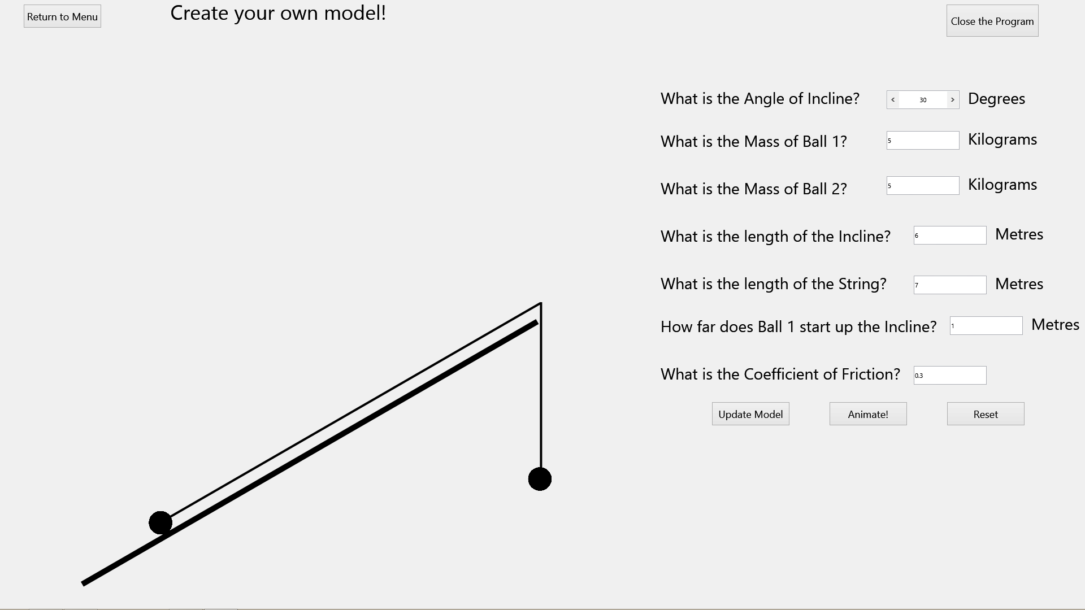

#### Create your own Model Annotated

CloseProgramButton

OwnModelFormWelcomeMessage



RequestForCoefficientOfFriction

RequestDistanceBall1StartsUpPlank

RequestForLengthOfString

RequestForLengthOfPlank

RequestMassOfBall2

RequestMassOfBall1

RequestForPlankAngle

AngleOfPlankSelector

MassOfBall2Selector

MassOfBall1Selector

LengthOfPlankSelector

Selector

Selector

LengthOfStringSelector

Selector

HowFarBall1UpPlankSelector

CoefficientOfFrictionSelector

HowFarBall1UpPlankMetres

StringLengthMetres

PlankLengthMetres

Ball2Kilograms

Ball1Kilograms

AngleDegrees

VerticalString

PlankString

Plank

Ball2

Ball1

ResetButton

AnimateModelButton

UpdateModelButton

ReturnToMenuButton

#### Create your own Model Table

|  |  |
| --- | --- |
| **Element** | **Type** |
| OwnModelFormWelcomeMessage | TLabel |
| ReturnToMenuButton | TButton |
| Ball1 | TBall (Programmer Defined) |
| Ball2 | TBall (Programmer Defined) |
| Plank | TLine |
| PlankString | TLine |
| VerticalString | TLine |
| RequestForPlankAngle | TLabel |
| RequestMassOfBall1 | TLabel |
| RequestMassOfBall2 | TLabel |
| RequestForLengthOfPlank | TLabel |
| RequestForLengthOfString | TLabel |
| RequestDistanceBall1StartsUpPlank | TLabel |
| RequestForCoefficientOfFriction | TLabel |
| CloseProgramButton | TButton |
| AngleOfPlankSelector | TSpinBox |
| MassOfBall1Selector | TEdit |
| MassOfBall2Selector | TEdit |
| LengthOfPlankSelector | TEdit |
| LengthOfStringSelector | TEdit |
| HowFarBall1UpPlankSelector | TEdit |
| CoefficientOfFrictionSelector | TEdit |
| UpdateModelButton | TButton |
| AnimateModelButton | TButton |
| ResetButton | TButton |
| AngleDegrees | TLabel |
| Ball1Kilograms | TLabel |
| Ball2Kilograms | TLabel |
| PlankLengthMetres | TLabel |
| StringLengthMetres | TLabel |
| HowFarBall1UpPlankMetres | TLabel |

### Practice Form

#### Practice Clean

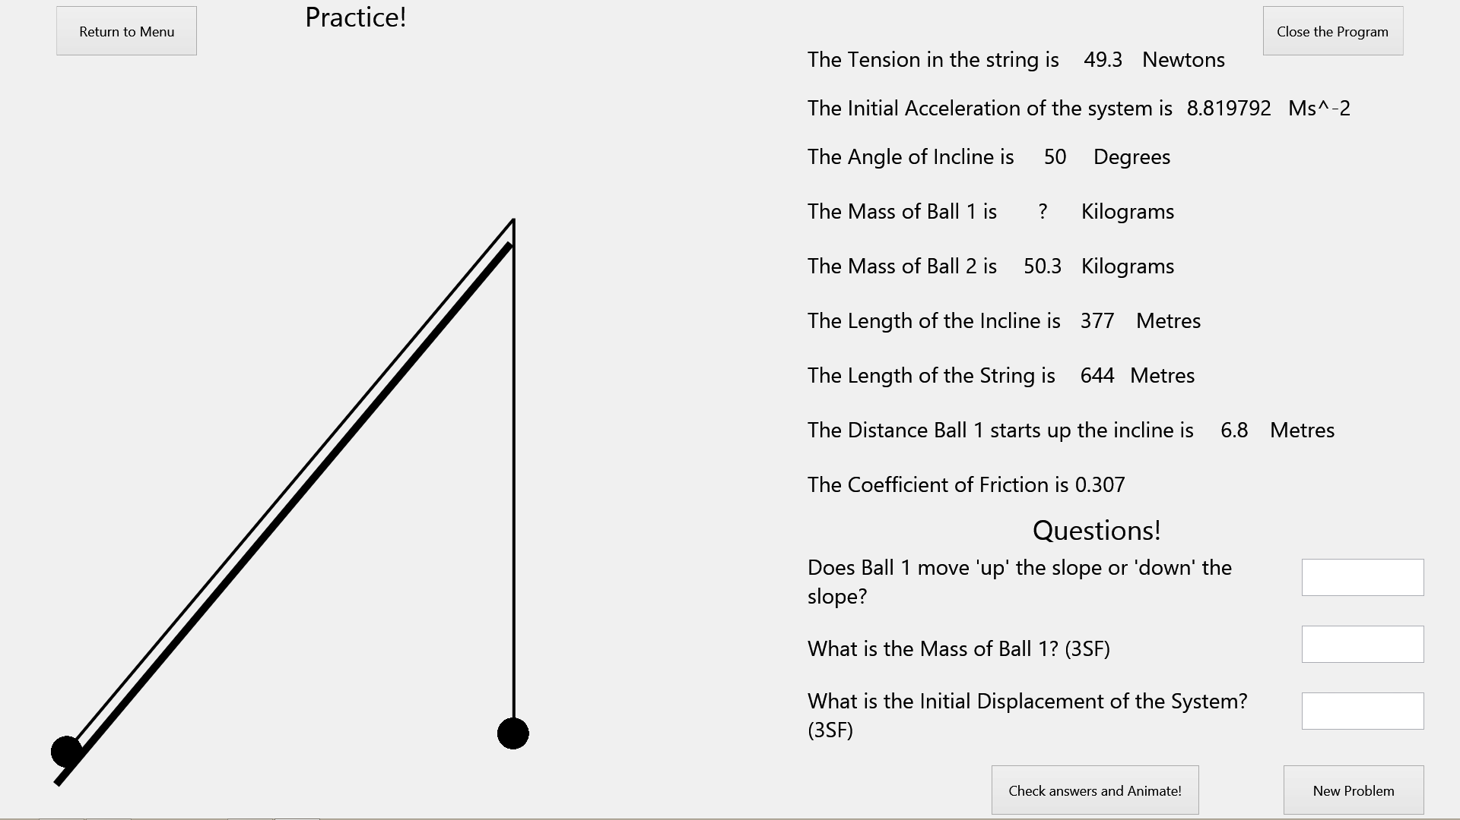

CloseProgramButton

PracticeFormWelcomeMessage

#### Practice Annotated

Ball2MassKilograms

Ball1MassKilograms

HowFarBall1StartsUpPlankMetres

LengthOfStringMetres

LengthOfPlankMetres

AngleOfPlankDegrees

TensionNewtons

AccelerationMetresPerSecondSquared

TensionShow

AccelerationShow

AngleOfPlankShow

Ball1MassShow

Ball2MassShow

LengthOfPlankShow

LengthOfStringShow

HowFarBall1StartsUpPlankShow

HowFarBall1StartsUpPlankDisclaimer

CoefficientOfFrictionShow

CoefficientOfFrictionDisclaimer

Question2Answer

Question3Answer

Question1Answer

NewProblemButton

CheckAndAnimateButton

Question2

Question3

Question1

QuestionsDisclaimer

LengthOfStringDisclaimer

LengthOfPlankDisclaimer

Ball1MassDisclaimer

Ball2MassDisclaimer

AngleOfPlankDisclaimer

AccelerationDisclaimer

TensionDisclaimer

VerticalString

Ball1

Plank

Ball2

PlankString

ReturnToMenuButton

|  |  |
| --- | --- |
| **Element** | **Type** |
| ReturnToMenuButton | TButton |
| PlankString | TLine |
| VerticalString | TLine |
| Plank | TLine |
| Ball1 | TBall (Programmer Defined) |
| Ball2 | TBall (Programmer Defined) |
| PracticeFormWelcomeMessage | TLabel |
| TensionDisclaimer | TLabel |
| AccelerationDisclaimer | TLabel |
| AngleOfPlankDisclaimer | TLabel |
| Ball1MassDisclaimer | TLabel |
| Ball2MassDisclaimer | TLabel |
| LengthOfPlankDisclaimer | TLabel |
| LengthOfStringDisclaimer | TLabel |
| HowFarBall1StartsUpPlankDisclaimer | TLabel |
| CoefficientOfFrictionDisclaimer | TLabel |
| Question1 | TLabel |
| Question2 | TLabel |
| Question3 | TLabel |
| CheckandAnimateButton | TButton |
| TensionShow | TLabel |
| AccelerationShow | TLabel |
| AngleOfPlankShow | TLabel |
| Ball1MassShow | TLabel |
| Ball2MassShow | TLabel |
| LengthOfPlankShow | TLabel |
| LengthOfStringShow | TLabel |
| HowFarBall1StartsUpPlankShow | TLabel |
| CoefficientOfFrictionShow | TLabel |
| CloseProgramButton | TButton |
| TensionNewtons | TLabel |
| AccelerationMetresPerSecondSquared | TLabel |
| AngleOfPlankDegrees | TLabel |
| Ball1MassKilograms | TLabel |
| Ball2MassKilograms | TLabel |
| LengthOfPlankMetres | TLabel |
| LengthOfStringMetres | TLabel |
| HowFarBall1StartsUpPlankMetres | TLabel |
| QuestionsDisclaimer | TLabel |
| Question1Answer | TLabel |
| Question2Answer | TLabel |
| Question3Answer | TLabel |
| NewProblemButton | TButton |

#### Practice Table

## Description of System Settings

Due to the nature of the program, some ‘system settings’ are constants that I define in each Unit. Here is a table explaining these settings, and what changing them would do:

|  |  |  |  |
| --- | --- | --- | --- |
| **Setting Name** | **Default Value** | **Units it’s found in** | **What it does and what changing it would effect** |
| g | 9.8 | OwnModelUnit, PracticeUnit | This is the stored approximation of acceleration due to gravity on earth. 9.8 is a fair approximation but if the maintainer wants to make the modelling even more accurate this value can be changed to be more accurate. |
| Smoothness Constant | 100 | OwnModelUnit, PracticeUnit | This is a constant that defines the number of small delta distances of animation will occur to give the perceived effect of acceleration. In essence, the higher this number, the smoother the animations will be. However, too high a number may result in lag due to the number of calculations that have to be executed. In my opinion, 100 is a good balance. However, a maintainer can change this value if they wish. |

The other system setting that could be potentially changed is the fact that the program is by default run in fullscreen. This was done by request of the main user, but can be changed if necessary. However, it has to be changed within each Unit that displays a form. It is normally listed as a setting of the form that can easily be changed.

## Functionality

### Introduction to Functionality

This section will explain how all the units and their subroutines interface with each other during program execution. To access the source code for the program you have to open the project file using a Delphi-Firemonkey compatibly compiler. It is important to note that the nature of Delphi-Firemonkey means that different parts of the program (Forms/Units) have their own sections of code and are modules themselves. To this end, there are no real ‘global variables’ within the program. However, each unit has their own variables which are used throughout the unit. These are much like global variables, except that they are only used by that unit. Therefore, when going through each unit I will refer to these as ‘unit global variables’.

However, there is some code used globally throughout the program. This is the code that defines the programmer-defined TBall class/object and is found in the BallUnit.

Starting with the BallUnit, this guide will now step through each unit explaining the functionality. All program code is in italics.

### BallUnit/TBall Object Overview

This Unit is only used to define the TBall object. This object is used by other units to display a Ball on screen.

#### Uses

The Program code below shows the System/FMX resources that the Unit uses:

*uses*

*System.SysUtils, System.Types, System.UITypes, System.Classes, System.Variants,*

*FMX.Types, FMX.Graphics, FMX.Controls, FMX.Forms, FMX.Dialogs, FMX.StdCtrls,FMX.Objects;*

#### Class Declarations

The only class declaration made is to declare and define the TBall object:

*type*

*TBall = Class(TImage)*

*Private*

*Public*

*Constructor Create(Stream:TStream; var AOwner);*

*Destructor Destroy;*

*End;*

#### Unit Global Variables

There are no Unit Global Variables for this unit.

#### Constants

There are no constants for this unit.

#### Explanation of each subroutine’s functionality

##### Constructor TBall.Create(Stream:TStream;Var AOwner)

This Constructor is part of the TBall class and is used to create the Ball on screen.

##### Destructor TBall.Destroy

This Destructor is part of the TBall class and is used to destroy the object so that memory is freed up.

#### Explanation of modular structure of this Unit’s code and how the code works

##### Creating a Ball on screen:

To create a ball on screen, the TBall.Create Constructor is called. This subroutines doesn’t call any other subroutines during execution:

*Constructor TBall.Create(Stream: TStream; Var AOwner);*

*begin*

*Inherited Create(TComponent(AOwner));*

*Bitmap.LoadFromStream(Stream);*

*Parent := TFMXObject(AOwner);*

*end;*

##### Freeing a ball from memory:

To free a ball from memory, the TBall.Destroy Destructor is called. This subroutine doesn’t call any other subroutines during execution.

*Destructor TBall.Destroy;*

*begin*

*Inherited Destroy;*

*end;*

### MainMenuUnit

This unit displays a form during execution which allows the user to move between the program’s forms.

#### Uses

The Program code below shows the System/FMX resources/other units that the Unit uses. This unit uses OwnModelUnit and PracticeUnit so that it has access to OwnModelForm and PracticeForm. This allows the MainMenuUnit to show and hide OwnModelForm and PracticeForm:

*uses*

*System.SysUtils, System.Types, System.UITypes, System.Classes, System.Variants,*

*FMX.Types, FMX.Graphics, FMX.Controls, FMX.Forms, FMX.Dialogs, FMX.StdCtrls, OwnModelUnit, PracticeUnit;*

#### Class Declarations

The only class declaration made is to declare and define the TMainMenuForm class:

*type*

*TMainMenuForm = class(TForm)*

*GoToOwnModelButton: TButton;*

*GoToPracticeButton: TButton;*

*WelcomeMessage: TLabel;*

*CloseProgramButton: TButton;*

*procedure GoToOwnModelButtonClick(Sender: TObject);*

*procedure GoToPracticeButtonClick(Sender: TObject);*

*procedure CloseProgramButtonClick(Sender: TObject);*

*private*

*public*

*end;*

#### Unit Global Variables

This form has one Unit global variable, the Main Menu Form:

*var*

*MainMenuForm: TMainMenuForm;*

#### Constants

There are no constants for this unit.

#### Explanation of each subroutine’s functionality

##### procedure TMainMenuForm.CloseProgramButtonClick(Sender: TObject);

This procedure closes the program.

##### procedure TMainMenuForm.GoToOwnModelButtonClick(Sender: TObject);

This procedure changes the program so it is now displaying the OwnModelForm.

##### procedure TMainMenuForm.GoToPracticeButtonClick(Sender: TObject);

This procedure changes the program so it is now displaying the PracticeForm.

#### Explanation of modular structure of this Unit’s code and how the code works (With references to Design and Testing)

##### Closing the program

This Functionality was tested in Test 2 of the System Testing and passed.

To do this, the CloseProgramButton is pressed. This event triggers this procedure to be executed, halting the program:

*procedure TMainMenuForm.CloseProgramButtonClick(Sender: TObject);*

*begin*

*halt;*

*end;*

##### Moving to the OwnModelForm

This Functionality was tested in Test 3 of the System Testing and passed.

To do this, the GoToOwnModelButton is pressed. This event triggers this procedure to be executed, hiding the MainMenuForm and showing the OwnModelForm.

*procedure TMainMenuForm.GoToOwnModelButtonClick(Sender: TObject);*

*begin*

*MainMenuForm.Hide;*

*OwnModelForm.Show;*

*end;*

##### Moving to the PracticeForm

This Functionality was tested in Test 4 of the System Testing and passed.

To do this, the GoToPracticeButton is pressed. This event triggers this procedure to be executed, hiding the MainMenuForm and showing the PracticeForm.

*procedure TMainMenuForm.GoToPracticeButtonClick(Sender: TObject);*

*begin*

*MainMenuForm.Hide;*

*PracticeForm.Show;*

*end;*

### OwnModelUnit

This Unit displays a form which allows the user to create their own M1 ‘pulley systems on an incline’ model.

#### Uses

The Program code below shows the System/FMX resources/libraries/other units that the Unit uses. This unit uses the Math library so it can use the built in Sin,Cos and DegtoRad functions. The unit also uses BallUnit so that it has access to the TBall class:

*uses*

*System.SysUtils, System.Types, System.UITypes, System.Classes, System.Variants,*

*FMX.Types, FMX.Graphics, FMX.Controls, FMX.Forms, FMX.Dialogs, FMX.StdCtrls,*

*FMX.Objects, Math, FMX.Edit,BallUnit;*

The unit also uses the MainMenuUnit at the implementation clause to give the unit access to the MainMenuForm. This allows the unit to show the MainMenuForm:

*implementation*

*uses MainMenuUnit;*

#### Class Declarations

The only class declaration made is to declare and define the TOwnModelForm class:

*type*

*TOwnModelForm = class(TForm)*

*Plank: TLine;*

*OwnModelFormWelcomeMessage: TLabel;*

*RequestForPlankAngle: TLabel;*

*RequestMassofBall1: TLabel;*

*RequestMassofBall2: TLabel;*

*RequestForLengthofPlank: TLabel;*

*RequestforDistanceBall1StartsupPlank: TLabel;*

*RequestforLengthofString: TLabel;*

*RequestforCoefficientOfFriction: TLabel;*

*AngleOfPlankSelector: TSpinBox;*

*AngleDegrees: TLabel;*

*MassOfBall1Selector: TEdit;*

*Ball1Kilograms: TLabel;*

*MassOfBall2Selector: TEdit;*

*LengthOfPlankSelector: TEdit;*

*LengthOfStringSelector: TEdit;*

*HowFarBall1UpPlankSelector: TEdit;*

*CoefficientOfFrictionSelector: TEdit;*

*Ball2Kilograms: TLabel;*

*PlankLengthMetres: TLabel;*

*StringLengthMetres: TLabel;*

*HowFarBall1UpPlankMetres: TLabel;*

*PlankString: TLine;*

*VerticalString: TLine;*

*AnimateModelButton: TButton;*

*UpdateModelButton: TButton;*

*ResetButton: TButton;*

*CloseProgramButton: TButton;*

*ReturnToMenuButton: TButton;*

*procedure AngleOfPlankSelectorChange(Sender: TObject);*

*procedure MassOfBall1SelectorChange(Sender: TObject);*

*procedure MassOfBall2SelectorChange(Sender: TObject);*

*procedure LengthOfPlankSelectorChange(Sender: TObject);*

*procedure LengthOfStringSelectorChange(Sender: TObject);*

*procedure HowFarBall1UpPlankSelectorChange(Sender: TObject);*

*procedure CoefficientOfFrictionSelectorChange(Sender: TObject);*

*procedure AnimatePlankAngle;*

*procedure AnimatePlankStringAngleAndPosition(TopOfSlopeY,TopOfSlopeX : real);*

*procedure AnimateVerticalStringPosition(TopOfSlopeY,TopOfSlopeX : real);*

*procedure AnimateBallsToCorrectPositions;*

*Procedure AnimateStringToCorrectHeight;*

*procedure UpdateModel;*

*procedure AnimateModelButtonClick(Sender: TObject);*

*procedure FormCreate(Sender: TObject);*

*procedure ResetToDefaultValues;*

*procedure UpdateModelButtonClick(Sender: TObject);*

*procedure CheckChosenValues;*

*procedure ResetButtonClick(Sender: TObject);*

*procedure FormKeyUp(Sender: TObject; var Key: Word; var KeyChar: Char;*

*Shift: TShiftState);*

*procedure CloseProgramButtonClick(Sender: TObject);*

*procedure ReturnToMenuButtonClick(Sender: TObject);*

*procedure FormShow(Sender: TObject);*

*private*

*public*

*end;*

#### Unit Global Variables

This unit uses one global variable for the OwnModelForm, and two for the two Balls to be displayed on screen (members of the TBall class from the BallUnit). Moreover, there are global variables for many mathematical quantities used throughout the unit. Their use is obvious from their identifiers:

*var*

*OwnModelForm: TOwnModelForm;*

*PlankAngleDegrees, PlankAngleRadians, Ball1Mass, Ball2Mass, PlankLength, StringLength, DistanceBall1StartsUpPlank, CoefficientOfFriction, DefaultPlankAngleDegrees, DefaultBall1Mass, DefaultBall2Mass, DefaultPlankLength, DefaultStringLength, DefaultDistanceBall1StartsUpPlank, DefaultCoefficientOfFriction,HeightOfPlankPixels : real;*

*Ball1,Ball2: TBall;*

#### Constants

This unit uses two constants. One to represent the value for natural freefall acceleration on earth (g or 9.8) and one which is called ‘SmoothnessConstant’. SmoothnessConstant is a programmer chosen number that effects how smooth the animation occurs. The bigger, the smoother the animation. 100 seems to be sufficient but it can be increased higher for a smooth animation:

*CONST*

*g = 9.8;*

*SmoothnessConstant=100;*

#### Explanation of each subroutine’s functionality

##### function ConvertMetresToPixels(Input : real) : real;

This function takes an input in metres and outputs the number of pixels that length represents on the screen.

##### function CalculateHeightofPlankToUseInPixels : real;

This function works out how many pixels the plank should take up on the screen based on the size of the display.

##### function CalculateSignificantFigures(Input:String) : integer;

This function takes a real number represented as a string and outputs the number of significant figures it has.

##### function RoundInputasString(Input:String;EndLength:Integer) : string;

This function takes a real number with no decimal place represented as a string and rounds it to a chosen number(EndLength) of significant figures.

##### function MakeXDigits(Input:real;X:Integer) : real;

This function takes a real number and outputs that number to a chosen number(X) of digits in length.

##### function CalculateIfValidXDigitPositiveReal(Input:String; X:integer) : boolean;

This function checks if a real number represented as a string is positive and less than or equal to X digits in length.

##### function CalculateTopOfSlopeY (HeightOfPlankPixels : real) : real;

This function checks calculates the Y coordinate of the Top of the Plank.

##### function CalculateTopOfSlopeX (HeightOfPlankPixels : real) : real;

This function checks calculates the X coordinate of the Top of the Plank.

##### procedure TOwnModelForm.AnimateBallsToCorrectPositions;

This procedure animates the balls on screen to the correct position based on user input.

##### procedure TOwnModelForm.AnimateModelButtonClick(Sender: TObject);

This procedure animates the model based on its configuration.

##### procedure TOwnModelForm.AnimatePlankAngle;

This procedure animates the plank angle correctly based on user input.

##### procedure TOwnModelForm.AnimatePlankStringAngleAndPosition(TopOfSlopeY,TopOfSlopeX : real);

This procedure animates the PlankString element to the correct angle and position based on user input.

##### procedure TOwnModelForm.AnimateVerticalStringPosition(TopOfSlopeY,TopOfSlopeX: Real);

This procedure animates the VerticalString to the correct position based on user input.

##### procedure TOwnModelForm.AnimateStringToCorrectHeight;

This procedure animates the height of VerticalString and PlankString such that the total length of the string matches user input.

##### procedure TOwnModelForm.UpdateModel;

This procedure updates the model based on user input.

##### procedure TOwnModelForm.UpdateModelButtonClick(Sender: TObject);

This procedure checks that user input is valid before updating the model based on the inputs.

##### procedure TOwnModelForm.AngleOfPlankSelectorChange(Sender: TObject);

This procedure checks that the plank angle chosen by the user is valid before updating the relevant variables.

##### procedure TOwnModelForm.CoefficientOfFrictionSelectorChange(Sender: TObject);

This procedure checks that the Coefficient of Friction chosen by the user is valid before updating the relevant variables.

##### procedure TOwnModelForm.ResetButtonClick(Sender: TObject);

This procedure resets all variable values to defaults before updating the model accordingly.

##### procedure TOwnModelForm.ResetToDefaultValues;

This procedure resets all variable values to defaults.

##### procedure TOwnModelForm.ReturnToMenuButtonClick(Sender: TObject);

This procedure moves the program to the MainMenuForm.

##### procedure TOwnModelForm.CheckChosenValues;

This procedure validates user input based on mathematical rules that must be obeyed for a model to be of M1 standard.

##### procedure TOwnModelForm.CloseProgramButtonClick(Sender: TObject);

This procedure closes the program.

##### procedure TOwnModelForm.FormCreate(Sender: TObject);

This procedure initializes all necessary variables and objects.

##### procedure TOwnModelForm.FormKeyUp(Sender: TObject; var Key: Word; var KeyChar: Char; Shift: TShiftState);

This procedure checks that user input is valid before updating the model based on the inputs.

##### procedure TOwnModelForm.FormShow(Sender: TObject);

This procedure sets the displayed model to its default configuration.

##### procedure TOwnModelForm.HowFarBall1UpPlankSelectorChange(Sender: TObject);

This procedure checks that the distance ball 1 starts up the plank chosen by the user is valid before updating the relevant variables.

##### procedure TOwnModelForm.LengthOfPlankSelectorChange(Sender: TObject);

This procedure checks that the Plank Length chosen by the user is valid before updating relevant variables.

##### procedure TOwnModelForm.LengthOfStringSelectorChange(Sender: TObject);

This procedure checks that the String Length chosen by the user is valid before updating relevant variables.

##### procedure TOwnModelForm.MassOfBall1SelectorChange(Sender: TObject);

This procedure checks that the Mass of Ball 1 chosen by the user is valid before updating relevant variables.

##### procedure TOwnModelForm.MassOfBall2SelectorChange(Sender: TObject);

This procedure checks that the Mass of Ball 2 chosen by the user is valid before updating relevant variables.

#### Explanation of modular structure of this Unit’s code and how the code works (With references to Design and Testing)

Note that any highlighted piece of code is a subroutine found in the next section, ‘referenced subroutines’. These are included there as they referenced many times in the main modules found below. Also note any complicated code is annotated and explained.

##### Initializing variables and objects when the form is created (at program start up)

*procedure TOwnModelForm.FormCreate(Sender: TObject);*

*var*

*Ballstream : TResourceStream;*

*begin*

*BallStream := TResourceStream.Create(MainInstance, 'BallImage', RT_RCDATA);*

*Ball1:=TBall.Create(BallStream,Self);*

*Ball2:=TBall.Create(BallStream,Self);*

*DefaultPlankLength:=6;*

*DefaultPlankAngleDegrees:=30;*

*DefaultBall1Mass:=5;*

*DefaultBall2Mass:=5;*

*DefaultStringLength:=7;*

*DefaultDistanceBall1StartsUpPlank:=1;*

*DefaultCoefficientOfFriction:=0.3;*

*ResetToDefaultValues;*

*end;*

##### Initializing model to default arrangement when the form is shown

This Functionality was tested in Test 3 of the System Testing and passed.

*procedure TOwnModelForm.FormShow(Sender: TObject);*

*var TopOfSlopeY,TopOfSlopeX,BottomOfPlankY,BottomOfPlankX,Ball1X,Ball1Y,Ball2X,Ball2Y : real;*

*begin*

*HeightofPlankPixels:=CalculateHeightofPlanktoUseInPixels;*

*Plank.SetBounds(70,OwnModelForm.Height-50-HeightOfPlankPixels,50,HeightofPlankPixels);*

*ResetToDefaultValues;*

*Plank.RotationAngle:=90-PlankAngleDegrees;*

*TopOfSlopeY:=CalculateTopOfSlopeY(HeightOfPlankPixels);*

*TopOfSlopeX:=CalculateTopOfSlopeX(HeightOfPlankPixels);*

*PlankString.rotationangle:=90-PlankAngleDegrees;*

*PlankString.Position.X:=TopOfSlopeX+80;*

*PlankString.Position.Y:=TopOfSlopeY-30;*

*VerticalString.Position.X:=TopOfSlopeX+80;*

*VerticalString.Position.Y:=TopOfSlopeY-30;*

*BottomOfPlankY:=Plank.Position.Y+HeightOfPlankPixels-52;*

*BottomOfPlankX:=Plank.Position.X-18;*

*Ball1X:=BottomOfPlankX+(ConvertMetresToPixels(DistanceBall1StartsUpPlank)*Cos(PlankAngleRadians));*

*Ball1Y:=BottomOfPlankY-(ConvertMetresToPixels(DistanceBall1StartsUpPlank)*Sin(PlankAngleRadians));*

*Ball2X:=BottomOfPlankX+HeightOfPlankPixels*Cos(PlankAngleRadians);*

*Ball2Y:=BottomOfPlankY - ConvertMetresToPixels((PlankLength*Sin(PlankAngleRadians))-StringLength+PlankLength-DistanceBall1StartsUpPlank);*

*Ball1.Position.X:=Ball1X;*

*Ball1.Position.Y:=Ball1Y;*

*Ball2.Position.X:=Ball2X;*

*Ball2.Position.Y:=Ball2Y;*

*PlankString.Height:=ConvertMetresToPixels(PlankLength-DistanceBall1StartsUpPlank);*

*VerticalString.Height:=ConvertMetresToPixels(StringLength-PlankLength+DistanceBall1StartsUpPlank);*

*end;*

##### Changing the Plank Angle

This Functionality was tested in Tests 9-11 of the System Testing and they all passed.

It is done by using the AngleOfPlankSelector to select a value. When this value is changed, this subroutine is called, validating the input before changing any relevant variables. If the input is invalid, an error message is displayed and the variables are reset to defaults:

*procedure TOwnModelForm.AngleOfPlankSelectorChange(Sender: TObject);*

*begin*

*if (StrtoInt(AngleofPlankSelector.Text)>89) or (StrtoInt(AngleofPlankSelector.Text)<1)then*

*begin*

*AngleOfPlankSelector.Text:=FloattoStr(DefaultPlankAngleDegrees);*

*ShowMessage('Not a valid angle of incline, please select an integer between 0 and 90');*

*end;*

*PlankAngleDegrees:=StrToInt(AngleofPlankSelector.Text);*

*PlankAngleRadians:=DegtoRad(PlankAngleDegrees);*

*end;*

##### Changing the Mass of Ball 1

This Functionality was tested in Tests 12-14 of the System Testing and they all passed.

It is done by using the MassOfBall1Selector to select a value. When this value is changed, this subroutine is called, validating the input before changing any relevant variables. If the input is invalid, an error message is displayed and the variables are reset to defaults:

*procedure TOwnModelForm.MassOfBall1SelectorChange(Sender: TObject);*

*begin*

*if CalculateIfValidXDigitPositiveReal(MassOfBall1Selector.Text,3) = false then*

*begin*

*MassOfBall1Selector.Text:=FloattoStr(DefaultBall1Mass);*

*ShowMessage('Not a valid mass of ball 1, please select a positive 3 digit or less real number');*

*end;*

*Ball1Mass:=StrToFloat(MassOfBall1Selector.Text);*

*end;*

##### Changing the Mass of Ball 2

This Functionality was tested in Tests 15-17 of the System Testing and they all passed.

It is done by using the MassOfBall2Selector to select a value. When this value is changed, this subroutine is called, validating the input before changing any relevant variables. If the input is invalid, an error message is displayed and the variables are reset to defaults:

*procedure TOwnModelForm.MassOfBall2SelectorChange(Sender: TObject);*

*begin*

*if CalculateIfValidXDigitPositiveReal(MassOfBall2Selector.Text,3) = false then*

*begin*

*MassOfBall2Selector.Text:=FloattoStr(DefaultBall2Mass);*

*ShowMessage('Not a valid mass of ball 2, please select a positive 3 digit or less real number');*

*end;*

*Ball2Mass:=StrToFloat(MassOfBall2Selector.Text);*

*end;*

##### Changing the Plank Length

This Functionality was tested in Tests 18-20 of the System Testing and they all passed.

It is done by using the LengthOfPlankSelector to select a value. When this value is changed, this subroutine is called, validating the input before changing any relevant variables. If the input is invalid, an error message is displayed and the variables are reset to defaults:

*procedure TOwnModelForm.LengthOfPlankSelectorChange(Sender: TObject);*

*begin*

*if CalculateIfValidXDigitPositiveReal(LengthOfPlankSelector.Text,3) = false then*

*begin*

*LengthOfPlankSelector.Text:=FloattoStr(DefaultPlankLength);*

*ShowMessage('Not a valid plank length, please select a positive 3 digit or less real number');*

*end;*

*PlankLength:=StrToFloat(LengthOfPlankSelector.Text);*

*end;*

##### Changing the String Length

This Functionality was tested in Tests 21-23 of the System Testing and they all passed.

It is done by using the LengthOfStringSelector to select a value. When this value is changed, this subroutine is called, validating the input before changing any relevant variables. If the input is invalid, an error message is displayed and the variables are reset to defaults:

*procedure TOwnModelForm.LengthOfStringSelectorChange(Sender: TObject);*

*begin*

*if CalculateIfValidXDigitPositiveReal(LengthOfStringSelector.Text,3) = false then*

*begin*

*LengthOfStringSelector.Text:=FloattoStr(DefaultStringLength);*

*ShowMessage('Not a valid string length, please select a positive 3 digit or less real number');*

*end;*

*StringLength:=StrToFloat(LengthOfStringSelector.Text);*

*end;*

##### Changing the distance Ball 1 starts up the Plank

This Functionality was tested in Tests 24-26 of the System Testing and they all passed.

It is done by using the HowFarBall1UpPlankSelector to select a value. When this value is changed, this subroutine is called, validating the input before changing any relevant variables. If the input is invalid, an error message is displayed and the variables are reset to defaults:

*procedure TOwnModelForm.HowFarBall1UpPlankSelectorChange(Sender: TObject);*

*begin*

*if CalculateIfValidXDigitPositiveReal(HowFarBall1UpPlankSelector.Text,3) = false then*

*begin*

*HowFarBall1UpPlankSelector.Text:=FloattoStr(DefaultDistanceBall1StartsUpPlank);*

*ShowMessage('Not a valid distance for ball 1 to start up plank, please select a positive 3 digit or less real number');*

*end;*

*DistanceBall1StartsUpPlank:=StrToFloat(HowFarBall1UpPlankSelector.Text);;*

*end;*

##### Changing the Coefficient Of Friction

This Functionality was tested in Tests 27-29 of the System Testing and they all passed.

It is done by using the CoefficientOfFrictionSelector to select a value. When this value is changed, this subroutine is called, validating the input before changing any relevant variables. If the input is invalid, an error message is displayed and the variables are reset to defaults:

*procedure TOwnModelForm.CoefficientOfFrictionSelectorChange(Sender: TObject);*

*begin*

*if CalculateIfValidXDigitPositiveReal(CoefficientOfFrictionSelector.Text,4) = false then*

*begin*

*CoefficientOfFrictionSelector.Text:=FloattoStr(DefaultCoefficientOfFriction);*

*ShowMessage('Not a valid coefficient of friction, please select a positive 4 digit or less real number');*

*end;*

*CoefficientOfFriction:=StrToFloat(CoefficientOfFrictionSelector.Text);*

*end;*

##### Updating the model to a user defined configuration (Note Design for Update Model Algorithm is found in Design document)

This Functionality was tested in Tests 30-38 of the System Testing and they all passed.

This is done by pressing the UpdateModelButton or pressing the Return Key. Each event triggers the relevant procedure below, validating the configuration mathematically before animating the model to that configuration:

*procedure TOwnModelForm.UpdateModelButtonClick(Sender: TObject);*

*begin*

*CheckChosenValues;*

*UpdateModel;*

*end;*

*procedure TOwnModelForm.FormKeyUp(Sender: TObject; var Key: Word; var KeyChar: Char; Shift: TShiftState);*

*begin*

*if Key=VKReturn then*

*begin*

*CheckChosenValues;*

*UpdateModel;*

*end;*

*end;*

##### Animating the model based on its current configuration (Annotated. Note Design for Animation Algorithm is found in Design document)

This Functionality was tested in Tests 39-43 of the System Testing and they all passed.

This is done by pressing the AnimateModelButton. This event triggers this procedure, which is very complicated so I have annotated it for clarification:

*procedure TOwnModelForm.AnimateModelButtonClick(Sender: TObject);*

*var UpSlope : string;*

*Counter : integer;*

*NewXBall1,NewYBall1,NewXBall2,NewYBall2,TimeForThisMovement,PartEndVelocity,Ball2YLocation,Ball1XLocation,Ball1YLocation,EachPartOfInitialMovementLength, InitialMovementLength,ExtraDisplacementLength,EachPartOfExtraDisplacementLength,Acceleration,VelocityOfBall1WhenBall2HitGround,VelocityOFBall2WhenBall1HitGround,CurrentInitialSpeed,WaitingTime,LowestRatioForMovement,HighestRatioForMovement:real;*

**Using Force analysis to determine which direction Ball 1 will move. As there are 3 options, a string UpSlope is used to store the result.**

**As Animations are handled within Delphi-Firemonkey after all have been calculated, this variable is used to keep track of the time a given animation must wait before executing. would all animate at the same time after all calculations are done.**

*begin*

*CurrentInitialSpeed:=0;*

*WaitingTime:=0;*

*if Ball2Mass>Ball1Mass*((CoefficientofFriction*Cos(PlankAngleRadians))+Sin(PlankAngleRadians)) then UpSlope:='UpSlope'*

*else if Ball2Mass<Ball1Mass*((-CoefficientofFriction*Cos(PlankAngleRadians))+Sin(PlankAngleRadians)) then UpSlope:='DownSlope'*

*else UpSlope:= 'Stationery';*

*if UpSlope = 'UpSlope' then*

**If Ball 1 would move up the slope, only particular Maths applies, so its case must be considered individually.**

*begin*

*Acceleration:=((-Ball1Mass*g*((Sin(PlankAngleRadians))+(CoefficientofFriction*(Cos(PlankAngleRadians)))))+(Ball2Mass*g))/(Ball1Mass+Ball2Mass);*

*VelocityOfBall1WhenBall2HitGround:= Sqrt(2*Acceleration*((PlankLength*Sin(PlankAngleRadians))-StringLength+PlankLength-DistanceBall1StartsUpPlank));*

*ExtraDisplacementLength:=(((VelocityOfBall1WhenBall2HitGround)*(VelocityOfBall1WhenBall2HitGround))/(2*g*((CoefficientofFriction*Cos(PlankAngleRadians))+(Sin(PlankAngleRadians)))));*

*EachPartOfExtraDisplacementLength:=ExtraDisplacementLength/SmoothnessConstant;*

*InitialMovementLength:=(PlankLength*Sin(PlankAngleRadians))-StringLength+PlankLength-DistanceBall1StartsUpPlank;*

*EachPartOfInitialMovementLength:=InitialMovementLength/SmoothnessConstant;*

**Using more Force analysis as well as constant acceleration formulae, the distance the Balls will originally move and the extra displacement Ball 1 will undertake after Ball 2 hits the floor is calculated. These distances are then divided by SmoothnessConstant to give small delta distances.**

*Ball2YLocation:=Ball2.Position.Y;*

**The initial locations of the balls are loaded into variables.**

**Validation check to make sure remains an M1 problem**

*Ball1YLocation:=Ball1.Position.Y;*

*Ball1XLocation:=Ball1.Position.X;*

*if DistanceBall1StartsUpPlank+InitialMovementLength+ExtraDisplacementLength>PlankLength*

*then Showmessage('Chosen Values result in a problem beyond the M1 Specification, Ball 1 would fly off the top of the incline')*

*else begin*

**Time for small movement calculated**

**This loop animates the balls a delta initial movement length SmoothnessConstant many times, so the final length the balls have moved is the initial movement length.**

*for counter := 1 to SmoothnessConstant do*

*begin*

*PartEndVelocity:=Sqrt((CurrentInitialSpeed*CurrentInitialSpeed)+(2*Acceleration*EachPartOfInitialMovementLength));*

*TimeForThisMovement:=(PartEndVelocity-CurrentInitialSpeed)/Acceleration;*

*NewYBall2:=Ball2YLocation+ConvertMetresToPixels(Counter*EachPartOfInitialMovementLength);*

*NewXBall1:= Ball1XLocation + ConvertMetresToPixels((Counter*EachPartOfInitialMovementLength)*Cos(PlankAngleRadians));*

*NewYBall1:= Ball1YLocation - ConvertMetresToPixels((Counter*EachPartOfInitialMovementLength)*Sin(PlankAngleRadians));*

**Balls animated to new position**

**New Ball coordinates calculated after delta distance movement.**

*Ball1.AnimateFloatDelay('position.Y',NewYBall1,TimeForThisMovement,WaitingTime);*

*Ball1.AnimateFloatDelay('position.X',NewXBall1,TimeForThisMovement,WaitingTime);*

*Ball2.AnimateFloatDelay('position.Y',NewYBall2,TimeForThisMovement,WaitingTime);*

*PlankString.AnimateFloatDelay('Height',ConvertMetresToPixels(PlankLength-(DistanceBall1StartsUpPlank+(Counter*EachPartOfInitialMovementLength))),TimeForThisMovement,WaitingTime);*

*VerticalString.AnimateFloatDelay('Height',ConvertMetresToPixels(StringLength-PlankLength+DistanceBall1StartsUpPlank+(Counter*EachPartOfInitialMovementLength)),TimeForThisMovement,WaitingTime);*

*WaitingTime:=WaitingTime+TimeforThisMovement;*

*CurrentInitialSpeed:=PartEndVelocity;*

**Both parts of String animated to new length**

*end;*

**Relevant variables updated for next loop.**

*Ball1XLocation:=NewXBall1;*

**Location of Balls updated after Balls moved initial movement length**

*Ball1YLocation:=NewYBall1;*

*for counter := 1 to (SmoothnessConstant) do*

**This loop animates ball 1 a delta extra displacement length SmoothnessConstant many times up the slope, so the final length the ball has moved is the extra displacement length.**

**Time for small movement calculated**

*begin*

*PartEndVelocity:=Sqrt((CurrentInitialSpeed*CurrentInitialSpeed)+(-2*g*((CoefficientofFriction*Cos(PlankAngleRadians))+Sin(PlankAngleRadians))*EachPartOfExtraDisplacementLength));*

*TimeForThisMovement:=(2*EachPartOfExtraDisplacementLength)/(CurrentInitialSpeed+PartEndVelocity);*

**New Ball 1 coordinates calculated after delta distance movement.**

*NewXBall1:=Ball1XLocation + ConvertMetresToPixels((Counter*EachPartOfExtraDisplacementLength)*Cos(PlankAngleRadians));*

*NewYBall1:= Ball1YLocation - ConvertMetresToPixels((Counter*EachPartOfExtraDisplacementLength)*Sin(PlankAngleRadians));*

*Ball1.AnimateFloatDelay('position.Y',NewYBall1,TimeForThisMovement,WaitingTime);*

*Ball1.AnimateFloatDelay('position.X',NewXBall1,TimeForThisMovement,WaitingTime);*

**Ball 1 animated to new position**

*PlankString.AnimateFloatDelay('Height',ConvertMetresToPixels(PlankLength-(DistanceBall1StartsUpPlank+InitialMovementLength+(Counter*EachPartOfExtraDisplacementLength))),TimeForThisMovement,WaitingTime);*

*WaitingTime:=WaitingTime+TimeForThisMovement;*

**Plank String animated to new length**

**Relevant variables updated for next loop.**

*CurrentInitialSpeed:=PartEndVelocity;*

*end;*

*Ball1XLocation:=NewXBall1;*

*Ball1YLocation:=NewYBall1;*

**Location of Ball 1 updated after moved extra displacement length up the slope. CurrentInitialSpeed is currently not 0 due to ignoring air resistance but should be under our model, so it is assigned to 0.**

*CurrentInitialSpeed:=0;*

**This loop animates ball 1 a delta extra displacement length SmoothnessConstant many times down the slope, so the final length the ball has moved is the extra displacement length.**

*for counter := 1 to (SmoothnessConstant) do*

**Time for small movement calculated**

*begin*

*PartEndVelocity:=Sqrt((CurrentInitialSpeed*CurrentInitialSpeed)+(2*g*((CoefficientofFriction*Cos(PlankAngleRadians))+Sin(PlankAngleRadians))*EachPartOfExtraDisplacementLength));*

*TimeForThisMovement:=(2*EachPartOfExtraDisplacementLength)/(CurrentInitialSpeed+PartEndVelocity);*

**New Ball 1 coordinates calculated after delta distance movement.**

*NewXBall1:=Ball1XLocation - ConvertMetresToPixels((Counter*EachPartOfExtraDisplacementLength)*Cos(PlankAngleRadians));*

*NewYBall1:=Ball1YLocation + ConvertMetresToPixels((Counter*EachPartOfExtraDisplacementLength)*Sin(PlankAngleRadians));*

**Ball 1 animated to new position**

**Plank String animated to new length**

*Ball1.AnimateFloatDelay('position.Y',NewYBall1,TimeForThisMovement,WaitingTime);*

*Ball1.AnimateFloatDelay('position.X',NewXBall1,TimeForThisMovement,WaitingTime);*

*PlankString.AnimateFloatDelay('Height',ConvertMetresToPixels(PlankLength-(DistanceBall1StartsUpPlank+InitialMovementLength+ExtraDisplacementLength-(Counter*EachPartOfExtraDisplacementLength))),TimeForThisMovement,WaitingTime);*

**Relevant variables updated for next loop.**

*WaitingTime:=WaitingTime+TimeForThisMovement;*

*CurrentInitialSpeed:=PartEndVelocity;*

*end;*

*end;*

*end*

**If Ball 1 would move down the slope, only particular Maths applies, so its case must be considered individually.**

*else if UpSlope = 'DownSlope' then begin*

*Acceleration:=((Ball1Mass*g*((Sin(PlankAngleRadians))-(CoefficientofFriction*(Cos(PlankAngleRadians)))))-(Ball2Mass*g))/(Ball1Mass+Ball2Mass);*

*VelocityOfBall2WhenBall1HitGround:= Sqrt(2*Acceleration*DistanceBall1StartsUpPlank);*

*InitialMovementLength:=DistanceBall1StartsUpPlank;*

*EachPartOfInitialMovementLength: =InitialMovementLength/SmoothnessConstant;*

*ExtraDisplacementLength:=((VelocityOfBall2WhenBall1HitGround)*(VelocityOfBall2WhenBall1HitGround))/(2*g);*

*EachPartOfExtraDisplacementLength:=ExtraDisplacementLength/SmoothnessConstant;*

**Using more Force analysis as well as constant acceleration formulae, the distance the Balls will originally move and the extra displacement Ball 2 will undertake after Ball 1 hits the floor is calculated. These distances are then divided by SmoothnessConstant to give small delta distances.**

*Ball2YLocation:=Ball2.Position.Y;*

**Validation check to make sure remains an M1 problem**

**The initial locations of the balls are loaded into variables.**

*Ball1YLocation:=Ball1.Position.Y;*

*Ball1XLocation:=Ball1.Position.X;*

*if (PlankLength*Sin(PlankAngleRadians))-StringLength+PlankLength-DistanceBall1StartsUpPlank+InitialMovementLength+ExtraDisplacementLength>PlankLength*Sin(PlankAngleRadians)*

*then Showmessage('Chosen Values result in a problem beyond the M1 Specification, Ball 2 would move higher than the top of the incline')*

*else begin*

**This loop animates the balls a delta initial movement length SmoothnessConstant many times, so the final length the balls have moved is the initial movement length.**

*for counter := 1 to SmoothnessConstant do*

*begin*

*PartEndVelocity:=Sqrt((CurrentInitialSpeed*CurrentInitialSpeed)+(2*Acceleration*EachPartOfInitialMovementLength));*

*TimeForThisMovement:=(PartEndVelocity-CurrentInitialSpeed)/Acceleration;*

**Time for small movement calculated**

**New Ball coordinates calculated after delta distance movement.**

*NewYBall2:=Ball2YLocation- ConvertMetresToPixels(Counter*EachPartOfInitialMovementLength);*

*NewXBall1:= Ball1XLocation - ConvertMetresToPixels((Counter*EachPartOfInitialMovementLength)*Cos(PlankAngleRadians));*

*NewYBall1:= Ball1YLocation + ConvertMetresToPixels((Counter*EachPartOfInitialMovementLength)*Sin(PlankAngleRadians));*

**Balls animated to new position**

*Ball1.AnimateFloatDelay('position.Y',NewYBall1,TimeForThisMovement,WaitingTime);*

*Ball1.AnimateFloatDelay('position.X',NewXBall1,TimeForThisMovement,WaitingTime);*

*Ball2.AnimateFloatDelay('position.Y',NewYBall2,TimeForThisMovement,WaitingTime);*

*PlankString.AnimateFloatDelay('Height',ConvertMetresToPixels(PlankLength-(DistanceBall1StartsUpPlank-(Counter*EachPartOfInitialMovementLength))),TimeForThisMovement,WaitingTime);*

**Both parts of String animated to new length**

*VerticalString.AnimateFloatDelay('Height',ConvertMetresToPixels(StringLength-PlankLength+DistanceBall1StartsUpPlank-(Counter*EachPartOfInitialMovementLength)),TimeForThisMovement,WaitingTime);*

**Relevant variables updated for next loop.**

*WaitingTime:=WaitingTime+TimeforThisMovement;*

*CurrentInitialSpeed:=PartEndVelocity;*

*end;*

**Y Coordinate of Ball 2 updated after Balls moved initial movement length**

**This loop animates ball 2 a delta extra displacement length SmoothnessConstant many times upwards, so the final length the ball has moved is the extra displacement length.**

**Time for small movement calculated**

*Ball2YLocation:=NewYBall2;*

*for counter := 1 to (SmoothnessConstant) do*

*begin*

*PartEndVelocity:=Sqrt((CurrentInitialSpeed*CurrentInitialSpeed)+(-2*g*EachPartOfExtraDisplacementLength));*

*TimeForThisMovement:=(2*EachPartOfExtraDisplacementLength)/(CurrentInitialSpeed+PartEndVelocity);*

*NewYBall2:=Ball2YLocation- ConvertMetresToPixels(Counter*EachPartOfExtraDisplacementLength);*

**New Ball 2 Y coordinate calculated after delta distance movement.**

*Ball2.AnimateFloatDelay('position.y',NewYBall2,TimeForThisMovement,WaitingTime);*

**Ball 2 animated to new position**

**Vertical String animated to new length**

*VerticalString.AnimateFloatDelay('Height',ConvertMetresToPixels(StringLength-PlankLength+DistanceBall1StartsUpPlank-InitialMovementLength-(Counter*EachPartOfExtraDisplacementLength)),TimeForThisMovement,WaitingTime);*

*WaitingTime:=WaitingTime+TimeForThisMovement;*

**Relevant variables updated for next loop.**

*CurrentInitialSpeed:=PartEndVelocity;*

*end;*

**Y Coordinate of Ball 2 updated after moved extra displacement length upwards. CurrentInitialSpeed is currently not 0 due to ignoring air resistance but should be under our model, so it is assigned to 0.**

*CurrentInitialSpeed:=0;*

*Ball2YLocation:=NewYBall2;*

*for counter := 1 to (SmoothnessConstant) do*

**This loop animates ball 2 a delta extra displacement length SmoothnessConstant many times downwards, so the final length the ball has moved is the extra displacement length.**

*begin*

*PartEndVelocity:=Sqrt((CurrentInitialSpeed*CurrentInitialSpeed)+(2*g*EachPartOfExtraDisplacementLength));*

*TimeForThisMovement:=(2*EachPartOfExtraDisplacementLength)/(CurrentInitialSpeed+PartEndVelocity);*

**Time for small movement calculated**

*NewYBall2:=Ball2YLocation+ConvertMetresToPixels(Counter*EachPartOfExtraDisplacementLength);*

*Ball2.AnimateFloatDelay('position.y',NewYBall2,TimeForThisMovement,WaitingTime);*

**Ball 2 animated to new position**

**New Ball 2 Y coordinate calculated after delta distance movement.**

*VerticalString.AnimateFloatDelay('Height',ConvertMetresToPixels(StringLength- PlankLength+DistanceBall1StartsUpPlank-InitialMovementLength-ExtraDisplacementLength+(Counter*EachPartOfExtraDisplacementLength)),TimeForThisMovement,WaitingTime);*

*WaitingTime:=WaitingTime+TimeForThisMovement;*

*CurrentInitialSpeed:=PartEndVelocity;*

**Vertical String animated to new length**

*end;*

**Relevant variables updated for next loop.**

*end;*

*end*

**If Ball 1 wouldn’t move, the scenario must be treated independently.**

*else if UpSlope = 'Stationery' then*

**The Ratio’s of Mass of Ball 2 to Mass of Ball 1 that would cause movement are calculated.**

*begin*

*LowestRatioForMovement:= (CoefficientofFriction*Cos(PlankAngleRadians))+Sin(PlankAngleRadians);*

*HighestRatioForMovement:=(-CoefficientofFriction*Cos(PlankAngleRadians))+Sin(PlankAngleRadians);*

**Case treated independently because a ratio smaller than 0 is impossible**

*if HighestRatioForMovement<0*

**Explanation to user of why no movement**

*then Showmessage('The Ball would not move! For this angle and coefficient of friction, the system will only move where the Mass of Ball 2 divided by the Mass of Ball 1 is greater than ' + FloattoStr(MakeXDigits(LowestRatioForMovement,4)))*

*else Showmessage('The Ball would not move! For this angle and coefficient of friction, the system will only move where the Mass of Ball 2 divided by the Mass of Ball 1 is greater than ' + FloattoStr(MakeXDigits(LowestRatioForMovement,4)) + ' or smaller than ' + FloattoStr(MakeXDigits(HighestRatioForMovement,4)));*

*end;*

**Explanation to user of why no movement if HighestRatioForMovement>0**

*end;*

##### Resetting the Model

This Functionality was tested in Test 44 of the System Testing and passed.

This is done by pressing the ResetButton. This even triggers this procedure, resetting the relevant variables to default values before updating the model:

*procedure TOwnModelForm.ResetButtonClick(Sender: TObject);*

*begin*

*ResetToDefaultValues;*

*UpdateModel;*

*end;*

##### Closing the Program

This Functionality was tested in Test 6 of the System Testing and passed.

This is done by pressing the CloseProgramButton. This event triggers this procedure, halting the program and freeing the ball objects from memory:

*procedure TOwnModelForm.CloseProgramButtonClick(Sender: TObject);*

*begin*

*halt;*

*Ball1.Destroy;*

*Ball2.Destroy;*

*end;*

##### Returning to the Main Menu

This Functionality was tested in Test 5 of the System Testing and passed.

This is done by pressing the ReturnToMenuButton. This event triggers this procedure, hiding the OwnModelForm and showing the MainMenuForm.

*procedure TOwnModelForm.ReturnToMenuButtonClick(Sender: TObject);*

*begin*

*MainMenuForm.Show;*

*OwnModelForm.Hide;*

*end;*

#### Referenced subroutines

Any highlighted code references another subroutine found in this section.

##### ConvertMetresToPixels

*function ConvertMetresToPixels(Input : real) : real;*

*begin*

*result:=Input*(HeightOfPlankPixels/PlankLength);*

*end;*

##### CalculateHeightofPlankToUseInPixels

*function CalculateHeightofPlankToUseInPixels : real;*

*begin*

*if OwnModelForm.Height < OwnModelForm.Width then result:= OwnModelForm.Height-150*

*else result:=OwnModelForm.Width-150;*

*end;*

##### CalculateSignificantFigures

*function CalculateSignificantFigures(Input:String) : integer;*

*var Stepper : integer;*

*begin*

*Result:=Length(Input);*

*for Stepper := 1 to Length(Input) do*

*begin*

*if Input[Stepper] = '.' then Result:=Length(Input) - 1*

*end;*

*end;*

##### RoundInputasString

*function RoundInputasString(Input:String;EndLength:Integer) : string;*

*var Stepper : integer;*

*Finished : boolean;*

*begin*

*if ord(Input[Endlength+1])>52*

*then begin*

*if ord(Input[Endlength])<57*

*then Input[EndLength]:=Char((Ord(Input[Endlength]))+1)*

*else begin*

*Input[Endlength]:='0';*

*Stepper:=EndLength-1;*

*while not Finished do*

*begin*

*if ord(input[Stepper])<57*

*then begin*

*Input[Stepper]:=Char((Ord(Input[Stepper]))+1);*

*Finished:=True;*

*end*

*else begin*

*Input[Stepper]:='0';*

*Stepper:=Stepper-1;*

*end;*

*end;*

*end;*

*end;*

*result:=Input;*

*end;*

##### MakeXDigits

*function MakeXDigits(Input:real;X:Integer) : real;*

*Var InputasString,InputasStringNoDecimal : String;*

*DecimalPlace : boolean;*

*Stepper,Counter,i,DecimalPosition : integer;*

*begin*

*InputasString:=FloattoStr(Input);*

*for Stepper := 1 to Length(InputAsString) do*

*begin*

*if InputasString[Stepper]='.'*

*then begin*

*DecimalPosition:=Stepper;*

*DecimalPlace:=true;*

*end*

*else begin*

*SetLength(InputAsStringNoDecimal,Length(InputAsStringNoDecimal)+1);*

*InputasStringNoDecimal[Length(InputAsStringNoDecimal)]:=InputasString[Stepper]*

*end;*

*end;*

*InputasStringNoDecimal:=RoundInputasString(InputasStringNoDecimal,X);*

*SetLength(InputasStringNoDecimal,X);*

*InputasString:=InputasStringNoDecimal;*

*if DecimalPlace=true*

*then begin*

*SetLength(InputasString,X+1);*

*for I := Length(InputasString) downto DecimalPosition+1 do*

*begin*

*InputasString[i]:=InputasString[i-1]*

*end;*

*InputasString[DecimalPosition]:='.';*

*end;*

*Result:=StrtoFloat(InputasString);*

*end;*

##### CalculateIfValidXDigitPositiveReal

*function CalculateIfValidXDigitPositiveReal(Input:String; X:integer) : boolean;*

*begin*

*if (StrtoFloat(input)<0) or (CalculateSignificantFigures(Input)>X) then result:=false*

*else result := true;*

*end;*

##### CalculateTopOfSlopeY

*function CalculateTopOfSlopeY (HeightOfPlankPixels : real) : real;*

*begin*

*Result:=OwnModelForm.Height-50-(HeightOfPlankPixels*Cos((pi/2)-PlankAngleRadians));*

*end;*

##### CalculateTopOfSlopeX

*function CalculateTopOfSlopeX (HeightOfPlankPixels : real) : real;*

*begin*

*Result:=70+(HeightOfPlankPixels*Sin((pi/2)-PlankAngleRadians));*

*end;*

##### AnimateBallsToCorrectPositions

*procedure TOwnModelForm.AnimateBallsToCorrectPositions;*

*var NewBall1X,NewBall1Y,NewBall2X,NewBall2Y,BottomOfPlankX,BottomOfPlankY : real;*

*begin*

*BottomOfPlankY:=Plank.Position.Y+HeightOfPlankPixels-52;*

*BottomOfPlankX:=Plank.Position.X-18;*

*NewBall1X:=BottomOfPlankX+(ConvertMetresToPixels(DistanceBall1StartsUpPlank)*Cos(PlankAngleRadians));*

*NewBall1Y:=BottomOfPlankY-(ConvertMetresToPixels(DistanceBall1StartsUpPlank)*Sin(PlankAngleRadians));*

*NewBall2X:=BottomOfPlankX+HeightOfPlankPixels*Cos(PlankAngleRadians);*

*NewBall2Y:=BottomOfPlankY - ConvertMetresToPixels((PlankLength*Sin(PlankAngleRadians))-StringLength+PlankLength-DistanceBall1StartsUpPlank);*

*Ball1.AnimateFloat('position.X',NewBall1X,1);*

*Ball1.AnimateFloat('position.Y',NewBall1Y,1);*

*Ball2.AnimateFloat('position.X',NewBall2X,1);*

*Ball2.AnimateFloat('position.Y',NewBall2Y,1);*

*end;*

##### AnimatePlankAngle

*procedure TOwnModelForm.AnimatePlankAngle;*

*begin*

*Plank.AnimateFloat('rotationangle',90-PlankAngleDegrees,1);*

*end;*

##### AnimatePlankStringAngleAndPosition

*procedure TOwnModelForm.AnimatePlankStringAngleAndPosition(TopOfSlopeY,TopOfSlopeX : real);*

*begin*

*PlankString.AnimateFloat('rotationangle',90-PlankAngleDegrees,1);*

*PlankString.AnimateFloat('position.X',TopOfSlopeX+80,1);*

*PlankString.AnimateFloat('position.Y',TopOfSlopeY-30,1);*

*end;*

##### AnimateVerticalStringPosition

*procedure TOwnModelForm.AnimateVerticalStringPosition(TopOfSlopeY,TopOfSlopeX: Real);*

*begin*

*VerticalString.AnimateFloat('position.X',TopOfSlopeX+80,1);*

*VerticalString.AnimateFloat('position.Y',TopOfSlopeY-30,1);*

*end;*

##### AnimateStringToCorrectHeight

*procedure TOwnModelForm.AnimateStringToCorrectHeight;*

*begin*

*PlankString.AnimateFloat('Height',ConvertMetresToPixels(PlankLength-DistanceBall1StartsUpPlank),1);*

*VerticalString.AnimateFloat('Height',ConvertMetresToPixels(StringLength-PlankLength+DistanceBall1StartsUpPlank),1);*

*end;*

##### UpdateModel

*procedure TOwnModelForm.UpdateModel;*

*var TopOfSlopeY, TopOfSlopeX : real;*

*begin*

*AnimatePlankAngle;*

*TopOfSlopeY:=CalculateTopOfSlopeY(HeightOfPlankPixels);*

*TopOfSlopeX:=CalculateTopOfSlopeX(HeightOfPlankPixels);*

*AnimatePlankStringAngleAndPosition(TopOfSlopeY,TopOfSlopeX);*

*AnimateVerticalStringPosition(TopOfSlopeY,TopOfSlopeX);*

*AnimateBallsToCorrectPositions;*

*AnimateStringToCorrectHeight;*

*end;*

##### ResetToDefaultValues

*procedure TOwnModelForm.ResetToDefaultValues;*

*begin*

*PlankLength:=DefaultPlankLength;*

*PlankAngleDegrees:= DefaultPlankAngleDegrees;*

*Ball1Mass:=DefaultBall1Mass;*

*Ball2Mass:=DefaultBall2Mass;*

*StringLength:=DefaultStringLength;*

*DistanceBall1StartsUpPlank:=DefaultDistanceBall1StartsUpPlank;*

*CoefficientOfFriction:=DefaultCoefficientOfFriction;*

*LengthOfPlankSelector.Text:=FloattoStr(DefaultPlankLength);*

*AngleOfPlankSelector.Text:= FloattoStr(DefaultPlankAngleDegrees);*

*MassOfBall1Selector.Text:=FloattoStr(DefaultBall1Mass);*

*MassOfBall2Selector.Text:=FloattoStr(DefaultBall2Mass);*

*LengthOfStringSelector.Text:=FloattoStr(DefaultStringLength);*

*HowFarBall1UpPlankSelector.Text:=FloattoStr(DefaultDistanceBall1StartsUpPlank);*

*CoefficientOfFrictionSelector.Text:=FloattoStr(DefaultCoefficientOfFriction);*

*end;*

##### CheckChosenValues

*procedure TOwnModelForm.CheckChosenValues;*

*begin*

*if DistanceBall1StartsUpPlank+StringLength<PlankLength*

*then begin*

*ShowMessage('Not an accepeted change, this would result in the string not begin long enough to connect two particles in this plane. Resetting to Default Values.');*

*ResettoDefaultValues;*

*end;*

*if DistanceBall1StartsUpPlank>PlankLength*

*then begin*

*ShowMessage('Not an accepted change, the distance Ball 1 starts up the incline cannot be greater than the length of the plank. Resetting to Default Values.');*

*ResetToDefaultValues;*

*end;*

*if StringLength-PlankLength+DistanceBall1StartsUpPlank>PlankLength*Sin(PlankAngleRadians)*

*then begin*

*ShowMessage('Not an accepted change, this would result in a slack string due to Ball 2 not being able to fall through the floor. Resetting to Default Values');*

*ResetToDefaultValues;*

*end;*

*end;*

### PracticeUnit

This Unit displays a form which questions the user on a random ‘pulley systems on an incline’ M1 model.

#### Uses

The Program code below shows the System/FMX resources/libraries/other units that the Unit uses. This unit uses the Math library so it can use the built in Sin,Cos, DegtoRad and Random functions. The unit also uses BallUnit so that it has access to the TBall class:

*uses*

*System.SysUtils, System.Types, System.UITypes, System.Classes, System.Variants,*

*FMX.Types, FMX.Graphics, FMX.Controls, FMX.Forms, FMX.Dialogs, FMX.StdCtrls,*

*FMX.Objects,Math,BallUnit, FMX.Edit;*

The unit also uses the MainMenuUnit at the implementation clause to give the unit access to the MainMenuForm. This allows the unit to show the MainMenuForm:

*implementation*

*uses MainMenuUnit;*

#### Class Declarations

The only class declaration made is to declare and define the TPraticeForm class:

*type*

*TPracticeForm = class(TForm)*

*PracticeFormWelcomeMessage: TLabel;*

*Plank: TLine;*

*PlankString: TLine;*

*VerticalString: TLine;*

*TensionDisclaimer: TLabel;*

*AngleOfPlankDisclaimer: TLabel;*

*Ball1MassDisclaimer: TLabel;*

*Ball2MassDisclaimer: TLabel;*

*LengthOfPlankDisclaimer: TLabel;*

*LengthOfStringDisclaimer: TLabel;*

*HowFarBall1StartsUpPlankDisclaimer: TLabel;*

*CoefficientOfFrictionDisclaimer: TLabel;*

*AccelerationDisclaimer: TLabel;*

*TensionNewtons: TLabel;*

*AccelerationMetresPerSecondSquared: TLabel;*

*AngleOfPlankDegrees: TLabel;*

*Ball1MassKilograms: TLabel;*

*Ball2MassKilograms: TLabel;*

*LengthOfPlankMetres: TLabel;*

*LengthOfStringMetres: TLabel;*

*HowFarBall1UpPlankMetres: TLabel;*

*TensionShow: TLabel;*

*AccelerationShow: TLabel;*

*AngleOfPlankShow: TLabel;*

*Ball1MassShow: TLabel;*

*CoefficientOfFrictionShow: TLabel;*

*HowFarBall1UpPlankShow: TLabel;*

*LengthOfStringShow: TLabel;*

*LengthOfPlankShow: TLabel;*

*Ball2MassShow: TLabel;*

*QuestionsDisclaimer: TLabel;*

*Question1: TLabel;*

*Question2: TLabel;*

*Question3: TLabel;*

*CheckAndAnimateButton: TButton;*

*Question1Answer: TEdit;*

*Question2Answer: TEdit;*

*Question3Answer: TEdit;*

*NewProblemButton: TButton;*

*CloseProgramButton: TButton;*

*ReturnToMenuButton: TButton;*

*procedure FormResize(Sender: TObject);*

*procedure UpdateModel;*

*procedure ChangeBallsToCorrectPositions;*

*procedure ChangePlankAngle;*

*procedure ChangePlankStringAngleAndPosition(TopOfSlopeY,TopOfSlopeX:Real);*

*procedure ChangeVerticalStringPosition(TopOfSlopeY,TopOfSlopeX:Real);*

*procedure ChangeStringToCorrectHeight;*

*procedure FormCreate(Sender: TObject);*

*procedure CheckAndAnimateButtonClick(Sender: TObject);*

*procedure NewProblemButtonClick(Sender: TObject);*

*procedure CreateProblem;*

*procedure FormShow(Sender: TObject);*

*procedure CloseProgramButtonClick(Sender: TObject);*

*procedure ReturnToMenuButtonClick(Sender: TObject);*

*private*

*public*

*end;*

#### Unit Global Variables

This unit uses one global variable for the OwnModelForm, and two for the two Balls to be displayed on screen (members of the TBall class from the BallUnit). Moreover, there are global variables for many mathematical quantities used throughout the unit. Their use is obvious from their identifiers. There are also two integers which are used to stored random numbers to aid with generating the random model and a string ‘UpSlope’ which acts as a 3-way Boolean variable to store whether the model remains stationary, moves up the slope or moves down the slope:

*var*

*PracticeForm: TPracticeForm;*

*Acceleration,Tension, PlankAngleDegrees, PlankAngleRadians, Ball1Mass, Ball2Mass, PlankLength, StringLength, DistanceBall1StartsUpPlank, CoefficientOfFriction, HeightOfPlankPixels,InitialMovementLength,ExtraDisplacementLength : real;*

*UpSlope : String;*

*RandomInteger1,RandomInteger2 : integer;*

*Ball1,Ball2: TBall;*

#### Constants

This unit uses two constants. One to represent the value for natural freefall acceleration on earth (g or 9.8) and one which is called ‘SmoothnessConstant’. SmoothnessConstant is a programmer chosen number that effects how smooth the animation occurs. The bigger, the smoother the animation. 100 seems to be sufficient but it can be increased higher for a smooth animation:

*CONST*

*g = 9.8;*

*SmoothnessConstant=100;*

#### Explanation of each subroutine’s functionality

##### function ConvertMetresToPixels(Input : real) : real;

This function takes an input in metres and outputs the number of pixels that length represents on the screen.

##### function CalculateHeightofPlankToUseInPixels : real;

This function works out how many pixels the plank should take up on the screen based on the size of the display.

##### function CalculateSignificantFigures(Input:String) : integer;

This function takes a real number represented as a string and outputs the number of significant figures it has.

##### function Random3DigitReal : real;

This function outputs a random 3 digit real number.

##### function RoundInputasString(Input:String;EndLength:Integer) : string;

This function takes a real number with no decimal place represented as a string and rounds it to a chosen number(EndLength) of significant figures.

##### function MakeXDigits(Input:real;X:Integer) : real;

This function takes a real number and outputs that number to a chosen number(X) of digits in length.

##### function CalculateTension:real;

This function outputs the tension in the string.

##### procedure CreateRandomValues;

This procedure assigns random values to all variables that effect the arrangement of the model.

##### function CalculateTopOfSlopeY (HeightOfPlankPixels : real) : real;

This function checks calculates the Y coordinate of the Top of the Plank.

##### function CalculateTopOfSlopeX (HeightOfPlankPixels : real) : real;

This function checks calculates the X coordinate of the Top of the Plank.

##### function SensibleM1Problem : boolean;

This function outputs a Boolean result true if the current model is M1 standard, and false if it isn’t.

##### procedure TPracticeForm.ChangeBallsToCorrectPositions;

This procedure moves the balls to the correct position based on the current values of the relevant variables.

##### procedure TPracticeForm.ChangePlankAngle;

This procedure changes the Plank’s angle to the correct orientation based on the current value of the relevant variable.

##### procedure TPracticeForm.ChangePlankStringAngleAndPosition(TopOfSlopeY,TopOfSlopeX : real);

This procedure changes the angle and position of the PlankString to the correct orientation based on the current values of the relevant variables.

##### procedure TPracticeForm.ChangeVerticalStringPosition(TopOfSlopeY,TopOfSlopeX: Real);

This procedure changes the position of the VerticalString to the correct position based on the current values of the relevant variables.

##### procedure TPracticeForm.CheckAndAnimateButtonClick(Sender: TObject);

This procedure checks that the user has answered the questions correctly, informing them if any are wrong. If the answers are correct, the procedure will animate the model based on its current configuration.

##### procedure TPracticeForm.CloseProgramButtonClick(Sender: TObject);

This procedure closes the program.

##### procedure TPracticeForm.ChangeStringToCorrectHeight;

This procedure changes the height of PlankString and VerticalString so the total length of the String matches the relevant variable values.

##### procedure TPracticeForm.UpdateModel;

This procedure updates the configuration of the model based on the relevant variable values.

##### procedure ResetValuestoZero;

This procedure resets all variables that effect the model to 0.

##### procedure TPracticeForm.CreateProblem;

This procedure creates a random model and the questions to be used. It then displays the model.

##### procedure TOwnModelForm.FormCreate(Sender: TObject);

This procedure initializes all necessary variables and objects. The randomize table is also initialized.

##### procedure TOwnModelForm.FormShow(Sender: TObject);

This procedure sets the displayed model to a random configuration when the form is shown.

##### procedure TPracticeForm.NewProblemButtonClick(Sender: TObject);

This procedure creates a random model and the questions to be used. It then displays the model.

##### procedure TPracticeForm.ReturnToMenuButtonClick(Sender: TObject);

This procedure returns the user to the MainMenuForm.

#### Explanation of modular structure of this Unit’s code and how the code works (With references to Design and Testing)

Note that any highlighted piece of code is a subroutine found in the next section, ‘referenced subroutines’. These are included there as they referenced many times in the main modules found below. Also note any complicated code is annotated and explained.

##### Initializing variables, objects and randomize table when the form is created (at program start up)

*procedure TPracticeForm.FormCreate(Sender: TObject);*

*var BallStream:TResourceStream;*

*begin*

*BallStream := TResourceStream.Create(MainInstance, 'BallImage', RT_RCDATA);*

*Ball1:=TBall.Create(BallStream,Self);*

*Ball2:=TBall.Create(BallStream,Self);*

*Randomize;*

*end;*

##### Initializing model to a random arrangement when the form is shown

This Functionality was tested in Test 4 of the System Testing and passed.

*procedure TPracticeForm.FormShow(Sender: TObject);*

*begin*

*HeightofPlankPixels:=CalculateHeightofPlanktoUseInPixels;*

*Plank.SetBounds(70,PracticeForm.Height-50-HeightOfPlankPixels,50,HeightofPlankPixels);*

*CreateProblem;*

*end;*

##### Returning to the Main Menu

This Functionality was tested in Test 7 of the System Testing and passed.

When the ReturnToMenuButton is pressed, the event triggers this procedure. This hides the PracticeForm, and shows the MainMenuForm:

*procedure TPracticeForm.ReturnToMenuButtonClick(Sender: TObject);*

*begin*

*MainMenuForm.Show;*

*PracticeForm.Hide;*

*end;*

##### Closing the Program

This Functionality was tested in Test 8 of the System Testing and passed.

This is done by pressing the CloseProgramButton. This event triggers this procedure, halting the program and freeing the ball objects from memory:

*procedure TPracticeForm.CloseProgramButtonClick(Sender: TObject);*

*begin*

*halt;*

*Ball1.Destroy;*

*Ball2.Destroy;*

*end;*

##### Checking answers to questions and animating the model

This Functionality was tested in Tests 45-46 of the System Testing and they both passed.

When the CheckAndAnimateButton is pressed, the event triggers this procedure. It first checks that the answers entered in the relevant text boxes are correct. If they are incorrect, the ones which are incorrect are notified to the user. If they are all correct, the model begins to animate. For a better explanation of how the animation functionality works, see the explanation of the relevant code in OwnModelUnit:

*procedure TPracticeForm.CheckAndAnimateButtonClick(Sender: TObject);*

*var Counter : integer;*

*NewXBall1,NewYBall1,NewXBall2,NewYBall2,TimeForThisMovement,PartEndVelocity,Ball2YLocation,Ball1XLocation,Ball1YLocation,EachPartOfInitialMovementLength,EachPartOfExtraDisplacementLength,VelocityOfBall1WhenBall2HitGround,VelocityOFBall2WhenBall1HitGround,CurrentInitialSpeed,WaitingTime,LowestRatioForMovement,HighestRatioForMovement:real;*

*Question1Correct,Question2Correct,Question3Correct : boolean;*

*begin*

*if Ball2Mass>Ball1Mass*((CoefficientofFriction*Cos(PlankAngleRadians))+Sin(PlankAngleRadians)) then UpSlope:='UpSlope'*

*else if Ball2Mass<Ball1Mass*((-CoefficientofFriction*Cos(PlankAngleRadians))+Sin(PlankAngleRadians)) then UpSlope:='DownSlope';*

*if UpSlope = 'UpSlope' then*

*begin*

*VelocityOfBall1WhenBall2HitGround:= Sqrt(2*Acceleration*((PlankLength*Sin(PlankAngleRadians))-StringLength+PlankLength-DistanceBall1StartsUpPlank));*

*ExtraDisplacementLength:=(((VelocityOfBall1WhenBall2HitGround)*(VelocityOfBall1WhenBall2HitGround))/(2*g*((CoefficientofFriction*Cos(PlankAngleRadians))+(Sin(PlankAngleRadians)))));*

*InitialMovementLength:=(PlankLength*Sin(PlankAngleRadians))-StringLength+PlankLength-DistanceBall1StartsUpPlank;*

*end;*

*if UpSlope = 'DownSlope' then*

*begin*

*VelocityOfBall2WhenBall1HitGround:= Sqrt(2*Acceleration*DistanceBall1StartsUpPlank);*

*InitialMovementLength:=DistanceBall1StartsUpPlank;*

*ExtraDisplacementLength:=((VelocityOfBall2WhenBall1HitGround)*(VelocityOfBall2WhenBall1HitGround))/(2*g);*

*end;*

*if (UpSlope='UpSlope') and (Uppercase(Question1Answer.Text)='UP') then Question1Correct:=True;*

*if (UpSlope='DownSlope') and (Uppercase(Question1Answer.Text)='DOWN') then Question1Correct:=True;*

*if (RandomInteger1=1) and (Question2Answer.Text=FloatToStr(Tension)) then Question2Correct:=True;*

*if (RandomInteger1=2) and (Question2Answer.Text=FloatToStr(Acceleration)) then Question2Correct:=True;*

*if (RandomInteger1=3) and (Question2Answer.Text=FloatToStr(PlankAngleDegrees)) then Question2Correct:=True;*

*if (RandomInteger1=4) and (Question2Answer.Text=FloatToStr(Ball1Mass)) then Question2Correct:=True;*

*if (RandomInteger1=5) and (Question2Answer.Text=FloatToStr(Ball2Mass)) then Question2Correct:=True;*

*if (RandomInteger1=6) and (Question2Answer.Text=FloatToStr(CoefficientOfFriction)) then Question2Correct:=True;*

*if (RandomInteger2=1) and (Question3Answer.Text=FloatToStr(Tension)) then Question3Correct:=True;*

*if (RandomInteger2=2) and (Question3Answer.Text=FloatToStr(Acceleration)) then Question3Correct:=True;*

*if (RandomInteger2=3) and (Question3Answer.Text=FloatToStr(PlankAngleDegrees)) then Question3Correct:=True;*

*if (RandomInteger2=4) and (Question3Answer.Text=FloatToStr(Ball1Mass)) then Question3Correct:=True;*

*if (RandomInteger2=5) and (Question3Answer.Text=FloatToStr(Ball2Mass)) then Question3Correct:=True;*

*if (RandomInteger2=6) and (Question3Answer.Text=FloatToStr(CoefficientOfFriction)) then Question3Correct:=True;*

*if (RandomInteger2=7) and (Question3Answer.Text=FloatToStr(InitialMovementLength)) then Question3Correct:=True;*

*if (RandomInteger2=8) and (Question3Answer.Text=FloatToStr(ExtraDisplacementLength)) then Question3Correct:=True;*

*if (Question1Correct=True) and (Question2Correct=True) and (Question3Correct=True)*

*then begin*

*ShowMessage('Answers Correct. Animating!');*

*CurrentInitialSpeed:=0;*

*WaitingTime:=0;*

*if UpSlope = 'UpSlope' then*

*begin*

*EachPartOfExtraDisplacementLength:=ExtraDisplacementLength/SmoothnessConstant;*

*EachPartOfInitialMovementLength:=InitialMovementLength/SmoothnessConstant;*

*Ball2YLocation:=Ball2.Position.Y;*

*Ball1YLocation:=Ball1.Position.Y;*

*Ball1XLocation:=Ball1.Position.X;*

*if DistanceBall1StartsUpPlank+InitialMovementLength+ExtraDisplacementLength>PlankLength*

*then Showmessage('Chosen Values result in a problem beyond the M1 Specification, Ball 1 would fly off the top of the incline')*

*else begin*

*for counter := 1 to SmoothnessConstant do*

*begin*

*PartEndVelocity:=Sqrt((CurrentInitialSpeed*CurrentInitialSpeed)+(2*Acceleration*EachPartOfInitialMovementLength));*

*TimeForThisMovement:=(PartEndVelocity-CurrentInitialSpeed)/Acceleration;*

*NewYBall2:=Ball2YLocation+ConvertMetresToPixels(Counter*EachPartOfInitialMovementLength);*

*NewXBall1:= Ball1XLocation + ConvertMetresToPixels((Counter*EachPartOfInitialMovementLength)*Cos(PlankAngleRadians));*

*NewYBall1:= Ball1YLocation - ConvertMetresToPixels((Counter*EachPartOfInitialMovementLength)*Sin(PlankAngleRadians));*

*Ball1.AnimateFloatDelay('position.Y',NewYBall1,TimeForThisMovement,WaitingTime);*

*Ball1.AnimateFloatDelay('position.X',NewXBall1,TimeForThisMovement,WaitingTime);*

*Ball2.AnimateFloatDelay('position.Y',NewYBall2,TimeForThisMovement,WaitingTime);*

*PlankString.AnimateFloatDelay('Height',ConvertMetresToPixels(PlankLength-(DistanceBall1StartsUpPlank+(Counter*EachPartOfInitialMovementLength))),TimeForThisMovement,WaitingTime);*

*VerticalString.AnimateFloatDelay('Height',ConvertMetresToPixels(StringLength-PlankLength+DistanceBall1StartsUpPlank+(Counter*EachPartOfInitialMovementLength)),TimeForThisMovement,WaitingTime);*

*WaitingTime:=WaitingTime+TimeforThisMovement;*

*CurrentInitialSpeed:=PartEndVelocity;*

*end;*

*Ball1XLocation:=NewXBall1;*

*Ball1YLocation:=NewYBall1;*

*for counter := 1 to (SmoothnessConstant-1) do*

*begin*

*PartEndVelocity:=Sqrt((CurrentInitialSpeed*CurrentInitialSpeed)+(-2*g*((CoefficientofFriction*Cos(PlankAngleRadians))+Sin(PlankAngleRadians))*EachPartOfExtraDisplacementLength));*

*TimeForThisMovement:=(2*EachPartOfExtraDisplacementLength)/(CurrentInitialSpeed+PartEndVelocity);*

*NewXBall1:=Ball1XLocation + ConvertMetresToPixels((Counter*EachPartOfExtraDisplacementLength)*Cos(PlankAngleRadians));*

*NewYBall1:= Ball1YLocation - ConvertMetresToPixels((Counter*EachPartOfExtraDisplacementLength)*Sin(PlankAngleRadians));*

*Ball1.AnimateFloatDelay('position.Y',NewYBall1,TimeForThisMovement,WaitingTime);*

*Ball1.AnimateFloatDelay('position.X',NewXBall1,TimeForThisMovement,WaitingTime);*

*PlankString.AnimateFloatDelay('Height',ConvertMetresToPixels(PlankLength-(DistanceBall1StartsUpPlank+InitialMovementLength+(Counter*EachPartOfExtraDisplacementLength))),TimeForThisMovement,WaitingTime);*

*WaitingTime:=WaitingTime+TimeForThisMovement;*

*CurrentInitialSpeed:=PartEndVelocity;*

*end;*

*Ball1XLocation:=NewXBall1;*

*Ball1YLocation:=NewYBall1;*

*CurrentInitialSpeed:=0;*

*for counter := 1 to (SmoothnessConstant-1) do*

*begin*

*PartEndVelocity:=Sqrt((CurrentInitialSpeed*CurrentInitialSpeed)+(2*g*((CoefficientofFriction*Cos(PlankAngleRadians))+Sin(PlankAngleRadians))*EachPartOfExtraDisplacementLength));*

*TimeForThisMovement:=(2*EachPartOfExtraDisplacementLength)/(CurrentInitialSpeed+PartEndVelocity);*

*NewXBall1:=Ball1XLocation - ConvertMetresToPixels((Counter*EachPartOfExtraDisplacementLength)*Cos(PlankAngleRadians));*

*NewYBall1:=Ball1YLocation + ConvertMetresToPixels((Counter*EachPartOfExtraDisplacementLength)*Sin(PlankAngleRadians));*

*Ball1.AnimateFloatDelay('position.Y',NewYBall1,TimeForThisMovement,WaitingTime);*

*Ball1.AnimateFloatDelay('position.X',NewXBall1,TimeForThisMovement,WaitingTime);*

*PlankString.AnimateFloatDelay('Height',ConvertMetresToPixels(PlankLength-(DistanceBall1StartsUpPlank+InitialMovementLength+ExtraDisplacementLength-(Counter*EachPartOfExtraDisplacementLength))),TimeForThisMovement,WaitingTime);*

*WaitingTime:=WaitingTime+TimeForThisMovement;*

*CurrentInitialSpeed:=PartEndVelocity;*

*end;*

*end;*

*end*

*else if UpSlope = 'DownSlope' then begin*

*EachPartOfInitialMovementLength:=InitialMovementLength/SmoothnessConstant;*

*EachPartOfExtraDisplacementLength:=ExtraDisplacementLength/SmoothnessConstant;*

*Ball2YLocation:=Ball2.Position.Y;*

*Ball1YLocation:=Ball1.Position.Y;*

*Ball1XLocation:=Ball1.Position.X;*

*if (PlankLength*Sin(PlankAngleRadians))-StringLength+PlankLength-DistanceBall1StartsUpPlank+InitialMovementLength+ExtraDisplacementLength>PlankLength*Sin(PlankAngleRadians)*

*then Showmessage('Chosen Values result in a problem beyond the M1 Specification, Ball 2 would move higher than the top of the incline')*

*else begin*

*for counter := 1 to SmoothnessConstant do*

*begin*

*PartEndVelocity:=Sqrt((CurrentInitialSpeed*CurrentInitialSpeed)+(2*Acceleration*EachPartOfInitialMovementLength));*

*TimeForThisMovement:=(PartEndVelocity-CurrentInitialSpeed)/Acceleration;*

*NewYBall2:=Ball2YLocation- ConvertMetresToPixels(Counter*EachPartOfInitialMovementLength);*

*NewXBall1:= Ball1XLocation - ConvertMetresToPixels((Counter*EachPartOfInitialMovementLength)*Cos(PlankAngleRadians));*

*NewYBall1:= Ball1YLocation + ConvertMetresToPixels((Counter*EachPartOfInitialMovementLength)*Sin(PlankAngleRadians));*

*Ball1.AnimateFloatDelay('position.Y',NewYBall1,TimeForThisMovement,WaitingTime);*

*Ball1.AnimateFloatDelay('position.X',NewXBall1,TimeForThisMovement,WaitingTime);*

*Ball2.AnimateFloatDelay('position.Y',NewYBall2,TimeForThisMovement,WaitingTime);*

*PlankString.AnimateFloatDelay('Height',ConvertMetresToPixels(PlankLength-(DistanceBall1StartsUpPlank-(Counter*EachPartOfInitialMovementLength))),TimeForThisMovement,WaitingTime);*

*VerticalString.AnimateFloatDelay('Height',ConvertMetresToPixels(StringLength-PlankLength+DistanceBall1StartsUpPlank-(Counter*EachPartOfInitialMovementLength)),TimeForThisMovement,WaitingTime);*

*WaitingTime:=WaitingTime+TimeforThisMovement;*

*CurrentInitialSpeed:=PartEndVelocity;*

*end;*

*Ball2YLocation:=NewYBall2;*

*for counter := 1 to (SmoothnessConstant-1) do*

*begin*

*PartEndVelocity:=Sqrt((CurrentInitialSpeed*CurrentInitialSpeed)+(-2*g*EachPartOfExtraDisplacementLength));*

*TimeForThisMovement:=(2*EachPartOfExtraDisplacementLength)/(CurrentInitialSpeed+PartEndVelocity);*

*NewYBall2:=Ball2YLocation- ConvertMetresToPixels(Counter*EachPartOfExtraDisplacementLength);*

*Ball2.AnimateFloatDelay('position.y',NewYBall2,TimeForThisMovement,WaitingTime);*

*VerticalString.AnimateFloatDelay('Height',ConvertMetresToPixels(StringLength-PlankLength+DistanceBall1StartsUpPlank-InitialMovementLength-(Counter*EachPartOfExtraDisplacementLength)),TimeForThisMovement,WaitingTime);*

*WaitingTime:=WaitingTime+TimeForThisMovement;*

*CurrentInitialSpeed:=PartEndVelocity;*

*end;*

*CurrentInitialSpeed:=0;*

*Ball2YLocation:=NewYBall2;*

*for counter := 1 to (SmoothnessConstant-1) do*

*begin*

*PartEndVelocity:=Sqrt((CurrentInitialSpeed*CurrentInitialSpeed)+(2*g*EachPartOfExtraDisplacementLength));*

*TimeForThisMovement:=(2*EachPartOfExtraDisplacementLength)/(CurrentInitialSpeed+PartEndVelocity);*

*NewYBall2:=Ball2YLocation+ConvertMetresToPixels(Counter*EachPartOfExtraDisplacementLength);*

*Ball2.AnimateFloatDelay('position.y',NewYBall2,TimeForThisMovement,WaitingTime);*

*VerticalString.AnimateFloatDelay('Height',ConvertMetresToPixels(StringLength-PlankLength+DistanceBall1StartsUpPlank-InitialMovementLength-ExtraDisplacementLength+(Counter*EachPartOfExtraDisplacementLength)),TimeForThisMovement,WaitingTime);*

*WaitingTime:=WaitingTime+TimeForThisMovement;*

*CurrentInitialSpeed:=PartEndVelocity;*

*end;*

*end;*

*end;*

*end*

*else if (Question1Correct=False) and (Question2Correct=True) and (Question3Correct=True) then ShowMessage('Answer to Question 1 is incorrect')*

*else if (Question1Correct=True) and (Question2Correct=False) and (Question3Correct=True) then ShowMessage('Answer to Question 2 is incorrect')*

*else if (Question1Correct=True) and (Question2Correct=True) and (Question3Correct=False) then ShowMessage('Answer to Question 3 is incorrect')*

*else if (Question1Correct=False) and (Question2Correct=False) and (Question3Correct=True) then ShowMessage('Answers to Question 1 and Question 2 are incorrect')*

*else if (Question1Correct=False) and (Question2Correct=True) and (Question3Correct=False) then ShowMessage('Answers to Question 1 and Question 3 are incorrect')*

*else if (Question1Correct=True) and (Question2Correct=False) and (Question3Correct=False) then ShowMessage('Answers to Question 2 and Question 3 are incorrect')*

*else if (Question1Correct=False) and (Question2Correct=False) and (Question3Correct=False) then ShowMessage('Answers to all Questions are incorrect')*

*end;*

##### Generating and displaying a new problem (Note Design for Create Random Problem Algorithm is found in Design document)

This Functionality was tested in Test 47 of the System Testing and passed.

When the NewProblemButton is pressed, the event triggers this procedure. This generates a random M1 ‘Pulley systems on an incline’ problem and displays it. It also generates the questions that will be used and displays them:

*procedure TPracticeForm.NewProblemButtonClick(Sender: TObject);*

*begin*

*CreateProblem;*

*end;*

#### Referenced Subroutines

Any highlighted code references another subroutine found in this section.

##### ConvertMetresToPixels

*function ConvertMetresToPixels(Input : real) : real;*

*begin*

*result:=Input*(HeightOfPlankPixels/PlankLength);*

*end;*

##### CalculateHeightofPlankToUseInPixels

*function CalculateHeightofPlankToUseInPixels : real;*

*begin*

*if PracticeForm.Height < PracticeForm.Width then result:= PracticeForm.Height-150*

*else result:=PracticeForm.Width-150;*

*end;*

##### CalculateSignificantFigures

*function CalculateSignificantFigures(Input:String) : integer;*

*var Stepper : integer;*

*begin*

*Result:=Length(Input);*

*for Stepper := 1 to Length(Input) do*

*begin*

*if Input[Stepper] = '.' then Result:=Length(Input) - 1*

*end;*

*end;*

##### Random3DigitReal

*function Random3DigitReal : real;*

*var FloatasString : String;*

*Counter,RandomDecisionValue : integer;*

*begin*

*for counter := 1 to 3 do*

*begin*

*FloatasString:=FloatasString+IntToStr(Random(9));*

*end;*

*RandomDecisionValue:=Random(100);*

*if RandomDecisionValue<33 then*

*begin*

*SetLength(FloatAsString,4);*

*FloatAsString[4]:=FloatAsString[3];*

*FloatAsString[3]:=FloatAsString[2];*

*FloatAsString[2]:='.';*

*end;*

*if (RandomDecisionValue>=33) and (RandomDecisionValue<66) then*

*begin*

*SetLength(FloatAsString,4);*

*FloatAsString[4]:=FloatAsString[3];*

*FloatAsString[3]:='.';*

*end;*

*result:=StrtoFloat(FloatasString);*

*end;*

##### RoundInputasString

*function RoundInputasString(Input:String;EndLength:Integer) : string;*

*var Stepper : integer;*

*Finished : boolean;*

*begin*

*if ord(Input[Endlength+1])>52*

*then begin*

*if ord(Input[Endlength])<57*

*then Input[EndLength]:=Char((Ord(Input[Endlength]))+1)*

*else begin*

*Input[Endlength]:='0';*

*Stepper:=EndLength-1;*

*while not Finished do*

*begin*

*if ord(input[Stepper])<57*

*then begin*

*Input[Stepper]:=Char((Ord(Input[Stepper]))+1);*

*Finished:=True;*

*end*

*else begin*

*Input[Stepper]:='0';*

*Stepper:=Stepper-1;*

*end;*

*end;*

*end;*

*end;*

*result:=Input;*

*end;*

##### MakeXDigits

*function MakeXDigits(Input:real;X:Integer) : real;*

*Var InputasString,InputasStringNoDecimal : String;*

*DecimalPlace : boolean;*

*Stepper,Counter,i,DecimalPosition : integer;*

*begin*

*InputasString:=FloattoStr(Input);*

*for Stepper := 1 to Length(InputAsString) do*

*begin*

*if InputasString[Stepper]='.'*

*then begin*

*DecimalPosition:=Stepper;*

*DecimalPlace:=true;*

*end*

*else begin*

*SetLength(InputAsStringNoDecimal,Length(InputAsStringNoDecimal)+1);*

*InputasStringNoDecimal[Length(InputAsStringNoDecimal)]:=InputasString[Stepper]*

*end;*

*end;*

*InputasStringNoDecimal:=RoundInputasString(InputasStringNoDecimal,X);*

*SetLength(InputasStringNoDecimal,X);*

*InputasString:=InputasStringNoDecimal;*

*if DecimalPlace=true*

*then begin*

*SetLength(InputasString,X+1);*

*for I := Length(InputasString) downto DecimalPosition+1 do*

*begin*

*InputasString[i]:=InputasString[i-1]*

*end;*

*InputasString[DecimalPosition]:='.';*

*end;*

*Result:=StrtoFloat(InputasString);*

*end;*

##### CalculateTension

*function CalculateTension:real;*

*var Temp : real;*

*begin*

*if UpSlope='UpSlope' then Temp:=Ball2Mass*(g-Acceleration);*

*if UpSlope='DownSlope' then Temp:=Ball2Mass*(g+Acceleration);*

*Result:=MakeXDigits(Temp,4);*

*end;*

##### CreateRandomValues

*procedure CreateRandomValues;*

*begin*

*PlankAngleDegrees:= RandomRange(0,90);*

*PlankAngleRadians:=DegtoRad(PlankAngleDegrees);*

*Ball1Mass:= Random3DigitReal;*

*Ball2Mass:= Random3DigitReal;*

*PlankLength:= Random3DigitReal;*

*DistanceBall1StartsUpPlank:= Random3DigitReal;*

*StringLength:= Random3DigitReal;*

*CoefficientOfFriction:= MakeXDigits(Random,4);*

*end;*

##### CalculateTopOfSlopeY

*function CalculateTopOfSlopeY (HeightOfPlankPixels : real) : real;*

*begin*

*Result:=PracticeForm.Height-50-(HeightOfPlankPixels*Cos((pi/2)-PlankAngleRadians));*

*end;*

##### CalculateTopOfSlopeX

*function CalculateTopOfSlopeX (HeightOfPlankPixels : real) : real;*

*begin*

*Result:=70+(HeightOfPlankPixels*Sin((pi/2)-PlankAngleRadians));*

*end;*

##### SensibleM1Problem

*function SensibleM1Problem : boolean;*

*var TempAcceleration,InitialMovementLength,ExtraDisplacementLength,VelocityOfBall1WhenBall2HitGround,VelocityOFBall2WhenBall1HitGround:real;*

*begin*

*if (DistanceBall1StartsUpPlank+StringLength<PlankLength)*

*or (DistanceBall1StartsUpPlank>PlankLength)*

*or (StringLength-PlankLength+DistanceBall1StartsUpPlank>PlankLength*Sin(PlankAngleRadians))*

*then result:=false*

*else begin*

*result:=true;*

*if Ball2Mass>Ball1Mass*((CoefficientofFriction*Cos(PlankAngleRadians))+Sin(PlankAngleRadians)) then UpSlope:='UpSlope'*

*else if Ball2Mass<Ball1Mass*((-CoefficientofFriction*Cos(PlankAngleRadians))+Sin(PlankAngleRadians)) then UpSlope:='DownSlope'*

*else result:=false;*

*if UpSlope = 'UpSlope' then*

*begin*

*TempAcceleration:=((-Ball1Mass*g*((Sin(PlankAngleRadians))+(CoefficientofFriction*(Cos(PlankAngleRadians)))))+(Ball2Mass*g))/(Ball1Mass+Ball2Mass);*

*Acceleration:=MakeXDigits(TempAcceleration,7);*

*if Acceleration<0*

*then result:=false*

*else begin*

*VelocityOfBall1WhenBall2HitGround:= Sqrt(2*Acceleration*((PlankLength*Sin(PlankAngleRadians))-StringLength+PlankLength-DistanceBall1StartsUpPlank));*

*ExtraDisplacementLength:=(((VelocityOfBall1WhenBall2HitGround)*(VelocityOfBall1WhenBall2HitGround))/(2*g*((CoefficientofFriction*Cos(PlankAngleRadians))+(Sin(PlankAngleRadians)))));*

*InitialMovementLength:=(PlankLength*Sin(PlankAngleRadians))-StringLength+PlankLength-DistanceBall1StartsUpPlank;*

*if DistanceBall1StartsUpPlank+InitialMovementLength+ExtraDisplacementLength>PlankLength then result:=false;*

*end;*

*end*

*else if UpSlope = 'DownSlope' then*

*begin*

*TempAcceleration:=((Ball1Mass*g*((Sin(PlankAngleRadians))-(CoefficientofFriction*(Cos(PlankAngleRadians)))))-(Ball2Mass*g))/(Ball1Mass+Ball2Mass);*

*Acceleration:=MakeXDigits(TempAcceleration,7);*

*if Acceleration<0*

*then result:=false*

*else begin*

*VelocityOfBall2WhenBall1HitGround:= Sqrt(2*Acceleration*DistanceBall1StartsUpPlank);*

*InitialMovementLength:=DistanceBall1StartsUpPlank;*

*ExtraDisplacementLength:=((VelocityOfBall2WhenBall1HitGround)*(VelocityOfBall2WhenBall1HitGround))/(2*g);*

*if PlankLength*Sin(PlankAngleRadians)-StringLength+PlankLength-DistanceBall1StartsUpPlank+InitialMovementLength+ExtraDisplacementLength > PlankLength*Sin(PlankAngleRadians) then result:=false;*

*end;*

*end;*

*end;*

*end;*

##### ChangeBallsToCorrectPositions

*procedure TPracticeForm.ChangeBallsToCorrectPositions;*

*var NewBall1X,NewBall1Y,NewBall2X,NewBall2Y,BottomOfPlankX,BottomOfPlankY : real;*

*begin*

*BottomOfPlankY:=Plank.Position.Y+HeightOfPlankPixels-52;*

*BottomOfPlankX:=Plank.Position.X-18;*

*NewBall1X:=BottomOfPlankX+(ConvertMetresToPixels(DistanceBall1StartsUpPlank)*Cos(PlankAngleRadians));*

*NewBall1Y:=BottomOfPlankY-(ConvertMetresToPixels(DistanceBall1StartsUpPlank)*Sin(PlankAngleRadians));*

*NewBall2X:=BottomOfPlankX+HeightOfPlankPixels*Cos(PlankAngleRadians);*

*NewBall2Y:=BottomOfPlankY - ConvertMetresToPixels((PlankLength*Sin(PlankAngleRadians))-StringLength+PlankLength-DistanceBall1StartsUpPlank);*

*Ball1.Position.X:=NewBall1X;*

*Ball1.Position.Y:=NewBall1Y;*

*Ball2.Position.X:=NewBall2X;*

*Ball2.Position.Y:=NewBall2Y;*

*end;*

##### ChangePlankAngle

*procedure TPracticeForm.ChangePlankAngle;*

*begin*

*Plank.RotationAngle:=90-PlankAngleDegrees;*

*end;*

##### ChangePlankStringAngleAndPosition

*procedure TPracticeForm.ChangePlankStringAngleAndPosition(TopOfSlopeY,TopOfSlopeX : real);*

*begin*

*PlankString.RotationAngle:=90-PlankAngleDegrees;*

*PlankString.Position.X:=TopOfSlopeX+6;*

*PlankString.Position.Y:=TopOfSlopeY-30;*

*end;*

##### ChangeVerticalStringPosition

*procedure TPracticeForm.ChangeVerticalStringPosition(TopOfSlopeY,TopOfSlopeX: Real);*

*begin*

*VerticalString.Position.X:=TopOfSlopeX+6;*

*VerticalString.Position.Y:=TopOfSlopeY-30;*

*end;*

##### ChangeStringToCorrectHeight

*procedure TPracticeForm.ChangeStringToCorrectHeight;*

*begin*

*PlankString.Height:=ConvertMetresToPixels(PlankLength-DistanceBall1StartsUpPlank);*

*VerticalString.Height:=ConvertMetresToPixels(StringLength-PlankLength+DistanceBall1StartsUpPlank);*

*end;*

##### UpdateModel

*procedure TPracticeForm.UpdateModel;*

*var TopOfSlopeY,TopOfSlopeX : real;*

*begin*

*HeightofPlankPixels:=CalculateHeightofPlanktoUseInPixels;*

*ChangePlankAngle;*

*TopOfSlopeY:=CalculateTopOfSlopeY(HeightOfPlankPixels);*

*TopOfSlopeX:=CalculateTopOfSlopeX(HeightOfPlankPixels);*

*ChangePlankStringAngleAndPosition(TopOfSlopeY,TopOfSlopeX);*

*ChangeVerticalStringPosition(TopOfSlopeY,TopOfSlopeX);*

*ChangeBallsToCorrectPositions;*

*ChangeStringToCorrectHeight;*

*end;*

##### ResetValuestoZero

*procedure ResetValuestoZero;*

*begin*

*RandomInteger1:=0;*

*RandomInteger2:=0;*

*Tension:=0;*

*Acceleration:=0;*

*PlankAngleDegrees:=0;*

*Ball1Mass:=0;*

*Ball2Mass:=0;*

*PlankLength:=0;*

*StringLength:=0;*

*DistanceBall1StartsUpPlank:=0;*

*CoefficientOfFriction:=0;*

*end;*

##### CreateProblem

*procedure TPracticeForm.CreateProblem;*

*Var QuestionsStream : TResourceStream;*

*QuestionsList : TStringList;*

*TensionQuestion,AccelerationQuestion,AngleQuestion,Ball1MassQuestion,Ball2MassQuestion,CoefficientQuestion : boolean;*

*begin*

*Question1Answer.Text:='';*

*Question2Answer.Text:='';*

*Question3Answer.Text:='';*

*ResetValuestoZero;*

*CreateRandomValues;*

*While not SensibleM1Problem = true do CreateRandomValues;*

*Tension:=CalculateTension;*

*QuestionsStream := TResourceStream.Create(MainInstance, 'Questions', RT_RCDATA);*

*QuestionsList:=TStringList.Create;*

*QuestionsList.LoadFromStream(QuestionsStream);*

*while (RandomInteger1=RandomInteger2)*

*or ((RandomInteger1=6) And (RandomInteger2=4))*

*or ((RandomInteger1=4) And (RandomInteger2=6))*

*or ((RandomInteger1=6) And (RandomInteger2=3))*

*or ((RandomInteger1=3) And (RandomInteger2=6))*

*do begin*

*RandomInteger1:=RandomRange(1,6);*

*RandomInteger2:=RandomRange(1,8);*

*end;*

*case RandomInteger1 of*

*1 : TensionQuestion:=True;*

*2 : AccelerationQuestion:=True;*

*3 : AngleQuestion:=True;*

*4 : Ball1MassQuestion:=True;*

*5 : Ball2MassQuestion:=True;*

*6 : CoefficientQuestion:=True;*

*end;*

*case RandomInteger2 of*

*1 : TensionQuestion:=True;*

*2 : AccelerationQuestion:=True;*

*3 : AngleQuestion:=True;*

*4 : Ball1MassQuestion:=True;*

*5 : Ball2MassQuestion:=True;*

*6 : CoefficientQuestion:=True;*

*end;*

*Question1.Text:=QuestionsList[8];*

*Question2.Text:=QuestionsList[RandomInteger1-1];*

*Question3.Text:=QuestionsList[RandomInteger2-1];*

*if AccelerationQuestion = true then AccelerationShow.Text:='?'*

*else AccelerationShow.Text:=FloattoStr(Acceleration);*

*if TensionQuestion = true then TensionShow.Text:='?'*

*else TensionShow.Text:=FloattoStr(Tension);*

*if AngleQuestion = true then AngleofPlankShow.Text:='?'*

*else AngleOfPlankShow.Text:=FloattoStr(PlankAngleDegrees);*

*if Ball1MassQuestion = true then Ball1MassShow.Text:='?'*

*else Ball1MassShow.Text:=FloattoStr(Ball1Mass);*

*if Ball2MassQuestion = true then Ball2MassShow.Text:='?'*

*else Ball2MassShow.Text:=FloattoStr(Ball2Mass);*

*if CoefficientQuestion = true then CoefficientOfFrictionShow.Text:='?'*

*else CoefficientOfFrictionShow.Text:=FloattoStr(CoefficientOfFriction);*

*LengthOfPlankShow.Text:=FloattoStr(PlankLength);*

*LengthOfStringShow.Text:=FloattoStr(StringLength);*

*HowFarBall1UpPlankShow.Text:=FloattoStr(DistanceBall1StartsUpPlank);*

*UpdateModel;*

*end;*

## Code Appendix

### BallUnit

*unit BallUnit;*

*interface*

*uses*

*System.SysUtils, System.Types, System.UITypes, System.Classes, System.Variants,*

*FMX.Types, FMX.Graphics, FMX.Controls, FMX.Forms, FMX.Dialogs, FMX.StdCtrls,FMX.Objects;*

*type*

*TBall = Class(TImage)*

*Private*

*Public*

*Constructor Create(Stream:TStream; var AOwner);*

*Destructor Destroy;*

*End;*

*implementation*

*{$R *.fmx}*

*Constructor TBall.Create(Stream: TStream; Var AOwner);*

*begin*

*Inherited Create(TComponent(AOwner));*

*Bitmap.LoadFromStream(Stream);*

*Parent := TFMXObject(AOwner);*

*end;*

*Destructor TBall.Destroy;*

*begin*

*Inherited Destroy;*

*end;*

*end.*

### MainMenuUnit

*unit MainMenuUnit;*

*interface*

*uses*

*System.SysUtils, System.Types, System.UITypes, System.Classes, System.Variants,*

*FMX.Types, FMX.Graphics, FMX.Controls, FMX.Forms, FMX.Dialogs, FMX.StdCtrls, OwnModelUnit, PracticeUnit;*

*type*

*TMainMenuForm = class(TForm)*

*GoToOwnModelButton: TButton;*

*GoToPracticeButton: TButton;*

*WelcomeMessage: TLabel;*

*CloseProgramButton: TButton;*

*procedure GoToOwnModelButtonClick(Sender: TObject);*

*procedure GoToPracticeButtonClick(Sender: TObject);*

*procedure CloseProgramButtonClick(Sender: TObject);*

*private*

*public*

*end;*

*var*

*MainMenuForm: TMainMenuForm;*

*implementation*

*{$R *.fmx}*

*procedure TMainMenuForm.CloseProgramButtonClick(Sender: TObject);*

*begin*

*halt;*

*end;*

*procedure TMainMenuForm.GoToOwnModelButtonClick(Sender: TObject);*

*begin*

*MainMenuForm.Hide;*

*OwnModelForm.Show;*

*end;*

*procedure TMainMenuForm.GoToPracticeButtonClick(Sender: TObject);*

*begin*

*MainMenuForm.Hide;*

*PracticeForm.Show;*

*end;*

*end.*

### OwnModelUnit

*unit OwnModelUnit;*

*interface*

*uses*

*System.SysUtils, System.Types, System.UITypes, System.Classes, System.Variants,*

*FMX.Types, FMX.Graphics, FMX.Controls, FMX.Forms, FMX.Dialogs, FMX.StdCtrls,*

*FMX.Objects, Math, FMX.Edit,BallUnit;*

*type*

*TOwnModelForm = class(TForm)*

*Plank: TLine;*

*OwnModelFormWelcomeMessage: TLabel;*

*RequestForPlankAngle: TLabel;*

*RequestMassofBall1: TLabel;*

*RequestMassofBall2: TLabel;*

*RequestForLengthofPlank: TLabel;*

*RequestforDistanceBall1StartsupPlank: TLabel;*

*RequestforLengthofString: TLabel;*

*RequestforCoefficientOfFriction: TLabel;*

*AngleOfPlankSelector: TSpinBox;*

*AngleDegrees: TLabel;*

*MassOfBall1Selector: TEdit;*

*Ball1Kilograms: TLabel;*

*MassOfBall2Selector: TEdit;*

*LengthOfPlankSelector: TEdit;*

*LengthOfStringSelector: TEdit;*

*HowFarBall1UpPlankSelector: TEdit;*

*CoefficientOfFrictionSelector: TEdit;*

*Ball2Kilograms: TLabel;*

*PlankLengthMetres: TLabel;*

*StringLengthMetres: TLabel;*

*HowFarBall1UpPlankMetres: TLabel;*

*PlankString: TLine;*

*VerticalString: TLine;*

*AnimateModelButton: TButton;*

*UpdateModelButton: TButton;*

*ResetButton: TButton;*

*CloseProgramButton: TButton;*

*ReturnToMenuButton: TButton;*

*procedure AngleOfPlankSelectorChange(Sender: TObject);*

*procedure MassOfBall1SelectorChange(Sender: TObject);*

*procedure MassOfBall2SelectorChange(Sender: TObject);*

*procedure LengthOfPlankSelectorChange(Sender: TObject);*

*procedure LengthOfStringSelectorChange(Sender: TObject);*

*procedure HowFarBall1UpPlankSelectorChange(Sender: TObject);*

*procedure CoefficientOfFrictionSelectorChange(Sender: TObject);*

*procedure AnimatePlankAngle;*

*procedure AnimatePlankStringAngleAndPosition(TopOfSlopeY,TopOfSlopeX : real);*

*procedure AnimateVerticalStringPosition(TopOfSlopeY,TopOfSlopeX : real);*

*procedure AnimateBallsToCorrectPositions;*

*Procedure AnimateStringToCorrectHeight;*

*procedure UpdateModel;*

*procedure AnimateModelButtonClick(Sender: TObject);*

*procedure FormCreate(Sender: TObject);*

*procedure ResetToDefaultValues;*

*procedure UpdateModelButtonClick(Sender: TObject);*

*procedure CheckChosenValues;*

*procedure ResetButtonClick(Sender: TObject);*

*procedure FormKeyUp(Sender: TObject; var Key: Word; var KeyChar: Char;*

*Shift: TShiftState);*

*procedure CloseProgramButtonClick(Sender: TObject);*

*procedure ReturnToMenuButtonClick(Sender: TObject);*

*procedure FormShow(Sender: TObject);*

*private*

*public*

*end;*

*var*

*OwnModelForm: TOwnModelForm;*

*PlankAngleDegrees, PlankAngleRadians, Ball1Mass, Ball2Mass, PlankLength, StringLength, DistanceBall1StartsUpPlank, CoefficientOfFriction, DefaultPlankAngleDegrees, DefaultBall1Mass, DefaultBall2Mass, DefaultPlankLength, DefaultStringLength, DefaultDistanceBall1StartsUpPlank, DefaultCoefficientOfFriction,HeightOfPlankPixels : real;*

*Ball1,Ball2: TBall;*

*CONST*

*g = 9.8;*

*SmoothnessConstant=100;*

*implementation*

*uses MainMenuUnit;*

*{$R *.fmx}*

*function ConvertMetresToPixels(Input : real) : real;*

*begin*

*result:=Input*(HeightOfPlankPixels/PlankLength);*

*end;*

*function CalculateHeightofPlankToUseInPixels : real;*

*begin*

*if OwnModelForm.Height < OwnModelForm.Width then result:= OwnModelForm.Height-150*

*else result:=OwnModelForm.Width-150;*

*end;*

*function CalculateSignificantFigures(Input:String) : integer;*

*var Stepper : integer;*

*begin*

*Result:=Length(Input);*

*for Stepper := 1 to Length(Input) do*

*begin*

*if Input[Stepper] = '.' then Result:=Length(Input) - 1*

*end;*

*end;*

*function RoundInputasString(Input:String;EndLength:Integer) : string;*

*var Stepper : integer;*

*Finished : boolean;*

*begin*

*if ord(Input[Endlength+1])>52*

*then begin*

*if ord(Input[Endlength])<57*

*then Input[EndLength]:=Char((Ord(Input[Endlength]))+1)*

*else begin*

*Input[Endlength]:='0';*

*Stepper:=EndLength-1;*

*while not Finished do*

*begin*

*if ord(input[Stepper])<57*

*then begin*

*Input[Stepper]:=Char((Ord(Input[Stepper]))+1);*

*Finished:=True;*

*end*

*else begin*

*Input[Stepper]:='0';*

*Stepper:=Stepper-1;*

*end;*

*end;*

*end;*

*end;*

*result:=Input;*

*end;*

*function MakeXDigits(Input:real;X:Integer) : real;*

*Var InputasString,InputasStringNoDecimal : String;*

*DecimalPlace : boolean;*

*Stepper,Counter,i,DecimalPosition : integer;*

*begin*

*InputasString:=FloattoStr(Input);*

*for Stepper := 1 to Length(InputAsString) do*

*begin*

*if InputasString[Stepper]='.'*

*then begin*

*DecimalPosition:=Stepper;*

*DecimalPlace:=true;*

*end*

*else begin*

*SetLength(InputAsStringNoDecimal,Length(InputAsStringNoDecimal)+1);*

*InputasStringNoDecimal[Length(InputAsStringNoDecimal)]:=InputasString[Stepper]*

*end;*

*end;*

*InputasStringNoDecimal:=RoundInputasString(InputasStringNoDecimal,X);*

*SetLength(InputasStringNoDecimal,X);*

*InputasString:=InputasStringNoDecimal;*

*if DecimalPlace=true*

*then begin*

*SetLength(InputasString,X+1);*

*for I := Length(InputasString) downto DecimalPosition+1 do*

*begin*

*InputasString[i]:=InputasString[i-1]*

*end;*

*InputasString[DecimalPosition]:='.';*

*end;*

*Result:=StrtoFloat(InputasString);*

*end;*

*function CalculateIfValidXDigitPositiveReal(Input:String; X:integer) : boolean;*

*begin*

*if (StrtoFloat(input)<0) or (CalculateSignificantFigures(Input)>X) then result:=false*

*else result := true;*

*end;*

*function CalculateTopOfSlopeY (HeightOfPlankPixels : real) : real;*

*begin*

*Result:=OwnModelForm.Height-50-(HeightOfPlankPixels*Cos((pi/2)-PlankAngleRadians));*

*end;*

*function CalculateTopOfSlopeX (HeightOfPlankPixels : real) : real;*

*begin*

*Result:=70+(HeightOfPlankPixels*Sin((pi/2)-PlankAngleRadians));*

*end;*

*procedure TOwnModelForm.AnimateBallsToCorrectPositions;*

*var NewBall1X,NewBall1Y,NewBall2X,NewBall2Y,BottomOfPlankX,BottomOfPlankY : real;*

*begin*

*BottomOfPlankY:=Plank.Position.Y+HeightOfPlankPixels-52;*

*BottomOfPlankX:=Plank.Position.X-18;*

*NewBall1X:=BottomOfPlankX+(ConvertMetresToPixels(DistanceBall1StartsUpPlank)*Cos(PlankAngleRadians));*

*NewBall1Y:=BottomOfPlankY-(ConvertMetresToPixels(DistanceBall1StartsUpPlank)*Sin(PlankAngleRadians));*

*NewBall2X:=BottomOfPlankX+HeightOfPlankPixels*Cos(PlankAngleRadians);*

*NewBall2Y:=BottomOfPlankY - ConvertMetresToPixels((PlankLength*Sin(PlankAngleRadians))-StringLength+PlankLength-DistanceBall1StartsUpPlank);*

*Ball1.AnimateFloat('position.X',NewBall1X,1);*

*Ball1.AnimateFloat('position.Y',NewBall1Y,1);*

*Ball2.AnimateFloat('position.X',NewBall2X,1);*

*Ball2.AnimateFloat('position.Y',NewBall2Y,1);*

*end;*

*procedure TOwnModelForm.AnimateModelButtonClick(Sender: TObject);*

*var UpSlope : string;*

*Counter : integer;*

*NewXBall1,NewYBall1,NewXBall2,NewYBall2,TimeForThisMovement,PartEndVelocity,Ball2YLocation,Ball1XLocation,Ball1YLocation,EachPartOfInitialMovementLength, InitialMovementLength,ExtraDisplacementLength,EachPartOfExtraDisplacementLength,Acceleration,VelocityOfBall1WhenBall2HitGround,VelocityOFBall2WhenBall1HitGround,CurrentInitialSpeed,WaitingTime,LowestRatioForMovement,HighestRatioForMovement:real;*

*begin*

*CurrentInitialSpeed:=0;*

*WaitingTime:=0;*

*if Ball2Mass>Ball1Mass*((CoefficientofFriction*Cos(PlankAngleRadians))+Sin(PlankAngleRadians)) then UpSlope:='UpSlope'*

*else if Ball2Mass<Ball1Mass*((-CoefficientofFriction*Cos(PlankAngleRadians))+Sin(PlankAngleRadians)) then UpSlope:='DownSlope'*

*else UpSlope:= 'Stationery';*

*if UpSlope = 'UpSlope' then*

*begin*

*Acceleration:=((-Ball1Mass*g*((Sin(PlankAngleRadians))+(CoefficientofFriction*(Cos(PlankAngleRadians)))))+(Ball2Mass*g))/(Ball1Mass+Ball2Mass);*

*VelocityOfBall1WhenBall2HitGround:= Sqrt(2*Acceleration*((PlankLength*Sin(PlankAngleRadians))-StringLength+PlankLength-DistanceBall1StartsUpPlank));*

*ExtraDisplacementLength:=(((VelocityOfBall1WhenBall2HitGround)*(VelocityOfBall1WhenBall2HitGround))/(2*g*((CoefficientofFriction*Cos(PlankAngleRadians))+(Sin(PlankAngleRadians)))));*

*EachPartOfExtraDisplacementLength:=ExtraDisplacementLength/SmoothnessConstant;*

*InitialMovementLength:=(PlankLength*Sin(PlankAngleRadians))-StringLength+PlankLength-DistanceBall1StartsUpPlank;*

*EachPartOfInitialMovementLength:=InitialMovementLength/SmoothnessConstant;*

*Ball2YLocation:=Ball2.Position.Y;*

*Ball1YLocation:=Ball1.Position.Y;*

*Ball1XLocation:=Ball1.Position.X;*

*if DistanceBall1StartsUpPlank+InitialMovementLength+ExtraDisplacementLength>PlankLength*

*then Showmessage('Chosen Values result in a problem beyond the M1 Specification, Ball 1 would fly off the top of the incline')*

*else begin*

*for counter := 1 to SmoothnessConstant do*

*begin*

*PartEndVelocity:=Sqrt((CurrentInitialSpeed*CurrentInitialSpeed)+(2*Acceleration*EachPartOfInitialMovementLength));*

*TimeForThisMovement:=(PartEndVelocity-CurrentInitialSpeed)/Acceleration;*

*NewYBall2:=Ball2YLocation+ConvertMetresToPixels(Counter*EachPartOfInitialMovementLength);*

*NewXBall1:= Ball1XLocation + ConvertMetresToPixels((Counter*EachPartOfInitialMovementLength)*Cos(PlankAngleRadians));*

*NewYBall1:= Ball1YLocation - ConvertMetresToPixels((Counter*EachPartOfInitialMovementLength)*Sin(PlankAngleRadians));*

*Ball1.AnimateFloatDelay('position.Y',NewYBall1,TimeForThisMovement,WaitingTime);*

*Ball1.AnimateFloatDelay('position.X',NewXBall1,TimeForThisMovement,WaitingTime);*

*Ball2.AnimateFloatDelay('position.Y',NewYBall2,TimeForThisMovement,WaitingTime);*

*PlankString.AnimateFloatDelay('Height',ConvertMetresToPixels(PlankLength-(DistanceBall1StartsUpPlank+(Counter*EachPartOfInitialMovementLength))),TimeForThisMovement,WaitingTime);*

*VerticalString.AnimateFloatDelay('Height',ConvertMetresToPixels(StringLength-PlankLength+DistanceBall1StartsUpPlank+(Counter*EachPartOfInitialMovementLength)),TimeForThisMovement,WaitingTime);*

*WaitingTime:=WaitingTime+TimeforThisMovement;*

*CurrentInitialSpeed:=PartEndVelocity;*

*end;*

*Ball1XLocation:=NewXBall1;*

*Ball1YLocation:=NewYBall1;*

*for counter := 1 to (SmoothnessConstant-1) do*

*begin*

*PartEndVelocity:=Sqrt((CurrentInitialSpeed*CurrentInitialSpeed)+(-2*g*((CoefficientofFriction*Cos(PlankAngleRadians))+Sin(PlankAngleRadians))*EachPartOfExtraDisplacementLength));*

*TimeForThisMovement:=(2*EachPartOfExtraDisplacementLength)/(CurrentInitialSpeed+PartEndVelocity);*

*NewXBall1:=Ball1XLocation + ConvertMetresToPixels((Counter*EachPartOfExtraDisplacementLength)*Cos(PlankAngleRadians));*

*NewYBall1:= Ball1YLocation - ConvertMetresToPixels((Counter*EachPartOfExtraDisplacementLength)*Sin(PlankAngleRadians));*

*Ball1.AnimateFloatDelay('position.Y',NewYBall1,TimeForThisMovement,WaitingTime);*

*Ball1.AnimateFloatDelay('position.X',NewXBall1,TimeForThisMovement,WaitingTime);*

*PlankString.AnimateFloatDelay('Height',ConvertMetresToPixels(PlankLength-(DistanceBall1StartsUpPlank+InitialMovementLength+(Counter*EachPartOfExtraDisplacementLength))),TimeForThisMovement,WaitingTime);*

*WaitingTime:=WaitingTime+TimeForThisMovement;*

*CurrentInitialSpeed:=PartEndVelocity;*

*end;*

*Ball1XLocation:=NewXBall1;*

*Ball1YLocation:=NewYBall1;*

*CurrentInitialSpeed:=0;*

*for counter := 1 to (SmoothnessConstant-1) do*

*begin*

*PartEndVelocity:=Sqrt((CurrentInitialSpeed*CurrentInitialSpeed)+(2*g*((CoefficientofFriction*Cos(PlankAngleRadians))+Sin(PlankAngleRadians))*EachPartOfExtraDisplacementLength));*

*TimeForThisMovement:=(2*EachPartOfExtraDisplacementLength)/(CurrentInitialSpeed+PartEndVelocity);*

*NewXBall1:=Ball1XLocation - ConvertMetresToPixels((Counter*EachPartOfExtraDisplacementLength)*Cos(PlankAngleRadians));*

*NewYBall1:=Ball1YLocation + ConvertMetresToPixels((Counter*EachPartOfExtraDisplacementLength)*Sin(PlankAngleRadians));*

*Ball1.AnimateFloatDelay('position.Y',NewYBall1,TimeForThisMovement,WaitingTime);*

*Ball1.AnimateFloatDelay('position.X',NewXBall1,TimeForThisMovement,WaitingTime);*

*PlankString.AnimateFloatDelay('Height',ConvertMetresToPixels(PlankLength-(DistanceBall1StartsUpPlank+InitialMovementLength+ExtraDisplacementLength-(Counter*EachPartOfExtraDisplacementLength))),TimeForThisMovement,WaitingTime);*

*WaitingTime:=WaitingTime+TimeForThisMovement;*

*CurrentInitialSpeed:=PartEndVelocity;*

*end;*

*end;*

*end*

*else if UpSlope = 'DownSlope' then begin*

*Acceleration:=((Ball1Mass*g*((Sin(PlankAngleRadians))-(CoefficientofFriction*(Cos(PlankAngleRadians)))))-(Ball2Mass*g))/(Ball1Mass+Ball2Mass);*

*VelocityOfBall2WhenBall1HitGround:= Sqrt(2*Acceleration*DistanceBall1StartsUpPlank);*

*InitialMovementLength:=DistanceBall1StartsUpPlank;*

*EachPartOfInitialMovementLength:=InitialMovementLength/SmoothnessConstant;*

*ExtraDisplacementLength:=((VelocityOfBall2WhenBall1HitGround)*(VelocityOfBall2WhenBall1HitGround))/(2*g);*

*EachPartOfExtraDisplacementLength:=ExtraDisplacementLength/SmoothnessConstant;*

*Ball2YLocation:=Ball2.Position.Y;*

*Ball1YLocation:=Ball1.Position.Y;*

*Ball1XLocation:=Ball1.Position.X;*

*if (PlankLength*Sin(PlankAngleRadians))-StringLength+PlankLength-DistanceBall1StartsUpPlank+InitialMovementLength+ExtraDisplacementLength>PlankLength*Sin(PlankAngleRadians)*

*then Showmessage('Chosen Values result in a problem beyond the M1 Specification, Ball 2 would move higher than the top of the incline')*

*else begin*

*for counter := 1 to SmoothnessConstant do*

*begin*

*PartEndVelocity:=Sqrt((CurrentInitialSpeed*CurrentInitialSpeed)+(2*Acceleration*EachPartOfInitialMovementLength));*

*TimeForThisMovement:=(PartEndVelocity-CurrentInitialSpeed)/Acceleration;*

*NewYBall2:=Ball2YLocation- ConvertMetresToPixels(Counter*EachPartOfInitialMovementLength);*

*NewXBall1:= Ball1XLocation - ConvertMetresToPixels((Counter*EachPartOfInitialMovementLength)*Cos(PlankAngleRadians));*

*NewYBall1:= Ball1YLocation + ConvertMetresToPixels((Counter*EachPartOfInitialMovementLength)*Sin(PlankAngleRadians));*

*Ball1.AnimateFloatDelay('position.Y',NewYBall1,TimeForThisMovement,WaitingTime);*

*Ball1.AnimateFloatDelay('position.X',NewXBall1,TimeForThisMovement,WaitingTime);*

*Ball2.AnimateFloatDelay('position.Y',NewYBall2,TimeForThisMovement,WaitingTime);*

*PlankString.AnimateFloatDelay('Height',ConvertMetresToPixels(PlankLength-(DistanceBall1StartsUpPlank-(Counter*EachPartOfInitialMovementLength))),TimeForThisMovement,WaitingTime);*

*VerticalString.AnimateFloatDelay('Height',ConvertMetresToPixels(StringLength-PlankLength+DistanceBall1StartsUpPlank-(Counter*EachPartOfInitialMovementLength)),TimeForThisMovement,WaitingTime);*

*WaitingTime:=WaitingTime+TimeforThisMovement;*

*CurrentInitialSpeed:=PartEndVelocity;*

*end;*

*Ball2YLocation:=NewYBall2;*

*for counter := 1 to (SmoothnessConstant-1) do*

*begin*

*PartEndVelocity:=Sqrt((CurrentInitialSpeed*CurrentInitialSpeed)+(-2*g*EachPartOfExtraDisplacementLength));*

*TimeForThisMovement:=(2*EachPartOfExtraDisplacementLength)/(CurrentInitialSpeed+PartEndVelocity);*

*NewYBall2:=Ball2YLocation- ConvertMetresToPixels(Counter*EachPartOfExtraDisplacementLength);*

*Ball2.AnimateFloatDelay('position.y',NewYBall2,TimeForThisMovement,WaitingTime);*

*VerticalString.AnimateFloatDelay('Height',ConvertMetresToPixels(StringLength-PlankLength+DistanceBall1StartsUpPlank-InitialMovementLength-(Counter*EachPartOfExtraDisplacementLength)),TimeForThisMovement,WaitingTime);*

*WaitingTime:=WaitingTime+TimeForThisMovement;*

*CurrentInitialSpeed:=PartEndVelocity;*

*end;*

*CurrentInitialSpeed:=0;*

*Ball2YLocation:=NewYBall2;*

*for counter := 1 to (SmoothnessConstant-1) do*

*begin*

*PartEndVelocity:=Sqrt((CurrentInitialSpeed*CurrentInitialSpeed)+(2*g*EachPartOfExtraDisplacementLength));*

*TimeForThisMovement:=(2*EachPartOfExtraDisplacementLength)/(CurrentInitialSpeed+PartEndVelocity);*

*NewYBall2:=Ball2YLocation+ConvertMetresToPixels(Counter*EachPartOfExtraDisplacementLength);*

*Ball2.AnimateFloatDelay('position.y',NewYBall2,TimeForThisMovement,WaitingTime);*

*VerticalString.AnimateFloatDelay('Height',ConvertMetresToPixels(StringLength-PlankLength+DistanceBall1StartsUpPlank-InitialMovementLength-ExtraDisplacementLength+(Counter*EachPartOfExtraDisplacementLength)),TimeForThisMovement,WaitingTime);*

*WaitingTime:=WaitingTime+TimeForThisMovement;*

*CurrentInitialSpeed:=PartEndVelocity;*

*end;*

*end;*

*end*

*else if UpSlope = 'Stationery' then*

*begin*

*LowestRatioForMovement:= (CoefficientofFriction*Cos(PlankAngleRadians))+Sin(PlankAngleRadians);*

*HighestRatioForMovement:=(-CoefficientofFriction*Cos(PlankAngleRadians))+Sin(PlankAngleRadians);*

*if HighestRatioForMovement<0*

*then Showmessage('The Ball would not move! For this angle and coefficient of friction, the system will only move where the Mass of Ball 2 divided by the Mass of Ball 1 is greater than ' + FloattoStr(MakeXDigits(LowestRatioForMovement,4)))*

*else Showmessage('The Ball would not move! For this angle and coefficient of friction, the system will only move where the Mass of Ball 2 divided by the Mass of Ball 1 is greater than ' + FloattoStr(MakeXDigits(LowestRatioForMovement,4)) + ' or smaller than ' + FloattoStr(MakeXDigits(HighestRatioForMovement,4)));*

*end;*

*end;*

*procedure TOwnModelForm.AnimatePlankAngle;*

*begin*

*Plank.AnimateFloat('rotationangle',90-PlankAngleDegrees,1);*

*end;*

*procedure TOwnModelForm.AnimatePlankStringAngleAndPosition(TopOfSlopeY,TopOfSlopeX : real);*

*begin*

*PlankString.AnimateFloat('rotationangle',90-PlankAngleDegrees,1);*

*PlankString.AnimateFloat('position.X',TopOfSlopeX+80,1);*

*PlankString.AnimateFloat('position.Y',TopOfSlopeY-30,1);*

*end;*

*procedure TOwnModelForm.AnimateVerticalStringPosition(TopOfSlopeY,TopOfSlopeX: Real);*

*begin*

*VerticalString.AnimateFloat('position.X',TopOfSlopeX+80,1);*

*VerticalString.AnimateFloat('position.Y',TopOfSlopeY-30,1);*

*end;*

*procedure TOwnModelForm.AnimateStringToCorrectHeight;*

*begin*

*PlankString.AnimateFloat('Height',ConvertMetresToPixels(PlankLength-DistanceBall1StartsUpPlank),1);*

*VerticalString.AnimateFloat('Height',ConvertMetresToPixels(StringLength-PlankLength+DistanceBall1StartsUpPlank),1);*

*end;*

*procedure TOwnModelForm.UpdateModel;*

*var TopOfSlopeY, TopOfSlopeX : real;*

*begin*

*AnimatePlankAngle;*

*TopOfSlopeY:=CalculateTopOfSlopeY(HeightOfPlankPixels);*

*TopOfSlopeX:=CalculateTopOfSlopeX(HeightOfPlankPixels);*

*AnimatePlankStringAngleAndPosition(TopOfSlopeY,TopOfSlopeX);*

*AnimateVerticalStringPosition(TopOfSlopeY,TopOfSlopeX);*

*AnimateBallsToCorrectPositions;*

*AnimateStringToCorrectHeight;*

*end;*

*procedure TOwnModelForm.UpdateModelButtonClick(Sender: TObject);*

*begin*

*CheckChosenValues;*

*UpdateModel;*

*end;*

*procedure TOwnModelForm.AngleOfPlankSelectorChange(Sender: TObject);*

*begin*

*if (StrtoInt(AngleofPlankSelector.Text)>89) or (StrtoInt(AngleofPlankSelector.Text)<1)then*

*begin*

*AngleOfPlankSelector.Text:=FloattoStr(DefaultPlankAngleDegrees);*

*ShowMessage('Not a valid angle of incline, please select an integer between 0 and 90');*

*end;*

*PlankAngleDegrees:=StrToInt(AngleofPlankSelector.Text);*

*PlankAngleRadians:=DegtoRad(PlankAngleDegrees);*

*end;*

*procedure TOwnModelForm.CoefficientOfFrictionSelectorChange(Sender: TObject);*

*begin*

*if CalculateIfValidXDigitPositiveReal(CoefficientOfFrictionSelector.Text,4) = false then*

*begin*

*CoefficientOfFrictionSelector.Text:=FloattoStr(DefaultCoefficientOfFriction);*

*ShowMessage('Not a valid coefficient of friction, please select a positive 4 digit or less real number');*

*end;*

*CoefficientOfFriction:=StrToFloat(CoefficientOfFrictionSelector.Text);*

*end;*

*procedure TOwnModelForm.ResetButtonClick(Sender: TObject);*

*begin*

*ResetToDefaultValues;*

*UpdateModel;*

*end;*

*procedure TOwnModelForm.ResetToDefaultValues;*

*begin*

*PlankLength:=DefaultPlankLength;*

*PlankAngleDegrees:= DefaultPlankAngleDegrees;*

*Ball1Mass:=DefaultBall1Mass;*

*Ball2Mass:=DefaultBall2Mass;*

*StringLength:=DefaultStringLength;*

*DistanceBall1StartsUpPlank:=DefaultDistanceBall1StartsUpPlank;*

*CoefficientOfFriction:=DefaultCoefficientOfFriction;*

*LengthOfPlankSelector.Text:=FloattoStr(DefaultPlankLength);*

*AngleOfPlankSelector.Text:= FloattoStr(DefaultPlankAngleDegrees);*

*MassOfBall1Selector.Text:=FloattoStr(DefaultBall1Mass);*

*MassOfBall2Selector.Text:=FloattoStr(DefaultBall2Mass);*

*LengthOfStringSelector.Text:=FloattoStr(DefaultStringLength);*

*HowFarBall1UpPlankSelector.Text:=FloattoStr(DefaultDistanceBall1StartsUpPlank);*

*CoefficientOfFrictionSelector.Text:=FloattoStr(DefaultCoefficientOfFriction);*

*end;*

*procedure TOwnModelForm.ReturnToMenuButtonClick(Sender: TObject);*

*begin*

*MainMenuForm.Show;*

*OwnModelForm.Hide;*

*end;*

*procedure TOwnModelForm.CheckChosenValues;*

*begin*

*if DistanceBall1StartsUpPlank+StringLength<PlankLength*

*then begin*

*ShowMessage('Not an accepeted change, this would result in the string not begin long enough to connect two particles in this plane. Resetting to Default Values.');*

*ResettoDefaultValues;*

*end;*

*if DistanceBall1StartsUpPlank>PlankLength*

*then begin*

*ShowMessage('Not an accepted change, the distance Ball 1 starts up the incline cannot be greater than the length of the plank. Resetting to Default Values.');*

*ResetToDefaultValues;*

*end;*

*if StringLength-PlankLength+DistanceBall1StartsUpPlank>PlankLength*Sin(PlankAngleRadians)*

*then begin*

*ShowMessage('Not an accepted change, this would result in a slack string due to Ball 2 not being able to fall through the floor. Resetting to Default Values');*

*ResetToDefaultValues;*

*end;*

*procedure TOwnModelForm.CloseProgramButtonClick(Sender: TObject);*

*begin*

*halt;*

*Ball1.Destroy;*

*Ball2.Destroy;*

*end;*

*procedure TOwnModelForm.FormCreate(Sender: TObject);*

*var*

*Ballstream : TResourceStream;*

*begin*

*BallStream := TResourceStream.Create(MainInstance, 'BallImage', RT_RCDATA);*

*Ball1:=TBall.Create(BallStream,Self);*

*Ball2:=TBall.Create(BallStream,Self);*

*DefaultPlankLength:=6;*

*DefaultPlankAngleDegrees:=30;*

*DefaultBall1Mass:=5;*

*DefaultBall2Mass:=5;*

*DefaultStringLength:=7;*

*DefaultDistanceBall1StartsUpPlank:=1;*

*DefaultCoefficientOfFriction:=0.3;*

*ResetToDefaultValues;*

*end;*

*procedure TOwnModelForm.FormKeyUp(Sender: TObject; var Key: Word; var KeyChar: Char; Shift: TShiftState);*

*begin*

*if Key=VKReturn then*

*begin*

*CheckChosenValues;*

*UpdateModel;*

*end;*

*end;*

*procedure TOwnModelForm.FormShow(Sender: TObject);*

*var TopOfSlopeY,TopOfSlopeX,BottomOfPlankY,BottomOfPlankX,Ball1X,Ball1Y,Ball2X,Ball2Y : real;*

*begin*

*HeightofPlankPixels:=CalculateHeightofPlanktoUseInPixels;*

*Plank.SetBounds(70,OwnModelForm.Height-50-HeightOfPlankPixels,50,HeightofPlankPixels);*

*ResetToDefaultValues;*

*Plank.RotationAngle:=90-PlankAngleDegrees;*

*TopOfSlopeY:=CalculateTopOfSlopeY(HeightOfPlankPixels);*

*TopOfSlopeX:=CalculateTopOfSlopeX(HeightOfPlankPixels);*

*PlankString.rotationangle:=90-PlankAngleDegrees;*

*PlankString.Position.X:=TopOfSlopeX+80;*

*PlankString.Position.Y:=TopOfSlopeY-30;*

*VerticalString.Position.X:=TopOfSlopeX+80;*

*VerticalString.Position.Y:=TopOfSlopeY-30;*

*BottomOfPlankY:=Plank.Position.Y+HeightOfPlankPixels-52;*

*BottomOfPlankX:=Plank.Position.X-18;*

*Ball1X:=BottomOfPlankX+(ConvertMetresToPixels(DistanceBall1StartsUpPlank)*Cos(PlankAngleRadians));*

*Ball1Y:=BottomOfPlankY-(ConvertMetresToPixels(DistanceBall1StartsUpPlank)*Sin(PlankAngleRadians));*

*Ball2X:=BottomOfPlankX+HeightOfPlankPixels*Cos(PlankAngleRadians);*

*Ball2Y:=BottomOfPlankY - ConvertMetresToPixels((PlankLength*Sin(PlankAngleRadians))-StringLength+PlankLength-DistanceBall1StartsUpPlank);*

*Ball1.Position.X:=Ball1X;*

*Ball1.Position.Y:=Ball1Y;*

*Ball2.Position.X:=Ball2X;*

*Ball2.Position.Y:=Ball2Y;*

*PlankString.Height:=ConvertMetresToPixels(PlankLength-DistanceBall1StartsUpPlank);*

*VerticalString.Height:=ConvertMetresToPixels(StringLength-PlankLength+DistanceBall1StartsUpPlank);*

*end;*

*procedure TOwnModelForm.HowFarBall1UpPlankSelectorChange(Sender: TObject);*

*begin*

*if CalculateIfValidXDigitPositiveReal(HowFarBall1UpPlankSelector.Text,3) = false then*

*begin*

*HowFarBall1UpPlankSelector.Text:=FloattoStr(DefaultDistanceBall1StartsUpPlank);*

*ShowMessage('Not a valid distance for ball 1 to start up plank, please select a positive 3 digit or less real number');*

*end;*

*DistanceBall1StartsUpPlank:=StrToFloat(HowFarBall1UpPlankSelector.Text);;*

*end;*

*procedure TOwnModelForm.LengthOfPlankSelectorChange(Sender: TObject);*

*begin*

*if CalculateIfValidXDigitPositiveReal(LengthOfPlankSelector.Text,3) = false then*

*begin*

*LengthOfPlankSelector.Text:=FloattoStr(DefaultPlankLength);*

*ShowMessage('Not a valid plank length, please select a positive 3 digit or less real number');*

*end;*

*PlankLength:=StrToFloat(LengthOfPlankSelector.Text);*

*end;*

*procedure TOwnModelForm.LengthOfStringSelectorChange(Sender: TObject);*

*begin*

*if CalculateIfValidXDigitPositiveReal(LengthOfStringSelector.Text,3) = false then*

*begin*

*LengthOfStringSelector.Text:=FloattoStr(DefaultStringLength);*

*ShowMessage('Not a valid string length, please select a positive 3 digit or less real number');*

*end;*

*StringLength:=StrToFloat(LengthOfStringSelector.Text);*

*end;*

*procedure TOwnModelForm.MassOfBall1SelectorChange(Sender: TObject);*

*begin*

*if CalculateIfValidXDigitPositiveReal(MassOfBall1Selector.Text,3) = false then*

*begin*

*MassOfBall1Selector.Text:=FloattoStr(DefaultBall1Mass);*

*ShowMessage('Not a valid mass of ball 1, please select a positive 3 digit or less real number');*

*end;*

*Ball1Mass:=StrToFloat(MassOfBall1Selector.Text);*

*end;*

*procedure TOwnModelForm.MassOfBall2SelectorChange(Sender: TObject);*

*begin*

*if CalculateIfValidXDigitPositiveReal(MassOfBall2Selector.Text,3) = false then*

*begin*

*MassOfBall2Selector.Text:=FloattoStr(DefaultBall2Mass);*

*ShowMessage('Not a valid mass of ball 2, please select a positive 3 digit or less real number');*

*end;*

*Ball2Mass:=StrToFloat(MassOfBall2Selector.Text);*

*end;*

*end.*

### PracticeUnit

*unit PracticeUnit;*

*interface*

*uses*

*System.SysUtils, System.Types, System.UITypes, System.Classes, System.Variants,*

*FMX.Types, FMX.Graphics, FMX.Controls, FMX.Forms, FMX.Dialogs, FMX.StdCtrls,*

*FMX.Objects,Math,BallUnit, FMX.Edit;*

*type*

*TPracticeForm = class(TForm)*

*PracticeFormWelcomeMessage: TLabel;*

*Plank: TLine;*

*PlankString: TLine;*

*VerticalString: TLine;*

*TensionDisclaimer: TLabel;*

*AngleOfPlankDisclaimer: TLabel;*

*Ball1MassDisclaimer: TLabel;*

*Ball2MassDisclaimer: TLabel;*

*LengthOfPlankDisclaimer: TLabel;*

*LengthOfStringDisclaimer: TLabel;*

*HowFarBall1StartsUpPlankDisclaimer: TLabel;*

*CoefficientOfFrictionDisclaimer: TLabel;*

*AccelerationDisclaimer: TLabel;*

*TensionNewtons: TLabel;*

*AccelerationMetresPerSecondSquared: TLabel;*

*AngleOfPlankDegrees: TLabel;*

*Ball1MassKilograms: TLabel;*

*Ball2MassKilograms: TLabel;*

*LengthOfPlankMetres: TLabel;*

*LengthOfStringMetres: TLabel;*

*HowFarBall1UpPlankMetres: TLabel;*

*TensionShow: TLabel;*

*AccelerationShow: TLabel;*

*AngleOfPlankShow: TLabel;*

*Ball1MassShow: TLabel;*

*CoefficientOfFrictionShow: TLabel;*

*HowFarBall1UpPlankShow: TLabel;*

*LengthOfStringShow: TLabel;*

*LengthOfPlankShow: TLabel;*

*Ball2MassShow: TLabel;*

*QuestionsDisclaimer: TLabel;*

*Question1: TLabel;*

*Question2: TLabel;*

*Question3: TLabel;*

*CheckAndAnimateButton: TButton;*

*Question1Answer: TEdit;*

*Question2Answer: TEdit;*

*Question3Answer: TEdit;*

*NewProblemButton: TButton;*

*CloseProgramButton: TButton;*

*ReturnToMenuButton: TButton;*

*procedure FormResize(Sender: TObject);*

*procedure UpdateModel;*

*procedure ChangeBallsToCorrectPositions;*

*procedure ChangePlankAngle;*

*procedure ChangePlankStringAngleAndPosition(TopOfSlopeY,TopOfSlopeX:Real);*

*procedure ChangeVerticalStringPosition(TopOfSlopeY,TopOfSlopeX:Real);*

*procedure ChangeStringToCorrectHeight;*

*procedure FormCreate(Sender: TObject);*

*procedure CheckAndAnimateButtonClick(Sender: TObject);*

*procedure NewProblemButtonClick(Sender: TObject);*

*procedure CreateProblem;*

*procedure FormShow(Sender: TObject);*

*procedure CloseProgramButtonClick(Sender: TObject);*

*procedure ReturnToMenuButtonClick(Sender: TObject);*

*private*

*public*

*end;*

*var*

*PracticeForm: TPracticeForm;*

*Acceleration,Tension, PlankAngleDegrees, PlankAngleRadians, Ball1Mass, Ball2Mass, PlankLength, StringLength, DistanceBall1StartsUpPlank, CoefficientOfFriction, HeightOfPlankPixels,InitialMovementLength,ExtraDisplacementLength : real;*

*UpSlope : String;*

*RandomInteger1,RandomInteger2 : integer;*

*Ball1,Ball2: TBall;*

*CONST*

*g = 9.8;*

*SmoothnessConstant=100;*

*implementation*

*uses MainMenuUnit;*

*{$R *.fmx}*

*function ConvertMetresToPixels(Input : real) : real;*

*begin*

*result:=Input*(HeightOfPlankPixels/PlankLength);*

*end;*

*function CalculateHeightofPlankToUseInPixels : real;*

*begin*

*if PracticeForm.Height < PracticeForm.Width then result:= PracticeForm.Height-150*

*else result:=PracticeForm.Width-150;*

*end;*

*function CalculateSignificantFigures(Input:String) : integer;*

*var Stepper : integer;*

*begin*

*Result:=Length(Input);*

*for Stepper := 1 to Length(Input) do*

*begin*

*if Input[Stepper] = '.' then Result:=Length(Input) - 1*

*end;*

*end;*

*function Random3DigitReal : real;*

*var FloatasString : String;*

*Counter,RandomDecisionValue : integer;*

*begin*

*for counter := 1 to 3 do*

*begin*

*FloatasString:=FloatasString+IntToStr(Random(9));*

*end;*

*RandomDecisionValue:=Random(100);*

*if RandomDecisionValue<33 then*

*begin*

*SetLength(FloatAsString,4);*

*FloatAsString[4]:=FloatAsString[3];*

*FloatAsString[3]:=FloatAsString[2];*

*FloatAsString[2]:='.';*

*end;*

*if (RandomDecisionValue>=33) and (RandomDecisionValue<66) then*

*begin*

*SetLength(FloatAsString,4);*

*FloatAsString[4]:=FloatAsString[3];*

*FloatAsString[3]:='.';*

*end;*

*result:=StrtoFloat(FloatasString);*

*end;*

*function RoundInputasString(Input:String;EndLength:Integer) : string;*

*var Stepper : integer;*

*Finished : boolean;*

*begin*

*if ord(Input[Endlength+1])>52*

*then begin*

*if ord(Input[Endlength])<57*

*then Input[EndLength]:=Char((Ord(Input[Endlength]))+1)*

*else begin*

*Input[Endlength]:='0';*

*Stepper:=EndLength-1;*

*while not Finished do*

*begin*

*if ord(input[Stepper])<57*

*then begin*

*Input[Stepper]:=Char((Ord(Input[Stepper]))+1);*

*Finished:=True;*

*end*

*else begin*

*Input[Stepper]:='0';*

*Stepper:=Stepper-1;*

*end;*

*end;*

*end;*

*end;*

*result:=Input;*

*end;*

*function MakeXDigits(Input:real;X:Integer) : real;*

*Var InputasString,InputasStringNoDecimal : String;*

*DecimalPlace : boolean;*

*Stepper,Counter,i,DecimalPosition : integer;*

*begin*

*InputasString:=FloattoStr(Input);*

*for Stepper := 1 to Length(InputAsString) do*

*begin*

*if InputasString[Stepper]='.'*

*then begin*

*DecimalPosition:=Stepper;*

*DecimalPlace:=true;*

*end*

*else begin*

*SetLength(InputAsStringNoDecimal,Length(InputAsStringNoDecimal)+1);*

*InputasStringNoDecimal[Length(InputAsStringNoDecimal)]:=InputasString[Stepper]*

*end;*

*end;*

*InputasStringNoDecimal:=RoundInputasString(InputasStringNoDecimal,X);*

*SetLength(InputasStringNoDecimal,X);*

*InputasString:=InputasStringNoDecimal;*

*if DecimalPlace=true*

*then begin*

*SetLength(InputasString,X+1);*

*for I := Length(InputasString) downto DecimalPosition+1 do*

*begin*

*InputasString[i]:=InputasString[i-1]*

*end;*

*InputasString[DecimalPosition]:='.';*

*end;*

*Result:=StrtoFloat(InputasString);*

*end;*

*function CalculateTension:real;*

*var Temp : real;*

*begin*

*if UpSlope='UpSlope' then Temp:=Ball2Mass*(g-Acceleration);*

*if UpSlope='DownSlope' then Temp:=Ball2Mass*(g+Acceleration);*

*Result:=MakeXDigits(Temp,4);*

*end;*

*procedure CreateRandomValues;*

*begin*

*PlankAngleDegrees:= RandomRange(0,90);*

*PlankAngleRadians:=DegtoRad(PlankAngleDegrees);*

*Ball1Mass:= Random3DigitReal;*

*Ball2Mass:= Random3DigitReal;*

*PlankLength:= Random3DigitReal;*

*DistanceBall1StartsUpPlank:= Random3DigitReal;*

*StringLength:= Random3DigitReal;*

*CoefficientOfFriction:= MakeXDigits(Random,4);*

*end;*

*function CalculateTopOfSlopeY (HeightOfPlankPixels : real) : real;*

*begin*

*Result:=PracticeForm.Height-50-(HeightOfPlankPixels*Cos((pi/2)-PlankAngleRadians));*

*end;*

*function CalculateTopOfSlopeX (HeightOfPlankPixels : real) : real;*

*begin*

*Result:=70+(HeightOfPlankPixels*Sin((pi/2)-PlankAngleRadians));*

*end;*

*function SensibleM1Problem : boolean;*

*var TempAcceleration,InitialMovementLength,ExtraDisplacementLength,VelocityOfBall1WhenBall2HitGround,VelocityOFBall2WhenBall1HitGround:real;*

*begin*

*if (DistanceBall1StartsUpPlank+StringLength<PlankLength)*

*or (DistanceBall1StartsUpPlank>PlankLength)*

*or (StringLength-PlankLength+DistanceBall1StartsUpPlank>PlankLength*Sin(PlankAngleRadians))*

*then result:=false*

*else begin*

*result:=true;*

*if Ball2Mass>Ball1Mass*((CoefficientofFriction*Cos(PlankAngleRadians))+Sin(PlankAngleRadians)) then UpSlope:='UpSlope'*

*else if Ball2Mass<Ball1Mass*((-CoefficientofFriction*Cos(PlankAngleRadians))+Sin(PlankAngleRadians)) then UpSlope:='DownSlope'*

*else result:=false;*

*if UpSlope = 'UpSlope' then*

*begin*

*TempAcceleration:=((-Ball1Mass*g*((Sin(PlankAngleRadians))+(CoefficientofFriction*(Cos(PlankAngleRadians)))))+(Ball2Mass*g))/(Ball1Mass+Ball2Mass);*

*Acceleration:=MakeXDigits(TempAcceleration,7);*

*if Acceleration<0*

*then result:=false*

*else begin*

*VelocityOfBall1WhenBall2HitGround:= Sqrt(2*Acceleration*((PlankLength*Sin(PlankAngleRadians))-StringLength+PlankLength-DistanceBall1StartsUpPlank));*

*ExtraDisplacementLength:=(((VelocityOfBall1WhenBall2HitGround)*(VelocityOfBall1WhenBall2HitGround))/(2*g*((CoefficientofFriction*Cos(PlankAngleRadians))+(Sin(PlankAngleRadians)))));*

*InitialMovementLength:=(PlankLength*Sin(PlankAngleRadians))-StringLength+PlankLength-DistanceBall1StartsUpPlank;*

*if DistanceBall1StartsUpPlank+InitialMovementLength+ExtraDisplacementLength>PlankLength then result:=false;*

*end;*

*end*

*else if UpSlope = 'DownSlope' then*

*begin*

*TempAcceleration:=((Ball1Mass*g*((Sin(PlankAngleRadians))-(CoefficientofFriction*(Cos(PlankAngleRadians)))))-(Ball2Mass*g))/(Ball1Mass+Ball2Mass);*

*Acceleration:=MakeXDigits(TempAcceleration,7);*

*if Acceleration<0*

*then result:=false*

*else begin*

*VelocityOfBall2WhenBall1HitGround:= Sqrt(2*Acceleration*DistanceBall1StartsUpPlank);*

*InitialMovementLength:=DistanceBall1StartsUpPlank;*

*ExtraDisplacementLength:=((VelocityOfBall2WhenBall1HitGround)*(VelocityOfBall2WhenBall1HitGround))/(2*g);*

*if PlankLength*Sin(PlankAngleRadians)-StringLength+PlankLength-DistanceBall1StartsUpPlank+InitialMovementLength+ExtraDisplacementLength > PlankLength*Sin(PlankAngleRadians) then result:=false;*

*end;*

*end;*

*end;*

*end;*

*procedure TPracticeForm.ChangeBallsToCorrectPositions;*

*var NewBall1X,NewBall1Y,NewBall2X,NewBall2Y,BottomOfPlankX,BottomOfPlankY : real;*

*begin*

*BottomOfPlankY:=Plank.Position.Y+HeightOfPlankPixels-52;*

*BottomOfPlankX:=Plank.Position.X-18;*

*NewBall1X:=BottomOfPlankX+(ConvertMetresToPixels(DistanceBall1StartsUpPlank)*Cos(PlankAngleRadians));*

*NewBall1Y:=BottomOfPlankY-(ConvertMetresToPixels(DistanceBall1StartsUpPlank)*Sin(PlankAngleRadians));*

*NewBall2X:=BottomOfPlankX+HeightOfPlankPixels*Cos(PlankAngleRadians);*

*NewBall2Y:=BottomOfPlankY - ConvertMetresToPixels((PlankLength*Sin(PlankAngleRadians))-StringLength+PlankLength-DistanceBall1StartsUpPlank);*

*Ball1.Position.X:=NewBall1X;*

*Ball1.Position.Y:=NewBall1Y;*

*Ball2.Position.X:=NewBall2X;*

*Ball2.Position.Y:=NewBall2Y;*

*end;*

*procedure TPracticeForm.ChangePlankAngle;*

*begin*

*Plank.RotationAngle:=90-PlankAngleDegrees;*

*end;*

*procedure TPracticeForm.ChangePlankStringAngleAndPosition(TopOfSlopeY,TopOfSlopeX : real);*

*begin*

*PlankString.RotationAngle:=90-PlankAngleDegrees;*

*PlankString.Position.X:=TopOfSlopeX+6;*

*PlankString.Position.Y:=TopOfSlopeY-30;*

*end;*

*procedure TPracticeForm.ChangeVerticalStringPosition(TopOfSlopeY,TopOfSlopeX: Real);*

*begin*

*VerticalString.Position.X:=TopOfSlopeX+6;*

*VerticalString.Position.Y:=TopOfSlopeY-30;*

*end;*

*procedure TPracticeForm.CheckAndAnimateButtonClick(Sender: TObject);*

*var Counter : integer;*

*NewXBall1,NewYBall1,NewXBall2,NewYBall2,TimeForThisMovement,PartEndVelocity,Ball2YLocation,Ball1XLocation,Ball1YLocation,EachPartOfInitialMovementLength,EachPartOfExtraDisplacementLength,VelocityOfBall1WhenBall2HitGround,VelocityOFBall2WhenBall1HitGround,CurrentInitialSpeed,WaitingTime,LowestRatioForMovement,HighestRatioForMovement:real;*

*Question1Correct,Question2Correct,Question3Correct : boolean;*

*begin*

*if Ball2Mass>Ball1Mass*((CoefficientofFriction*Cos(PlankAngleRadians))+Sin(PlankAngleRadians)) then UpSlope:='UpSlope'*

*else if Ball2Mass<Ball1Mass*((-CoefficientofFriction*Cos(PlankAngleRadians))+Sin(PlankAngleRadians)) then UpSlope:='DownSlope';*

*if UpSlope = 'UpSlope' then*

*begin*

*VelocityOfBall1WhenBall2HitGround:= Sqrt(2*Acceleration*((PlankLength*Sin(PlankAngleRadians))-StringLength+PlankLength-DistanceBall1StartsUpPlank));*

*ExtraDisplacementLength:=(((VelocityOfBall1WhenBall2HitGround)*(VelocityOfBall1WhenBall2HitGround))/(2*g*((CoefficientofFriction*Cos(PlankAngleRadians))+(Sin(PlankAngleRadians)))));*

*InitialMovementLength:=(PlankLength*Sin(PlankAngleRadians))-StringLength+PlankLength-DistanceBall1StartsUpPlank;*

*end;*

*if UpSlope = 'DownSlope' then*

*begin*

*VelocityOfBall2WhenBall1HitGround:= Sqrt(2*Acceleration*DistanceBall1StartsUpPlank);*

*InitialMovementLength:=DistanceBall1StartsUpPlank;*

*ExtraDisplacementLength:=((VelocityOfBall2WhenBall1HitGround)*(VelocityOfBall2WhenBall1HitGround))/(2*g);*

*end;*

*if (UpSlope='UpSlope') and (Uppercase(Question1Answer.Text)='UP') then Question1Correct:=True;*

*if (UpSlope='DownSlope') and (Uppercase(Question1Answer.Text)='DOWN') then Question1Correct:=True;*

*if (RandomInteger1=1) and (Question2Answer.Text=FloatToStr(Tension)) then Question2Correct:=True;*

*if (RandomInteger1=2) and (Question2Answer.Text=FloatToStr(Acceleration)) then Question2Correct:=True;*

*if (RandomInteger1=3) and (Question2Answer.Text=FloatToStr(PlankAngleDegrees)) then Question2Correct:=True;*

*if (RandomInteger1=4) and (Question2Answer.Text=FloatToStr(Ball1Mass)) then Question2Correct:=True;*

*if (RandomInteger1=5) and (Question2Answer.Text=FloatToStr(Ball2Mass)) then Question2Correct:=True;*

*if (RandomInteger1=6) and (Question2Answer.Text=FloatToStr(CoefficientOfFriction)) then Question2Correct:=True;*

*if (RandomInteger2=1) and (Question3Answer.Text=FloatToStr(Tension)) then Question3Correct:=True;*

*if (RandomInteger2=2) and (Question3Answer.Text=FloatToStr(Acceleration)) then Question3Correct:=True;*

*if (RandomInteger2=3) and (Question3Answer.Text=FloatToStr(PlankAngleDegrees)) then Question3Correct:=True;*

*if (RandomInteger2=4) and (Question3Answer.Text=FloatToStr(Ball1Mass)) then Question3Correct:=True;*

*if (RandomInteger2=5) and (Question3Answer.Text=FloatToStr(Ball2Mass)) then Question3Correct:=True;*

*if (RandomInteger2=6) and (Question3Answer.Text=FloatToStr(CoefficientOfFriction)) then Question3Correct:=True;*

*if (RandomInteger2=7) and (Question3Answer.Text=FloatToStr(InitialMovementLength)) then Question3Correct:=True;*

*if (RandomInteger2=8) and (Question3Answer.Text=FloatToStr(ExtraDisplacementLength)) then Question3Correct:=True;*

*if (Question1Correct=True) and (Question2Correct=True) and (Question3Correct=True)*

*then begin*

*ShowMessage('Answers Correct. Animating!');*

*CurrentInitialSpeed:=0;*

*WaitingTime:=0;*

*if UpSlope = 'UpSlope' then*

*begin*

*EachPartOfExtraDisplacementLength:=ExtraDisplacementLength/SmoothnessConstant;*

*EachPartOfInitialMovementLength:=InitialMovementLength/SmoothnessConstant;*

*Ball2YLocation:=Ball2.Position.Y;*

*Ball1YLocation:=Ball1.Position.Y;*

*Ball1XLocation:=Ball1.Position.X;*

*if DistanceBall1StartsUpPlank+InitialMovementLength+ExtraDisplacementLength>PlankLength*

*then Showmessage('Chosen Values result in a problem beyond the M1 Specification, Ball 1 would fly off the top of the incline')*

*else begin*

*for counter := 1 to SmoothnessConstant do*

*begin*

*PartEndVelocity:=Sqrt((CurrentInitialSpeed*CurrentInitialSpeed)+(2*Acceleration*EachPartOfInitialMovementLength));*

*TimeForThisMovement:=(PartEndVelocity-CurrentInitialSpeed)/Acceleration;*

*NewYBall2:=Ball2YLocation+ConvertMetresToPixels(Counter*EachPartOfInitialMovementLength);*

*NewXBall1:= Ball1XLocation + ConvertMetresToPixels((Counter*EachPartOfInitialMovementLength)*Cos(PlankAngleRadians));*

*NewYBall1:= Ball1YLocation - ConvertMetresToPixels((Counter*EachPartOfInitialMovementLength)*Sin(PlankAngleRadians));*

*Ball1.AnimateFloatDelay('position.Y',NewYBall1,TimeForThisMovement,WaitingTime);*

*Ball1.AnimateFloatDelay('position.X',NewXBall1,TimeForThisMovement,WaitingTime);*

*Ball2.AnimateFloatDelay('position.Y',NewYBall2,TimeForThisMovement,WaitingTime);*

*PlankString.AnimateFloatDelay('Height',ConvertMetresToPixels(PlankLength-(DistanceBall1StartsUpPlank+(Counter*EachPartOfInitialMovementLength))),TimeForThisMovement,WaitingTime);*

*VerticalString.AnimateFloatDelay('Height',ConvertMetresToPixels(StringLength-PlankLength+DistanceBall1StartsUpPlank+(Counter*EachPartOfInitialMovementLength)),TimeForThisMovement,WaitingTime);*

*WaitingTime:=WaitingTime+TimeforThisMovement;*

*CurrentInitialSpeed:=PartEndVelocity;*

*end;*

*Ball1XLocation:=NewXBall1;*

*Ball1YLocation:=NewYBall1;*

*for counter := 1 to (SmoothnessConstant-1) do*

*begin*

*PartEndVelocity:=Sqrt((CurrentInitialSpeed*CurrentInitialSpeed)+(-2*g*((CoefficientofFriction*Cos(PlankAngleRadians))+Sin(PlankAngleRadians))*EachPartOfExtraDisplacementLength));*

*TimeForThisMovement:=(2*EachPartOfExtraDisplacementLength)/(CurrentInitialSpeed+PartEndVelocity);*

*NewXBall1:=Ball1XLocation + ConvertMetresToPixels((Counter*EachPartOfExtraDisplacementLength)*Cos(PlankAngleRadians));*

*NewYBall1:= Ball1YLocation - ConvertMetresToPixels((Counter*EachPartOfExtraDisplacementLength)*Sin(PlankAngleRadians));*

*Ball1.AnimateFloatDelay('position.Y',NewYBall1,TimeForThisMovement,WaitingTime);*

*Ball1.AnimateFloatDelay('position.X',NewXBall1,TimeForThisMovement,WaitingTime);*

*PlankString.AnimateFloatDelay('Height',ConvertMetresToPixels(PlankLength-(DistanceBall1StartsUpPlank+InitialMovementLength+(Counter*EachPartOfExtraDisplacementLength))),TimeForThisMovement,WaitingTime);*

*WaitingTime:=WaitingTime+TimeForThisMovement;*

*CurrentInitialSpeed:=PartEndVelocity;*

*end;*

*Ball1XLocation:=NewXBall1;*

*Ball1YLocation:=NewYBall1;*

*CurrentInitialSpeed:=0;*

*for counter := 1 to (SmoothnessConstant-1) do*

*begin*

*PartEndVelocity:=Sqrt((CurrentInitialSpeed*CurrentInitialSpeed)+(2*g*((CoefficientofFriction*Cos(PlankAngleRadians))+Sin(PlankAngleRadians))*EachPartOfExtraDisplacementLength));*

*TimeForThisMovement:=(2*EachPartOfExtraDisplacementLength)/(CurrentInitialSpeed+PartEndVelocity);*

*NewXBall1:=Ball1XLocation - ConvertMetresToPixels((Counter*EachPartOfExtraDisplacementLength)*Cos(PlankAngleRadians));*

*NewYBall1:=Ball1YLocation + ConvertMetresToPixels((Counter*EachPartOfExtraDisplacementLength)*Sin(PlankAngleRadians));*

*Ball1.AnimateFloatDelay('position.Y',NewYBall1,TimeForThisMovement,WaitingTime);*

*Ball1.AnimateFloatDelay('position.X',NewXBall1,TimeForThisMovement,WaitingTime);*

*PlankString.AnimateFloatDelay('Height',ConvertMetresToPixels(PlankLength-(DistanceBall1StartsUpPlank+InitialMovementLength+ExtraDisplacementLength-(Counter*EachPartOfExtraDisplacementLength))),TimeForThisMovement,WaitingTime);*

*WaitingTime:=WaitingTime+TimeForThisMovement;*

*CurrentInitialSpeed:=PartEndVelocity;*

*end;*

*end;*

*end*

*else if UpSlope = 'DownSlope' then begin*

*EachPartOfInitialMovementLength:=InitialMovementLength/SmoothnessConstant;*

*EachPartOfExtraDisplacementLength:=ExtraDisplacementLength/SmoothnessConstant;*

*Ball2YLocation:=Ball2.Position.Y;*

*Ball1YLocation:=Ball1.Position.Y;*

*Ball1XLocation:=Ball1.Position.X;*

*if (PlankLength*Sin(PlankAngleRadians))-StringLength+PlankLength-DistanceBall1StartsUpPlank+InitialMovementLength+ExtraDisplacementLength>PlankLength*Sin(PlankAngleRadians)*

*then Showmessage('Chosen Values result in a problem beyond the M1 Specification, Ball 2 would move higher than the top of the incline')*

*else begin*

*for counter := 1 to SmoothnessConstant do*

*begin*

*PartEndVelocity:=Sqrt((CurrentInitialSpeed*CurrentInitialSpeed)+(2*Acceleration*EachPartOfInitialMovementLength));*

*TimeForThisMovement:=(PartEndVelocity-CurrentInitialSpeed)/Acceleration;*

*NewYBall2:=Ball2YLocation- ConvertMetresToPixels(Counter*EachPartOfInitialMovementLength);*

*NewXBall1:= Ball1XLocation - ConvertMetresToPixels((Counter*EachPartOfInitialMovementLength)*Cos(PlankAngleRadians));*

*NewYBall1:= Ball1YLocation + ConvertMetresToPixels((Counter*EachPartOfInitialMovementLength)*Sin(PlankAngleRadians));*

*Ball1.AnimateFloatDelay('position.Y',NewYBall1,TimeForThisMovement,WaitingTime);*

*Ball1.AnimateFloatDelay('position.X',NewXBall1,TimeForThisMovement,WaitingTime);*

*Ball2.AnimateFloatDelay('position.Y',NewYBall2,TimeForThisMovement,WaitingTime);*

*PlankString.AnimateFloatDelay('Height',ConvertMetresToPixels(PlankLength-(DistanceBall1StartsUpPlank-(Counter*EachPartOfInitialMovementLength))),TimeForThisMovement,WaitingTime);*

*VerticalString.AnimateFloatDelay('Height',ConvertMetresToPixels(StringLength-PlankLength+DistanceBall1StartsUpPlank-(Counter*EachPartOfInitialMovementLength)),TimeForThisMovement,WaitingTime);*

*WaitingTime:=WaitingTime+TimeforThisMovement;*

*CurrentInitialSpeed:=PartEndVelocity;*

*end;*

*Ball2YLocation:=NewYBall2;*

*for counter := 1 to (SmoothnessConstant-1) do*

*begin*

*PartEndVelocity:=Sqrt((CurrentInitialSpeed*CurrentInitialSpeed)+(-2*g*EachPartOfExtraDisplacementLength));*

*TimeForThisMovement:=(2*EachPartOfExtraDisplacementLength)/(CurrentInitialSpeed+PartEndVelocity);*

*NewYBall2:=Ball2YLocation- ConvertMetresToPixels(Counter*EachPartOfExtraDisplacementLength);*

*Ball2.AnimateFloatDelay('position.y',NewYBall2,TimeForThisMovement,WaitingTime);*

*VerticalString.AnimateFloatDelay('Height',ConvertMetresToPixels(StringLength-PlankLength+DistanceBall1StartsUpPlank-InitialMovementLength-(Counter*EachPartOfExtraDisplacementLength)),TimeForThisMovement,WaitingTime);*

*WaitingTime:=WaitingTime+TimeForThisMovement;*

*CurrentInitialSpeed:=PartEndVelocity;*

*end;*

*CurrentInitialSpeed:=0;*

*Ball2YLocation:=NewYBall2;*

*for counter := 1 to (SmoothnessConstant-1) do*

*begin*

*PartEndVelocity:=Sqrt((CurrentInitialSpeed*CurrentInitialSpeed)+(2*g*EachPartOfExtraDisplacementLength));*

*TimeForThisMovement:=(2*EachPartOfExtraDisplacementLength)/(CurrentInitialSpeed+PartEndVelocity);*

*NewYBall2:=Ball2YLocation+ConvertMetresToPixels(Counter*EachPartOfExtraDisplacementLength);*

*Ball2.AnimateFloatDelay('position.y',NewYBall2,TimeForThisMovement,WaitingTime);*

*VerticalString.AnimateFloatDelay('Height',ConvertMetresToPixels(StringLength-PlankLength+DistanceBall1StartsUpPlank-InitialMovementLength-ExtraDisplacementLength+(Counter*EachPartOfExtraDisplacementLength)),TimeForThisMovement,WaitingTime);*

*WaitingTime:=WaitingTime+TimeForThisMovement;*

*CurrentInitialSpeed:=PartEndVelocity;*

*end;*

*end;*

*end;*

*end*

*else if (Question1Correct=False) and (Question2Correct=True) and (Question3Correct=True) then ShowMessage('Answer to Question 1 is incorrect')*

*else if (Question1Correct=True) and (Question2Correct=False) and (Question3Correct=True) then ShowMessage('Answer to Question 2 is incorrect')*

*else if (Question1Correct=True) and (Question2Correct=True) and (Question3Correct=False) then ShowMessage('Answer to Question 3 is incorrect')*

*else if (Question1Correct=False) and (Question2Correct=False) and (Question3Correct=True) then ShowMessage('Answers to Question 1 and Question 2 are incorrect')*

*else if (Question1Correct=False) and (Question2Correct=True) and (Question3Correct=False) then ShowMessage('Answers to Question 1 and Question 3 are incorrect')*

*else if (Question1Correct=True) and (Question2Correct=False) and (Question3Correct=False) then ShowMessage('Answers to Question 2 and Question 3 are incorrect')*

*else if (Question1Correct=False) and (Question2Correct=False) and (Question3Correct=False) then ShowMessage('Answers to all Questions are incorrect')*

*end;*

*procedure TPracticeForm.CloseProgramButtonClick(Sender: TObject);*

*begin*

*halt;*

*Ball1.Destroy;*

*Ball2.Destroy;*

*end;*

*procedure TPracticeForm.ChangeStringToCorrectHeight;*

*begin*

*PlankString.Height:=ConvertMetresToPixels(PlankLength-DistanceBall1StartsUpPlank);*

*VerticalString.Height:=ConvertMetresToPixels(StringLength-PlankLength+DistanceBall1StartsUpPlank);*

*end;*

*procedure TPracticeForm.UpdateModel;*

*var TopOfSlopeY,TopOfSlopeX : real;*

*begin*

*HeightofPlankPixels:=CalculateHeightofPlanktoUseInPixels;*

*ChangePlankAngle;*

*TopOfSlopeY:=CalculateTopOfSlopeY(HeightOfPlankPixels);*

*TopOfSlopeX:=CalculateTopOfSlopeX(HeightOfPlankPixels);*

*ChangePlankStringAngleAndPosition(TopOfSlopeY,TopOfSlopeX);*

*ChangeVerticalStringPosition(TopOfSlopeY,TopOfSlopeX);*

*ChangeBallsToCorrectPositions;*

*ChangeStringToCorrectHeight;*

*end;*

*procedure ResetValuestoZero;*

*begin*

*RandomInteger1:=0;*

*RandomInteger2:=0;*

*Tension:=0;*

*Acceleration:=0;*

*PlankAngleDegrees:=0;*

*Ball1Mass:=0;*

*Ball2Mass:=0;*

*PlankLength:=0;*

*StringLength:=0;*

*DistanceBall1StartsUpPlank:=0;*

*CoefficientOfFriction:=0;*

*end;*

*procedure TPracticeForm.CreateProblem;*

*Var QuestionsStream : TResourceStream;*

*QuestionsList : TStringList;*

*TensionQuestion,AccelerationQuestion,AngleQuestion,Ball1MassQuestion,Ball2MassQuestion,CoefficientQuestion : boolean;*

*begin*

*Question1Answer.Text:='';*

*Question2Answer.Text:='';*

*Question3Answer.Text:='';*

*ResetValuestoZero;*

*CreateRandomValues;*

*While not SensibleM1Problem = true do CreateRandomValues;*

*Tension:=CalculateTension;*

*QuestionsStream := TResourceStream.Create(MainInstance, 'Questions', RT_RCDATA);*

*QuestionsList:=TStringList.Create;*

*QuestionsList.LoadFromStream(QuestionsStream);*

*while (RandomInteger1=RandomInteger2)*

*or ((RandomInteger1=6) And (RandomInteger2=4))*

*or ((RandomInteger1=4) And (RandomInteger2=6))*

*or ((RandomInteger1=6) And (RandomInteger2=3))*

*or ((RandomInteger1=3) And (RandomInteger2=6))*

*do begin*

*RandomInteger1:=RandomRange(1,6);*

*RandomInteger2:=RandomRange(1,8);*

*end;*

*case RandomInteger1 of*

*1 : TensionQuestion:=True;*

*2 : AccelerationQuestion:=True;*

*3 : AngleQuestion:=True;*

*4 : Ball1MassQuestion:=True;*

*5 : Ball2MassQuestion:=True;*

*6 : CoefficientQuestion:=True;*

*end;*

*case RandomInteger2 of*

*1 : TensionQuestion:=True;*

*2 : AccelerationQuestion:=True;*

*3 : AngleQuestion:=True;*

*4 : Ball1MassQuestion:=True;*

*5 : Ball2MassQuestion:=True;*

*6 : CoefficientQuestion:=True;*

*end;*

*Question1.Text:=QuestionsList[8];*

*Question2.Text:=QuestionsList[RandomInteger1-1];*

*Question3.Text:=QuestionsList[RandomInteger2-1];*

*if AccelerationQuestion = true then AccelerationShow.Text:='?'*

*else AccelerationShow.Text:=FloattoStr(Acceleration);*

*if TensionQuestion = true then TensionShow.Text:='?'*

*else TensionShow.Text:=FloattoStr(Tension);*

*if AngleQuestion = true then AngleofPlankShow.Text:='?'*

*else AngleOfPlankShow.Text:=FloattoStr(PlankAngleDegrees);*

*if Ball1MassQuestion = true then Ball1MassShow.Text:='?'*

*else Ball1MassShow.Text:=FloattoStr(Ball1Mass);*

*if Ball2MassQuestion = true then Ball2MassShow.Text:='?'*

*else Ball2MassShow.Text:=FloattoStr(Ball2Mass);*

*if CoefficientQuestion = true then CoefficientOfFrictionShow.Text:='?'*

*else CoefficientOfFrictionShow.Text:=FloattoStr(CoefficientOfFriction);*

*LengthOfPlankShow.Text:=FloattoStr(PlankLength);*

*LengthOfStringShow.Text:=FloattoStr(StringLength);*

*HowFarBall1UpPlankShow.Text:=FloattoStr(DistanceBall1StartsUpPlank);*

*UpdateModel;*

*end;*

*procedure TPracticeForm.FormCreate(Sender: TObject);*

*var BallStream:TResourceStream;*

*begin*

*BallStream := TResourceStream.Create(MainInstance, 'BallImage', RT_RCDATA);*

*Ball1:=TBall.Create(BallStream,Self);*

*Ball2:=TBall.Create(BallStream,Self);*

*Randomize;*

*end;*

*procedure TPracticeForm.FormShow(Sender: TObject);*

*begin*

*HeightofPlankPixels:=CalculateHeightofPlanktoUseInPixels;*

*Plank.SetBounds(70,PracticeForm.Height-50-HeightOfPlankPixels,50,HeightofPlankPixels);*

*CreateProblem;*

*end;*

*procedure TPracticeForm.NewProblemButtonClick(Sender: TObject);*

*begin*

*CreateProblem;*

*end;*

*procedure TPracticeForm.ReturnToMenuButtonClick(Sender: TObject);*

*begin*

*MainMenuForm.Show;*

*PracticeForm.Hide;*

*end;*

*end.*

# User Manual

User Manual 222

Introduction 224

Installation 225

System Requirements 225

Installation Guide 225

Tutorial 226

Getting Started – The Main Menu 226

‘Close the Program’ Button 226

‘Create your own model!’ Button 226

‘Practice!’ Button 226

Create your own model! 227

Returning to the Menu 228

Close the Program 228

Updating the model 228

Animating the model 230

Resetting the model 232

Practice! 233

Returning to the Menu 234

Close the Program 234

Check answers and Animate! 235

New Problem 237

Error Messages 238

The Main Menu 238

Create your own Problem! 238

Angle of Incline 238

Mass of Ball 1 238

Mass of Ball 2 239

Length of Incline 239

Length of String 239

Distance Ball 1 up Incline 239

Coefficient of Friction 240

Distance Ball 1 starts up the Plank < Length of the Plank 240

Distance Ball 1 starts up the Plank + Length of the String > Length of the Plank 240

(Length of the Plank * Sin(Plank Angle)) – Length of the String + Length of the Plank – Distance Ball 1 starts up the Plank > 0 241

If Ball 1 moving up the slope: (Length of the Plank * Sin(Plank Angle)) – Length of the String + Extra Displacement < 0 241

If Ball 1 moving down the slope: Length of the Plank – Length of the String + Extra Displacement < 0 241

Practice! 241

## Introduction

This aim of this guide is to provide information about the features of the interactive ‘pulley systems on an incline’ modelling software and how to use them. The program is designed to be used by students and teachers of the M1 Mathematics Mechanics module at Merchant Taylors’ School.

The program can be found on the school network in executable format. See installation for more information.

The program is split into two parts:

1. Allows the user to create their own ‘pulley systems on an incline’ M1 model, before seeing it animate based on its configuration.
2. Creates a random ‘pulley systems on an incline’ M1 model, and questions the user on the model.

This guide explains these two parts in greater detail, and explains how to use each feature of the program. It also advises the user on why error messages appear and how to recover from them.

## Installation

### System Requirements

The system has been tested on the following minimum specifications:

|  |  |
| --- | --- |
| **Component** | **Requirement** |
| Processor | 500 MHz or higher |
| Memory | 256 MB of DDR3 RAM or higher |
| Hard Disk | 20 MB of free space for the executable file |
| Display | 1280 x 768 resolution or higher |
| Operating System | Windows XP or later |

### Installation Guide

No specific installation is necessary by the user as the executable is stored on the school network and can be run by all. To access it:

1. Log into the school network.
2. Browse to the applications folder within the file directory.
3. Select the Maths folder.
4. Within the Maths folder, the program’s executable ‘Pulley systems on an incline’ can be found.
5. The program can then be run from this folder by double clicking on the executable file.

## Tutorial

### Getting Started – The Main Menu

On starting the program, a form as shown below is displayed:

This is the Main Menu of the program. There are 3 buttons that can be selected and their funnctionality it expained below:

#### ‘Close the Program’ Button

Clicking on this button will close the program.

‘Create your own model!’ Button

Clicking on this button will display a form where M1 ‘pulley systems on an incline’ models can be created and animated.

‘Practice!’ Button

Clicking on this button will display a form where ‘pulley systems on an incline’ knowledge will be tested by questioning the user on a randomly generated model.

For the purposes of this walkthrough of the entire programs functionality, It is assumed the ‘Create your own model!’ button is used.

### Create your own model!

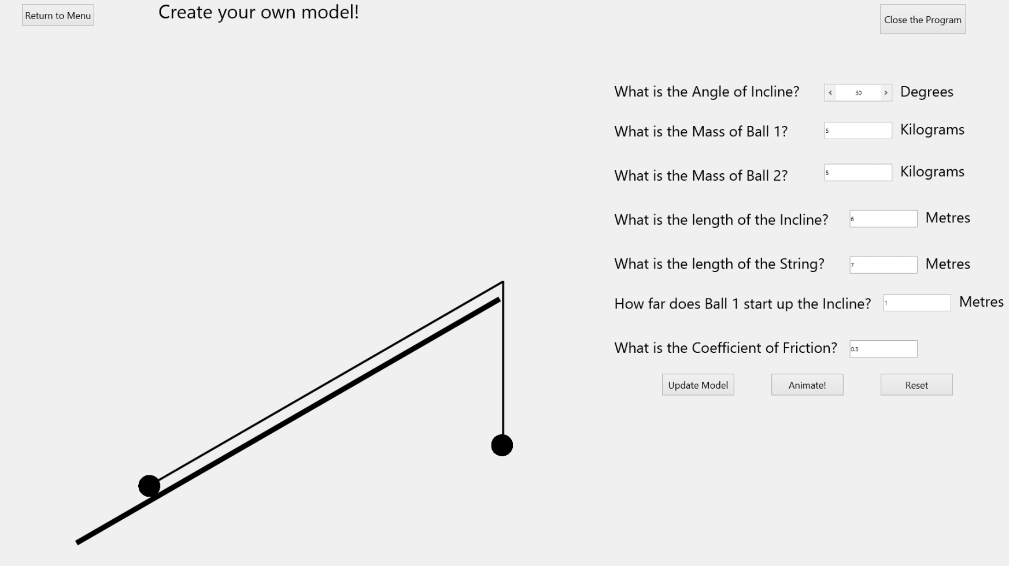When moving to this part of the program, a form shown below is displayed:

Note:

Ball 1

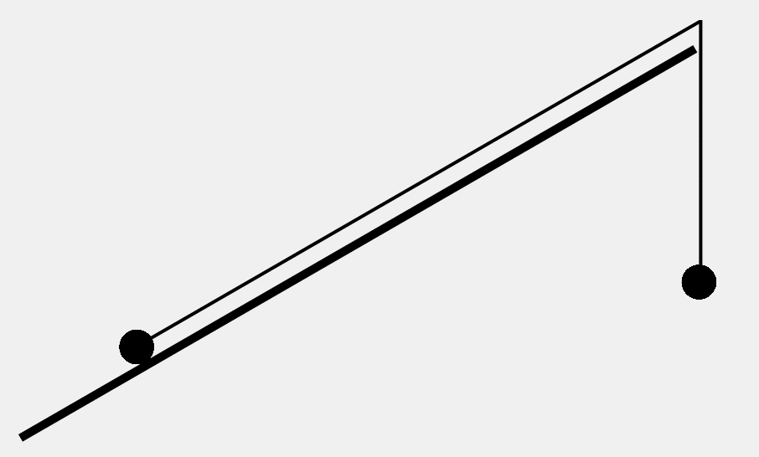

Ball 2

The functionality of this form is five fold.

#### Returning to the Menu

To return to the Main Menu, select the ‘Return to Menu’ button.

#### Close the Program

To close the program, select the ‘Close the program’ button.

#### Updating the model

The ‘Update Model’ button will animate the model on the left side of the screen to the configuration defined by the user. To define the configuration, the user can edit the selectors on the right hand side of the screen:



The model

Selectors the user can edit

As an example, if the selectors are changed to the configuration below:

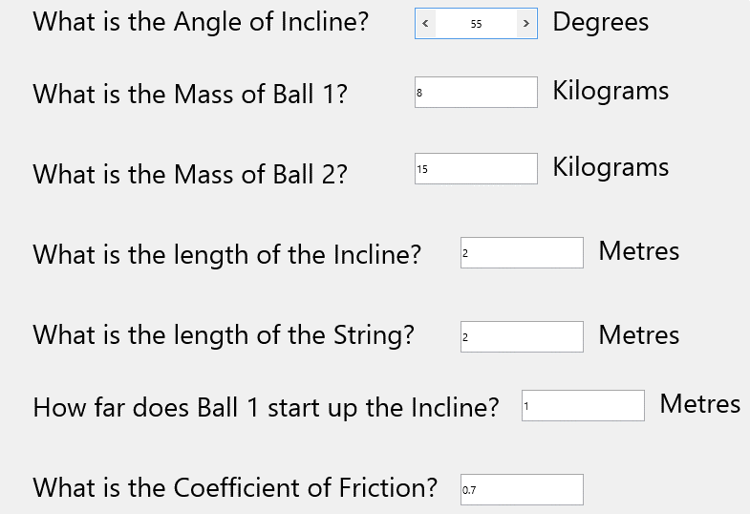

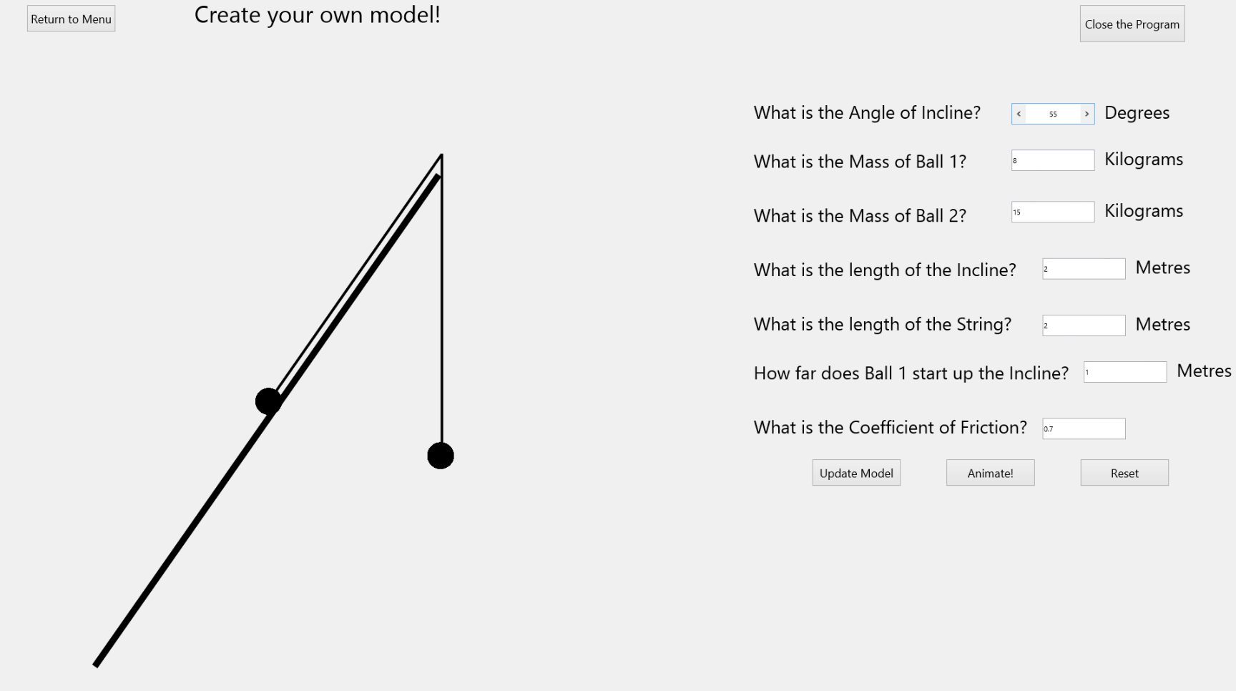And then the ‘Update Model’ button is selected, the model on the left will animate to that user-defined configuration. The new form would look like this:

It is worth noting that the selectors themselves only accept values according to the following rules:

|  |  |
| --- | --- |
| **Selector** | **Rule** |
| Angle of Incline | Integer between 0 and 90 non-inclusive |
| Mass of Ball 1 | 3 digit or less real |
| Mass of Ball 2 | 3 digit or less real |
| Length of the Incline | 3 digit or less real |
| Length of the String | 3 digit or less real |
| How far Ball 1 starts up Incline | 3 digit or less real |
| Coefficient of Friction | 4 digit or less real |

If these rules are broken an error message will be displayed. The specifics of this will be covered later in this User manual in the section ‘error messages’.

#### Animating the model

The ‘Animate!’ button will animate the model on the left side of the screen based on its current configuration. For example, if the button was selected after updating the model to the configuration used in the last section, the model would animate, leaving it in this configuration:

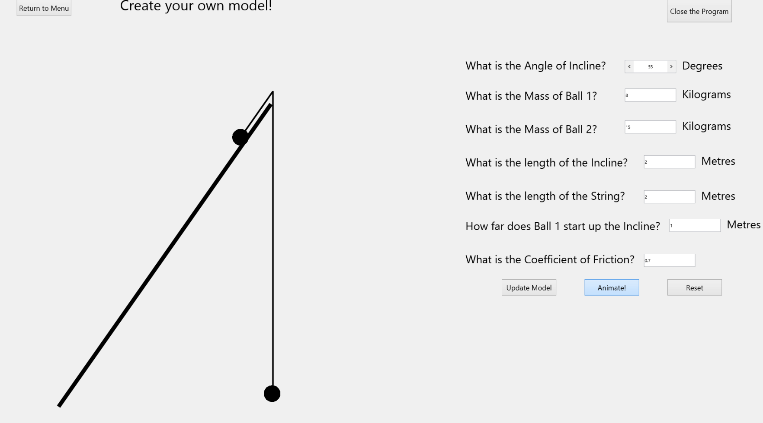

This occurred because Ball 2 was heavy enough to pull Ball 1 up the slope, despite any resistive forces. In some configurations Ball 1 will roll down the slope, pulling Ball 2 upwards. However, in other configurations, the values will be such that the balls do not move. If this occurs, a message is displayed explaining why this is. For example, if the configuration is changed so it is as below:

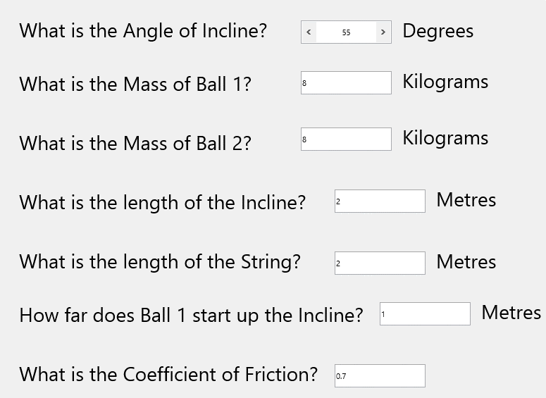

This value has changed

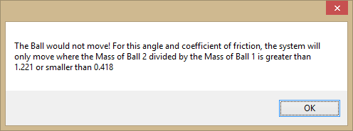And the ‘Animate!’ button is selected, no animation occurs and this message is displayed:

This informs why no animation occurred and implies what could be changed to make the system animate.

#### Resetting the model

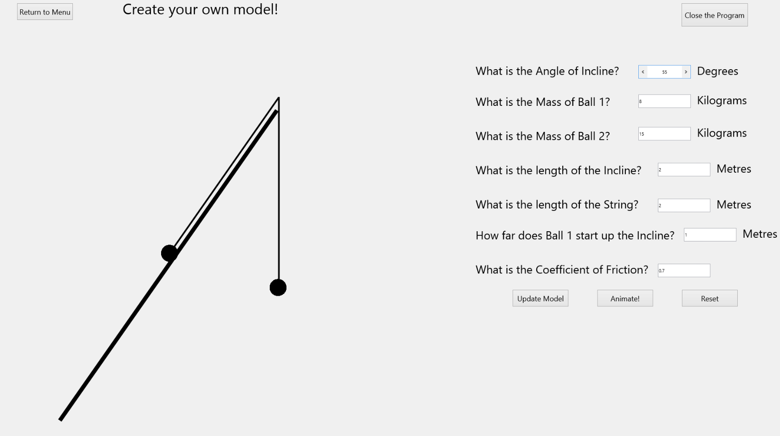The ‘Reset’ button resets the configuration and the model to default values. For example, if the configuration and model were setup as below:

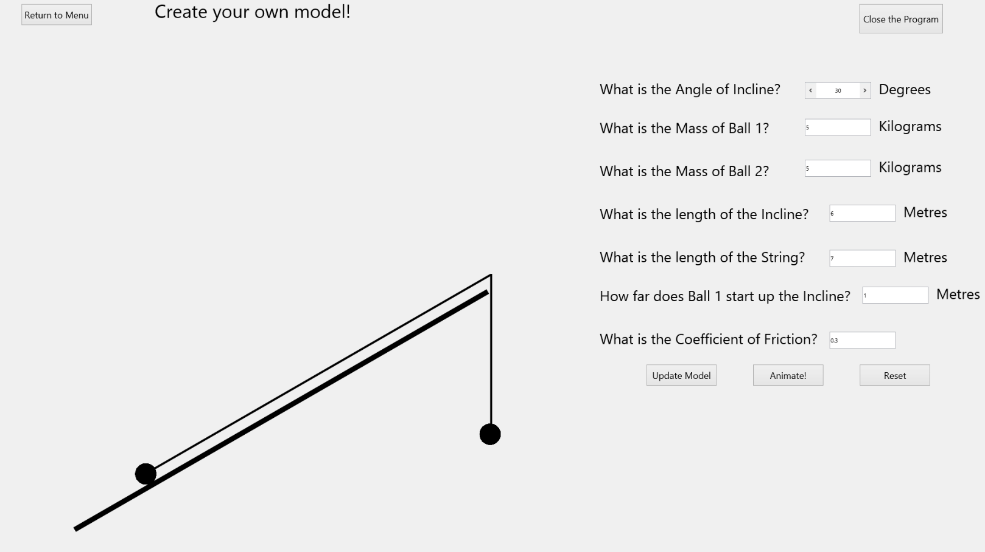And then the ‘Reset’ button was pressed, the system would reset to:

Note that this is the same configuration the form is found in when it is originally opened.

### Practice!

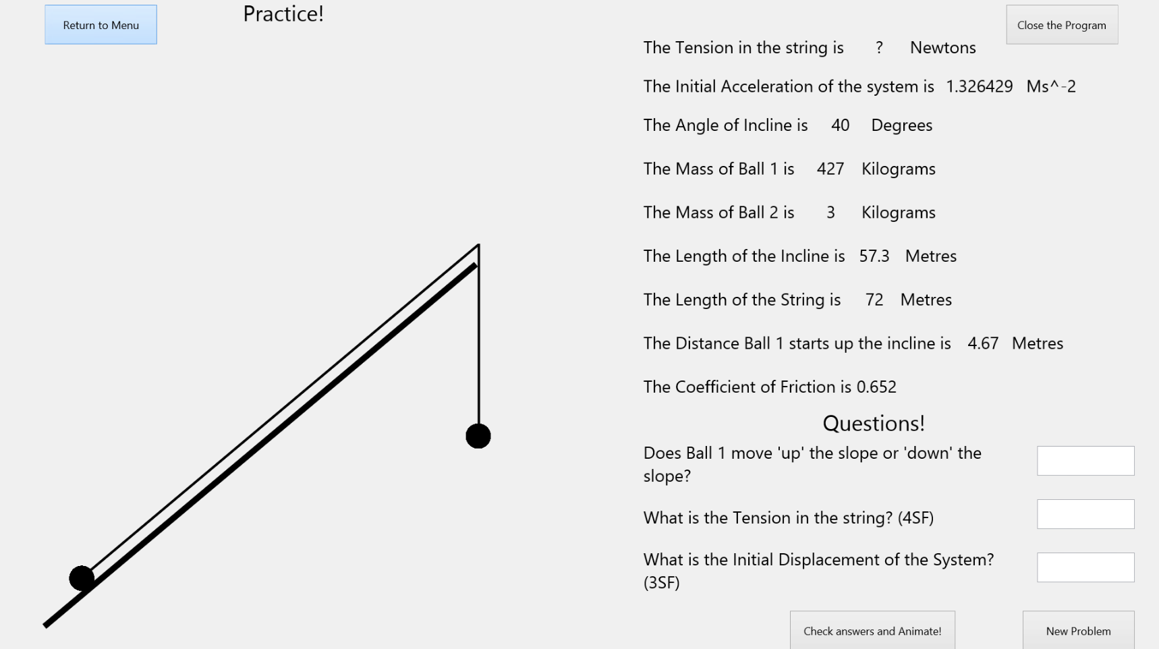This is the second part of the program which can be accessed from the Main Menu. It initially displays a form as below:

When the form is opened, a random M1 pulley systems on an incline problem is created. The values for which are displayed on the right side of the screen:

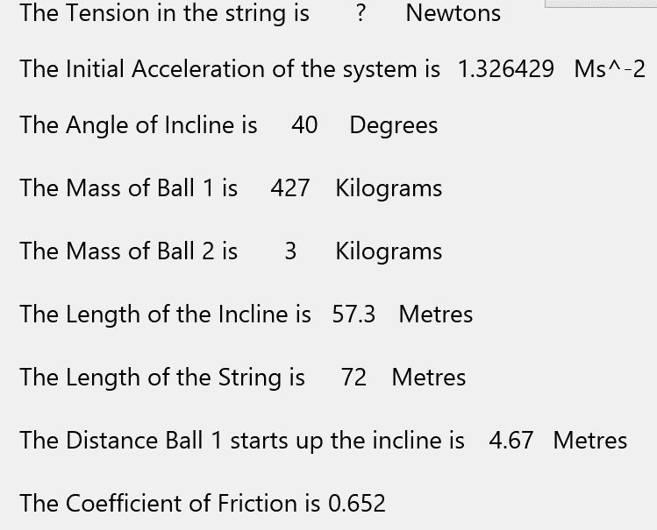

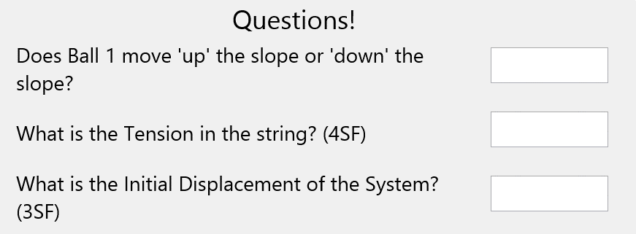Any values that are ‘?’ are values to be questoined on. The questions appear below the information:

The first question always is whether Ball 1 moves up or down the slope. The other two questions either ask you to calculate values marked ‘?’ or another variable that can be calculated from the given information (Such as ‘initial displacement’). All the answers can be calculated using M1 equations for pulley systems on an incline. Answers to the questions should be entered into the adjacent text-boxes:

Text-boxes



The functionality of the buttons on this form are four fold:

#### Returning to the Menu

To return to the Main Menu, select the ‘Return to Menu’ button.

#### Close the Program

To close the program, select the ‘Close the program’ button.

#### Check answers and Animate!

When this button is selected, the answers will be compared against the correct answers. If any of the answers are incorrect, a message that looks like this will be displayed:

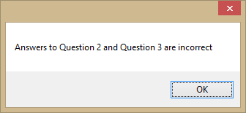

This message will change based on what questions are wrong.

However, if all answers are correct, this message will be displayed:

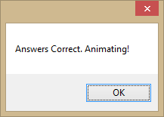

When this message is closed, the model on the left side of the screen will animate based on the configuration. In the example used above (included again here):

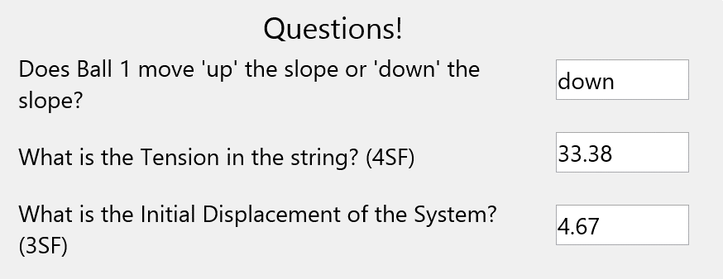The correct answers are:

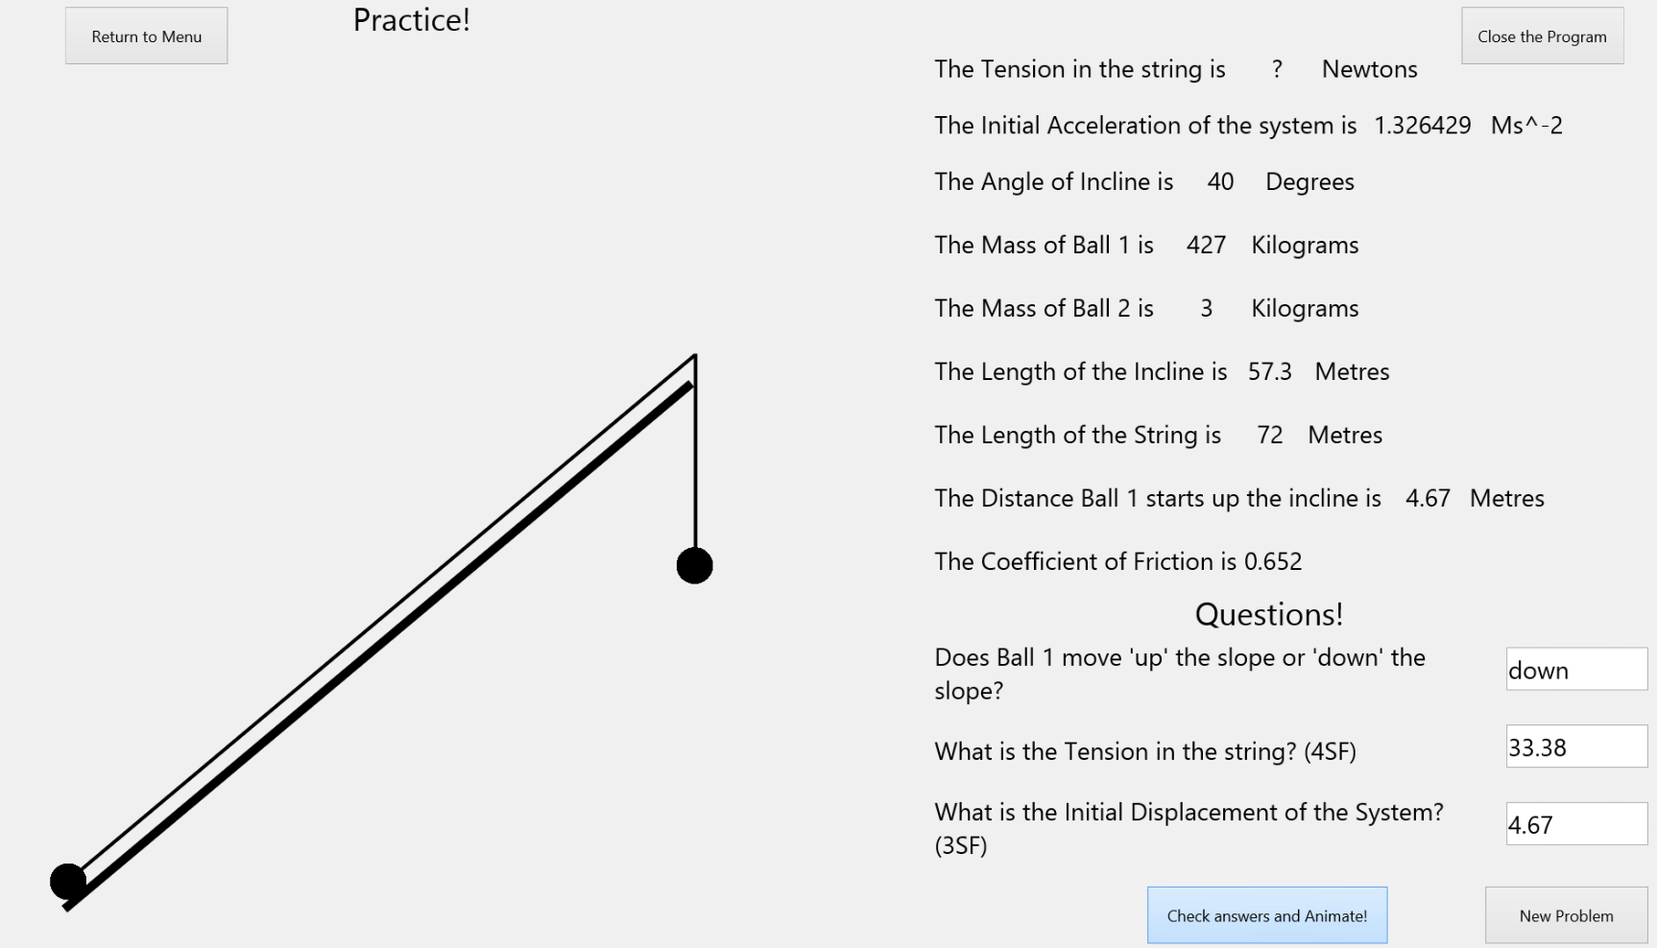The animation that follows leaves the form looking like this:

#### New Problem

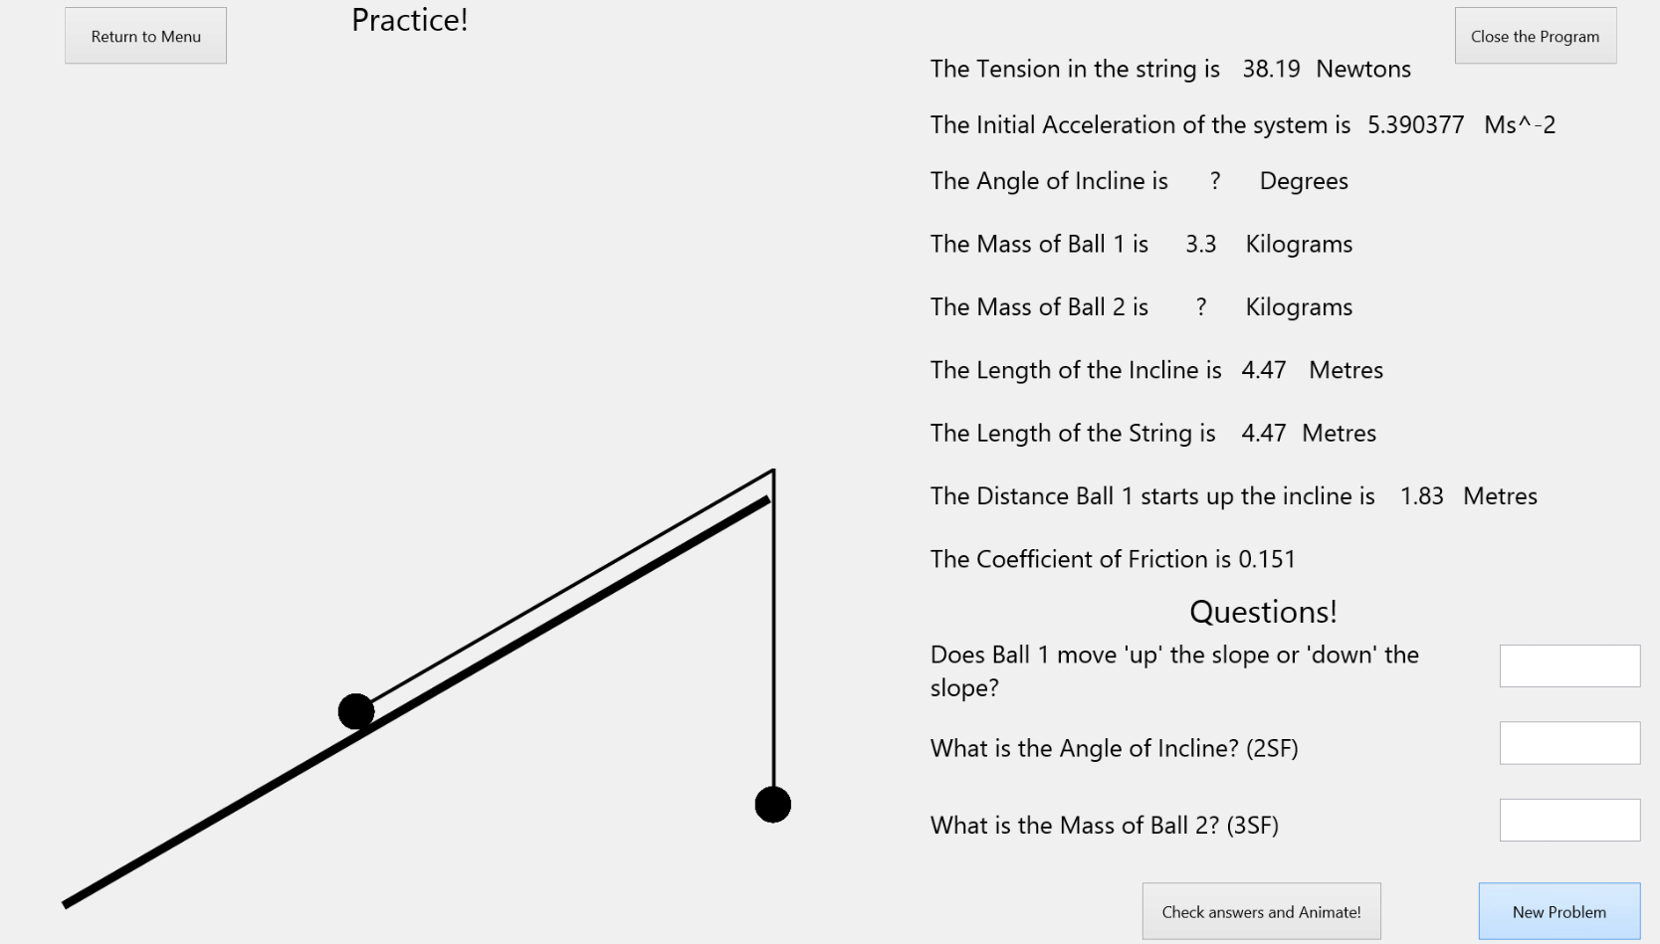The New Problem button generates a new problem, For example:

## Error Messages

#### The Main Menu

There are no error messages that can appear on this form.

#### Create your own Problem!

On this form, the user can encounter errors if the user’s inputs don’t follow these rules:

|  |  |
| --- | --- |
| **Selector** | **Rule** |
| Angle of Incline | Integer between 0 and 90 non-inclusive |
| Mass of Ball 1 | 3 digit or less real |
| Mass of Ball 2 | 3 digit or less real |
| Length of the Incline | 3 digit or less real |
| Length of the String | 3 digit or less real |
| How far Ball 1 starts up Incline | 3 digit or less real |
| Coefficient of Friction | 4 digit or less real |

If any of these rules are broken, a corresponding error message will be shown:

##### Angle of Incline

##### Mass of Ball 1

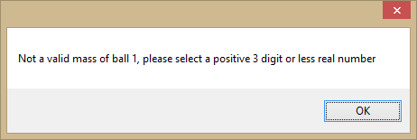

##### Mass of Ball 2

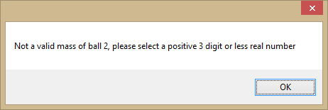

##### Length of Incline

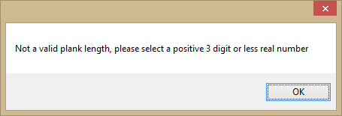

##### Length of String

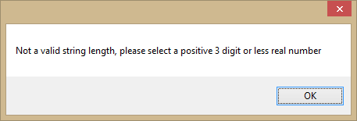

##### Distance Ball 1 up Incline

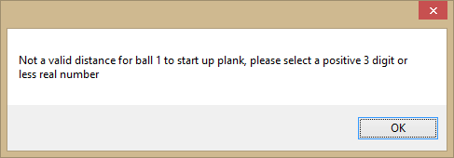

##### Coefficient of Friction

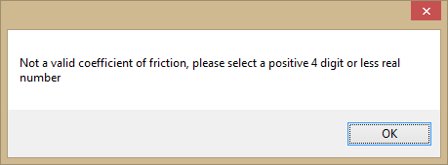

To recover from these error messages, select OK. This will reset the value you changed to its default value.

There are also other error messages. If the model the user tries to create is not within the bounds of the M1 specification, an error message corresponding to the validation check it failed is displayed:

##### Distance Ball 1 starts up the Plank < Length of the Plank

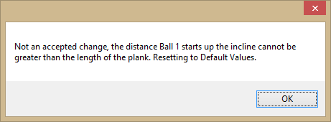

##### Distance Ball 1 starts up the Plank + Length of the String > Length of the Plank

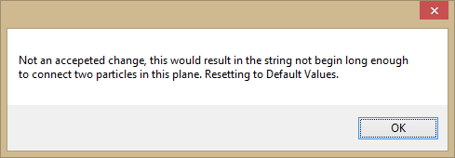

##### (Length of the Plank * Sin(Plank Angle)) – Length of the String + Length of the Plank – Distance Ball 1 starts up the Plank > 0

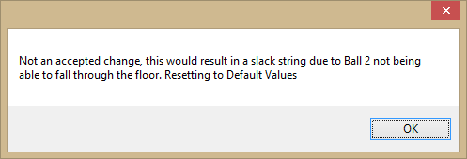

To recover from the three error messages above, select OK. This resets the model to default values.

These error message depend on which way Ball 1 is moving. Note that Extra Displacement is the additional displacement one of the Balls undergoes after the model passes the equilibrium position for the first time:

##### If Ball 1 moving up the slope: (Length of the Plank * Sin(Plank Angle)) – Length of the String + Extra Displacement < 0

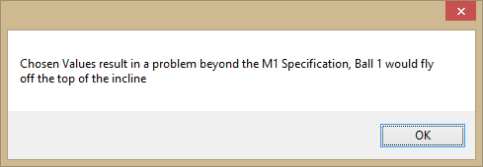

##### If Ball 1 moving down the slope: Length of the Plank – Length of the String + Extra Displacement < 0

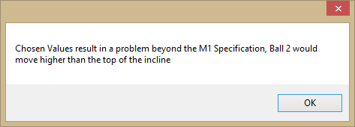

To recover from these error messages, select OK. No animation will occur, and the user will be able to change your values to make the model M1 standard.

#### Practice!

No error messages can occur on this form.

# Appraisal

## Introduction

I have created a program that can be used by students and teachers at Merchant Taylors’ School in order to learn or teach the ‘Pulley systems on an Incline’ part of the Edexcel M1 Mathematics Specification. The program is split into two parts. In the first part, the user can create their own ‘Pulley systems on an Incline’ M1 model before seeing it animate based on what would happen to the model if it was left in the user defined configuration. In the second part, the user is tested on randomly generated ‘Pulley systems on an Incline’ M1 models to test their knowledge on the subject.

Throughout the process, I was in regular communication with Mr.Slator, Head of Mathematics at Merchant Taylors' School. He helped me to shape the system to the needs of the Mathematics department and it was to him that I presented the final system. He helped analyse whether the objectives had been fulfilled and gave me the final feedback on the system. His feedback will be included later in this appraisal.

## Fulfilment of Objectives

The Objectives were:

**To make the program consist of two parts, one which allows a user to create their own model of a pulley system on an incline and then see it animate, and another which questions the user on a randomly created model.**

This objective has been fully achieved. The fact that this objective has been completed means that the program provides an interactive learning and teaching environment.

**To make both parts of the program have the functionality to animate the model to show what would happen if the model was left in its configuration.**

Both parts of the program have animation functionality, albeit the causes of the animation are different. This functionality is very important to the program as both me and Mr.Slator think it will keep students engaged when using the program.

**To make the program correctly calculate the direction of motion (if any) of a model.**

This functionality was tested in Test 39-41. The tests all passed, and so the objective has been fully achieved. Achieving this objective contributes to making an accurate model.

**To make the program correctly calculate the initial accleration (if any) of a model.**

This functionality was tested in Test 42. The test passed, and so the objective has been fully achieved. Achieving this objective contributes to making an accurate model.

**To make the program correctly calculate any extra displacement that a Ball undertakes after passing the equilibrium position due to its own momentum.**

This functionality was tested in Test 43. The test passed, and so the objective has been fully achieved. Achieving this objective contributes to making an accurate model.

**To make the program such that it is usable as a stand-alone executable without the need for any other files.**

This was a very important request by Mr.Slator. I have achieved this objective fully by embedding any resources I use such as Image and Text files into the executable.

**To have 3 questions per model in the part of the program that questions the user on a randomly created model.**

This was again specified by Mr.Slator. This was an easy objective to achieve but that being said it has been achieved.

**To make the part where the user is questioned on the model only animate if the user has got all the questions correct.**

This functionality was tested in Tests 45-46. The tests passed, and so the objective has been fully achieved. This encourages the user to learn from their mistakes and get better at the topic so that they can their models animate.

**To have the program explain why a model remained stationary if this has occurred**

This functionality was tested in Test 41. The test passed, and so the objective has been fully achieved. This not only helps the user learn what causes certain configuration to be in equilibrium, but also tells the user why an animation hasn’t occurred so they don’t assume the program is broken.

**To make sure that any animated model is within the bounds of the M1 specification**

This was by far the hardest objcetive to achieve. The mathematical rigour needed to validate all inputs or randomly generated values such that only M1 problems are displayed was very difficult. I needed a large number of validation checks. These validation checks were tested in Tests 9-38, and fortunately all of them passed. To this end, this objective has been fully achieved.

**To display error messages within 2 seconds**

I didn’t test this functionality in my system testing as I felt that it would be better tested by the User. Mr.Slator used the program for about 30 minutes after I first gave it to him and he confirmed that error messages were displayed seemingly instantaneously. Therefore, this objective has been fully achieved.

**To make items displayed in the program scale with screen size**

My tests were done on a 21 inch 1080p monitor. Mr.Slator then used the program on a 52 inch 720p smartboard. All items within the program scaled to fit the same proportions of the screen in both cases. I realise that this isn’t technically sufficient evidence to fully justify that the objective has been achieved, as I would need to test the program on infinitely many displays to do this. However, given my knowledge of the code and this evidence, I can say this objective has been achieved.

**To make the program fullscreen**

This objective was achieved. It was easy to achieve it because in Delphi-Firemonkey each form has an attribute ‘fullscreen’ which can be assigned at startup.

**To design the interface such that a user can understand and operate it with the aid of a user guide within 5 minutes**

When I first gave Mr.Slator the finished program, I timed how long it took him to understand the interface and operate the program with the aid of the User guide. It took him just over a minute, and so this objective has been fully achieved. The interface is so simple that I believe someone would be able to understand and operate this program within 5 minutes without the use of a user guide.

**To process and display randomly created models within 2 seconds of the action that triggered it**

Once again, Mr.Slator confirmed this process occurred instantaneously. Therefore this objective has been achieved fully.

**To begin animations within 2 seconds of the action that triggered it.**

Once again, Mr.Slator confirmed this process occurred instantaneously. Therefore this objective has been achieved fully.

## User Feedback

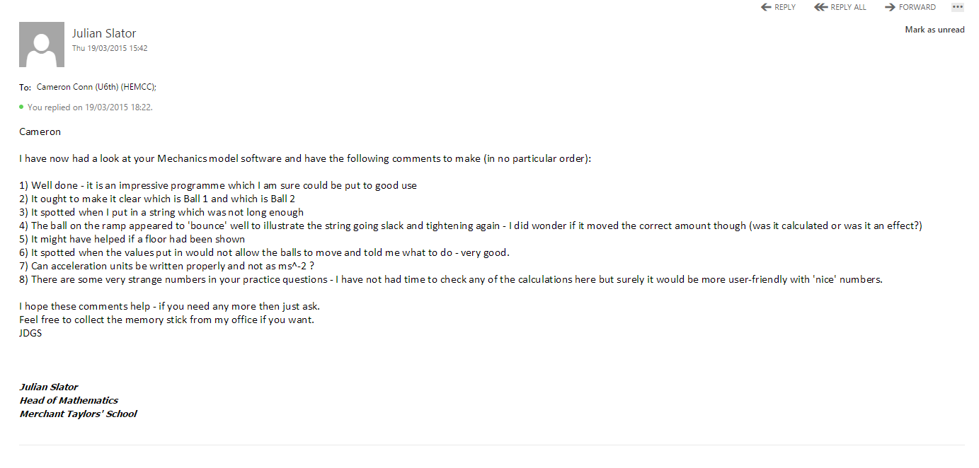After analysing whether I had completed the Objectives for the system with Mr.Slator, I asked him if he could test the program more extensively and give me some final feedback on what he liked and disliked most about the program. He emailed me back this response:

## Analysis of User Feedback

I will now analyse each comment one by one:

1. Not much to say here other than that I am glad Mr.Slator liked the program!
2. I’m afraid to say that I got so lost in the intricacies of the Maths and the code that I didn’t even consider making it clear which was Ball 1 and which was Ball 2 within the interface. I checked the User Manual I created, and luckily it makes it clear which is which. However something as basic as this should be easily understood from within the program. Considering how easy this would be to correct, I will definitely be adressing this in my Potential System Improvements.
3. This is an example of the program limiting problems to ones of M1 standard. This was already an objective of the system that was passed due to the personal testing I completed, however the fact that Mr.Slator was pleased with the functionality in his own use means that the objective was very successfully completed.
4. After using the program again myself and checking the Mathematics and some questions from the M1 textbook, I can confirm that the bounce was the correct length.
5. Again another fair point that I didn’t think of. Once again I will be considering action to correct this in my Potential System Improvements.
6. This functionality was a fufilled objective, so no further comment is needed other than that it was important to get this functionality correct as Mr.Slator had originally specified it existed.
7. I agree with Mr.Slator that Ms^-2 doesn’t look particularly good. However, I don’t think I am going to change it. This is because Metres per Second Squared takes up to much space and would effect the rest of the UI too much.
8. Essentially what Mr.Slator means is that the Random Problems generated include either very long Plank Lengths or a very small Distance that Ball 1 starts up the Plank, or both. This makes a lot of the problems seem odd and similar. This is a problem that I will fully explain and address in my Potential System Improvements.

## Potential System Improvements

After analysing my user feedback and reflecting on the finished program personally, I have thought of the following potential improvements:

### Make ‘random’ problems truly random

As Mr.Slator pointed out, the numbers in my random practice problems are ‘very strange’ and not ‘nice’. This is because the ‘random’ problems created are not truly mathematically random. Although I use a random number generator to create the values, due to the nature of my validation rules there is a much larger chance for the first problem that satisfies all the rules to have the following characteristics:

1. Ball 1 is close to the bottom of the slope.
2. The Length of the Incline is very large.

To this end, my variables are random, but the problems that combine all the variables are not random, and have an element of mathematical bias. The program would be better if this bias could be eliminated. However, this is not easy. To do this, one would have to cycle through each potential problem (this could be automated), and record the distance ball 1 starts up the plank, and the length of the incline. Then, these two values would have to be multiplied together, let this new value be x. Potential problems must then be sorted into ascending order by x. In this order, each potential problem should be assigned a unique integer value n, with the first problem having n=1, the second problem having n=2 and so on. The next step is to find an approximate function that maps n onto x. This can be achieved by drawing a graph of n against x and using graph analytics. The function will almost certainly be in the form kye^z where k,y and z are reals to be found due to the nature of the bias. Once this function is found, find the inverse function of this function. Now normalise the inverse function so that the integral of the normalised function between 1 and the largest n value is 1. Call this new function g(n). Now for a given n, the probability weighting that should be applied to that problem to eliminate bias is g(n).

### UI Improvements

If I had more time to create the program, I would certainly make some UI Improvements to improve the user experience and make it easier to use the program:

#### Labelling Ball 1 and Ball 2

Currently, Ball 1 and Ball 2 are not labelled within the program. For the user to know which is which, another source such as the user guide is needed. The User guide clearly explains which is which, but I still feel that if the Balls were labelled the program would be even easier to use. This change could easily be achieved by using image manipulation software to edit the images of the Balls such that they have a number on them for labelling purposes.

#### Adding a Floor

As Mr.Slator suggested in his final User Feedback, having a floor would make it easier for the user to see when either of the Balls had hit the floor. This could be implemented very easily by including another horizontal TLine.

#### Changing how the direction of motion question is answered

Currently, this question is answered by typing in ‘up’ or ‘down’ into a textbox. While the program accepts any capital letter/non-capital letter representation of these words, I feel it would be easier if the question was answered a different way. I would probably use radio buttons to make the selection more intuitive.

### Sharing problems across the school network

While not something suggested by Mr.Slator, I have recently thought of functionality that would potentially make the program better. If students are all using the program at the same time, I think it would be helpful if it was possible for one student to share a problem they are working on with another student. For example, if a student is stuck on a problem, they would be able to send it to a friend to look at so that they can help them. There could even be functionality that allowed the problem to be broadcast to the whole class. This could be achieved be using the UDP or TCP protocols (depending on the scenario) to send the variable values.